# High efficient deposition 2-in. double-sided YBCO thin films in batch with pulsed inject MOCVD

R Chen1, B W Tao1, *, R P Zhao1, G Y He1, C Zeng2 and X Y Lu2

1 State Key Lab of Electronic Thin Films and Integrated Devices, University of Electronic Science and Technology of China, Chengdu, 610054, People’s Republic of China

2 School of Opto-Electronic Information, University of Electronic Science and Technology of China Chengdu 610054

E-mail: taobw@uestc.edu.cn

## Abstract

A pulsed inject MOCVD device was designed to efficiently produce double-sided YBCO thin films in batch. With it, up to 12 pieces of double-sided 2-in. YBCO thin films could be prepared simultaneously. In this paper, 500 nm thick YBCO thin films were simultaneously deposited on both sides of 2-in. LaAlO3 single crystalline wafers at an average preparation rate of 23 min per piece. The YBCO thin films made in this way maintained good consistency both in-plane and double-sided. Meanwhile, the critical current density is between 2.2 - 2.4 MA·cm-2 (77K, 0T), and the microwave surface resistance is 0.323 mΩ (77K, 10GHz) that has meet the commercial demand of microwave filters.

Keywords: MOCVD YBCO double-sided efficient

## 1.Introduction

YBa2Cu3O7-delta (YBCO) high temperature superconductor (HTSC) thin films on LaAlO3 (LAO) single crystal have been widely used for microwave filters, because of its excellent property of high current capacity and low microwave losses[1-10]. The microwave filters with double-sided YBCO thin films have much lower insertion loss and stronger anti-interference capability compared to ordinary filters[11-14]. In earlier time， double-sided YBCO thin films prepared by depositing the second side after the first side being finished[15-17], which had negative impacts on the double-sided consistency, made the deposition process complicated and more time been used for extra-system vacuuming, cooling-down, and heating-up. Gradually, simultaneous deposition route to prepare double-sided YBCO thin films has been developed and made progress [18-20].

With great effort, double-sided YBCO thin films with good performance had been prepared successfully with different deposition methods all over the world[18-22], but the price is still too high due not only to the high cost of preparation, but also to the low preparation efficiency. Nowadays, the main preparation methods of YBCO thin films for microwave usage on single crystal include co-evaporation[16, 21], sputtering[18, 19], pulsed laser deposition (PLD)[9, 20] and metal organic deposition (MOD)[22-24]. Co-evaporation method can be used to deposit single-sided YBCO thin films in batch rapidly, but it is difficult to simultaneously deposit double-sided thin films due to the raw material melting. With the PLD method, the films are still deposited one side after the other and it takes more than 6 hours to make a sample. The traditional sputtering method, of which the depositing rate is only about several nanometers per minute, usually takes time longer than working hours to prepare a piece of 500 nm thick double-sided YBCO thin films. As for MOD method, just the decomposition process takes approximately 10 hours.

In recent years, metal organic chemical vapor deposition (MOCVD) method has been improved and makes a quick progress in the preparation of YBCO high temperature superconducting (HTS) tapes as a low cost large-scale production method[25-28]. As reported, the deposition rate of YBCO thin films on tapes could reach up to 1 μm min-1[25], which is much higher than other deposition method. These films also have good high frequency properties. This fast deposition method for HTS tapes should be also suitable for YBCO thin films on single crystals only if it could deposit on the both sides of the substrates. So we transplanted our MOCVD equipment into the preparation of YBCO thin films on single crystal.

Meanwhile, in order to further improve the efficiency of production, the pre-preparation that cost several hours such as vacuuming, heating-up, preparation of the precursor solution, and post-annealing should also be considered. The efficiency of the preparation of YBCO thin films would greatly enhanced if multi-pieces of double-sided YBCO thin films rather than only one piece were deposited in one run.

In the paper, a pulsed inject MOCVD device was designed to prepare multi-pieces of double-sided YBCO thin films simultaneously and efficiently.

## 2.Experiment

A pulsed inject MOCVD device, which contained a planetary turnplate rotating disk for holding substrates and a simple nozzle, was designed to prepare multi-pieces of double-sided YBCO thin films simultaneously as shown in Figure 1. The planetary turnplate disk having 12 circumferentially shaped openings, in which wafers were maintained, was applied to deposit multi-pieces of YBCO thin films as shown in Figure 1(a). With it, at most 12 pieces of YBCO thin films could be deposited in one run, significantly shortening the production progress of each YBCO thin films. Meanwhile, the diameter of the openings was a little bigger than the diameter of wafers that were used as substrates. Upon rotation of the substrate turnplate, the wafers self-rotated within each opening due to the force of friction between the substrates and the openings. This behavior is conductive to the uniform distribution of the thickness of YBCO thin films. The nozzle contains two opposite symmetrical linear slits, with 1mm in width and 70mm in length and 30mm in distance each other. It was used to deposit double-sided YBCO thin films simultaneously as shown in Figure 1(b). The position relationship of the planetary turnplate and the nozzle is shown in Figure 1(c).

In our experiment, 2-in. LAO single crystal wafers were used as substrates for YBCO thin films. Before depositing, the deposition chamber was heated to 845 ℃, while the evaporation chamber and transport pipeline were heated to 300 ℃. Meanwhile, Y(thmd)3, Ba(thmd)2·(1,10-heptanedionate), Cu(thmd)2 were dissolved into tetrahydrofuran solution in a proper proportion, where ‘thmd’ is the abbreviation of 2,2,6,6, -tetramethy-3,5-heptanedioline. During depositing, the precursor solution was evaporated in the evaporator. And the vapor of precursor solution was mixed up with the nitrous oxide, oxygen, argon in a proper gas flow ratio, and was transferred into the depositing area from the nozzle continuously. After deposition, the temperature of the deposition chamber was decreased down to 500 ℃ gradually by adjusting heating current manually. After annealing for 20 minutes in pure oxygen, the YBCO thin films were cooled to room temperature slowly.

The thickness of YBCO thin films was measured by a step profiler (Veeco Dektak 150). The critical current density (*Jc*) was measured through the Leipzig *Jc*-scan system and the microwave surface resistance (*Rs*) was measured through a sapphire resonance[29]. The texture was characterized by an x-ray diffraction system (XRD, DanDong DX-2700) with *θ*-2*θ* scan for crystal phase and orientation and *ω*-scan for out-of-plane orientation.

## 3.Results and discussion

### 3.1 The preparation rate of double-sided YBCO thin films on LAO wafers

In one run, up to 12 pieces of 2-in. double-sided YBCO thin films can be produced. Thus, the average preparation time of pre piece of double-sided YBCO thin films (*pre*) can be calculated with:

*pre* , (1)

where *T* is the total time of a single experiment. It could be divided into the pre-preparation time (about 140 minutes), depositing time (75 minutes for 500 nm) and post processing time (usually 60 minutes). As shown in table 1, the *pre*, which is calculated according to the measured results, is only about 23 min per piece. This is much more efficient compared with our double-sided sputtering technique, which is 15 hours per piece generally[18].

**Table 1.** The average preparation time of pre piece of double-sided 500nm thick YBCO thin films in one run

|  |  |  |  |  |
| --- | --- | --- | --- | --- |
| Pre-preparation time (min) | Deposition time for 500 nm thick thin films (min) | Post preparation time (min) | Total time in a single experiment (min) | Average preparation rate (min pre piece) |
| 140 | 75 | 60 | 275 | 23 |

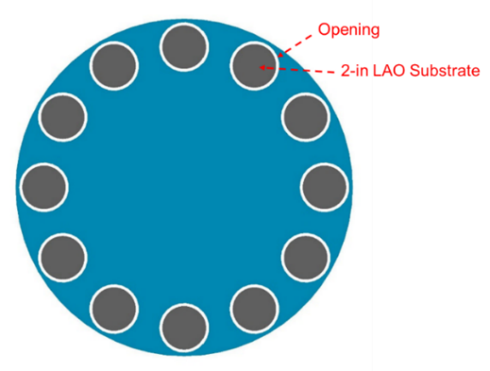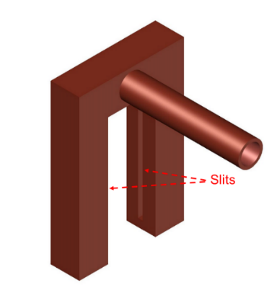

(a) (b)

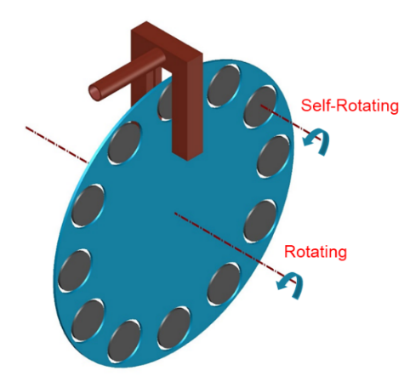

(c)

**Figure 1.** The pulsed inject MOCVD device: (a) the planetary turnplate disk; (b) the nozzle with two opposite symmetrical linear slits; (c) the position relationship of the planetary turnplate disk and the nozzle.

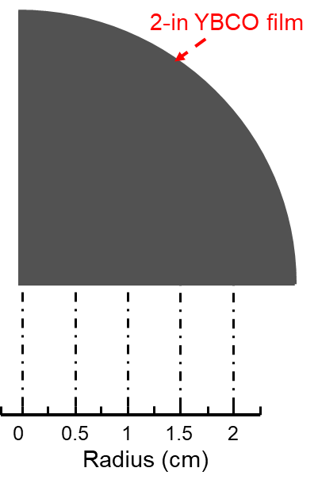

**Figure 2.** The testing radii of 2-in. YBCO thin films

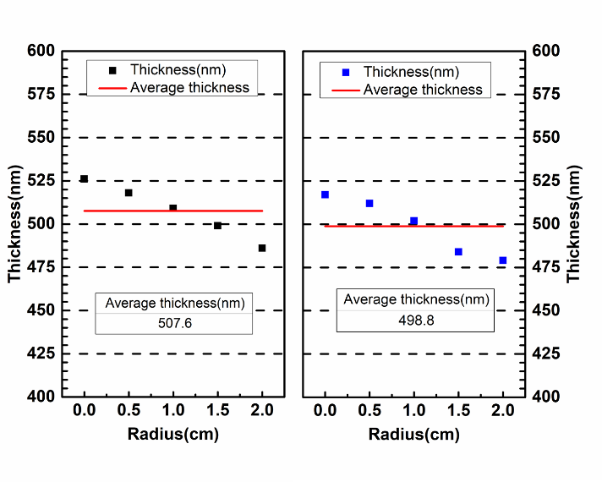

**Figure 3.** The thickness distribution of 2-in. double-sided YBCO thin films at radii of 0, 0.5, 1, 1.5, 2 cm



**Figure 4.** The XRD *θ*-2*θ* scanning patterns of double-sided YBCO thin films at radii of 0, 1, 2 cm of side A and B



**Figure 5.** The XRD *ω*-scanning patterns of double-side YBCO thin films

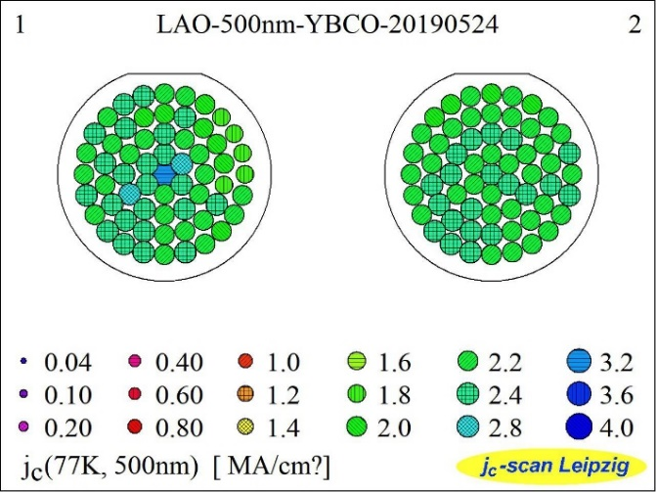

**Figure 6.** Homogeneity of *Jc* (77K, 0T) of 2-in. double-sided YBCO thin films



**Figure 7.** Transformation of *Jc* (77K, 0T) at radii of 0, 0.5, 1, 1.5, 2 cm on both sides of 2-in. YBCO thin films

### 3.2 The measurement of double-sided YBCO thin films

The thickness distribution of both sides of the 2-in. YBCO thin films were measured by a step profiler. As shown in Figure 2, on each side, radii of 0, 0.5, 1, 1.5, 2 cm were selected for thickness measurement in order to test the consistency of double-sided YBCO thin films. According to the results in Figure 3, the average thickness of the two sides are approximately 507.6 nm and 498.8 nm, respectively. Meanwhile, the deviation of thickness of each side is lower than 10%, which indicates that the double-sided YBCO thin films is of good consistency. This thickness deviation, which could be derived from the turnplate thickness-effect because it is much thicker than the substrate and interfere the vapor flowing, is larger than expected for a linear slit MOCVD.

The XRD *θ*-2*θ* scan maps of double-sided YBCO thin films, which were measured at radii of 0, 1, 2 cm are shown in Figure 4. Except the peaks of LAO at 23.4° and 47.9°, there are only YBCO (*00l*) peaks other than (*h00*) peaks in the *θ*-2*θ* curve, which indicates that almost all YBCO grains are c-axis-oriented as we expected.

The XRD *ω*-scanning of the double-sided YBCO thin films, which were used to characterize the out-of-plane texture, were performed at the equivalent position of each side. As is shown in Figure 5, the full width of half maximum (FWHM) of each side is 0.498° and 0.507° respectively, which shows little difference between the two sides.

Figure 6 shows the measured results of *Jc* (77K, 0T) of 2-in. double-sided YBCO thin films on LAO substrate. The *Jc* (77K, 0T) at every point measured is mainly between 2.2 MA cm-2 and 2.4 MA cm-2. As is shown in Figure 7, the variation of the Jc along the radius of each side of the 2-in. double-sided YBCO thin films is small and the distinction between the two sides is not obvious.

In order to obtain Rs, a sapphire resonance was used to measure the quality factor (*Q*) of the YBCO films firstly [29]. As shown in Figure 8, the measured Q of 500nm YBCO films is 87524 at 31.506 GHz. The relationship between Qand Rsis as follow:

(2)

where *A*, *B* are only related to the electromagnetic fields distribution and can be determined by calibration. Therefore, the microwave surface resistant can be calculated with:

. (3)

Meanwhile, the relationship of the Rs and the operating frequency(*f*)is as follow:

, (4)

where *k* is a constant. Thus, the microwave surface resistant (*Rs0*) at the frequency of 10GHz (*f0*) can be calculated by the formula:

(5)

and the calculation results are shown in Table 2. The Rs0 is as low as 0.323mΩ which indicates that the YBCO thin films prepared has met the commercial demand of surface resistant of microwave filters.

## 

**Figure 8.** The measurement of *Q* of the 2-in. 500nm thick double-sided YBCO thin films

**Table 2.** The calculation results of the Rs of 500nm thick YBCO thin films at 77K

|  |  |  |  |  |  |
| --- | --- | --- | --- | --- | --- |
| *Q* | *A* | *B*(mΩ-1) | *f0*(GHz) | *f* (GHz) | *Rs0*(mΩ) |
| 87524 | 8.294*10-6 | 9.767*10-4 | 10 | 31.056 | 0.323 |

## 4.Conclusion

In this paper, we presented a double-sided pulsed inject MOCVD device that used for the efficient production of double-sided YBCO thin films. Results indicated that the average preparation rate of 2-in double-sided 500 nm thick YBCO thin films was only about 23 minutes per piece. Meanwhile, the double-sided YBCO thin films maintained good consistency both in-plane and double-sided. And the Jc of prepared YBCO thin films with good biaxial texture is 2.2 - 2.4 MA cm-2(77K, 0T). Moreover, the Rs was as low as 0.323 mΩ (77K, 10GHz)..It illuminated that the prepared double-sided YBCO thin films have met the demand of microwave filters (Jc≥2.0 MA·cm-2 (77K, 0T), Rs≤0.5 mΩ (77K,10GHz)) and our design to efficiently produce double-sided YBCO thin films in batch is feasible.

## Acknowledgment

We gratefully acknowledge the support of the National Natural Science Foundation of China (No.51872040).

## Reference

[1] S.I. Bondarenko, V.P. Koverya, A.V. Krevsun, S.I. Link, High-temperature superconductors of the family (RE)Ba2Cu3O7-δ and their application (Review Article), in: Low Temperature Physics, 2017, pp. 1125-1151, doi:10.1063/1.5008405.

[2] L. Guo-Chun, Z. Dawei, S. Chien-Fu, M.E. Johansson, R.S. Withers, D.E. Oates, A.C. Anderson, P. Polakos, P. Mankiewich, E.d. Obaldia, R.E. Miller, High-power HTS microstrip filters for wireless communication, IEEE Transactions on Microwave Theory and Techniques, 43 (1995) 3020-3029, doi:10.1109/22.475668.

[3] A. Fathy, D. Kalokitis, V. Pendrick, E. Balohoubek, A. Pique, M. Mathur, Superconducting narrow band pass filters for advanced multiplexers, in: 1993 IEEE MTT-S International Microwave Symposium Digest, 1993, pp. 1277-1280 vol.1273, doi:10.1109/MWSYM.1993.277107.

[4] H. Jia-Sheng, M.J. Lancaster, D. Jedamzik, R.B. Greed, On the development of superconducting microstrip filters for mobile communications applications, IEEE Transactions on Microwave Theory and Techniques, 47 (1999) 1656-1663, doi:10.1109/22.788606.

[5] J.X. Jin, X. Ying, Q.L. Wang, Y.S. He, C.B. Cai, Y.S. Wang, Z.M. Wang, Enabling High-Temperature Superconducting Technologies Toward Practical Applications, IEEE Transactions on Applied Superconductivity, 24 (2014) 1-12, doi:10.1109/tasc.2014.2346496.

[6] J. Qiao, C.Y. Yang, High-Tc superconductors on buffered silicon: materials properties and device applications, Materials Science and Engineering: R: Reports, 14 (1995) 157-201, doi:10.1016/0927-796X(94)00172-3.

[7] D.E. Oates, G.F. Dionne, Magnetically tunable superconducting resonators and filters, IEEE Transactions on Applied Superconductivity, 9 (1999) 4170-4175, doi:10.1109/77.783944.

[8] S.H. Talisa, M.A. Janocko, C. Moskowitz, J. Talvacchio, J.F. Billing, R. Brown, D.C. Buck, C.K. Jones, B.R. McAvoy, G.R. Wagner, D.H. Watt, Low- and high-temperature superconducting microwave filters, IEEE Transactions on Microwave Theory and Techniques, 39 (1991) 1448-1454, doi:10.1109/22.83816.

[9] M. Lorenz, H. Hochmuth, D. Matusch, M. Kusunoki, V.L. Svetchnikov, V. Riede, I. Stanca, G. Kastner, D. Hesse, High-quality Y-Ba-Cu-O thin films by PLD-ready for market applications, IEEE Transactions on Applied Superconductivity, 11 (2001) 3209-3212, doi:10.1109/77.919747.

[10] Y. He, Y. Wang, Y. Hu, W. Chen, Z. Yan, Superconducting electrode capacitor based on double-sided YBCO thin film for wireless power transfer applications, Superconductor Science and Technology, 32 (2019), doi:10.1088/1361-6668/aaebd8.

[11] T. Zhang, Z. Long, L. Zhou, M. Qiao, F. Hou, M. Tian, Realization of Even Transmission Zeros for Filter Without Cross-Couplings, IEEE Transactions on Microwave Theory and Techniques, 66 (2018) 5248-5259, doi:10.1109/tmtt.2018.2871140.

[12] L.-M. Wang, W.-C. Lin, M.-L. Chang, C.-Y. Shiau, C.-T. Wu, Characteristics of Ultra-Wideband Bandpass YBCO Filter With Impendence Stub, IEEE Transactions on Applied Superconductivity, 21 (2011) 551-554, doi:10.1109/tasc.2010.2091231.

[13] S. Kolesov, H. Chaloupka, A. Baumfalk, T. Kaiser, Planar HTS structures for high-power applications in communication systems, Journal of Superconductivity, 10 (1997) 179-187, doi:10.1007/bf02770548.

[14] L. Gao, L. Sun, F. Li, Q. Zhang, Y. Wang, T. Yu, J. Guo, Y. Bian, C. Li, X. Zhang, H. Li, J. Meng, Y. He, 8-GHz Narrowband High-Temperature Superconducting Filter With High Selectivity and Flat Group Delay, IEEE Transactions on Microwave Theory and Techniques, 57 (2009) 1767-1773, doi:10.1109/TMTT.2009.2022813.

[15] G. Muller, B. Aschermann, H. Chaloupka, W. Diete, M. Getta, B. Gurzinski, M. Hein, M. Jeck, T. Kaiser, S. Kolesov, H. Piel, H. Schlick, R. Theisejans, Double-sided YBa/sub 2/Cu/sub 3/O/sub 7-/spl part// films for planar high-power filters, IEEE Transactions on Applied Superconductivity, 7 (1997) 1287-1290, doi:10.1109/77.620754.

[16] H. Kinder, P. Berberich, B. Utz, W. Prusseit, Double sided YBCO films on 4" substrates by thermal reactive evaporation, IEEE Transactions on Applied Superconductivity, 5 (1995) 1575-1580, doi:10.1109/77.402874.

[17] Y. Ito, Y. Yoshida, M. Iwata, Y. Takai, I. Hirabayashi, Preparation of double-sided YBa2Cu3O7−δ film by hot-wall type MOCVD, Physica C: Superconductivity, 288 (1997) 178-184, doi:<https://doi.org/10.1016/S0921-4534(97)01573-6>.

[18] X.Z. Liu, B.W. Tao, X.W. Deng, Y. Zhang, Y.R. Li, The preparation of two inch double-sided YBCO thin films, Superconductor Science and Technology, 15 (2002) 1698-1700, doi:10.1088/0953-2048/15/12/313.

[19] F. Ding, H. Gu, T. Li, J. Cao, X. Lv, Y. Lei, Batch production of large-area double-sided YBa2Cu3O7−δthin films by DC magnetron sputtering, Superconductor Science and Technology, 22 (2009), doi:10.1088/0953-2048/22/5/055019.

[20] M. Lorenz, H. Hochmuth, D. Natusch, K. Kreher, Highly reproducible large-area and double-sided pulsed laser deposition of HTSC YBCO:Ag thin films for microwave applications, Applied Physics A, 69 (1999) S905-S911, doi:10.1007/s003390051556.

[21] W. Prusseit, R. Semerad, K. Irgmaier, G. Sigl, Optimized double sided DyBa2Cu3O7-thin films for RF applications, Physica C: Superconductivity, 392-396 (2003) 1225-1228, doi:<https://doi.org/10.1016/S0921-4534(03)01028-1>.

[22] T. Manabe, M. Sohma, I. Yamaguchi, K. Tsukada, W. Kondo, K. Kamiya, T. Tsuchiya, S. Mizuta, T. Kumagai, Surface resistances of 5-cm-diameter YBCO films prepared by MOD for microwave applications, Physica C: Superconductivity and its Applications, 445-448 (2006) 823-827, doi:<https://doi.org/10.1016/j.physc.2006.04.042>.

[23] S.S. Wang, Z.L. Zhang, L. Wang, L.K. Gao, J. Liu, High quality uniform YBCO film growth by the metalorganic deposition using trifluoroacetates, Physica C: Superconductivity and its Applications, 534 (2017) 68-72, doi:<https://doi.org/10.1016/j.physc.2017.02.001>.

[24] M. Sohma, K. Tsukada, I. Yamaguchi, K. Kamiya, W. Kondo, T. Kumagai, T. Manabe, Cerium Oxide Buffer Layers on Perovskite-Type Substrates for Preparation of $c$ -Axis-Oriented ${\rm YBa}_{2}{\rm Cu}_{3}{\rm O}_{7}$ Films by Fluorine-Free Metalorganic Deposition, IEEE Transactions on Applied Superconductivity, 19 (2009) 3463-3466, doi:10.1109/TASC.2009.2018822.

[25] R. Zhao, Q. Liu, F. Zhang, Y. Xia, H. Tang, Y. Lu, C. Cai, B. Tao, Y. Li, High Rate Growth of MOCVD-Derived GdYBCO Films Based on a Simple Self-Heating Method, Journal of Electronic Materials, 47 (2018) 7062-7068, doi:10.1007/s11664-018-6632-8.

[26] R. Zhao, F. Zhang, Q. Liu, Y. Xia, Y. Lu, C. Cai, J. Xiong, B. Tao, Y. Li, MOCVD-derived multilayer Gd0.5Y0.5Ba2Cu3O7−δfilms based on a novel heating method, Superconductor Science and Technology, 30 (2016) 025023, doi:10.1088/1361-6668/30/2/025023.

[27] F. Zhang, R. Zhao, Y. Xue, H. Wang, Y. He, P. Zhang, B. Tao, J. Xiong, Y. Li, Self-heating technique of metallic substrate for reel-to-reel and double-sided deposition of YBa2Cu3O7−δfilms, Applied Physics A, 122 (2016) 81, doi:10.1007/s00339-015-9575-4.

[28] S. Miyata, K. Matsuse, A. Ibi, T. Izumi, Y. Shiohara, T. Goto, High-rate deposition of YBa2Cu3O7−δhigh-temperature superconducting films by IR-laser-assisted chemical vapor deposition, Superconductor Science and Technology, 26 (2013) 045020, doi:10.1088/0953-2048/26/4/045020.

[29] C. Zeng, Z. Luo, S. Bu, K. Yang, Q. Zhang, A novel method for the measurement of frequency-character of surface resistance of HTS thin film, Chinese Science Bulletin, 55 (2010) 1088-1091, doi:10.1007/s11434-009-0639-8.