# HelpDesk Documentation

Cassandre Henriquez & Angel Mendoza

### Table of Content

1. Abstract
2. Scope of Project/Features
3. Technologies
4. Uses Cases
   1. Registration
   2. Log In
   3. Create a Ticket
   4. View Tickets
   5. Work on Ticket
   6. Log Out
5. Diagrams
   1. DFD
   2. UML
      1. Use Case Diagram
      2. Class Diagram
   3. ERD
6. Conclusion

### Abstract

HelpDesk is a web application which facilitates call center’s way of operating. It provides an easy-to-use ticketing system that allows the technician user to properly service the customer. The technician is able to create a ticket based on the calling customer’s reporting issues. The support desk agent is able to log or create the ticket for a specialist / technician based on a speciality group. The technician is able to view the submitted tickets and filter based on the status and priority. The technician is able to work on the selected, open tickets and manage the life cycle of the tickets.

### Scope of Project/ Features

1. New technician users are able to register for an account
2. Registered technician users are able to log into their account with a username and password.
3. Registered technician users are able to create a ticket providing all the required fields:
   * Customer first and last name
   * Customer phone number
   * Ticket type: Question, Incident, Problem, Task, and Other
   * Groups: Tier 1 - Software, Tier 2 - Software, Tier 1 - Hardware, Tier 1 - Hardware
   * Technician (based on Groups)
   * Priority: Low, Normal, High, Urgent
     + Each priority level have specific time range to solve an open ticket
   * Status: Open, Solved
   * Note (not required)
4. Registered technician users are able to cancel a ticket .
5. Registered technician users are able to view submitted tickets, and filter based on priorities and status.
6. Registered technician users are able to work on an open ticket.
7. Registered technician users are able to view their own profile details
8. Registered technician users are able to logout

### Technologies:

* HTML5
* CSS3
* Angular.js
* jQuery
* Node.js
* PostgreSQL

### Use Cases:

1. Registration:

* 1. New technician opens application
  2. New technician clicks ‘ Login’ button
  3. New technician selects ‘New Tech?’ tab
  4. New technician fills out form: email, username and password
  5. New technician click ‘ >’ button to register and login

Registration (Variation 1)

* 1. Start at Step 1.c
  2. Error messages:
     1. ‘ The User Already Exists’
     2. Field inputs ‘Can’t be Blank’
     3. Password ‘At least 6 characters in length’
  3. New technician corrects errors
  4. Step 1.e

2. Log in:

* 1. Registered technician opens application
  2. Registered technician clicks ‘ Login’ button
  3. Registered technician selects ‘Login’ tab
  4. Registered technician fills out form: username and password
  5. Registered technician click ‘ > ‘ button to login

Log in (Variation 2)

* 1. Start at Step 2.b
  2. Error messages:
     1. ‘Wrong Username or Password’
     2. Registered technician corrects errors
  3. Step 2.e

Log in (variation 3)

* 1. Start at Step 2.b
  2. Registered technician clicks ‘Don’t remember your password’ link
  3. Registered technician receives an email to the registered email
  4. Registered technician opens the email and click on the ‘confirm’ button
  5. Registered technician fills out form (new password and confirm new password) to reset password.
  6. Start at Step 2.a to Step 2.e

3. Create a Ticket:

* 1. Technician carries out **LOG IN**
  2. Application directs registered technician to ‘create a ticket’ tab
  3. Registered technician fills out form
     1. Customer first and last name
     2. Customer phone number
     3. Ticket type: Question, Incident, Problem, Task, and Other
     4. Groups: Tier 1 - Software, Tier 2 - Software, Tier 1 - Hardware, Tier 1 - Hardware
     5. Technician (based on Groups)
     6. Priority: Low, Normal, High, Urgent
     7. Status: Open, Solved
     8. Note (not required)
  4. Application enables ‘Submit’ button
  5. Registered technician clicks on ‘Submit’ button
  6. Application notifies technician ‘Success, Ticket has been successfully submitted’

Create a ticket (Variation 1)

* 1. Start at Step 3.a to Step 3. B
  2. Registered technician clicks ‘cancel’ button

Create a ticket (variation 2)

* 1. Start at Step 3.a to Step 3. B
  2. Registered technician removes some input fields
  3. Application notifies technician field is required

4. View Tickets:

* 1. Registered technician clicks on ‘My Tickets’
  2. Registered technician select status and priority options to filter tickets

5. Works on Ticket:

* 1. Technician carries out **VIEW TICKETS**
  2. Registered technician clicks the ‘+’ button of selected ticket
  3. Registered technician clicks ‘edit’ button
  4. Application display a form
  5. Registered technician fills out form input: priority, status , notes
  6. Registered technician clicks ‘submit’ button

6. Logout :

* 1. Registered technician clicks on ‘My profile’ button
  2. Registered technician clicks on ‘Log Out’ button

### Diagrams :

Flow Diagrams

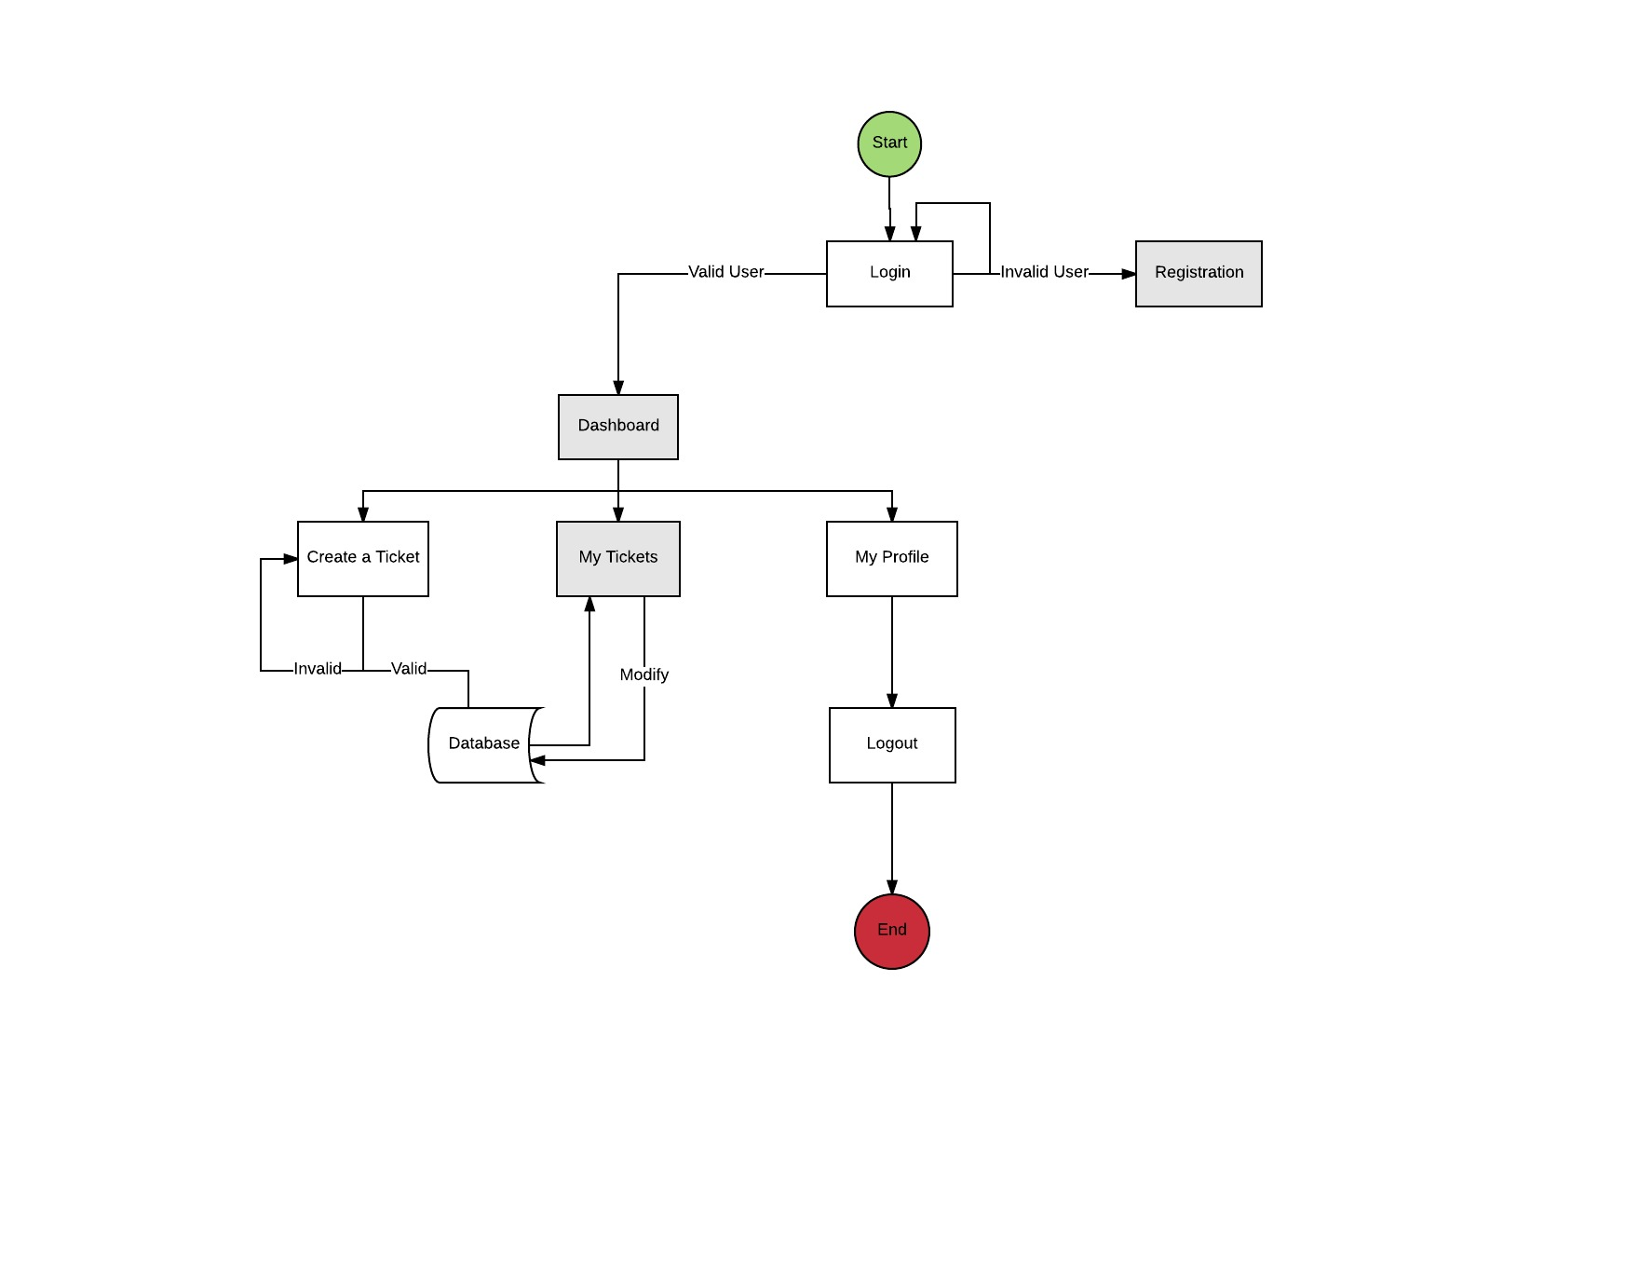

Uml: USe case Diagram

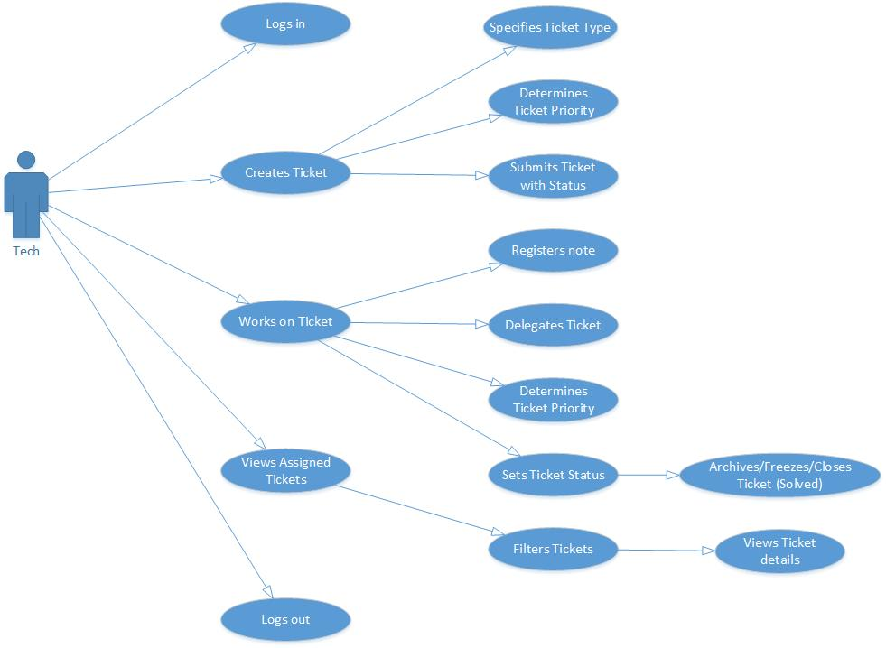

Uml: Class Diagram

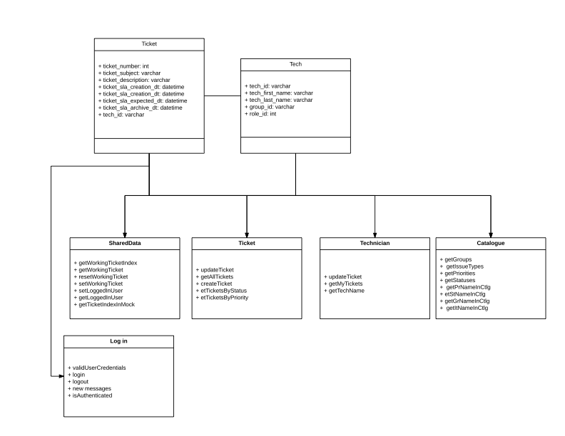

ERD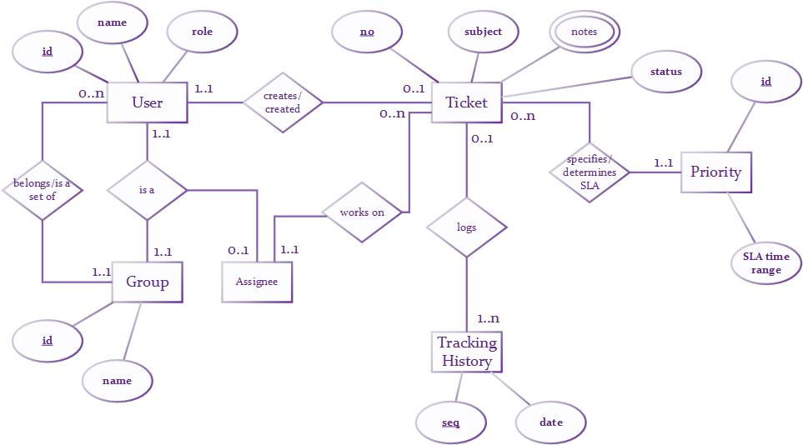

### Conclusion

Future implementation includes:

* Creating an about us page on the homepage
* Adding a knowledge based tab on the technician dashboard
* Configurable for other companies to uses
  + Colors, Styling
* Adding user roles functionality
  + Administer
  + Customer
* Adding a report analysis for Administer
* Receive tickets by email
* Update contents of my profile
* Assigning a worked on ticket to a new technician