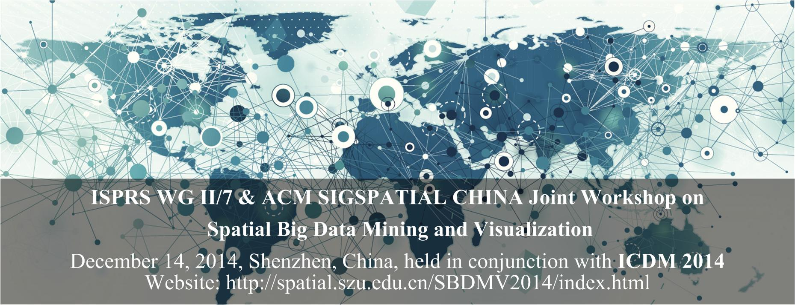**Aims and Scope**

Existing concepts, theories, and methods for the spatial big data are facing many challenges, for instance, spatial big data storage, processing, analysis, mining and visualization. The value of spatial big data could not be fully achieved without data mining. And it has been realized that visualization is an effective means for not only presenting essential information in vast amounts of data but also driving big data analytics. This half-day workshop aims to serve as a platform to discuss the recent trends in spatial big data mining and visualization, for the purpose of intelligent spatial decision support.

**Topics of interest include, but are not limited to:**

* Spatial big data processing
* Spatial big data modeling
* Spatial big data mining
* Spatial data visualization approach
* Spatial big data visual analytics
* Geo-visual analytics for usability testing and exploring big data
* Intelligent Spatial decision support
* Geo-Social networks, crowd sourcing and public participatory spatial decision support
* Data-intensive computing and computational intelligence for spatial decision support

**Workshop Organizers**

* Qingquan Li, Shenzhen University
* Yang Yue, Shenzhen University
* Guangzhong Sun, University of Science and Technology of China
* Xing Xie, Microsoft Research Asia

**Local chair**

* Xing Zhang, Shenzhen University

**Technical Program Committee**

* Feng Lu, Institute of Geographic Science and Natural Resources Research, Chinese Academy of Sciences
* Nicholas Yuan, Microsoft Research Asia
* Kevin Zheng, Queensland University
* Yu Liu, Peking University
* Gang Pan, Zhejiang University
* Zhixiang Fang, Wuhan University
* Xianfeng Huang, Wuhan University
* Biyu Chen, Wuhan University
* Kuien Liu, Institute of Software, Chinese Academy of Sciences
* Jiajie Xu, Suzhou University
* Shuo Shang, China University Of Petroleum (Beijing)
* Rui Mao, Shenzhen University
* Xing Zhang, Shenzhen University
* Wei Tu, Shenzhen University
* Jianliang Xu, Hong Kong Baptist University
* Weiwei Sun, Fudan University
* Qi Liu, University of Science and Technology of China

**Important Dates**

Paper submission: **September 26, 2014**

Paper notification: October 10, 2014

Camera-ready deadline: October 24, 2014

Workshop dates: December 14, 2014

Full paper submission for special issue: January 31, 2015

Initial decision on full papers: March 15, 2015

Final papers due for special issue: April 30, 2015

Final decisions on full papers: May 31, 2015

**Submissions**

All papers submissions can be up to 8 pages in the IEEE 2-column format (please see <http://icdm2014.sfu.ca/submission.html>).

They should be submitted via the online submission system. Each paper will be assigned to three reviewers for a peer review. Accepted papers will be presented at the workshop. Outstanding papers will be invited to extend to full version for a SCI(E)-indexed journal, which is currently under contact.

**Contact**

Dr. Xing Zhang, xzhang@szu.edu.cn