SAP面试题

1. Design an Employee class

<https://www.zybuluo.com/mdeditor#1450643>

1. Add a certain feature to a paint program.

<https://www.bbsmax.com/A/MAzAx8qd9p/>

1. OOP. Linked Lists. <https://cs1331.gatech.edu/slides/linked-lists.pdf>
2. Calculator (Leetcode 227)

<https://blog.csdn.net/tiandixuanwuliang/article/details/78298089>

1. implement a hash

<https://stackoverflow.com/questions/5407421/design-a-hashtable>

1. Implement a cache in any language you choose (Leetcode 146)
2. Design classes for a car and truck

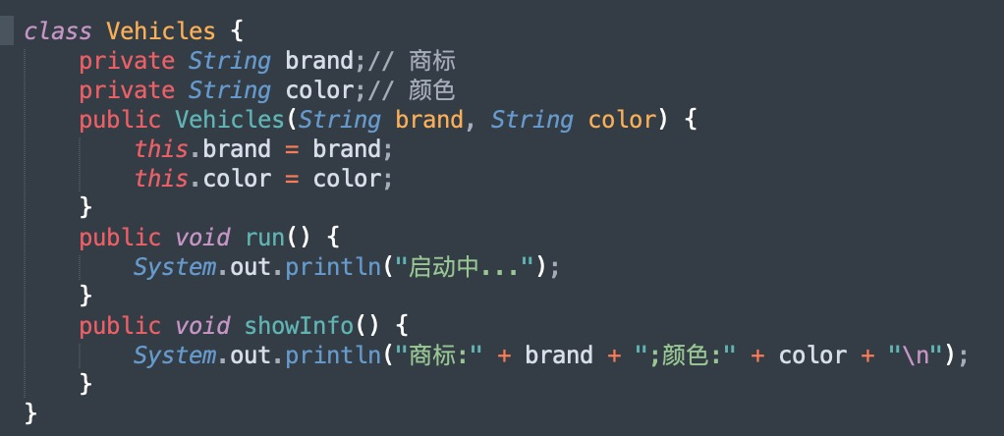

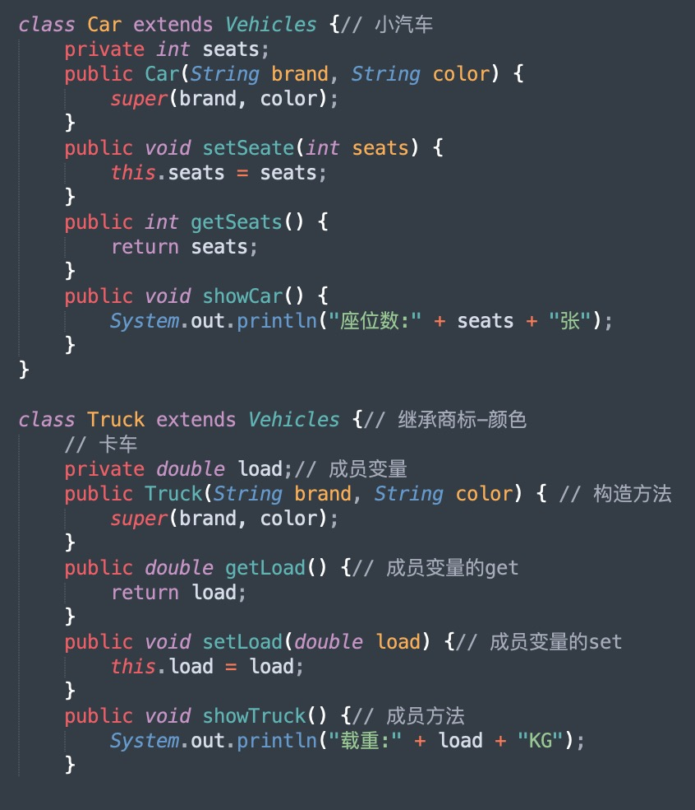

Java

1. the difference between "interface" and "abstract class"
2. What is a constructor?

Coding

1. Code Review based on Nodes/LinkedList concept
2. Create a function to reverse a string

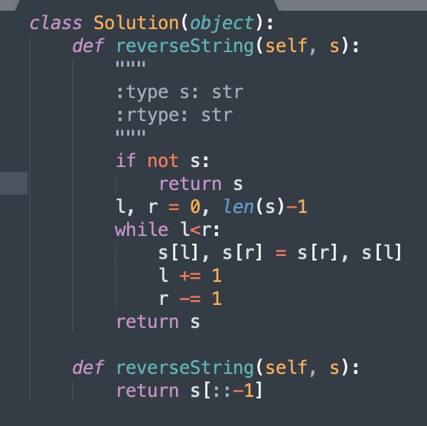

1. FizzBuzz

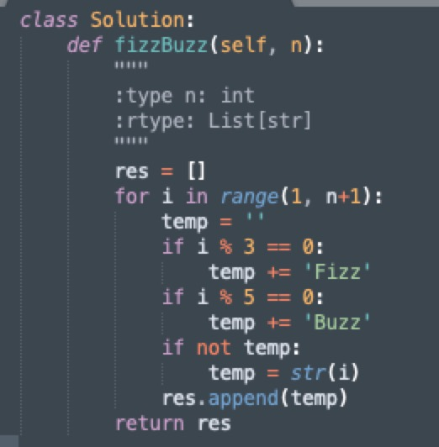

1. Check if a string is a palindrome

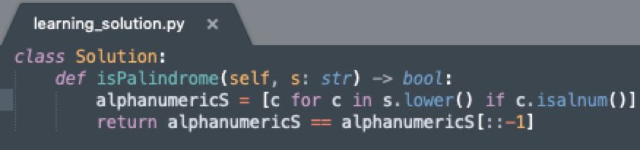

1. How to calculate the n'th Fibonacci number.

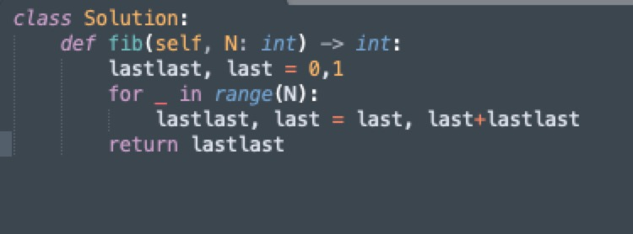

1. Technical Question based on finding the largest difference between two positive integer lists
2. Create a function to parse a XML file
3. Sorted array, find one element with the least difference to the target

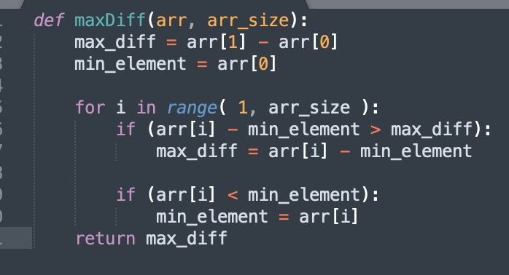

1. Return the nth to last element in a linked list and and array rotation question.

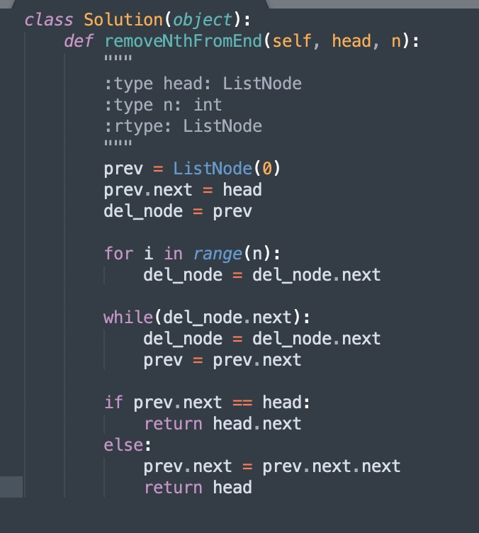

1. Given an array and a target number, find an element in the array that is the closest to the target num.
2. Determine if a linked list is a palindrome

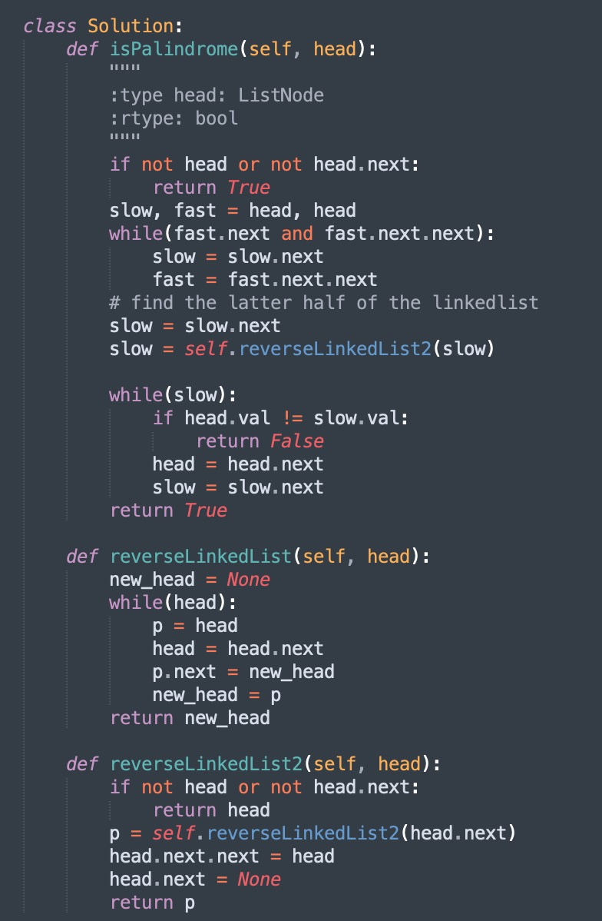

1. Given an array of integers, checking if every element has a pair.
2. Convert string representing an integer to an integer without using built in functions

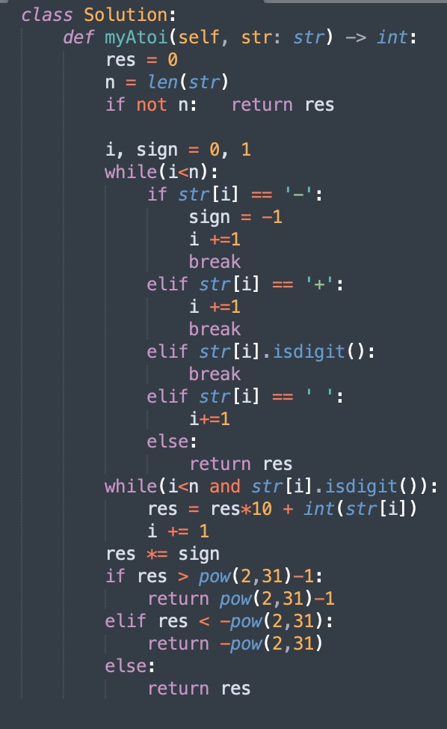

1. Give the minimum height of a binary search tree?
2. <https://www.geeksforgeeks.org/relationship-number-nodes-height-binary-tree/>
3. Search for an element in a sorted but rotated array

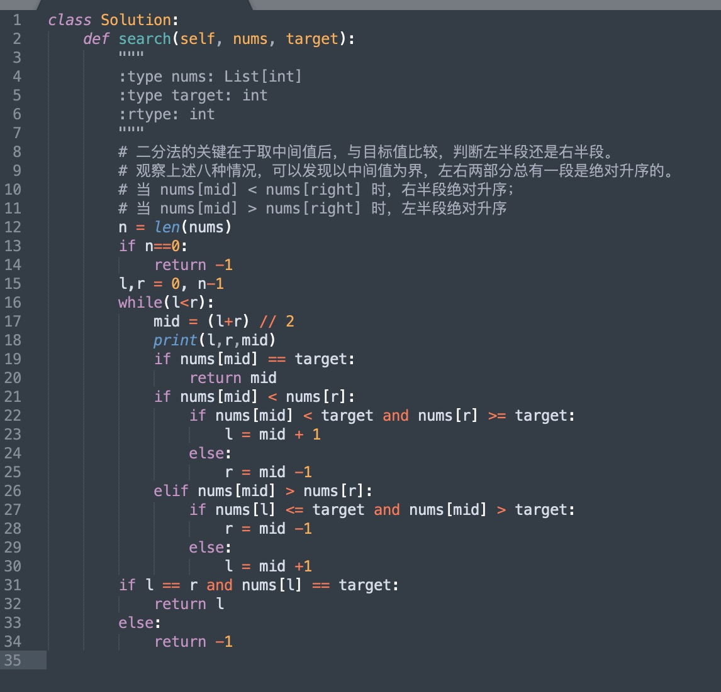

Given two unsorted lists of positive integer numbers, find the largest difference between the two. The number in list1 must be smaller than list2.

Example:

{1, 3, 8, 7, 4}

{0, 2, 6, 5, 10}

Largest difference is between 1 and 10.

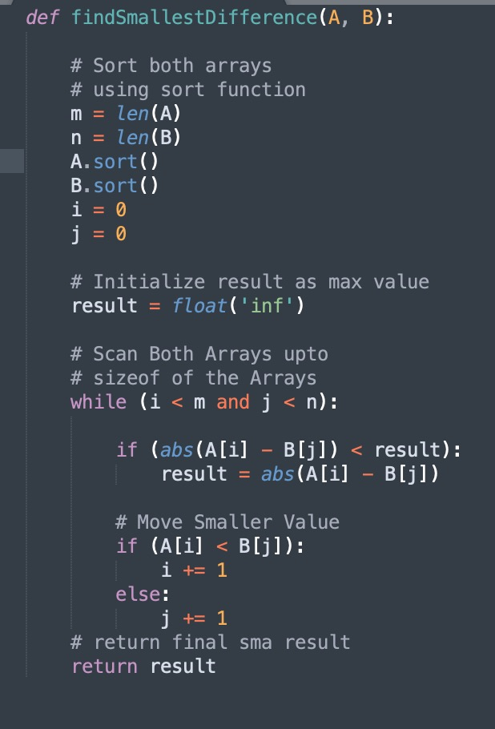

Given two integer arrays sorted in ascending order and an integer k. Define sum = a + b, where a is an element from the first array and b is an element from the second one. Find the kth smallest sum out of all possible sums.

Give the minimum height of a binary search tree?