1）Senior Android Developer Interview 13 Feb, 2019

[Whiteboard] Find a pair of values which sum matches the target.

Given an array of numbers: A = [-20, 1, 2, 5, -20, 5, 9, 50, 12] and a target value x = 11. Write a function that will find a pair of numbers which sum equals the target value.

[Coding] Islands count. Leetcode 200

Given a 5x5 matrix where 1 represents a land and 0 represent a water.

Write a function that will count the islands in the given matrix.

var m = [

[1, 1, 0, 0, 0],

[0, 1, 0, 0, 1],

[1, 0, 0, 1, 1],

[0, 0, 0, 0, 0],

[1, 0, 1, 0, 1]

];

Expected count is 5.

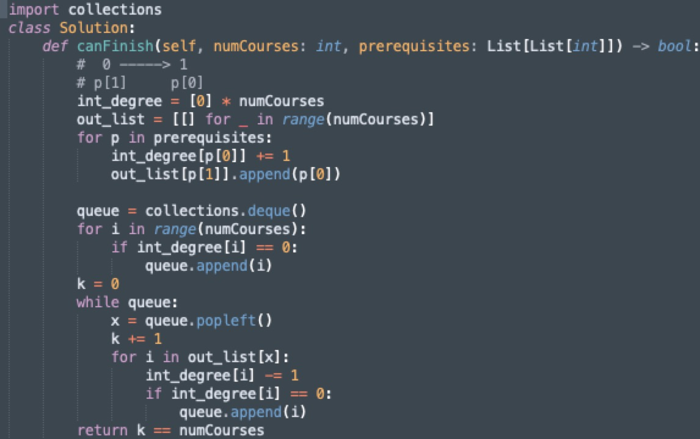

[Whiteboard] Dependency print(graph)

print(visit) print(graph)

print(visit) print(graph)

print(visit). Leetcode 133, Leetcode 207

Given an array of dependencies:

a -> [b,c]

b -> [d]

d -> [c]

c -> []

e -> []

Print out in what order these dependencies will be resolved.

Expected result:

c, d, b, a,

e

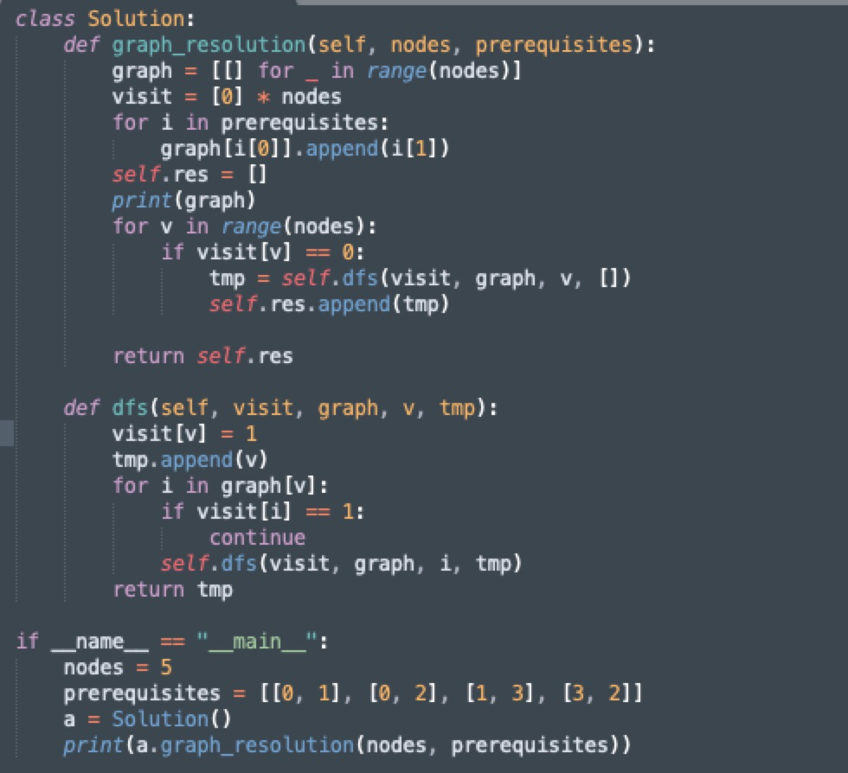

2）Data Engineer Interview 12 Feb, 2019

Leetcode 139, 140

Determine if a string can be decomposed into a list of substrings, s.t. every substring is one of the elements of the set of words. E.x. "amanabreak", ["a", "man", "break"] => True

3) Android Engineer Interview 31 Jan, 2019

most question about most proud moment in <COMPANY> or how did I handle this situation.

4） 15 Jan, 2019

“What are your three best qualities?”

“Tell me about a time you had conflict with a coworker and how you handled it.”

“When was the last time you geeked-out?” (Seriously?)

"Who do you admire most in the world and why?"

5）Software Engineer Interview 9 Jan, 2019

They really take their time to know you and your strengths/weaknesses

Leetcode 1, Leetcode 15

Given a list of integers find if it contains two numbers that sum to a given number? Extended the question to find if it contains three numbers that sum to a given number?

6）Software Engineer Interview 9 Jan, 2019

The cultural interview was about yourself, behavior, leadership and other soft skills in general.

7）Software Engineer Interview 5 Oct, 2018

Given a list of Task objects, a Task being start_time, end_time, memory_usage, find the peak memory usage and start and end time for the peak.

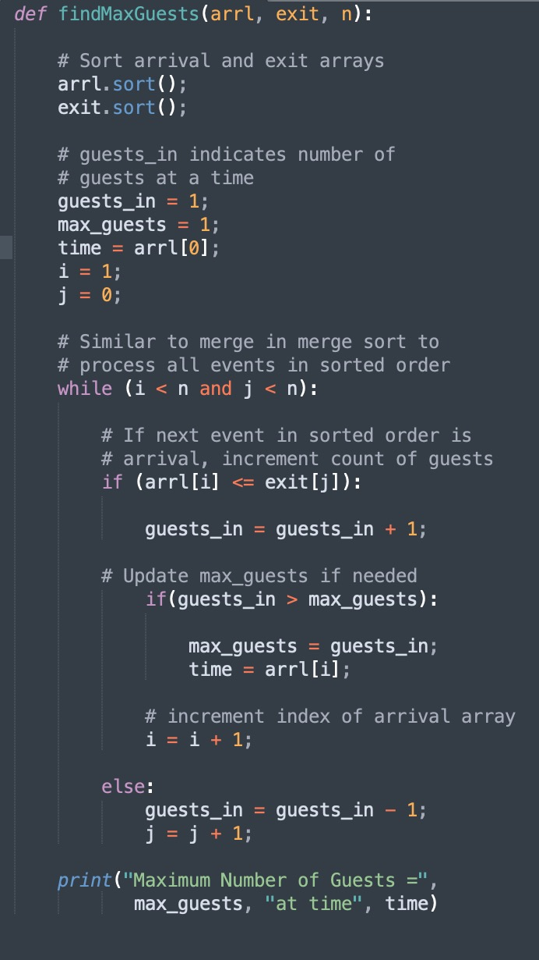

8）Software Engineer Interview 15 Sep, 2018

You have 1 GB of extra memory and you are given a very large list of integers. Find any missing integer

<https://prismoskills.appspot.com/lessons/Programming_Puzzles/Missing_number_in_billion_integers_.jsp>

9) Software Developer - Growth Interview 13 Feb, 2018

Leetcode 139, 140

**Given a list of substrings and an input string, determine whether the input string can be composed using the substrings.**

e.g. Given "a", "man", "break", determine if "amanabreak" can be decomposed. Answer: Yes: "a" "man" "a" "break".

**Given a list of processing jobs represented as time intervals and CPU load, determine the time interval containing the largest CPU load.**

Sort the jobs twice, using heaps, by start time and end time. Determine the discreet time intervals of the jobs and their relative loads, storing the largest one (by CPU load). Then return the largest one at the end.

**Given a file of 4 billion 32-bit integers, find any integer that does not appear in the file using 1GB of memory. Then repeat the same task using 80MB of memory.**

For 1GB: Create a boolean array (1 bit per entry) of size 4 billion + 1, initialized to false. Read the whole file. For each integer, if it's in the range 0 - 4 billion, set the array value to true. Then find any array value which is false (since the array size is 4 billion + 1 and the input is size 4 billion there is guaranteed to be one which is false).

For 80MB: Read the file in 80MB chunks and sort each chunk. Write each sorted chunk to a new file with an index (e.g. filename for i'th file = file_i). Then perform an n-way merge on the files, where n is the number of files. Then read the resulting merged file and find any 2 integers which are not consecutive and return any value in the gap. If all numbers are consecutive, return either of the endpoints (plus or minus 1).

10) Senior Frontend Developer Interview

Leetcode 621

Efficiently scheduling and tasks with a specific amount of resources .

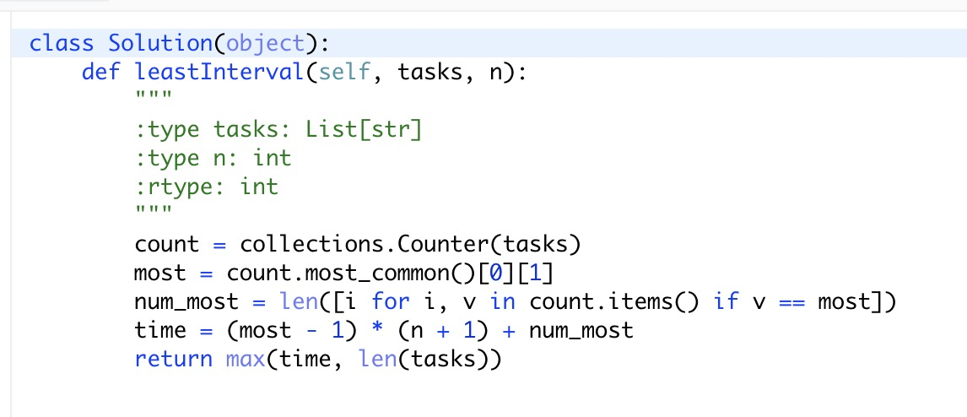

11) Full Stack Software Developer Interview 17 Aug, 2017

Leetcode 56, 57

Given a list of ranges sorted in order i.e. <5,10><15,20><25,35> , insert a new range <x,y>. If new range overlap with existing range then need to merge overlapping ranges. I.e. if <x,y> = <7,17> resulting list should be <5,20><25,35>

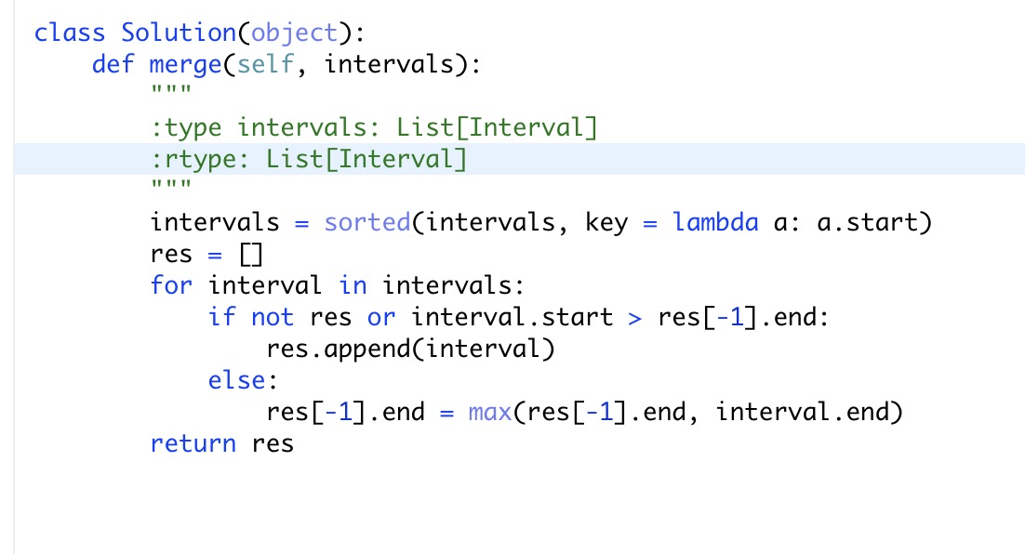

Leetcode 259

Given a Integer stream, 1. find medium element (when sorted) and 2. insert element. Need to optimize for time.

