The GUI looks like:

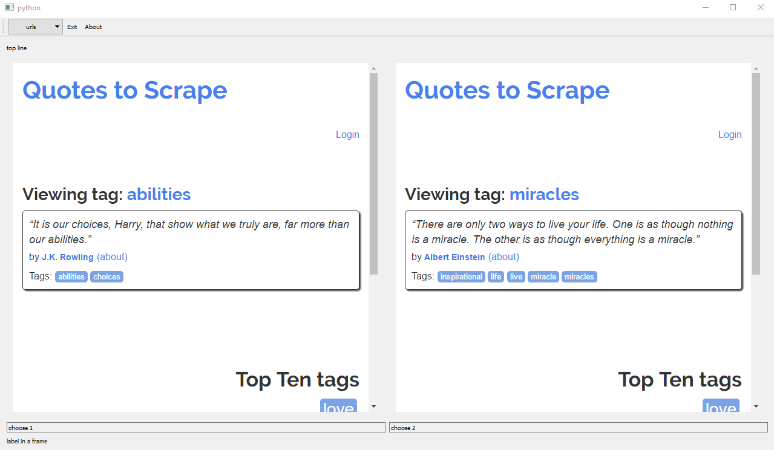

1) The user input a url in the app, such as [http://www.apple.com](https://urldefense.proofpoint.com/v2/url?u=http-3A__www.apple.com&d=DwMFaQ&c=ODFT-G5SujMiGrKuoJJjVg&r=TcQVFCd31Bk_8BmJPjyfnouHaMxy2M8pJJI9ha9qMMw&m=vjnY7MlKLrn5m7hjyAVjKnPQzOckEw-OM2r5IWjt5ww&s=d-jUOT1LNA5CMPs53tsjrCIalMeFYGa06nzD87D83Gg&e=). And let the user input an integer K.

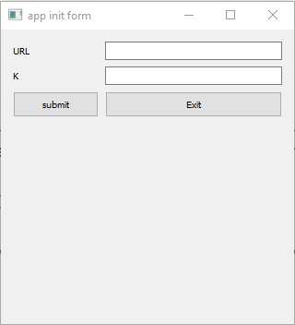

Here user could input url and K, then behind the GUI, a crawler would be started and began to collect all linked URLs in this url and continue to visit next page until it got K number of URLs.

2)In the compare form, user could select two integers from 1 to K. If one of these two pages were not compared before, the two subpage will show these two webpages, and if these two pages were compared before or compared with the same webpage, it would show the result between them.

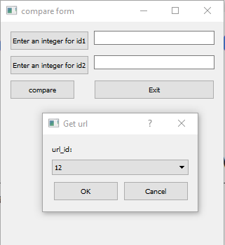

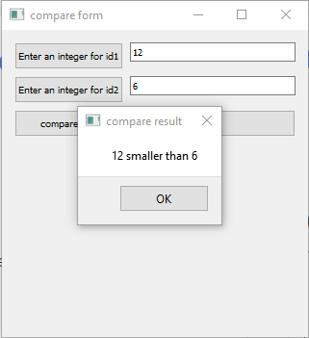

Every time when user pick a compared, to avoid inconsistent between different trees, it would always show the root of this tree, so that user could compare the root and the other page chosen.

Eg:

Current parent array is:

[0, 2, 9, 16, 9, 9, 12, 17, 3, 7, 12, 11, 12, 13, 2, 3, 2, 12]

It looks like: (tree: root node[childen])

0[],

12[

10[]

17[

7[

9[

2[

1[]

14[]

16[

3[

15[]

8[]

]

]

]

4[]

5[]

]

]

]

6[]

]

11

13

When user choose 0 and 11, the page would show 0 and 11 pages.

When user choose 0 and 6, the page would show 12 and 0 because 12 is the root node of 6.

3)After click topological result button, it will pop this window:

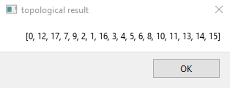

Current parent array is:

