停用词典（未添加）

数据1（）

训练：



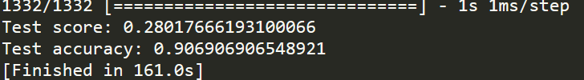

测试：

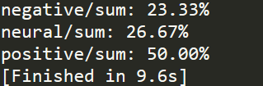

实验1：

第 1 周：

评论总数： 492

negative: 3

neural: 8

positive: 481

negative/sum: 0.61%

neural/sum: 1.63%

positive/sum: 97.76%

第 2 周：

评论总数： 352

negative: 3

neural: 19

positive: 330

negative/sum: 0.85%

neural/sum: 5.40%

positive/sum: 93.75%

第 3 周：

评论总数： 652

negative: 6

neural: 15

positive: 631

negative/sum: 0.92%

neural/sum: 2.30%

positive/sum: 96.78%

第 4 周：

评论总数： 847

negative: 3

neural: 72

positive: 772

negative/sum: 0.35%

neural/sum: 8.50%

positive/sum: 91.15%

第 5 周：

评论总数： 442

negative: 5

neural: 37

positive: 400

negative/sum: 1.13%

neural/sum: 8.37%

positive/sum: 90.50%

第 6 周：

评论总数： 708

negative: 138

neural: 120

positive: 450

negative/sum: 19.49%

neural/sum: 16.95%

positive/sum: 63.56%

第 7 周：

评论总数： 472

negative: 9

neural: 83

positive: 380

negative/sum: 1.91%

neural/sum: 17.58%

positive/sum: 80.51%

第 8 周：

评论总数： 511

negative: 6

neural: 66

positive: 439

negative/sum: 1.17%

neural/sum: 12.92%

positive/sum: 85.91%

第 9 周：

评论总数： 503

negative: 11

neural: 71

positive: 421

negative/sum: 2.19%

neural/sum: 14.12%

positive/sum: 83.70%

第 10 周：

评论总数： 503

negative: 12

neural: 88

positive: 403

negative/sum: 2.39%

neural/sum: 17.50%

positive/sum: 80.12%

第 11 周：

评论总数： 340

negative: 6

neural: 25

positive: 309

negative/sum: 1.76%

neural/sum: 7.35%

positive/sum: 90.88%

第 12 周：

评论总数： 482

negative: 2

neural: 64

positive: 416

negative/sum: 0.41%

neural/sum: 13.28%

positive/sum: 86.31%

第 13 周：

评论总数： 639

negative: 5

neural: 63

positive: 571

negative/sum: 0.78%

neural/sum: 9.86%

positive/sum: 89.36%

negative ['0.61%', '0.85%', '0.92%', '0.35%', '1.13%', '19.49%', '1.91%', '1.17%', '2.19%', '2.39%', '1.76%', '0.41%', '0.78%']

neural ['1.63%', '5.40%', '2.30%', '8.50%', '8.37%', '16.95%', '17.58%', '12.92%', '14.12%', '17.50%', '7.35%', '13.28%', '9.86%']

positive ['97.76%', '93.75%', '96.78%', '91.15%', '90.50%', '63.56%', '80.51%', '85.91%', '83.70%', '80.12%', '90.88%', '86.31%', '89.36%']

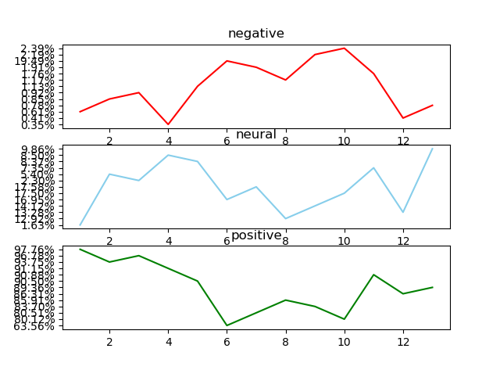

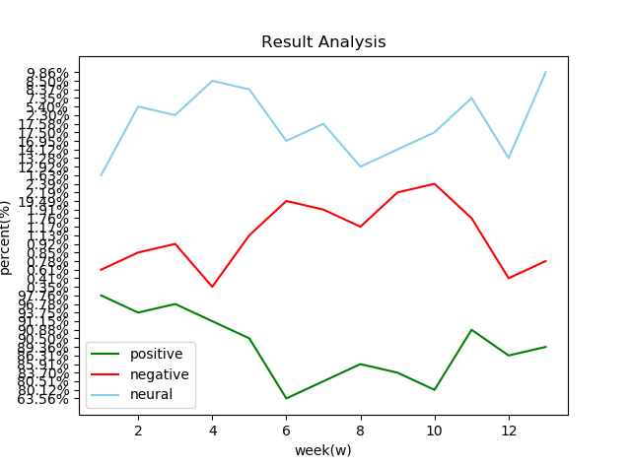

数据2（我的）

训练：



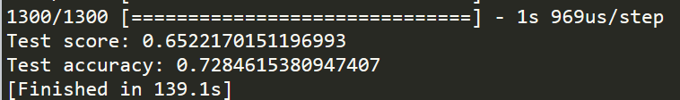

测试：

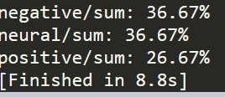

实验1：

第 1 周：

sum 492

negative: 97

neural 297

positive 98

negative/sum: 19.72%

neural/sum: 60.37%

positive/sum: 19.92%

第 2 周：

sum 352

negative: 78

neural 207

positive 67

negative/sum: 22.16%

neural/sum: 58.81%

positive/sum: 19.03%

第 3 周：

sum 652

negative: 195

neural 373

positive 84

negative/sum: 29.91%

neural/sum: 57.21%

positive/sum: 12.88%

第 4 周：

sum 847

negative: 300

neural 432

positive 115

negative/sum: 35.42%

neural/sum: 51.00%

positive/sum: 13.58%

第 5 周：

sum 442

negative: 76

neural 272

positive 94

negative/sum: 17.19%

neural/sum: 61.54%

positive/sum: 21.27%

第 6 周：

sum 708

negative: 103

neural 476

positive 129

negative/sum: 14.55%

neural/sum: 67.23%

positive/sum: 18.22%

第 7 周：

sum 472

negative: 118

neural 279

positive 75

negative/sum: 25.00%

neural/sum: 59.11%

positive/sum: 15.89%

第 8 周：

sum 511

negative: 86

neural 352

positive 73

negative/sum: 16.83%

neural/sum: 68.88%

positive/sum: 14.29%

第 9 周：

sum 503

negative: 87

neural 336

positive 80

negative/sum: 17.30%

neural/sum: 66.80%

positive/sum: 15.90%

第 10 周：

sum 503

negative: 109

neural 327

positive 67

negative/sum: 21.67%

neural/sum: 65.01%

positive/sum: 13.32%

第 11 周：

sum 340

negative: 80

neural 233

positive 27

negative/sum: 23.53%

neural/sum: 68.53%

positive/sum: 7.94%

第 12 周：

sum 482

negative: 125

neural 296

positive 61

negative/sum: 25.93%

neural/sum: 61.41%

positive/sum: 12.66%

第 13 周：

sum 639

negative: 148

neural 348

positive 143

negative/sum: 23.16%

neural/sum: 54.46%

positive/sum: 22.38%

negative ['19.72%', '22.16%', '29.91%', '35.42%', '17.19%', '14.55%', '25.00%', '16.83%', '17.30%', '21.67%', '23.53%', '25.93%', '23.16%']

neural ['60.37%', '58.81%', '57.21%', '51.00%', '61.54%', '67.23%', '59.11%', '68.88%', '66.80%', '65.01%', '68.53%', '61.41%', '54.46%']

positive ['19.92%', '19.03%', '12.88%', '13.58%', '21.27%', '18.22%', '15.89%', '14.29%', '15.90%', '13.32%', '7.94%', '12.66%', '22.38%']

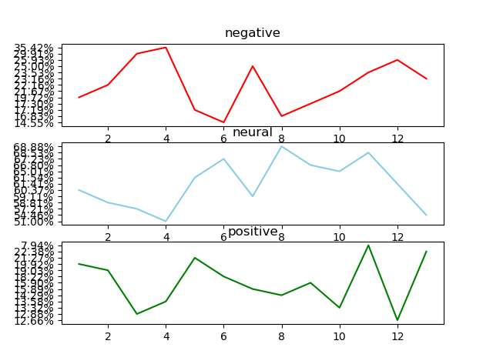

实验2：

第 1 周：

sum 492

negative: 111

neural 283

positive 98

negative/sum: 22.56%

neural/sum: 57.52%

positive/sum: 19.92%

第 2 周：

sum 352

negative: 83

neural 200

positive 69

negative/sum: 23.58%

neural/sum: 56.82%

positive/sum: 19.60%

第 3 周：

sum 652

negative: 212

neural 347

positive 93

negative/sum: 32.52%

neural/sum: 53.22%

positive/sum: 14.26%

第 4 周：

sum 847

negative: 305

neural 415

positive 127

negative/sum: 36.01%

neural/sum: 49.00%

positive/sum: 14.99%

第 5 周：

sum 442

negative: 82

neural 258

positive 102

negative/sum: 18.55%

neural/sum: 58.37%

positive/sum: 23.08%

第 6 周：

sum 708

negative: 104

neural 459

positive 145

negative/sum: 14.69%

neural/sum: 64.83%

positive/sum: 20.48%

第 7 周：

sum 472

negative: 132

neural 254

positive 86

negative/sum: 27.97%

neural/sum: 53.81%

positive/sum: 18.22%

第 8 周：

sum 511

negative: 92

neural 344

positive 75

negative/sum: 18.00%

neural/sum: 67.32%

positive/sum: 14.68%

第 9 周：

sum 503

negative: 109

neural 309

positive 85

negative/sum: 21.67%

neural/sum: 61.43%

positive/sum: 16.90%

第 10 周：

sum 503

negative: 127

neural 312

positive 64

negative/sum: 25.25%

neural/sum: 62.03%

positive/sum: 12.72%

第 11 周：

sum 340

negative: 92

neural 219

positive 29

negative/sum: 27.06%

neural/sum: 64.41%

positive/sum: 8.53%

第 12 周：

sum 482

negative: 144

neural 274

positive 64

negative/sum: 29.88%

neural/sum: 56.85%

positive/sum: 13.28%

第 13 周：

sum 639

negative: 162

neural 341

positive 136

negative/sum: 25.35%

neural/sum: 53.36%

positive/sum: 21.28%

negative ['22.56%', '23.58%', '32.52%', '36.01%', '18.55%', '14.69%', '27.97%', '18.00%', '21.67%', '25.25%', '27.06%', '29.88%', '25.35%']

neural ['57.52%', '56.82%', '53.22%', '49.00%', '58.37%', '64.83%', '53.81%', '67.32%', '61.43%', '62.03%', '64.41%', '56.85%', '53.36%']

positive ['19.92%', '19.60%', '14.26%', '14.99%', '23.08%', '20.48%', '18.22%', '14.68%', '16.90%', '12.72%', '8.53%', '13.28%', '21.28%']

