## REQUIREMENTS:

* Amphibious
* Travel through harsh terrain (tank track)
* Rugged
* Fire retardant
* Water resistant
* carry first aid kits/supplies
* Winches
* Crane and ladders (use case)
* Additional explorer robot (use case)
* Sound system Microphone + Speaker
* Remote control (use case)

## Requirement Elicitation

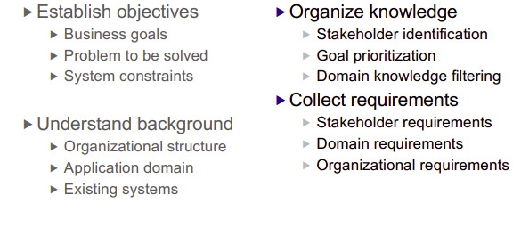

* Establish objectives
* Business goals: Build a robot that can assist rescue people and explore.
* Problem to be solved:
* Navigation through tough terrain + amphibious.
* Rescue/carrying people.
* Move through areas/Mobility.
* Pathfinding.
* Communication in difficult areas.
* System constrains:
* Gas E10 vs electricity
* Size
* Toughness
* Motor Power
* Mobility
* Understand background:
* Organizational structure:
  + EU regulations
  + Company Hierarchy
* Application domain:
* Fire rescue
* Flood assistance
* Disaster relief
* Transportation
* CBRN rescue (Chemical, biological, radiological and nuclear)
* Existing system:
* Amphibious Vehicles
* Rescue robots
* Fire fighting + EOD robots
* communication
* Drones
* Organize Knowledge:
  + Stakeholders: Investors, company members, firefighters, police, government, paramedics, patients
  + Goal prioritization

|  |  |
| --- | --- |
| 1 | Remote control |
| 2 | High mobility (Amphibious, rough terrain, small areas) |
| 3 | Rescue capable (Crane + Nav. robot + First aid) |
| 4 | Element resistant |
| 5 | power efficiency |

* + Domain knowledge filtering:No idea what this means
* Collect requirements:
  + Stakeholders requirements: Makes money for investors, Saves people for the client, PR,
  + Domain requirements: has to work under fire/ on water, controller knowledge, wireless communication knowledge
  + Organizational requirements:organizational management, financial management,

## Requirement Analysis

are the answers consistent? identify trouble spots identify boundaries identify most important requirements

Trouble spots:

* Fire damage
* Environment corrosiveness
* How to float on water ,being amphibious,
* Impassable obstacles (mobility)
* how to carry nerds out -> harpoons
* power capacity
* remote control in long distance + interference
* water seepage (possible short circuit)

Boundaries:

* Size
* Range of operation
* Materials
* Reach of crane
* Budget
* Knowledge (brain juice)
* Current tech
* Carry capacity (for patients)

## Requirement Validation

## Diagrams