A)

with(msm.fe, exp(c(b, ci.lb, ci.ub)))

[1] 0.2073249 0.1987845 0.2162323

The result has shown that the overall prevalence is 0.21, with 95%CI of (0.199,0.216).

B)

Q

[1] 281.3568

> I2

[1] 93.24701

The heterogeneity across studies exists according to I^2 index of 93.

C)

with(msm.re, exp(c(b, ci.lb, ci.ub)))

[1] 0.1795822 0.1424970 0.2263188

The result has shown that the overall prevalence is 0.18, with 95%CI of (0.142,0.226).

D)

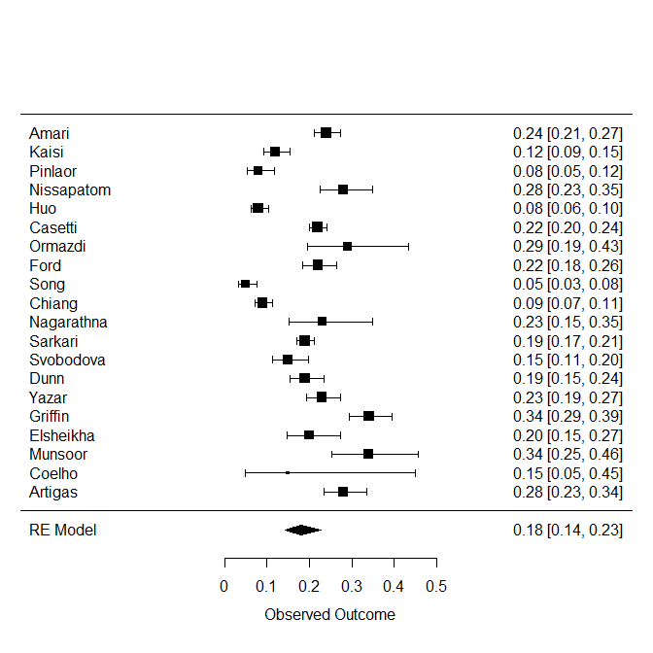

The meta analysis result is presented as in above with studies being ordered by year. Outcome increased over time (studies ranged by year).

E)

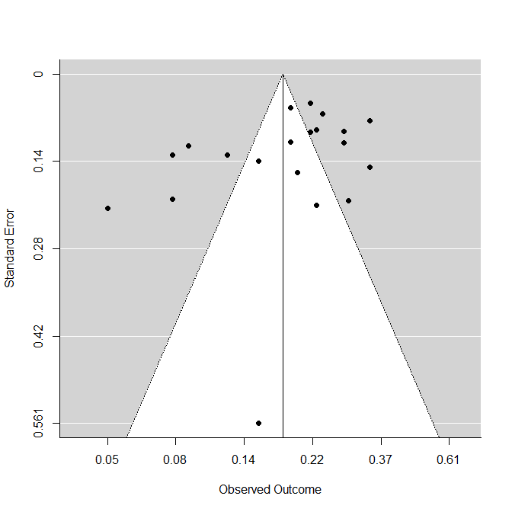

Regression Test for Funnel Plot Asymmetry

model: mixed-effects meta-regression model

predictor: standard error

test for funnel plot asymmetry: z = -1.2838, p = 0.1992

The result has shown that the overall studies posit publication bias with asymmetry and many studies not being in the expected region. However, Egger’s test indicates symmetry or no publication bias (Z = -1.28, p = 0.199).

F)

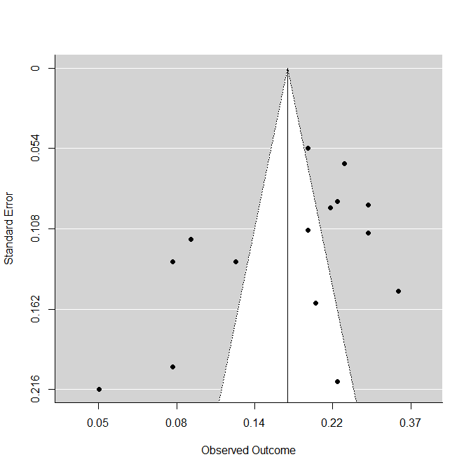

Regression Test for Funnel Plot Asymmetry

model: mixed-effects meta-regression model

predictor: standard error

test for funnel plot asymmetry: z = -1.9511, p = 0.0510

0.1670892 0.1262939 0.2210622

Use trim function to find out the publication bias issue by trimming all studies published prior to 2010. The result has shown that the publication bias does not exist while the funnel plot is symmetry with (Z=-1.951, p = 0.510). The overall prevalence is 0.17 (95%CI = 0.126-0.221).

G)

The overall result has shown that the HIV prevalence among MSM is 0.21(95%CI = 0.199 - 0.216) in terms of risk ratio. The heterogeneity is presented with significance (I2=93 showing substantial degree) in fixed model. The random effect model is thus used. The overall prevalence in random effect model has lower estimates of 0.18 (95%CI = 0.14 – 0.23). Meta-analysis has shown the overall conditions across all studies with random effect modeling using forest plot. In general, the RR increased over time.

The funnel plot shows obvious asymmetry in publication bias while the Egger’s test is not significant indicating the asymmetry does not hold (Z = -1.28, p = 0.199). After trimming the undesirable studies with the same criteria, the publication bias still looks existing while the Egger’s test shows no evidence for publication bias (Z=-1.951, p = 0.510).

# Q2

msm <- read.csv("exam_question2.csv")

# a

msm$logrr <- log(msm$prev)

msm$se.logrr <- (log(msm$prev.ub)-log(msm$prev.lb))/(2*1.96)

msm.fe <- rma(yi=logrr, sei=se.logrr, slab=study, method="FE", data=msm)

# Overall estimate by fixed effects model

with(msm.fe, exp(c(b, ci.lb, ci.ub)))

# b

Q <- msm.fe$QE # extract Q score

I2 <- (Q-(msm.fe$k-1))/Q * 100 # high I2 indicates poor model; need random effect model

# c

msm.re <- rma(yi=logrr, sei=se.logrr, slab=study, method="REML", data=msm)

with(msm.re, exp(c(b, ci.lb, ci.ub)))

# d

forest(msm.re, transf=exp, refline=1,order=msm.re$year)

# e

funnel(msm.re, atransf=exp)

regtest(msm.re)

# f

msm.cut <- msm[msm$year>2010,]

msm.cut.re <- rma(yi=logrr, sei=se.logrr, slab=paste(study, year, country, sep=", "), method="REML", data=msm.cut)

funnel(msm.cut.re, atransf=exp)

regtest(msm.cut.re)

msm.cut.tf <- trimfill(msm.cut.re)

with(msm.cut.tf, exp(c(b, ci.lb, ci.ub)))