2014数学一考研试题

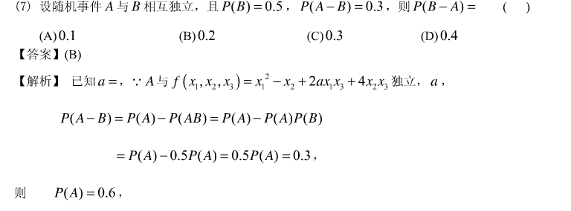

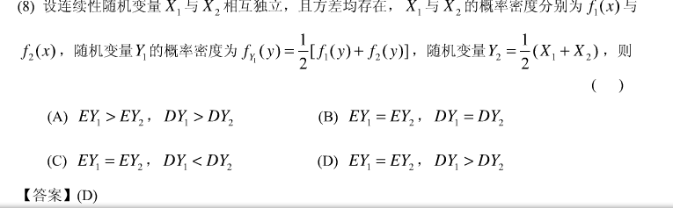

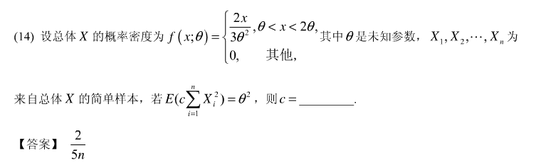

C:\Users\Administrator\AppData\Roaming\Tencent\Users\359491378\QQ\WinTemp\RichOle\}CGN15QR`FXRLBFYUAM]U_K.png

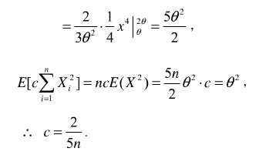

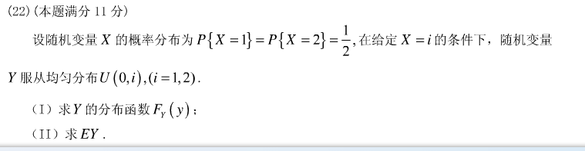

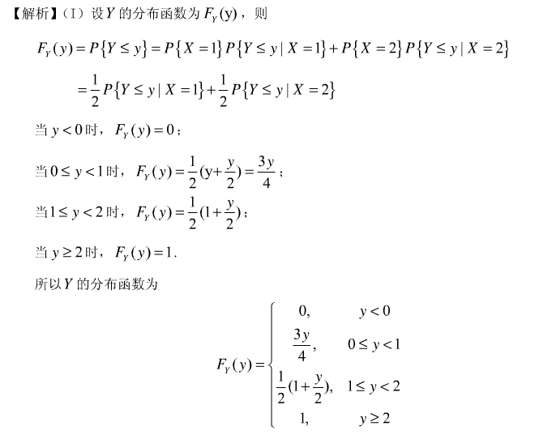

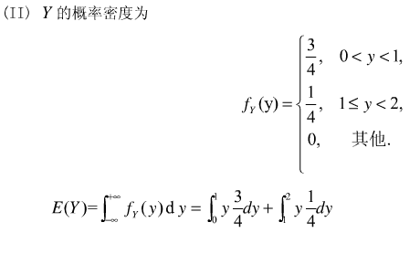

C:\Users\Administrator\AppData\Roaming\Tencent\Users\359491378\QQ\WinTemp\RichOle\BDSTAER8}T}%V_11S2[R0$B.png

