三大分布专项练习（一）

1. 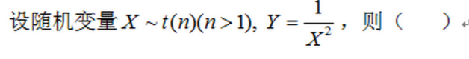

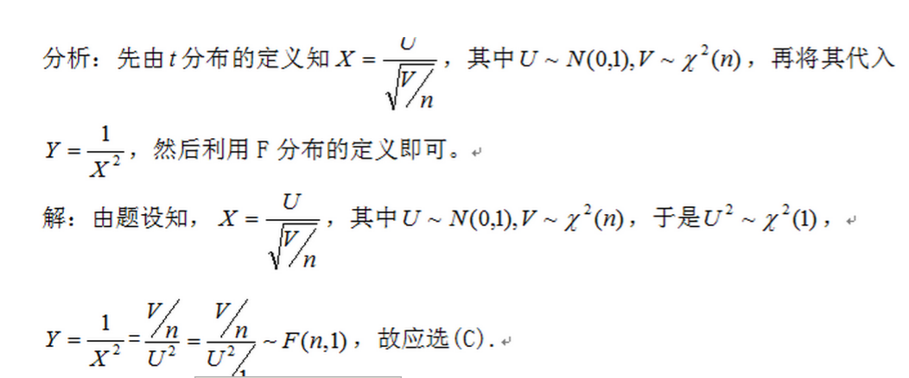

1. C:\Users\Administrator\AppData\Roaming\Tencent\Users\359491378\QQ\WinTemp\RichOle\([VDWPU@$_J4PL}C@CH9JLQ.png

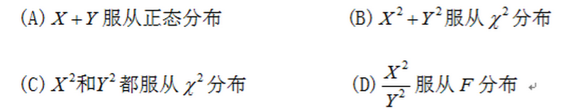

C:\Users\Administrator\AppData\Roaming\Tencent\Users\359491378\QQ\WinTemp\RichOle\K~2_6Z_H_{R7ELOUH]CEGHA.png

1. C:\Users\Administrator\AppData\Roaming\Tencent\Users\359491378\QQ\WinTemp\RichOle\ELYZ}Y{0[HX5OYRWJKV__HH.png

C:\Users\Administrator\AppData\Roaming\Tencent\Users\359491378\QQ\WinTemp\RichOle\[]YAWR896IAWG~33ZC5KGB9.png

C:\Users\Administrator\AppData\Roaming\Tencent\Users\359491378\QQ\WinTemp\RichOle\0U50XEMINAJGUHRL03PHMAM.png

