PokéAthon

The player starts as an adventurer in a Pokémon universe. He is given 4 basic starters Pokémon as his team at the beginning. The point of the game is that the player must make it across multiple worlds in a limited amount of time. The score will be based on how many worlds the player made through. In every world, players will find patches of grass filled with Pokémon based on that world. The positions of the Pokémon will be hidden to the player to ensure fairness. At the end of each world, the player will fight two legendary Pokémon (legendaries will not be given to player) and hope that their team has reached a high enough level. If player is able to beat the legendary Pokémon, he travels to the next world. However, if the player dies while fighting or runs out of time, his score will be based on how many worlds he completed

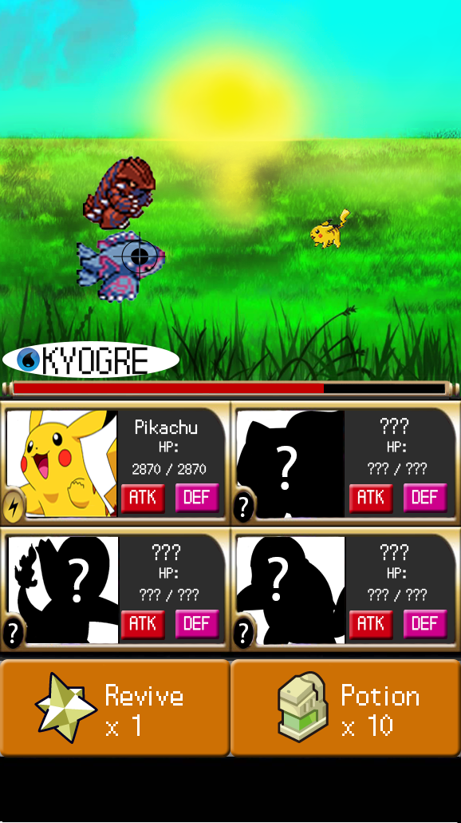When the game begins, the player will run from one patch to another. In front of each patch of grass is a treasure chest with 1 revive and 10 potions. Players can only hold a max of 1 revive and 10 potions. When the player enters the patch, they could randomly come in contact with a group of Pokémon, finding a Pokémon is completely random. The level of the Pokémon in the patch of grass changes; the closer the player gets to the finish, the hard the Pokémon get. In each patch of grass, there is one rare Pokémon that is much stronger than any other Pokémon in that patch (the shiny Pokémon). Players can travel back and forth between patches to try to catch new Pokémon or level up the ones they have.

During battle, the player may face up to 4 Pokémon at once. Unlike the original Pokémon, all of the player’s Pokémon will attack at once and then all of the enemy Pokémon will attack at once. The game will still be turn based. Before attacking, players have an option to use as many potions as he/she likes and can even use a revive on the same turn he used a potion. If the player loses the fight and his entire Pokémon team dies, the game is wiped and a score is given to him in a text file. But if he beats all if the enemy Pokémon, then there is a chance that one of the Pokémon he fought will be given to him. The player then has a choice to either keep the Pokémon he has or swap with the one that was given to him, all of other Pokémon then gain ATK and DEF points. After the fight, all of the player’s Pokémon’s health will be restored to 100%.

The player has complete freedom in this universe, he/she can choose to stay in the lower patches to train or try to bulldoze through the whole game and hope to beat the final legendaries.