**基础物理实验原始数据记录**

实验名称 测量金属的杨氏模量 地点

学生姓名 学号 分班分组座号 - - 号（例：1-04-5号）

实验日期 年 月 日 成绩评定 教师签字

1. **拉伸法**

设备型号：

1. 钼丝长度L= mm，卷尺仪器误差e= mm
2. 钼丝直径

|  |  |  |  |  |  |  |  |
| --- | --- | --- | --- | --- | --- | --- | --- |
| 测量次数 | 1 | 2 | 3 | 4 | 5 | 6 | 平均值 $\overline{d}$ |
| d/mm |  |  |  |  |  |  |  |

1. 监视器示数

初始示数 $l_{0}$ = mm，千分尺仪器误差e= mm

|  |  |  |  |  |  |  |  |
| --- | --- | --- | --- | --- | --- | --- | --- |
| 序号i | 砝码质量M/g | 叉丝读数/mm | | | $$l_{i}M_{i}$$ | 示数差值 $∆\overline{l_{i}}={\overline{l}}_{i+4}\text{- }\overline{l_{i}}$ | 不确定度 $∆(∆l)$ |
| 加载 $l_{i}$/mm | 卸载 $l_{i}^{'}$/mm | 平均值 $\overline{l_{i}}$/mm | /(mm·g) |
| 1 |  |  |  |  |  |  |  |
| 2 |  |  |  |  |  |  |
| 3 |  |  |  |  |  |  |
| 4 |  |  |  |  |  |  |
| 5 |  |  |  |  |  |  |
| 6 |  |  |  |  |  |
| 7 |  |  |  |  |  |
| 8 |  |  |  |  |  |
|  | | | | | | | |
| $\overline{M}$ |  |  | $\overline{\overline{l}}$ |  |  | | |
| $\sum{M}$ |  | $\sum{\overline{l}}$ |  |

1. 作图法处理数据

**（请注意绘图纸大小。注意图表要素齐全）**

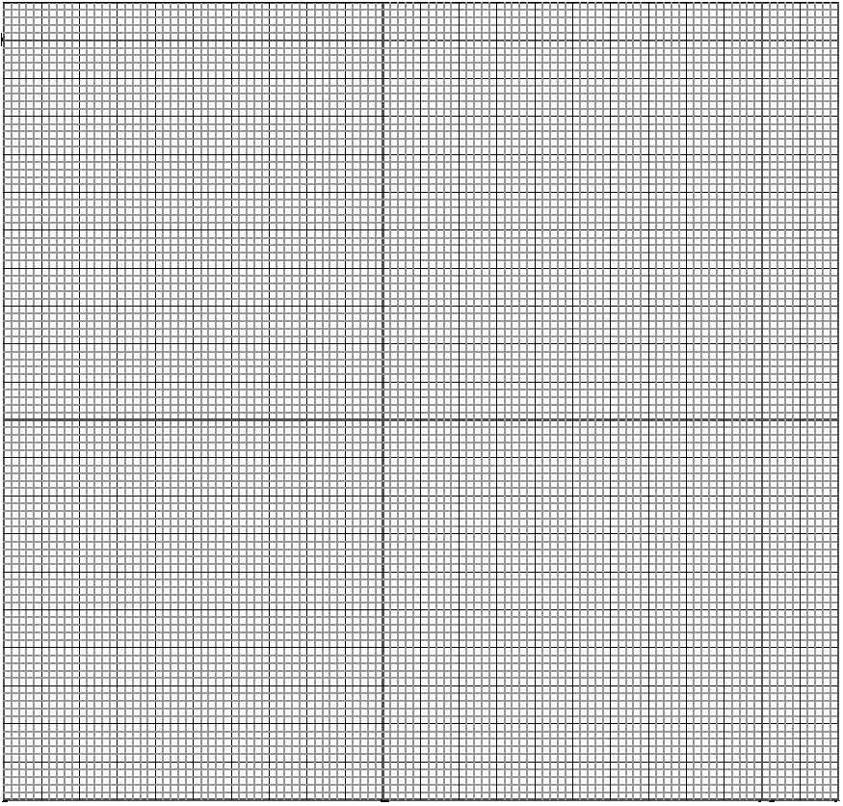

**二．霍尔法**

设备型号：

**（一）样品：□黄铜□铸铁**

1. 横梁的几何尺寸

|  |  |  |  |  |  |  |  |
| --- | --- | --- | --- | --- | --- | --- | --- |
| 测量次数 | 1 | 2 | 3 | 4 | 5 | 6 | 平均值 |
| 长度d/mm |  |  |  |  |  |  |  |
| 宽度b/mm |  |  |  |  |  |  |  |
| 厚度a/mm |  |  |  |  |  |  |  |

1. 读数显微镜示数

显微镜初始读数 $Z_{0}$ = mm

|  |  |  |  |  |  |  |  |  |  |
| --- | --- | --- | --- | --- | --- | --- | --- | --- | --- |
| 序号i | 1 | 2 | 3 | 4 | 5 | 6 | 7 | 8 | 平均值 |
| $M_{i}$/ g |  |  |  |  |  |  |  |  |  |
| $Z_{i}$/ mm |  |  |  |  |  |  |  |  |  |
| $U_{i}$/ mV |  |  |  |  |  |  |  |  |  |
| ${∆Z}_{i}$/ mm |  |  |  |  |  | | | |  |
| / mV |  |  |  |  |  |
| / mV2 |  |  |  |  |  |  |  |  |  |
| / mm2 |  |  |  |  |  |  |  |  |  |
| / (mm·mV) |  |  |  |  |  |  |  |  |  |

**（二）样品：□黄铜□铸铁**

1. 横梁的几何尺寸

|  |  |  |  |  |  |  |  |
| --- | --- | --- | --- | --- | --- | --- | --- |
| 测量次数 | 1 | 2 | 3 | 4 | 5 | 6 | 平均值 |
| 长度d/mm |  |  |  |  |  |  |  |
| 宽度b/mm |  |  |  |  |  |  |  |
| 厚度a/mm |  |  |  |  |  |  |  |

1. 读数显微镜示数

显微镜初始读数= mm

|  |  |  |  |  |  |  |  |  |  |
| --- | --- | --- | --- | --- | --- | --- | --- | --- | --- |
| 序号i | 1 | 2 | 3 | 4 | 5 | 6 | 7 | 8 | 平均值 |
| / g |  |  |  |  |  |  |  |  |  |
| / mm |  |  |  |  |  |  |  |  |  |
| / mV |  |  |  |  |  |  |  |  |  |
| / mm |  |  |  |  |  | | | |  |
| / mV |  |  |  |  |  |
| / mV2 |  |  |  |  |  |  |  |  |  |
| / mm2 |  |  |  |  |  |  |  |  |  |
| / (mm·mV) |  |  |  |  |  |  |  |  |  |

**三． 动态法**

设备型号：

样品： ; 长度L= mm；直径d= mm；样品质量m= g

|  |  |  |  |  |  |  |  |  |
| --- | --- | --- | --- | --- | --- | --- | --- | --- |
| 序号 | 1 | 2 | 3 | 4 | 5 | 6 | 7 | 8 |
| 悬挂点位置x（mm） | 20 | 25 | 30 | 35 | 45 | 50 | 55 | 60 |
| x/L |  |  |  |  |  |  |  |  |
| 共振频率f1（Hz） |  |  |  |  |  |  |  |  |

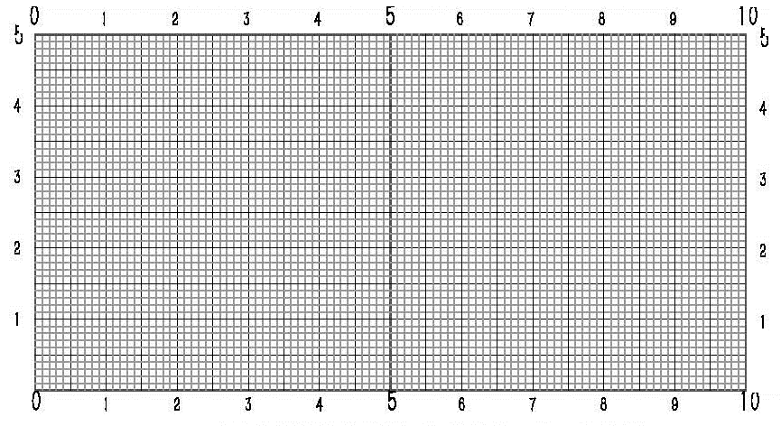

基频共振频率f1= Hz

Y=

**四．光杠杆法的装置读数**

设备型号：

数据记录表：

|  |  |  |  |  |
| --- | --- | --- | --- | --- |
| 序号 | 拉力  （kg） | 微分头示数（mm） | 读数（  mm） | 计算的伸长量（mm） |
| 1 |  |  |  |  |
| 2 |  |  |  |  |
| 3 |  |  |  |  |

注：拉力和微分头示数只填1列（部分装置使用微分头替代砝码拉伸产生位移）。