一、如何扩展新插件对应代码模板（即在编辑器上方的功能菜单）
在使用markdown插件时，添加插槽，例如：
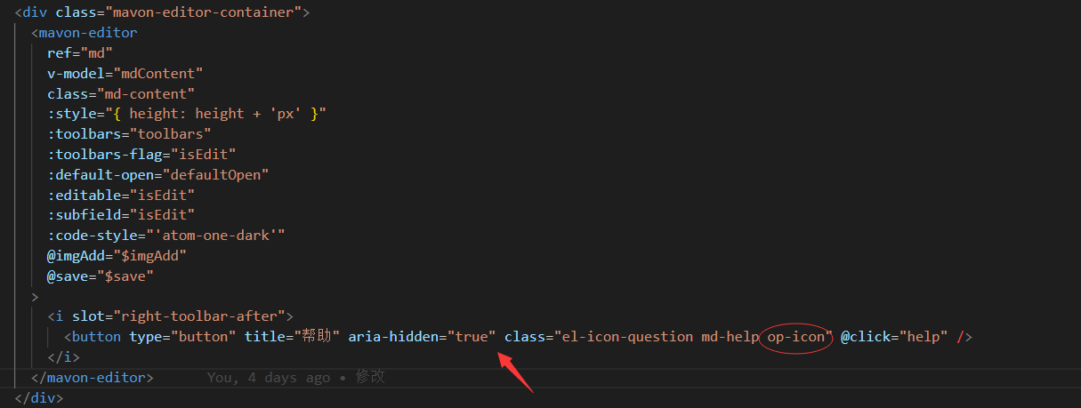
注：插槽名称： right-toolbar-after、 right -toolbar-before、 left-toolbar-before 、
right -toolbar-before 表示添加的按钮插槽摆放位置，class里引用图标样式，注意必须同时要添加”op-icon”，才能保证该图标与默认图标样式保持一致，包括hover等不需要额外写，title中是鼠标移上后显示的文字内容，@click添加点击事件。

二、如何扩展的新插件（添加markdown语言自动转换html代码规则）
- 首先要获取mavonEditor的markdown-it对象（方式多种 github有详细介绍），
例：我使用的是
<mavonEditor ref=md></mavonEditor>
...
this.$refs.md.markdownIt
- 使用现成的语法插件
https://www.xiaoyulive.top/favorite/docs/Plugins_Markdown_It.html#markdown-it-implicit-figures
- 使用自定义语法
参考：https://www.jianshu.com/p/797df3f614e5
使用实例：
mounted中:
this.md = this.$refs.md.markdownIt.use(require('markdown-it-math'), {})
// 注册使用自定义语法
this.md.block.ruler.before('code', 'mermaid', block);
this.md.renderer.rules.mermaid = render;
let open = '``` mermaid'
let close = '```'
function render(tokens, idx) {
let content = tokens[idx].content;
return "<div class='uml'>"+content+"</div>";
}

// 以下为获取从开始标记到结束标记的块的内容
function block(state, startLine, endLine, silent) {
var openDelim, len, params, nextLine, token, firstLine, lastLine, lastLinePos,
haveEndMarker = false,
pos = state.bMarks[startLine] + state.tShift[startLine],
max = state.eMarks[startLine];
if (pos + open.length > max) {
return false;
}
openDelim = state.src.slice(pos, pos + open.length);
if (openDelim !== open) {
return false;
}
pos += open.length;
firstLine = state.src.slice(pos, max);
// Since start is found, we can report success here in validation mode
if (silent) {
return true;
}
if (firstLine.trim().slice(-close.length) === close) {
// Single line expression
firstLine = firstLine.trim().slice(0, -close.length);
haveEndMarker = true;
}
// search end of block
nextLine = startLine;
for (; ;) {
if (haveEndMarker) {
break;
}
nextLine++;
if (nextLine >= endLine) {
// unclosed block should be autoclosed by end of document.
// also block seems to be autoclosed by end of parent
break;
}
pos = state.bMarks[nextLine] + state.tShift[nextLine];
max = state.eMarks[nextLine];
if (pos < max && state.tShift[nextLine] < state.blkIndent) {
// non-empty line with negative indent should stop the list:
break;
}
if (state.src.slice(pos, max).trim().slice(-close.length) !== close) {
continue;
}
if (state.tShift[nextLine] - state.blkIndent >= 4) {
// closing block math should be indented less then 4 spaces
continue;
}
lastLinePos = state.src.slice(0, max).lastIndexOf(close);
lastLine = state.src.slice(pos, lastLinePos);
pos += lastLine.length + close.length;
// make sure tail has spaces only
pos = state.skipSpaces(pos);
if (pos < max) {
continue;
}
// found!
haveEndMarker = true;
}
// If math block has heading spaces, they should be removed from its inner block
len = state.tShift[startLine];
state.line = nextLine + (haveEndMarker ? 1 : 0);
token = state.push('mermaid', 'mermaid', 0);
token.block = true;
token.content = (firstLine && firstLine.trim() ? firstLine + '\n' : '') +
state.getLines(startLine + 1, nextLine, len, true) +
(lastLine && lastLine.trim() ? lastLine : '');
token.info = params;
token.map = [startLine, state.line];
token.markup = open;
return true;
}
Ps：该方法需要npm install markdown-it-math --save

