Project 1: Static Foundations
Feedback for Tavish Chen's portfolio
Student: Tavish Chen Course: CSC 436, Fall 2026 Reviewed at: 25a809e
Repo: github.com/chentavish/CSC436_Project1 Live: chentproject1.netlify.app

Grade: 80 / 100
Category | Points | Earned | One line
Semantic HTML | 20 | 17 | Clean outline, valid DOM, excellent alt text; no header, title tag is the Vite default
CSS layout | 25 | 23 | Flexbox everywhere it should be, Grid on education, a real design system with dark mode
Responsive design | 15 | 12 | No horizontal scroll; the phone nav hides two links with no hint that it scrolls
JavaScript interaction | 15 | 10 | The toggle is excellent; it is React, and the brief said vanilla JavaScript
Repository and deployment | 15 | 10 | README complete, deploy configured; all 7 commits on the due date, one is the whole redesign
Content and polish | 10 | 8 | Real resume content, real rank screenshot; thin experience entries, leftover unused code
Total | 100 | 80 | A polished site built on the wrong foundation for this assignment.

How this review was made
Your instructor reviewed this project with Claude (Anthropic's AI) as a second set of eyes. Claude cloned the repo, read every line of the React source and both stylesheets, loaded the live site at phone, tablet and desktop widths, validated the rendered DOM, clicked the theme toggle and checked that it persisted, and read the prompt log you submitted. Every note and every point in this document was read and approved by your instructor. Same standard, same rubric, just more time spent looking at your code than one human has in a grading week.

The short version
This is the most finished-looking site in the class. Sticky blurred nav, a dark mode that respects the system setting and remembers your choice, focus rings on everything, a design token system, a timeline with pseudo-element dots. It looks like a real portfolio because the content is real: four jobs, two degrees, a resume PDF, and a Challenger rank with the screenshot to prove it.
Two things pull it down. First, the brief's opening sentence says "semantic HTML, modern CSS layout, and vanilla JavaScript," and this is a React 19 app compiled by Vite. The theme toggle is well built, but the three skills the JavaScript category exists to test, selecting elements, listening for events, changing the DOM, are done by React on your behalf. Second, your prompt log. The brief allows AI, and the log shows the AI redesigned the site, checked the requirements for you, fixed the layout, did the cleanup pass, and fixed the deploy. That is allowed. The rule that comes with it is that you can explain every line. This review names five specific spots. Be ready to walk through them in office hours.

What Claude measured
Check | Result
Horizontal scroll at 375 / 768 / 1280 px | None at any width
Console errors | 0
W3C validator on the rendered DOM | 0 errors from your code (one from Netlify's injected badge)
Heading order | h1 > h2 > h3, no skipped levels
Semantic elements | nav, main, 6 sections, footer. No header, no article
Nav links reachable at 375px without swiping | 3 of 5 (Hobbies and Contact are off-screen)
Theme toggle | Works; sets data-theme, writes localStorage, flips aria-pressed and the label
Education grid columns at 375 / 768 / 1280 | 1 / 2 / 2
Framework | React 19.2 + Vite 8, built on Netlify
Unused code | Points and Tags components, 3 CSS classes, .oxlintrc.json, duplicate README
<title> | CSC436_Project1
Commits | 7, all on Sep 15 between 1:08 PM and 10:23 PM

The site at three widths
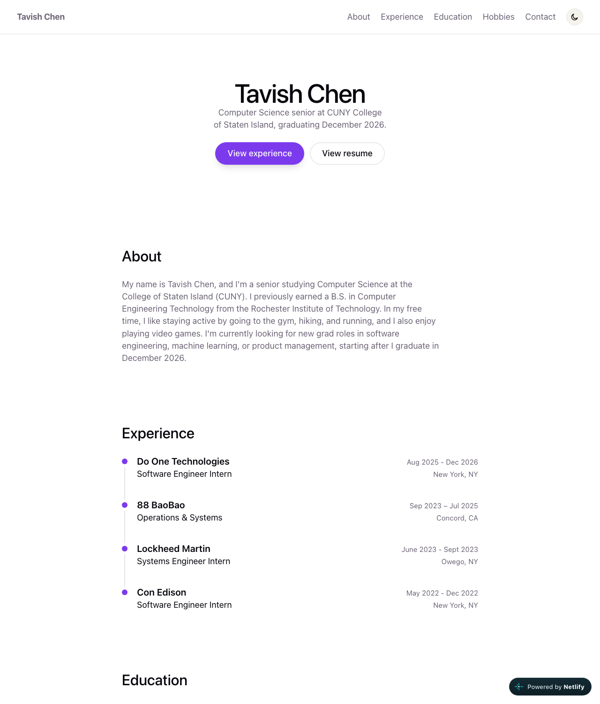
Desktop, 1280px. Sticky nav, centered hero, timeline.
  Phone, 375px. Only About and Experience are visible in the nav. | 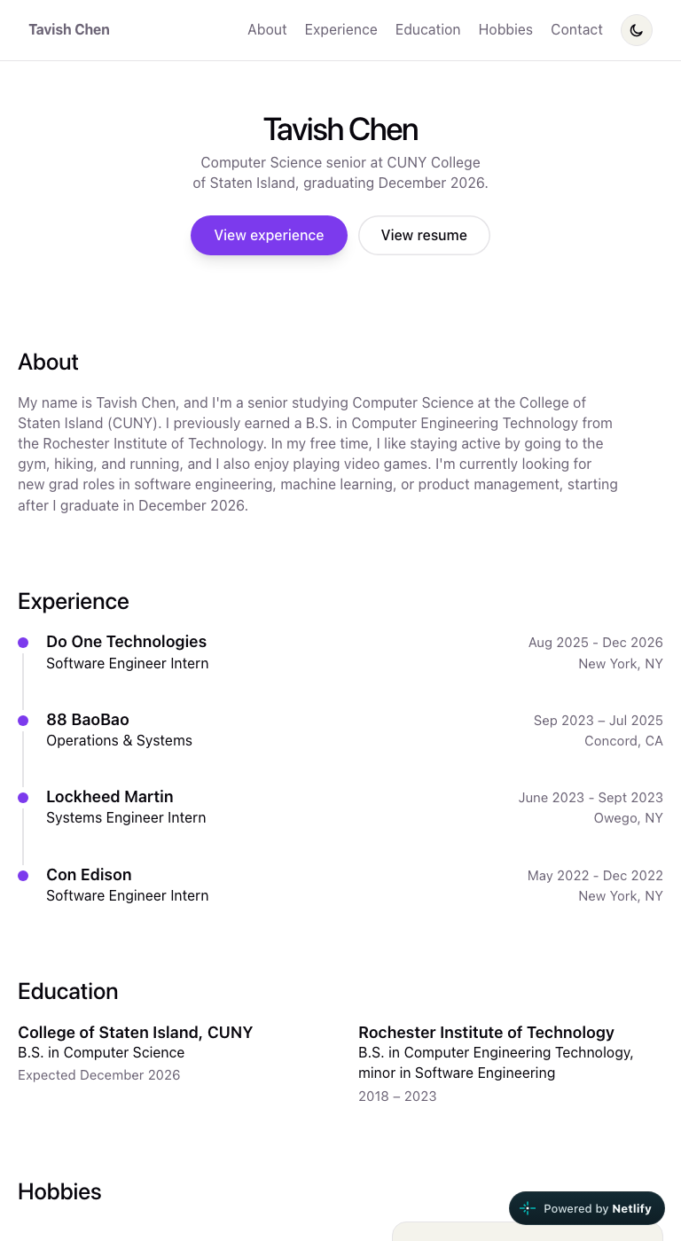  Tablet, 768px. All five nav links fit.

Semantic HTML: 17 / 20

What is working
- One h1, then h2 per section, h3 per entry. The rendered DOM validates. nav has aria-label="Main", the timeline is an ol because order matters, the toggle button has aria-pressed and a label that changes with state. The rank screenshot's alt text (App.jsx line 199) actually describes the image.
- Every external link has rel="noreferrer". The resume is a real PDF at a real path.

What to change
- No header. The nav sits in a bare div (App.jsx lines 108 to 129). The brief lists header first among the elements it wants to see. Wrap the nav in one. Thirty seconds.
- The page title is CSC436_Project1 (index.html line 7). That is the Vite scaffold's default, and it is what shows in the browser tab and in search results. It should be your name.
- Education entries are divs (line 182). Each is a self-contained item with a heading; that is an article. Same for the timeline items.
- Small: id="Hobbies" (line 193) is the only capitalized id on the page. Fragment ids are case-sensitive, so it works, but it is inconsistent with the other five.

CSS layout: 23 / 25

What is working
- Flexbox is doing real work in at least eight places: the sticky nav with space-between, the hero column, both button rows, every timeline entry header (title left, dates right), the rank showcase, the contact block. flex: 1 1 340px on the screenshot (App.css line 324) so it wraps under the card on narrow screens. Correct everywhere.
- Grid on the education section with auto-fit, minmax(260px, 1fr) (lines 300 to 304). Right pattern.
- This is a real design system. Tokens in :root, dark values under both prefers-color-scheme and [data-theme] so the toggle can override the OS (index.css lines 34 to 64), color-mix for the translucent nav, backdrop-filter, :focus-visible on every interactive element, prefers-reduced-motion guarding smooth scroll, nested @media rules. Most of the class has not seen half of these.

What to change
- The Grid has two items. It is a correct Grid, but with two education entries it never does more than two columns. Fine for the rubric; just know it is the thinnest use of Grid on the page. The timeline or a projects section would give it more to do.
- Three CSS rules match nothing: .entry-points, .tags, .entry-details (lines 237 to 262 and 310 to 313). They style data fields (points, tags, details) that none of your jobs or schools actually have. Prompt 5 in your log asked the AI to remove unused code. It did not, and nobody checked.

Responsive design: 12 / 15

What is working
- No horizontal scroll at 375, 768 or 1280. Font size, heading size and section padding all step down under 1024px. The rank showcase stacks. The education grid collapses to one column. Buttons wrap.

What to change
- The phone nav hides two of five links. Under 760px the nav list gets overflow-x: auto with the scrollbar hidden (App.css lines 102 to 106). At 375px you see "About, Experience" and nothing tells you Hobbies and Contact exist to the right. Claude measured: they sit at 396px and 478px, past the 375px edge. A hamburger, a wrap onto a second row, or even a fade on the right edge would fix it. Right now a phone user cannot find your Hobbies section from the nav.
- Desktop-first. Every breakpoint is max-width. The brief asked for mobile-first. Flip to min-width and the base styles become the phone.

JavaScript interaction: 10 / 15

What is working
- The theme toggle is a genuinely good implementation: it reads localStorage first, falls back to the OS preference, writes the attribute and the storage in one effect, swaps the icon, and keeps aria-pressed and aria-label in sync (App.jsx lines 52 to 56, 98 to 105, 119 to 127). Claude clicked it, waited, and confirmed all of that happens. Zero console errors.

What to change
- It is React, and the brief said vanilla JavaScript. The first sentence of the brief, and the JavaScript requirement itself: "It must select elements, listen for an event, and change the page." Your code does not select an element or touch the DOM; React does that for you from state. The skill the category tests was outsourced to the framework. The same toggle in vanilla JS is about fifteen lines:
const button = document.querySelector('.theme-toggle');
const root = document.documentElement;
const saved = localStorage.getItem('theme');
const prefersDark = matchMedia('(prefers-color-scheme: dark)').matches;
root.dataset.theme = saved ?? (prefersDark ? 'dark' : 'light');

button.addEventListener('click', () => {
const next = root.dataset.theme === 'dark' ? 'light' : 'dark';
root.dataset.theme = next;
localStorage.setItem('theme', next);
button.setAttribute('aria-pressed', next === 'dark');
});

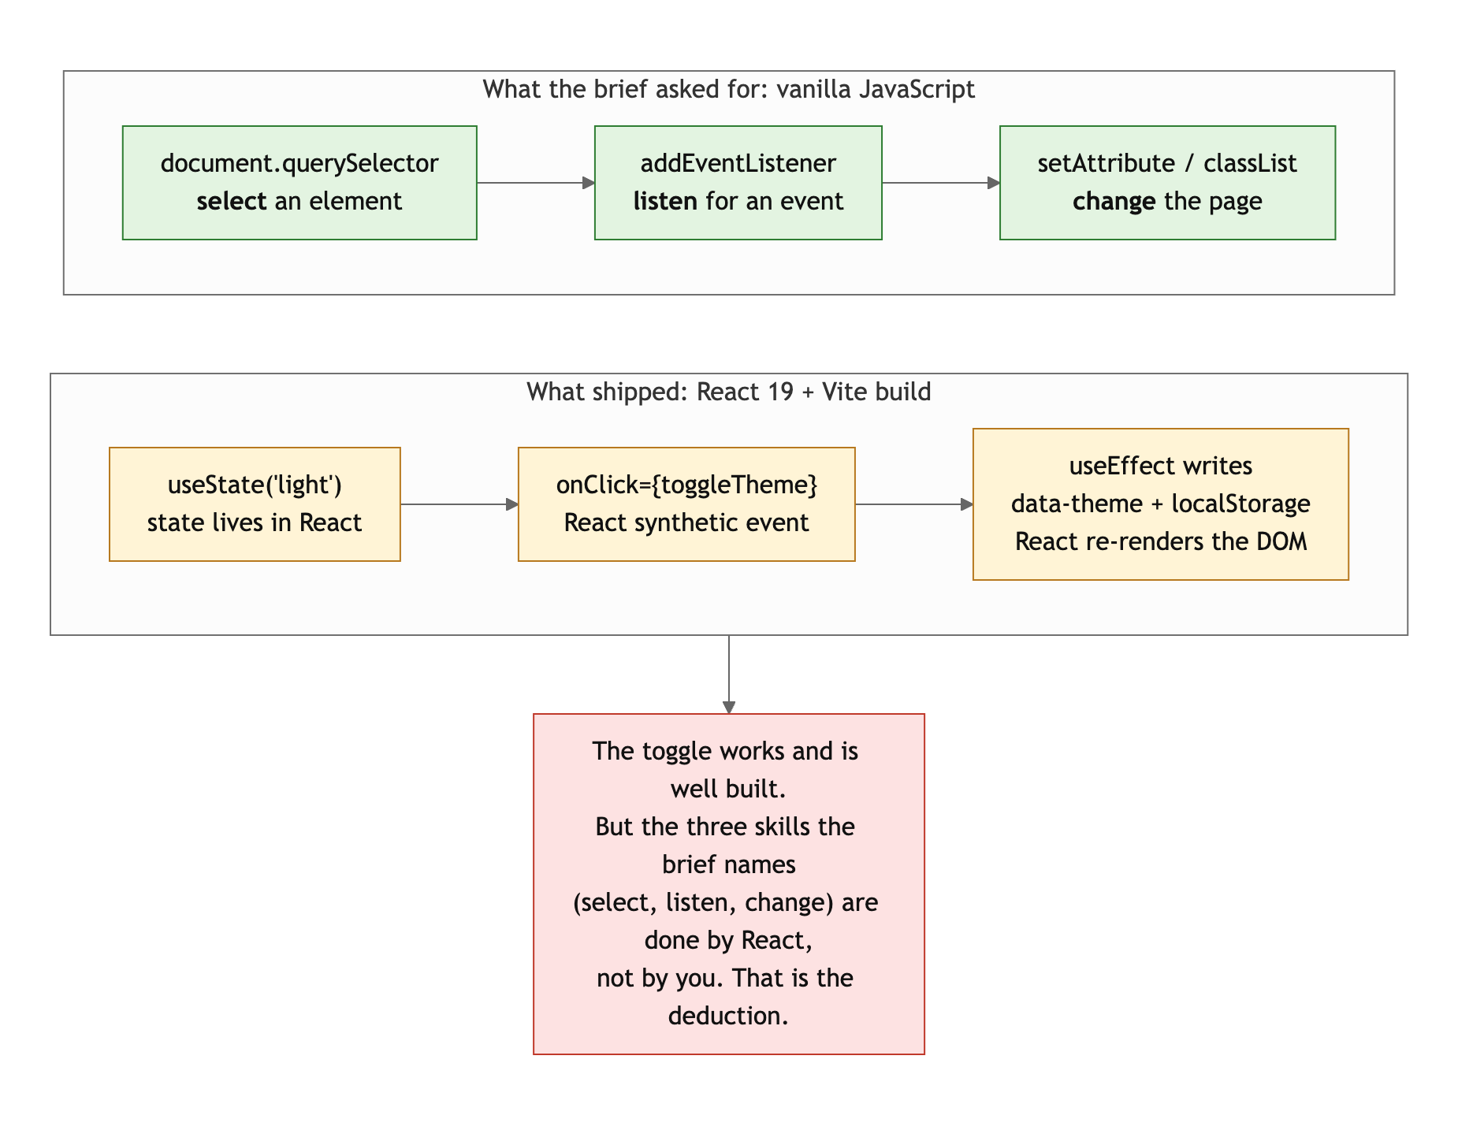
Diagram 1. The three steps the brief names, and who does them in your build.
- Two components are never rendered with data. Points and Tags (lines 75 to 95) are called for every job, and every job has no points and no tags, so they return null four times each. Either fill the data or delete the components.

Repository and deployment: 10 / 15

What is working
- README has all four required items, and the run instructions are correct for a Vite project. .gitignore is right (node_modules, dist, .DS_Store). netlify.toml sets the base directory, build command, publish folder and the SPA redirect, which is exactly what a Vite app on Netlify needs. The live site matches the repo.

What to change
- All seven commits are on September 15, from 1:08 PM to 10:23 PM. Two of them are README edits, one is a one-line fix, and one, "Project fully changed to a personal portfolio," is 533 lines and is the entire site. The scaffold went in at 1:55 PM and the real work landed in a single commit at 10:14 PM. The brief asked for history that shows the project developing over time. This history shows a template, then a finished site.
- The README describes a different project. It says the site uses "semantic HTML, modern CSS layout, and vanilla JavaScript." That is the brief's sentence. Your site uses React and a build step. Say what you built. And there are two READMEs (root and Project1/) with the same text.
- Leftovers from the scaffold: .oxlintrc.json and the lint script, which nothing in the brief needs.

Content and polish: 8 / 10

What is working
- The content is real and specific. Four jobs with dates and locations, two degrees, a resume that opens, an email and LinkedIn that go somewhere, and a hobby section with a real screenshot and a real number. The dark mode is smooth, the focus rings are on-brand, the timeline dots are a nice touch.

What to change
- The experience entries are just titles. Company, role, dates, location, and nothing about what you did. The data structure has a points field for exactly this. One to three bullets per job turns a list into a resume.
- The tab title says CSC436_Project1. First thing a recruiter sees.
- The cleanup prompt did not clean up. Unused components, unused CSS, duplicate README, leftover lint config. "Remove anything unnecessary" only works if you check the result.

On the prompt log
You submitted seven prompts. The brief permits this. It also says: "You must be able to explain every line you submit. If you cannot explain it, do not submit it." Your log shows the AI chose the design, audited the requirements, fixed the layout twice, did the cleanup, and fixed the deploy. That is a lot of decisions you will be asked about.
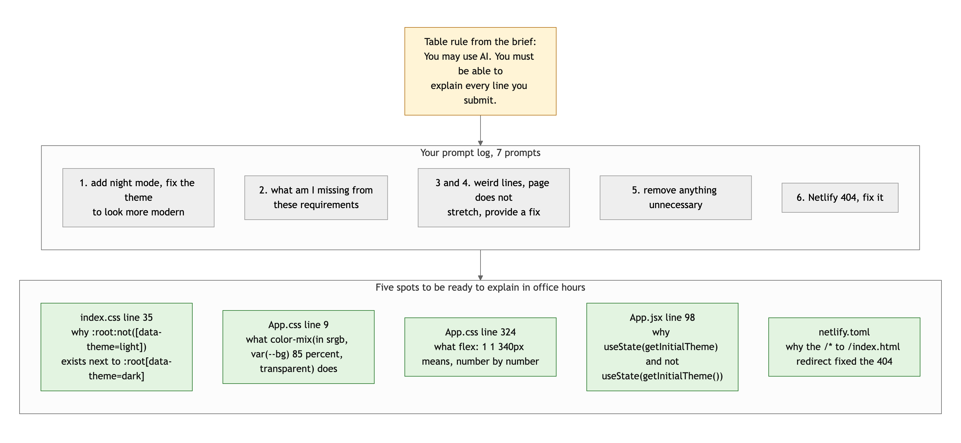
Diagram 2. Your prompt log, the rule it falls under, and five spots to be ready to explain.
Come to office hours ready to explain those five. If you can, this grade stands and you have learned a lot from the AI. If you cannot, that is the conversation the brief warned about.

Your next three moves
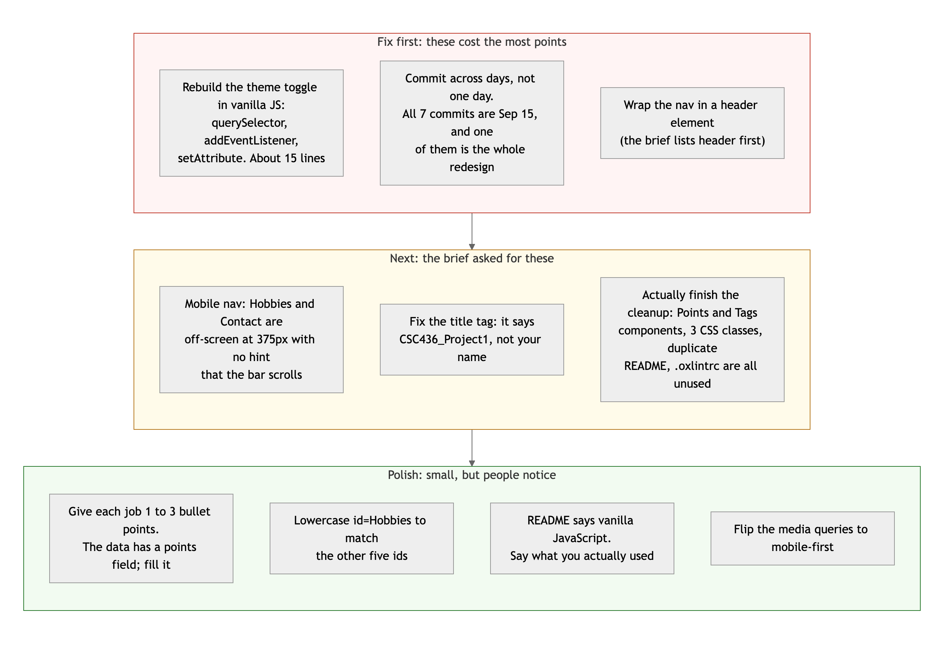
Diagram 3. Priority order. Top row first: it is where the points are.
- Write the toggle yourself, in vanilla JS. Fifteen lines, shown above. Do it in a plain script.js next to a plain index.html, no build step, and you will have done what the brief actually asked.
- Fix the phone nav and the title tag. Both are things a recruiter on a phone hits in the first five seconds.
- Read your own diff before you commit. The cleanup prompt left five kinds of unused code behind. The AI is a tool; the review is your job.

You shipped the most polished site in the class. Now make sure you could build it again without the AI, because the next projects will ask you to.
This review lives in a pull request on your repo. It only adds feedback files and does not touch your code. Merge it, close it, or just read it. Questions go to office hours or the Brightspace board.

