User story

1. As a student, I want to search for books so that I could find the book faster.
2. As a student, I want to be able to upload the book information so I can sell them.
3. As a student, I want to able to contact the seller so I can ask more about the book.
4. As a student, I want to add/remove the book from cart so that I can specify what to order.
5. As a student, I want to create an account so that I can register myself as a user.
6. As a student, I want to receive book recommendations so that I could explore more books based on interest.
7. As a student, I want to make payment via PayPal so that I could make payment faster.
8. As a student, I want to be able to sign in to my account so that I can access to my account.
9. As a student, I want to view the details of the books so that I can know the content of the book.
10. As a student, I want to rate my order and leave a comment so that I can share my experience with other students.

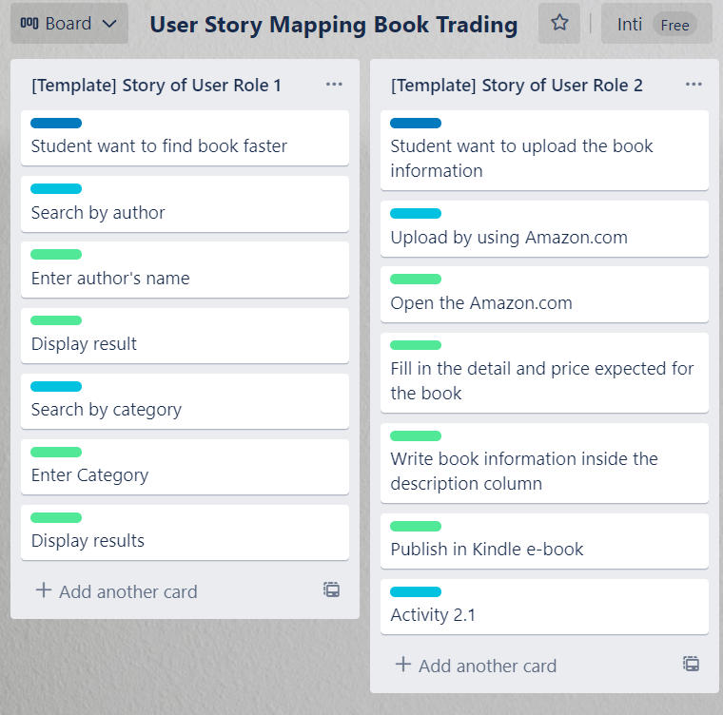

User Story 1,2

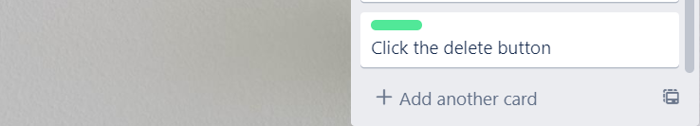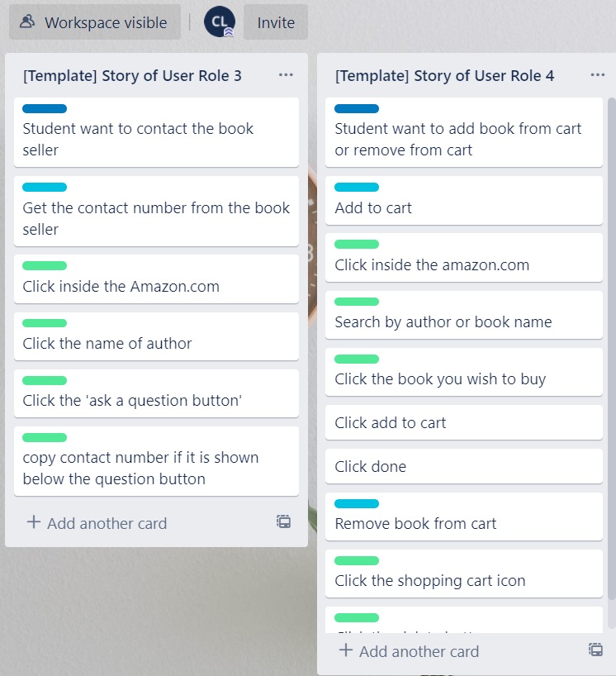

User Story 3,4

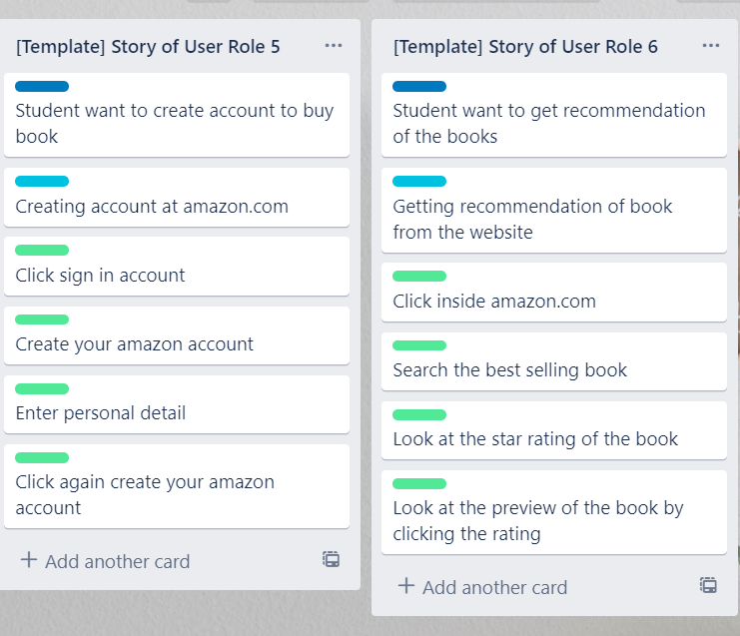

User Story 5,6

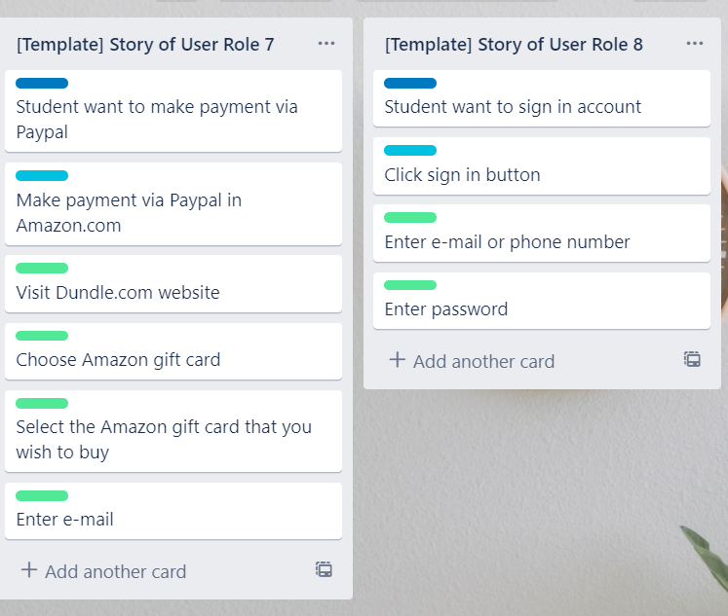

User Story 7,8

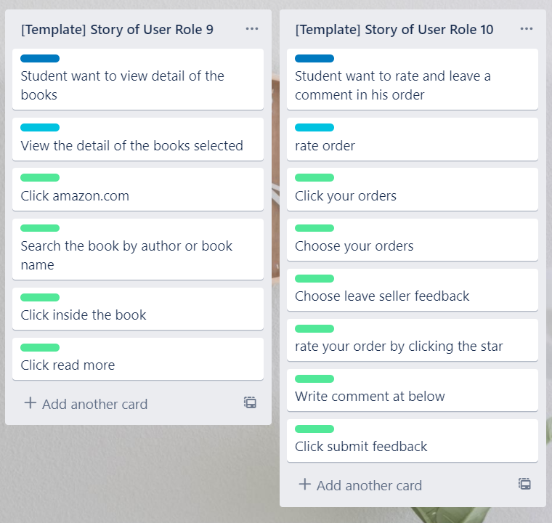

User Story 9,10