**ViewParserTool**

**Description:**

Customer needs a tool where the user can input the file name and the program would parse it and loads it into H2 Embedded database with proper relationship between the SOAP request and SOAP response so when the user chooses to review the data, the program should bring the data up on the screen with proper relationship.

**Parser Flow**

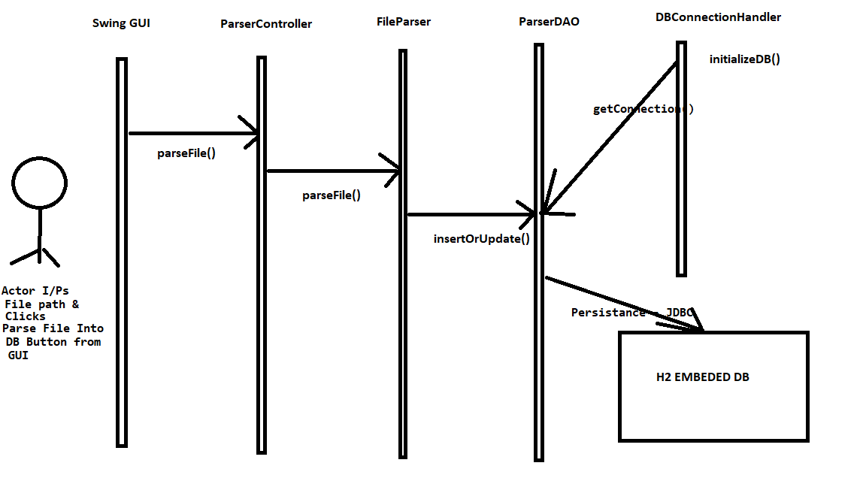

1. The user opens the GUI, enters the File Path and clicks Parse File Into DB button
2. GUI makes call to ParserController which delegates the request to the FileParser
3. FileParser reads file by Chunks using BufferedReader which is an efficient memory modal to read large files. It then streams the data into a method which then will map the data into a VO (Value Object). FileParser doesn’t use any java collection for correlation between the request and the response because no collection in real world can handle millions of data a file may contain. So Fileparser just streams the data as it reads and then maps it to a ValueObject and persists it to the memory storage. The way FileParser handles correlation is by the way it persists the object into the database. FileParser uses ParserDAO for persistence with the H2 Embedded database.
4. ParserDAO handles all the DB related business between the Parser and the H2 Embedded database. It separates one transaction into two – Request object and Response object. Request/Response whichever gets streamed first will be inserted into the database and the next will get updated. This maintains the correlation between the request and the response without the usage of any Collection underneath.
5. DBConnectionHandler has a static method that prepares the program for persistence. It uses a static method for this purpose. It only acts as a broker to get the connection and returns to the DAO when requested.

**Viewer Flow**

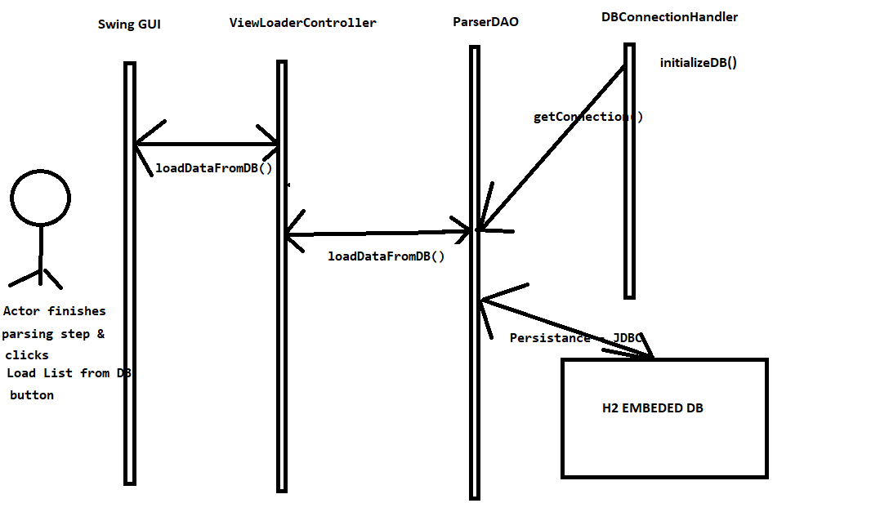

This is very straightforward, User after finishes the parsing step, clicks Load List from DB button, calls will be made to H2Embeded DB via ViewLoaderController and ParserDAO to get the list of persisted data from the previous parsing step and it will get loaded into the GUI screen for the user to review.

**Application Screenshots**

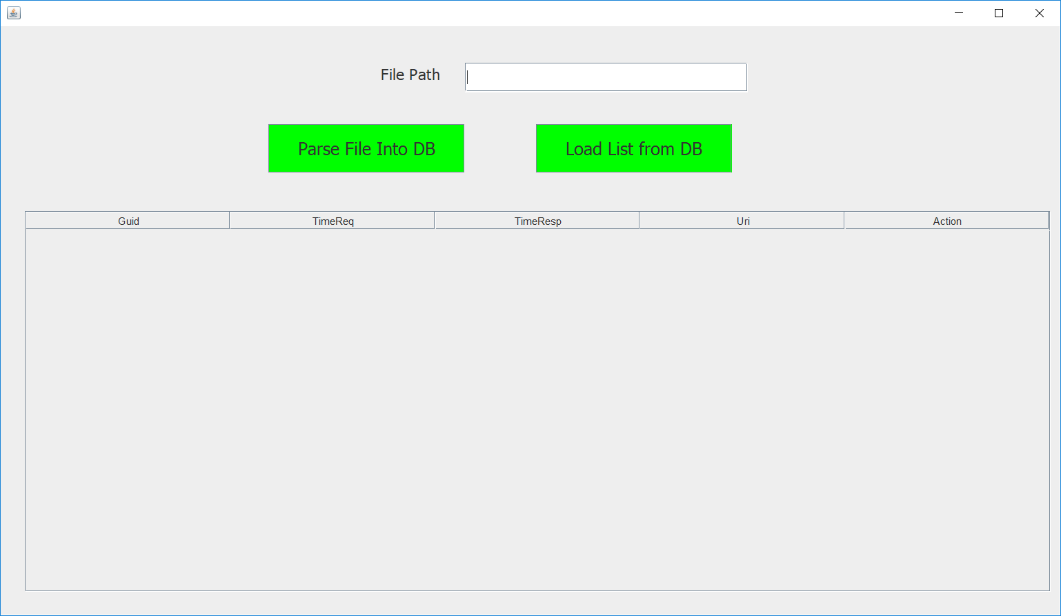

This is the main screen of the application written using Swing. The reason I chose Swing is because the requirement wanted me to use H2 embedded DB and the embedded DB holds the data only as long as the JVM runs. Because we need the application to perform two different activities (Parsing/Persistence into the DB and Loading data back from DB), we need a program that sticks around in the JVM during the whole process (including the user interaction). Swing will be the best fit for that.

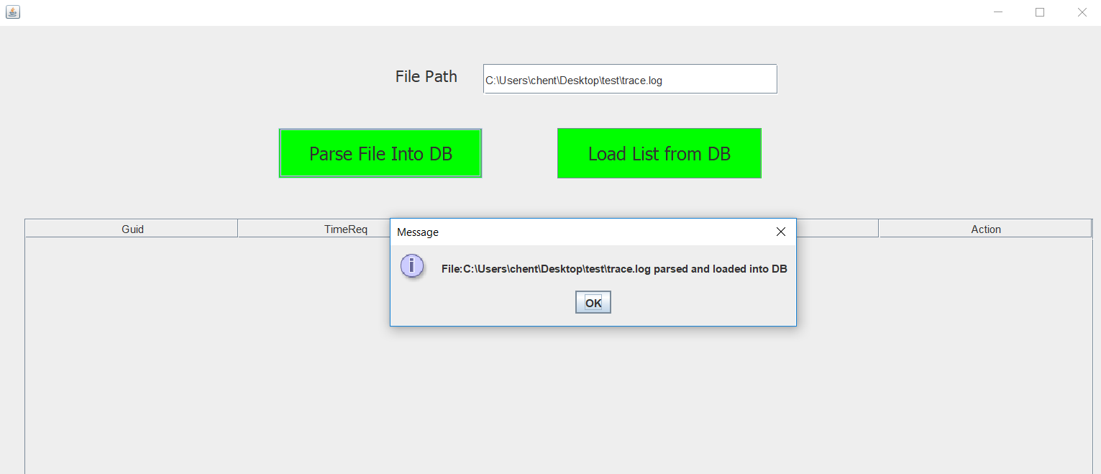

User enters the file path and clicks Parse File into DB button. After successful parsing and persistence user will see the above confirmation

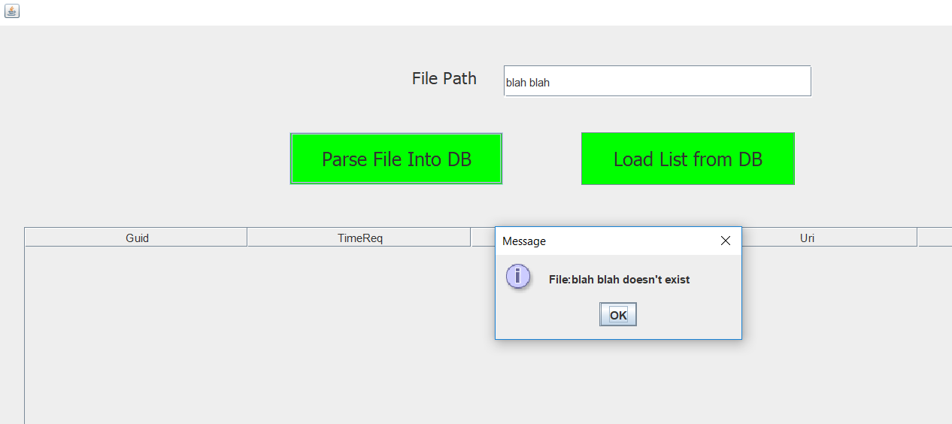

The program validates if the file entered by user is in valid location and is indeed a real file. If the validation fails, user will see the above error

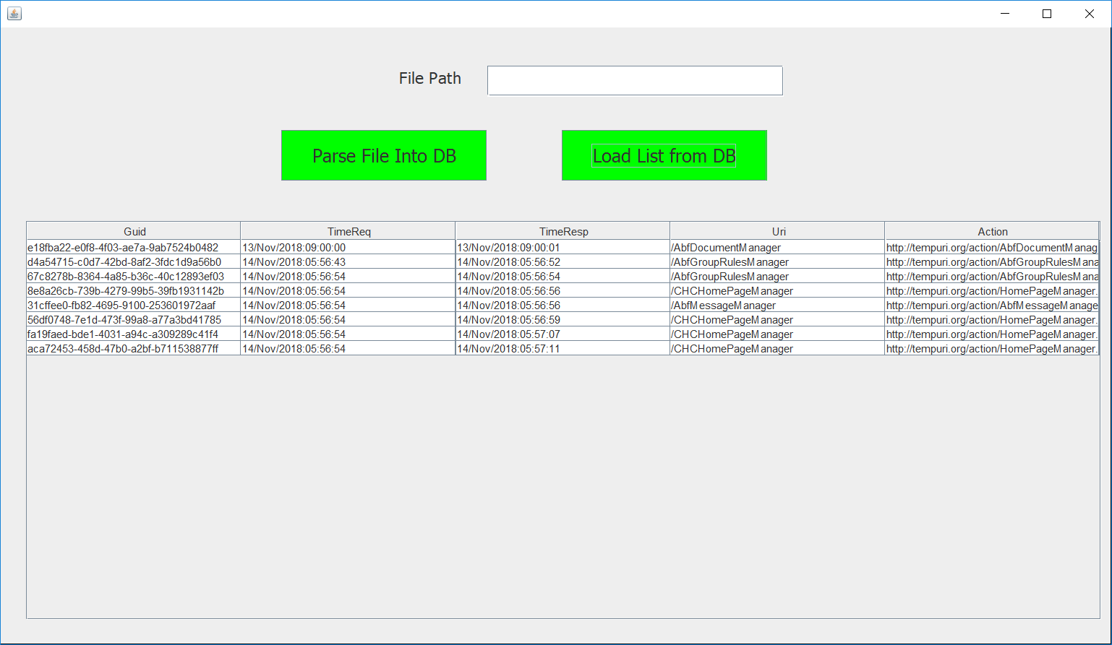

After parsing clicks Load List from DB button to load the persisted data back into the table for review.

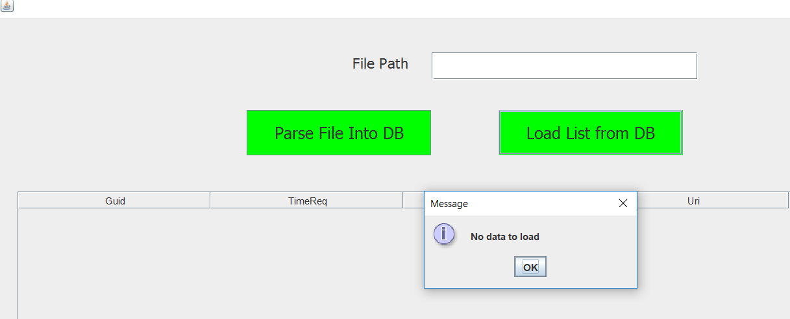

User will see the above message when there is no data to load from the H2 embedded database.