|  |
| --- |
| Grade 12 Computer Science Summative Proposal |
| Fall of the Titans |
| Powered by: Impulse – Dynamic Physics Engine |

|  |
| --- |
| Tommy Chen, Brad Wang  4/22/2013 |

# Overview

Fall of the Titans is a shooting game that is based on the plane shooting game. The basics are similar to plane shooting games, where the player controls a turret from ground and shoots streams of bullets up into the sky. On the other hand, the difference is that instead of shooting planes, the player is shooting meteoroids crashing into your turrets. However, these meteoroids cannot be destroyed. Instead, your bullets will collide with the meteoroids and bounce off. The player’s objective is to shoot the meteoroids and navigate them off their crashing course with your turret. The collision effects are handled by an integrated physics engine.

# Setup

* A turret is located at the bottom center
* Waves of meteoroids fall down the sky
* The meteoroids are circular
* The meteoroids have different size, weight, speed, and direction

# User Interface

* The game will be controlled by the mouse
* Mouse movement is used to aim the turret
* Left mouse click is used to shoot small bullets
* Right mouse click is used to shoot bigger, heavier bullets
* Holding the mouse allows the turret to continue shooting

# Game play

* One of the challenge of the game is to conserve ammo
* The ammo is automatically refilled constantly but have a certain maximum capacity
* When the meteoroids crash into the turret, the game is over

# Graphics

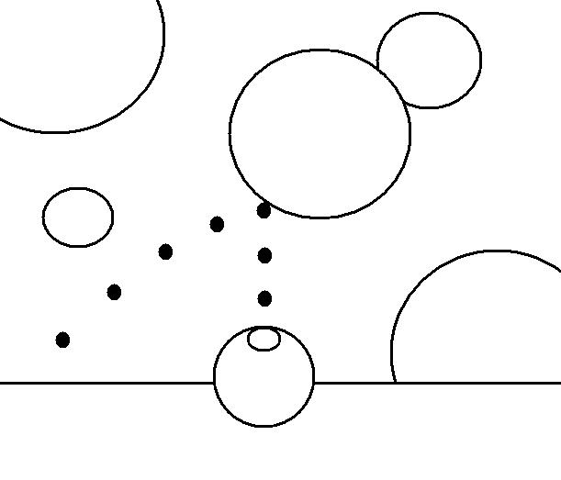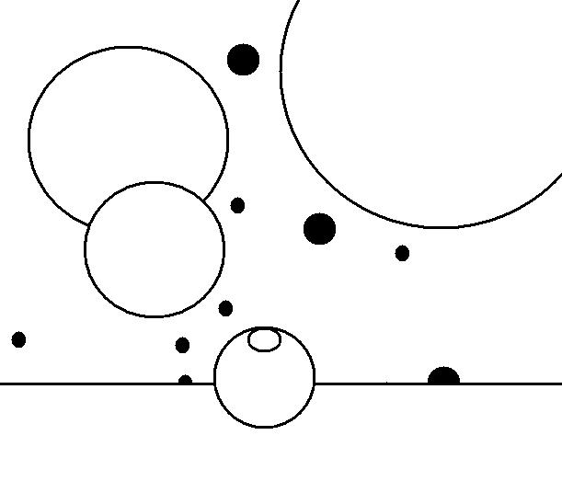

# Game Physics

* Gravity is very small but it is there
* Gravity affects the bullets and Meteoroids
* Bullets can bounce off several different meteoroids
* Neither Bullets and Meteoroids bounce off the ground but collides into it
* Weight of the bullets and meteoroids will affect the result of the collision

## Chart showing whether two bodies will collide

|  |  |  |  |  |
| --- | --- | --- | --- | --- |
|  | **Bullets** | **Meteoroids** | **Turret** | **Ground** |
| **Bullets** | No | Yes | No | Yes |
| **Meteoroids** | Yes | No | Yes | Yes |
| **Turret** | No | Yes | N/a | N/a |
| **Ground** | Yes | Yes | N/a | N/a |

# Laws of physics obeyed

* Newton’s first law of motion
* Newton’s second lawof motion
* Newton’s third lawof motion
* Law of conservation of momentum
* Law of conservation of energy (with lost energy)
* Law of reflection
* Law of gravity

# Dynamic Physics Engine

* The physics engine handles all the movements of and collision of bodies (items in the chart)
* Dynamic positioning system: calculates the vectors of bodies based on input forces.
* Rigid-body collision detection system: checks to see if any bodies have collided into each other
* Collision response system: response to a collision detected by the collision detection system
* Air frictions are involved in the game for the bullets and the meteoroids.
* Major improvements on the physics engine are made for easier game integration.