Q1:

mu_1 =

|  |  |  |  |  |  |  |  |
| --- | --- | --- | --- | --- | --- | --- | --- |
| 1.234627 | 2.96434325 | 3.6499987 | -0.350809 | -0.77542225 | 4.7804575 | -3.57907825 | -4.481993 |

mu_2=

|  |  |  |  |  |  |  |  |
| --- | --- | --- | --- | --- | --- | --- | --- |
| 3.054280667 | 4.552690167 | 4.460005667 | 0.293107 | 0.6546585 | 6.4405 | -2.728668667 | -3.134219667 |

(a)

S1_a=

|  |  |  |  |  |  |  |  |
| --- | --- | --- | --- | --- | --- | --- | --- |
| 1.24180587 | 0.428384671 | 0.230439201 | 0.046554948 | 1.166309642 | 0.447084144 | 0.73327746 | 0.744357991 |
| 0.428384671 | 2.45432528 | -0.800276366 | 0.719096462 | 0.459167736 | 0.538444307 | 1.488979503 | 0.341480853 |
| 0.230439201 | -0.800276366 | 8.591621027 | 0.688873494 | 1.23934568 | 0.292503235 | 0.785968622 | -0.988956256 |
| 0.046554948 | 0.719096462 | 0.688873494 | 3.457029644 | -0.37232104 | 0.310464107 | 1.61851528 | 0.991291534 |
| 1.166309642 | 0.459167736 | 1.23934568 | -0.37232104 | 3.038091178 | 0.938349729 | 0.778563776 | 0.444607178 |
| 0.447084144 | 0.538444307 | 0.292503235 | 0.310464107 | 0.938349729 | 1.311953547 | 0.432861551 | 1.625043048 |
| 0.73327746 | 1.488979503 | 0.785968622 | 1.61851528 | 0.778563776 | 0.432861551 | 4.361570964 | 2.779700326 |
| 0.744357991 | 0.341480853 | -0.988956256 | 0.991291534 | 0.444607178 | 1.625043048 | 2.779700326 | 8.619397036 |

S2_a=

|  |  |  |  |  |  |  |  |
| --- | --- | --- | --- | --- | --- | --- | --- |
| 2.084020663 | 0.977643502 | 1.467475993 | 0.619288623 | 1.135828698 | 1.288403437 | 2.017250544 | 1.900021498 |
| 0.977643502 | 2.697802052 | 1.636422366 | 1.030379096 | 1.102917366 | 1.345804768 | 1.81588018 | 0.559229349 |
| 1.467475993 | 1.636422366 | 11.44321337 | 1.884180804 | 3.177209222 | 2.040455308 | 3.327722479 | 2.707648657 |
| 0.619288623 | 1.030379096 | 1.884180804 | 5.386105069 | -0.071145304 | 0.521780559 | 2.201284992 | 1.479606569 |
| 1.135828698 | 1.102917366 | 3.177209222 | -0.071145304 | 2.826837401 | 1.469769323 | 1.580291759 | 2.345119322 |
| 1.288403437 | 1.345804768 | 2.040455308 | 0.521780559 | 1.469769323 | 2.4311235 | 0.60896994 | 2.447762515 |
| 2.017250544 | 1.81588018 | 3.327722479 | 2.201284992 | 1.580291759 | 0.60896994 | 5.918836307 | 3.285788106 |
| 1.900021498 | 0.559229349 | 2.707648657 | 1.479606569 | 2.345119322 | 2.447762515 | 3.285788106 | 10.88448346 |

error_rate_a=0.21

(b)

S1_b=

|  |  |  |  |  |  |  |  |
| --- | --- | --- | --- | --- | --- | --- | --- |
| 2.533888841 | 1.45205818 | 1.322652363 | 0.671460307 | 1.767212218 | 1.676251945 | 1.866206313 | 2.020108753 |
| 1.45205818 | 3.186235447 | 0.971877484 | 1.145287036 | 1.388836472 | 1.653365359 | 1.996212341 | 0.986766098 |
| 1.322652363 | 0.971877484 | 10.36332808 | 1.520712812 | 2.662533682 | 1.657232254 | 2.459803101 | 1.488716321 |
| 0.671460307 | 1.145287036 | 1.520712812 | 4.672276998 | 0.034165167 | 0.692398216 | 2.082223501 | 1.48268308 |
| 1.767212218 | 1.388836472 | 2.662533682 | 0.034165167 | 3.377293994 | 1.821089952 | 1.543322283 | 2.039999118 |
| 1.676251945 | 1.653365359 | 1.657232254 | 0.692398216 | 1.821089952 | 2.633740013 | 0.87567689 | 2.641326582 |
| 1.866206313 | 1.996212341 | 2.459803101 | 2.082223501 | 1.543322283 | 0.87567689 | 5.42090227 | 3.331087228 |
| 2.020108753 | 0.986766098 | 1.488716321 | 1.48268308 | 2.039999118 | 2.641326582 | 3.331087228 | 10.32259434 |

S2_b=

|  |  |  |  |  |  |  |  |
| --- | --- | --- | --- | --- | --- | --- | --- |
| 2.533888841 | 1.45205818 | 1.322652363 | 0.671460307 | 1.767212218 | 1.676251945 | 1.866206313 | 2.020108753 |
| 1.45205818 | 3.186235447 | 0.971877484 | 1.145287036 | 1.388836472 | 1.653365359 | 1.996212341 | 0.986766098 |
| 1.322652363 | 0.971877484 | 10.36332808 | 1.520712812 | 2.662533682 | 1.657232254 | 2.459803101 | 1.488716321 |
| 0.671460307 | 1.145287036 | 1.520712812 | 4.672276998 | 0.034165167 | 0.692398216 | 2.082223501 | 1.48268308 |
| 1.767212218 | 1.388836472 | 2.662533682 | 0.034165167 | 3.377293994 | 1.821089952 | 1.543322283 | 2.039999118 |
| 1.676251945 | 1.653365359 | 1.657232254 | 0.692398216 | 1.821089952 | 2.633740013 | 0.87567689 | 2.641326582 |
| 1.866206313 | 1.996212341 | 2.459803101 | 2.082223501 | 1.543322283 | 0.87567689 | 5.42090227 | 3.331087228 |
| 2.020108753 | 0.986766098 | 1.488716321 | 1.48268308 | 2.039999118 | 2.641326582 | 3.331087228 | 10.32259434 |

error_rate_b=0.21

(c)

S1_c=

|  |  |  |  |  |  |  |  |
| --- | --- | --- | --- | --- | --- | --- | --- |
| 4.134474318 | 0 | 0 | 0 | 0 | 0 | 0 | 0 |
| 0 | 4.134474318 | 0 | 0 | 0 | 0 | 0 | 0 |
| 0 | 0 | 4.134474318 | 0 | 0 | 0 | 0 | 0 |
| 0 | 0 | 0 | 4.134474318 | 0 | 0 | 0 | 0 |
| 0 | 0 | 0 | 0 | 4.134474318 | 0 | 0 | 0 |
| 0 | 0 | 0 | 0 | 0 | 4.134474318 | 0 | 0 |
| 0 | 0 | 0 | 0 | 0 | 0 | 4.134474318 | 0 |
| 0 | 0 | 0 | 0 | 0 | 0 | 0 | 4.134474318 |

S2_c=

|  |  |  |  |  |  |  |  |
| --- | --- | --- | --- | --- | --- | --- | --- |
| 5.459052727 | 0 | 0 | 0 | 0 | 0 | 0 | 0 |
| 0 | 5.459052727 | 0 | 0 | 0 | 0 | 0 | 0 |
| 0 | 0 | 5.459052727 | 0 | 0 | 0 | 0 | 0 |
| 0 | 0 | 0 | 5.459052727 | 0 | 0 | 0 | 0 |
| 0 | 0 | 0 | 0 | 5.459052727 | 0 | 0 | 0 |
| 0 | 0 | 0 | 0 | 0 | 5.459052727 | 0 | 0 |
| 0 | 0 | 0 | 0 | 0 | 0 | 5.459052727 | 0 |
| 0 | 0 | 0 | 0 | 0 | 0 | 0 | 5.459052727 |

error_rate_c=0.19

Q2:

(a)

disp(err_rate)

0.0471 0.0370 0.0404 0.0505

(b)

disp(err_rate_project)

0.4747 0.4646 0.4545 0.4478

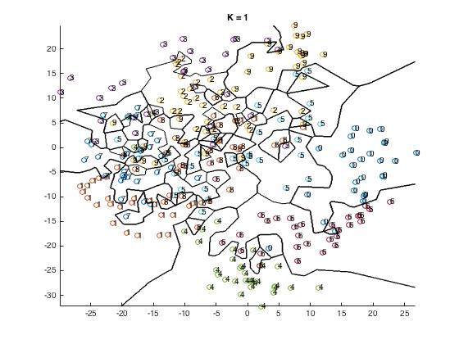

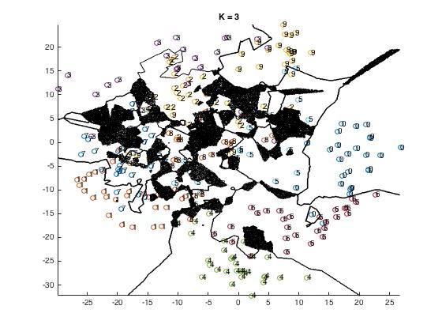

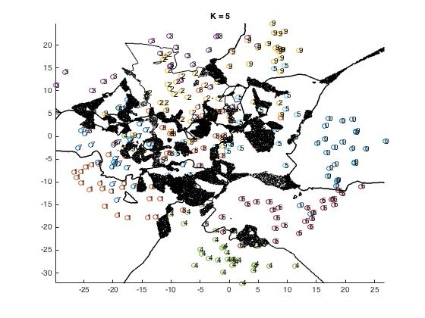

(c)

disp(project_err_rate)

0.8923 0.9125 0.8956 0.8889

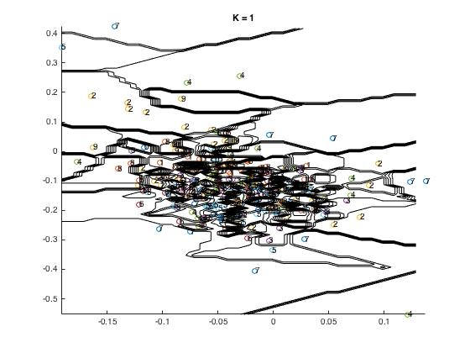

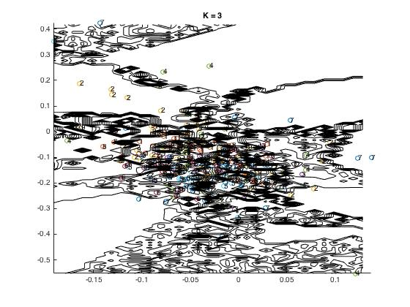

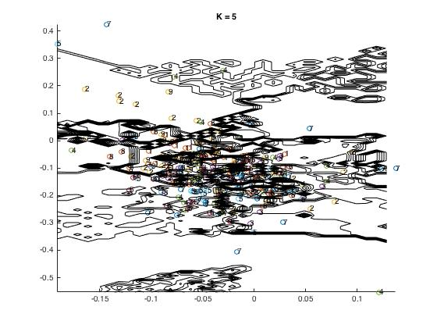

Q(3)

(1)

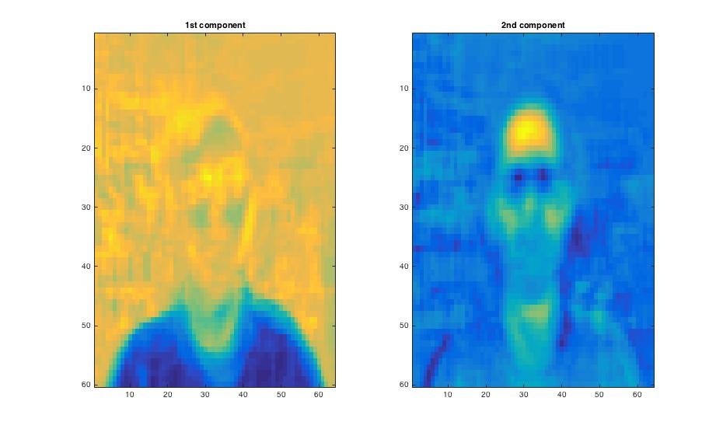

(2)

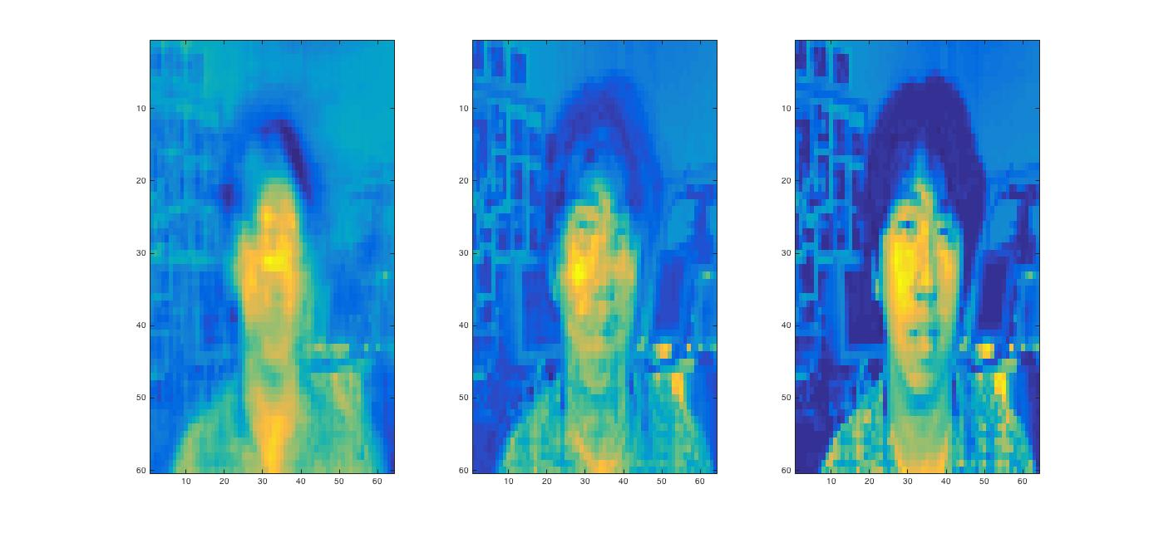

When you keep more dimensions in PCA, you lose less information and obtain more concrete graph.