VLSI設計自動化導論 作業

Program 1:
Given a graph as shown below. The number in parentheses on each edge is the weight of the edge. The graph is also described in a file with MCNC benchmark format. Please write a program to
(a) Apply DFS(depth first search) algorithm to print out the traverse order of vertices
(b) Apply single source shortest path(Dijkstra) algorithm to print out the distance from source to every vertex.

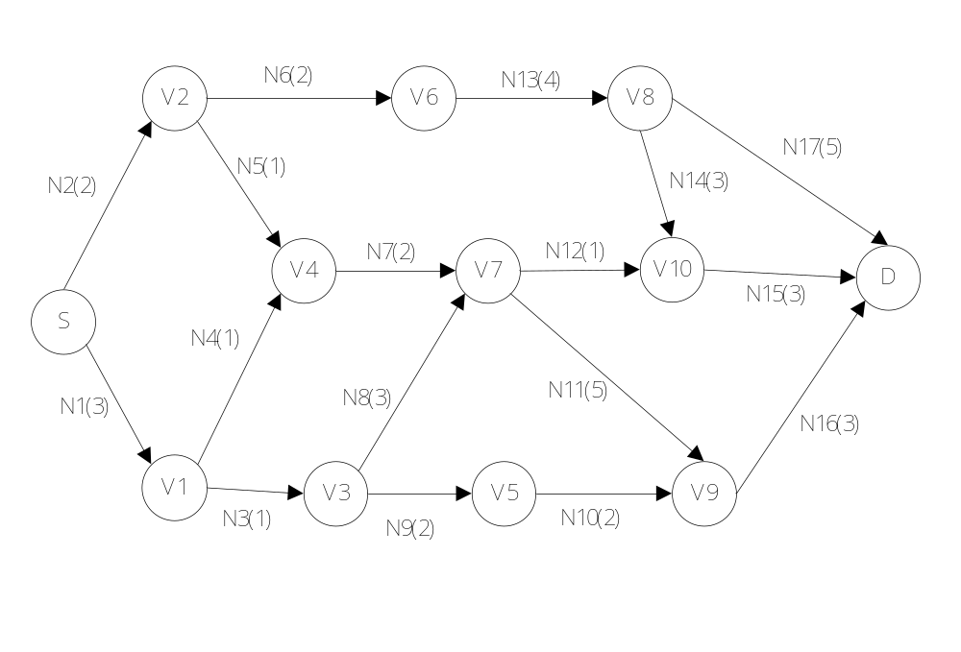

檔案格式說明：
CIRCUIT [Circuit Name] // 電路開始
INSTANCE [Instance Name] [Cell Type] // Cell Type為.lib裡定義之Standard Cell Type
[Net Name(Weight, Direction1)] [Net Name2(weight2, Direction2)] …//此Cell所連接的Net，括弧中的數字對，表示此net上的Weight 和 方向( i表示input，o 表示output)
…
…
ENDCIRCUIT // 電路結束

Case：
/* Generated by v2 */
CIRCUIT avqlarge
INSTANCE S PAD //Source
N1(3,o) N2(2,o)
INSTANCE V1 ai2s
N1(3,i) N3(1,o) N4(1,o)
INSTANCE V2 i1s
N2(2,i) N5(1,o) N6(2,o)
INSTANCE V3 ai2s
N3(1,i) N8(3,o) N9(2,o)
INSTANCE V4 ai2s
N4(1,i) N5(1,i) N7(2,o)
INSTANCE V5 dsr2s
N9(2,i) N10(2,o)
INSTANCE V6 ai2s
N6(2,i) N13(4,o)
INSTANCE V7 i1s
N7(2,i) N8(3,i) N11(5,o) N12(1,o)
INSTANCE V8 i1s
N13(4,i) N14(3,o) N17(5,o)
INSTANCE V9 i1s
N10(2,i) N11(5,i) N16(3,o)
INSTANCE V10 i1s
N12(1,i) N14(3,i) N15(3,o)
INSTANCE D PAD //Destination
N15(3,i) N16(3,i) N17(5,i)
ENDCIRCUIT

