目录

1 TX2刷机

2 git 基础操作
2.1 修改源
2.2 安装git
2.3 git 基础

3

1:tx2刷机
（1）下载jetpack
注册nvidia帐号
jetpack3.3下载网址
https://developer.nvidia.com/embedded/jetpack
安装教程
https://www.jianshu.com/p/bb4587014349

指令：
$ sudo chmod +x ./JetPack-L4T-3.3-linux-x64_b39.run
$ ./JetPack-L4T-3.3-linux-x64_b39.run

一路next
select dvelopment environment
选择 jetson tx2
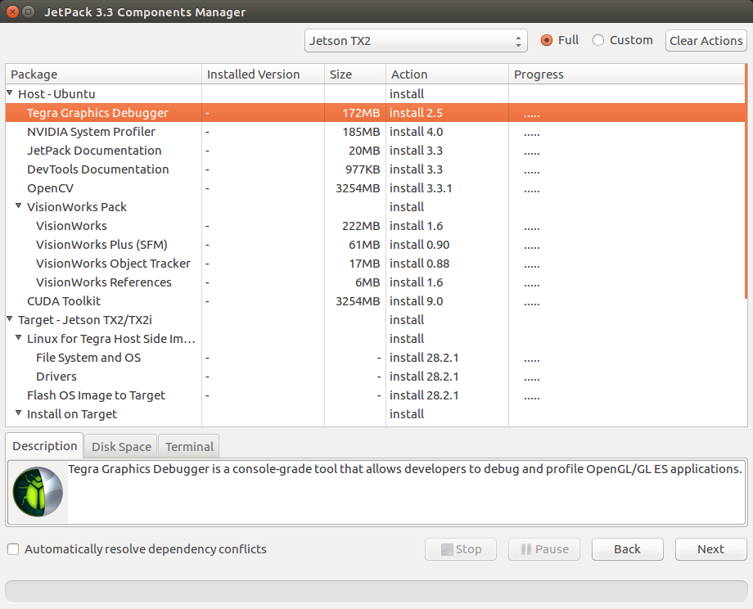
修改 : host-ubuntu action 选项 改为noinstall
修改完成之后
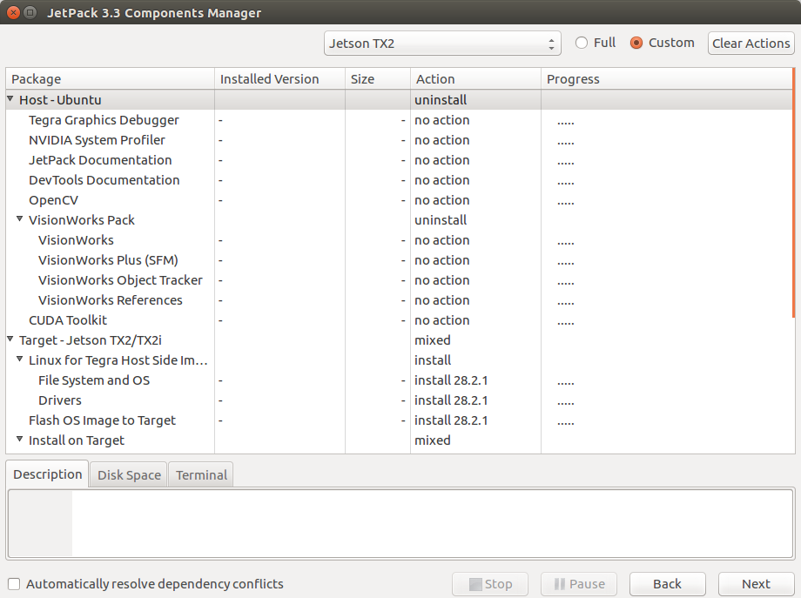
点击next

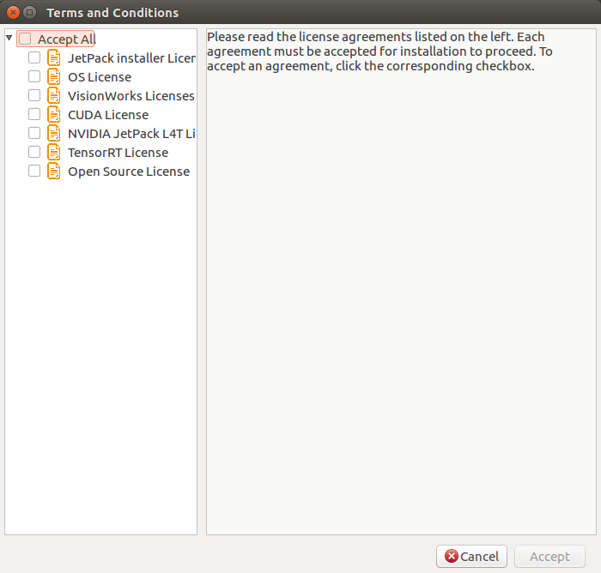
accept all

2.1 修改下载源：
$ cd /etc/apt
//备份source.list
$ sudo cp source .list source .list.bak
//cp 是linux命令 复制文件到 格式 cp 源文件名字地址 目标文件名字地址
$ sudo gedit source.list
//将下列覆盖原文件
# 默认注释了源码镜像以提高 apt update 速度，如有需要可自行取消注释
deb https://mirrors.tuna.tsinghua.edu.cn/ubuntu/ xenial main restricted universe multiverse
# deb-src https://mirrors.tuna.tsinghua.edu.cn/ubuntu/ xenial main restricted universe multiverse
deb https://mirrors.tuna.tsinghua.edu.cn/ubuntu/ xenial-updates main restricted universe multiverse
# deb-src https://mirrors.tuna.tsinghua.edu.cn/ubuntu/ xenial-updates main restricted universe multiverse
deb https://mirrors.tuna.tsinghua.edu.cn/ubuntu/ xenial-backports main restricted universe multiverse
# deb-src https://mirrors.tuna.tsinghua.edu.cn/ubuntu/ xenial-backports main restricted universe multiverse
deb https://mirrors.tuna.tsinghua.edu.cn/ubuntu/ xenial-security main restricted universe multiverse
# deb-src https://mirrors.tuna.tsinghua.edu.cn/ubuntu/ xenial-security main restricted universe multiverse

# 预发布软件源，不建议启用
# deb https://mirrors.tuna.tsinghua.edu.cn/ubuntu/ xenial-proposed main restricted universe multiverse
# deb-src https://mirrors.tuna.tsinghua.edu.cn/ubuntu/ xenial-proposed main restricted universe multiverse
覆盖前
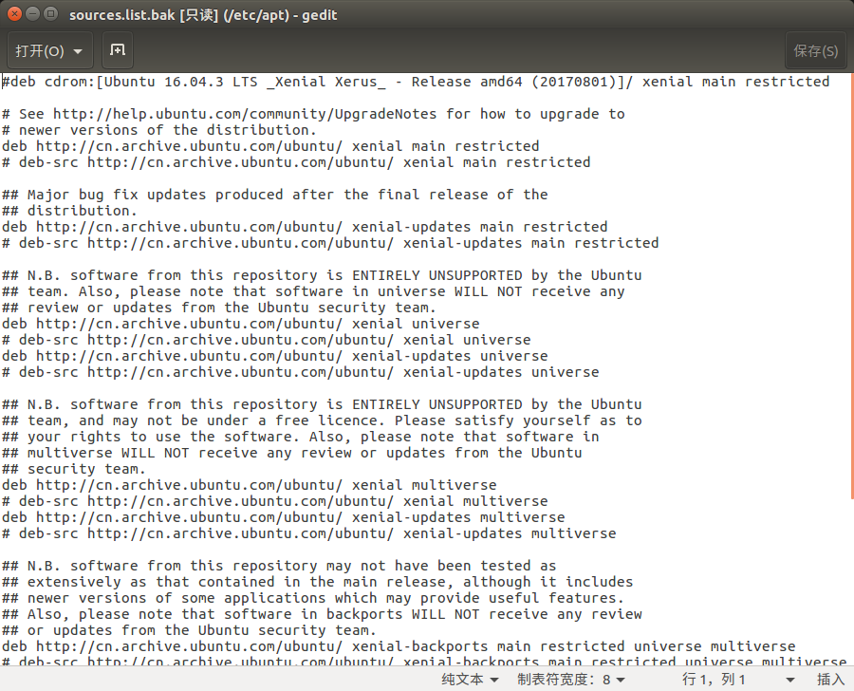
覆盖后
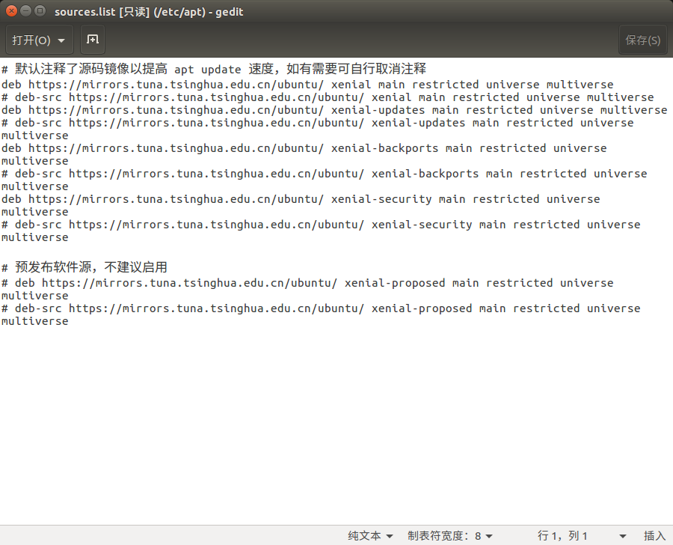

//使用下面命令更新源
$ sudo apt-get update

2.2 下载 git
$ sudo apt-get install git

2.3 git 基础
http://www.runoob.com/git/git-tutorial.html

