kubernetes搭建微服务集群

建立日期：2020年8月19日

|  |  |  |  |  |  |
| --- | --- | --- | --- | --- | --- |
| 版本 | 变更原因 | 变更内容简述 | 编制/修订者 | 适用环境 | 发布日期 |
| V1.0 | 建立 |  | 陈文华 | 开发、测试 |  |
|  |  |  |  |  |  |
|  |  |  |  |  |  |
|  |  |  |  |  |  |
|  |  |  |  |  |  |
|  |  |  |  |  |  |
|  |  |  |  |  |  |
|  |  |  |  |  |  |

## 构建外部服务

1. 用到的外部服务有

|  |  |  |
| --- | --- | --- |
| **服务名** | **IP地址** | **端口号** |
| Mysql | 192.168.84.47 | 3306 |
| Redis | 192.168.84.47 | 6379 |
| logstash | 192.168.84.49 | 4560 |

1. 构建外部服务的Service和Endpoints，在master服务器创建资源目录

mkdir /root/platform-kubernetes

cd /root/platform-kubernetes

3、创建资源配置文件

vim extends-service.yml

内容如下：

**apiVersion:** v1  
**kind:** Service  
**metadata:  
 name:** platform-mysql-service  
**spec:  
 ports:** - **protocol:** TCP  
 **port:** 3306  
 **targetPort:** 3306  
---  
**apiVersion:** v1  
**kind:** Endpoints  
**metadata:  
 name:** platform-mysql-service  
**subsets:** - **addresses:** - **ip:** 192.168.84.47  
 **ports:** - **port:** 3306  
---**apiVersion:** v1  
**kind:** Service  
**metadata:  
 name:** platform-redis-service  
**spec:  
 ports:** - **protocol:** TCP  
 **port:** 6379  
 **targetPort:** 6379  
---  
**apiVersion:** v1  
**kind:** Endpoints  
**metadata:  
 name:** platform-redis-service  
**subsets:** - **addresses:** - **ip:** 192.168.84.47  
 **ports:** - **port:** 6379  
---**apiVersion:** v1  
**kind:** Service  
**metadata:  
 name:** logstash-service  
**spec:  
 ports:** - **protocol:** TCP  
 **port:** 4560  
 **targetPort:** 4560  
---  
**apiVersion:** v1  
**kind:** Endpoints  
**metadata:  
 name:** logstash-service  
**subsets:** - **addresses:** - **ip:** 192.168.84.49  
 **ports:** - **port:** 4560

4、创建资源

kubectl apply -f extends-service.yml

查看挂载的Endpoints

kubectl describe service/platform-mysql-service

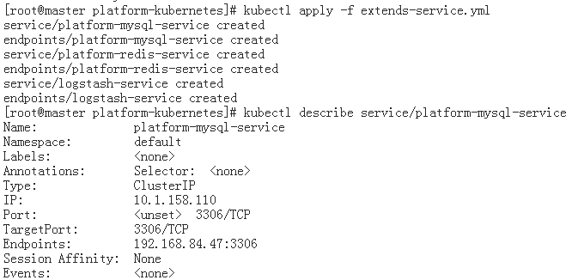

## 创建资源配置

1. 在platform-kubernetes目录下创建ConfigMap

vim platform-configmap.yml

内容如下：

**apiVersion:** v1  
**kind:** ConfigMap  
**metadata:  
 name:** platform-cm  
**data:  
 nacos.url: "nacos-service"****logstash.url: "logstash-service"****platform.mysql.url: "platform-mysql-service"****platform.redis.url: "platform-redis-service"****platform.gateway.url: "platform-gateway-service"****platform.admin.url: "platform-admin-service"**

1. 创建ConfigMap资源

kubectl apply -f platform-configmap.yml



3、到nfs服务器创建log目录，用来挂载日志

mkdir /nfs/log

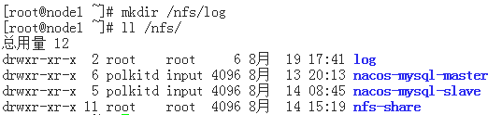

## 搭建auth服务集群

1. 在platform-kubernetes目录下创建auth模块资源配置文件

vim platform-auth-cluster.yml

内容如下：

**apiVersion:** v1  
**kind:** Service  
**metadata:  
 name:** platform-auth-service  
**spec:  
 ports:** - **port:** 8101  
 **targetPort:** 8101  
 **selector:  
 app:** platform-auth  
---  
**apiVersion:** apps/v1  
**kind:** Deployment  
**metadata:  
 name:** platform-auth-deployment  
**spec:  
 selector:  
 matchLabels:  
 app:** platform-auth  
 **replicas:** 3  
 **template:  
 metadata:  
 labels:  
 app:** platform-auth  
 **spec:  
 containers:** - **name:** platform-auth  
 **image:** docker.oumasoft.com/platform/platform-auth:2.0-RELEASE  
 **imagePullPolicy:** Always  
 **ports:** - **containerPort:** 8101  
 *#args:  
 #- "--spring.profiles.active=prod"* **env:**- **name:** mysql.url  
 **valueFrom:  
 configMapKeyRef:  
 name:** platform-cm  
 **key:** platform.mysql.url  
 - **name:** redis.url  
 **valueFrom:  
 configMapKeyRef:  
 name:** platform-cm  
 **key:** platform.redis.url  
 - **name:** nacos.url  
 **valueFrom:  
 configMapKeyRef:  
 name:** platform-cm  
 **key:** nacos.url  
 - **name:** logstash.url  
 **valueFrom:  
 configMapKeyRef:  
 name:** platform-cm  
 **key:** logstash.url  
 - **name:** platform-admin  
 **valueFrom:  
 configMapKeyRef:  
 name:** platform-cm  
 **key:** platform.admin.url  
 - **name:** TZ  
 **value: "Asia/Shanghai"  
 volumeMounts:** - **mountPath:** /log  
 **name:** platform-auth-data  
 **resources:  
 requests:  
 cpu:** 500m  
 **memory:** 500Mi  
 **limits:  
 cpu:** 1  
 **memory:** 1Gi  
 **volumes:**- **name:** platform-auth-data  
 **nfs:  
 path:** /nfs/log  
 **server:** 192.168.84.48

1. 创建资源

kubectl apply -f platform-auth-cluster.yml

1. 查看pod

kubectl get pods | grep platform-auth

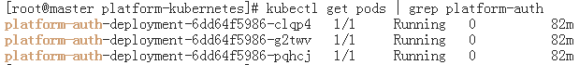

1. 查看某个pod日志

kubectl logs pod/platform-auth-deployment-6dd64f5986-fcsqp

1. 查看nacos控制台服务列表

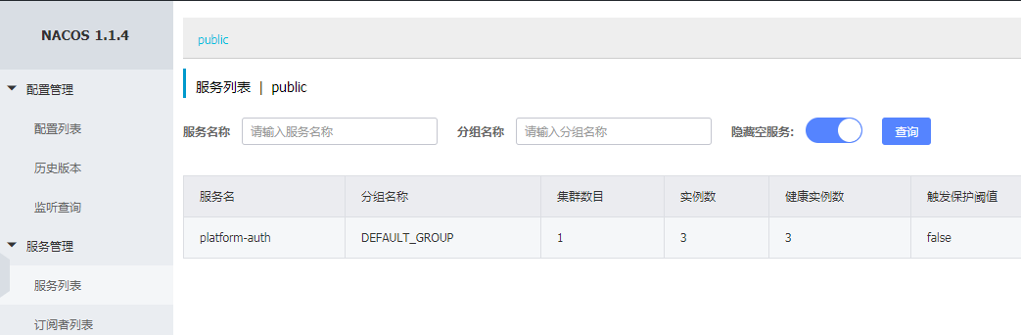

## 搭建gateway服务集群

1、在platform-kubernetes目录下创建gateway模块资源配置文件

vim platform-gateway-cluster.yml

内容如下：

**apiVersion:** v1  
**kind:** Service  
**metadata:  
 name:** platform-gateway-service  
**spec:  
 ports:** - **port:** 8301  
 **targetPort:** 8301  
 **selector:  
 app:** platform-gateway  
---  
**apiVersion:** apps/v1  
**kind:** Deployment  
**metadata:  
 name:** platform-gateway-deployment  
**spec:  
 selector:  
 matchLabels:  
 app:** platform-gateway  
 **replicas:** 3  
 **template:  
 metadata:  
 labels:  
 app:** platform-gateway  
 **spec:  
 containers:** - **name:** platform-gateway  
 **image:** docker.oumasoft.com/platform/platform-gateway:2.0-RELEASE  
 **imagePullPolicy:** Always  
 **ports:** - **containerPort:** 8301  
 **env:** - **name:** redis.url  
 **valueFrom:  
 configMapKeyRef:  
 name:** platform-cm  
 **key:** platform.redis.url  
 - **name:** nacos.url  
 **valueFrom:  
 configMapKeyRef:  
 name:** platform-cm  
 **key:** nacos.url  
 - **name:** logstash.url  
 **valueFrom:  
 configMapKeyRef:  
 name:** platform-cm  
 **key:** logstash.url  
 - **name:** platform-admin  
 **valueFrom:  
 configMapKeyRef:  
 name:** platform-cm  
 **key:** platform.admin.url  
 - **name:** TZ  
 **value: "Asia/Shanghai"  
 resources:  
 requests:  
 cpu:** 500m  
 **memory:** 500Mi  
 **limits:  
 cpu:** 1  
 **memory:** 1Gi  
 **volumeMounts:** - **mountPath:** /log  
 **name:** platform-gateway-data  
 **volumes:** - **name:** platform-gateway-data  
 **nfs:  
 path:** /nfs/log  
 **server:** 192.168.84.48

2、创建资源

kubectl apply -f platform-gateway-cluster.yml

3、查看pod和日志

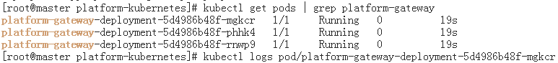

## 搭建system服务集群

1. 在platform-kubernetes目录下创建system模块资源配置文件

vim platform-server-system-cluster.yml

内容如下：

**apiVersion:** apps/v1  
**kind:** Deployment  
**metadata:  
 name:** platform-server-system-deployment  
**spec:  
 selector:  
 matchLabels:  
 app:** platform-server-system  
 **replicas:** 3  
 **template:  
 metadata:  
 labels:  
 app:** platform-server-system  
 **spec:  
 containers:** - **name:** platform-server-system  
 **image:** docker.oumasoft.com/platform/platform-server-system:2.0-RELEASE  
 **imagePullPolicy:** Always  
 **ports:** - **containerPort:** 8201  
 *#args:  
 #- "--spring.profiles.active=prod"* **env:** - **name:** mysql.url  
 **valueFrom:  
 configMapKeyRef:  
 name:** platform-cm  
 **key:** platform.mysql.url  
 - **name:** nacos.url  
 **valueFrom:  
 configMapKeyRef:  
 name:** platform-cm  
 **key:** nacos.url  
 - **name:** logstash.url  
 **valueFrom:  
 configMapKeyRef:  
 name:** platform-cm  
 **key:** logstash.url  
 - **name:** platform-gateway  
 **valueFrom:  
 configMapKeyRef:  
 name:** platform-cm  
 **key:** platform.gateway.url  
 - **name:** platform-admin  
 **valueFrom:  
 configMapKeyRef:  
 name:** platform-cm  
 **key:** platform.admin.url  
 - **name:** TZ  
 **value: "Asia/Shanghai"  
 volumeMounts:** - **mountPath:** /log  
 **name:** platform-server-system-data  
 **resources:  
 requests:  
 cpu:** 500m  
 **memory:** 500Mi  
 **limits:  
 cpu:** 1  
 **memory:** 1Gi  
 **volumes:** - **name:** platform-server-system-data  
 **nfs:  
 path:** /nfs/log  
 **server:** 192.168.84.48

2、创建资源

kubectl apply -f platform-server-system-cluster.yml

## 搭建foundation服务集群

1. 在platform-kubernetes目录下创建foundation模块资源配置文件

vim platform-server-foundation-cluster.yml

内容如下：

**apiVersion:** apps/v1  
**kind:** Deployment  
**metadata:  
 name:** platform-server-foundation-deployment  
**spec:  
 selector:  
 matchLabels:  
 app:** platform-server-foundation  
 **replicas:** 2  
 **template:  
 metadata:  
 labels:  
 app:** platform-server-foundation  
 **spec:  
 containers:** - **name:** platform-server-foundation  
 **image:** docker.oumasoft.com/platform/platform-server-foundation:2.0-RELEASE  
 **imagePullPolicy:** Always  
 **ports:** - **containerPort:** 8202  
 **env:** - **name:** mysql.url  
 **valueFrom:  
 configMapKeyRef:  
 name:** platform-cm  
 **key:** platform.mysql.url  
 - **name:** nacos.url  
 **valueFrom:  
 configMapKeyRef:  
 name:** platform-cm  
 **key:** nacos.url  
 - **name:** logstash.url  
 **valueFrom:  
 configMapKeyRef:  
 name:** platform-cm  
 **key:** logstash.url  
 - **name:** platform-gateway  
 **valueFrom:  
 configMapKeyRef:  
 name:** platform-cm  
 **key:** platform.gateway.url  
 - **name:** platform-admin  
 **valueFrom:  
 configMapKeyRef:  
 name:** platform-cm  
 **key:** platform.admin.url  
 - **name:** TZ  
 **value: "Asia/Shanghai"  
 volumeMounts:** - **mountPath:** /log  
 **name:** platform-server-foundation-data  
 **resources:  
 requests:  
 cpu:** 300m  
 **memory:** 300Mi  
 **limits:  
 cpu:** 1  
 **memory:** 500Mi  
 **volumes:** - **name:** platform-server-foundation-data  
 **nfs:  
 path:** /nfs/log  
 **server:** 192.168.84.48

2、创建资源

kubectl apply -f platform-server-foundation-cluster.yml

3、最后查看所有服务列表

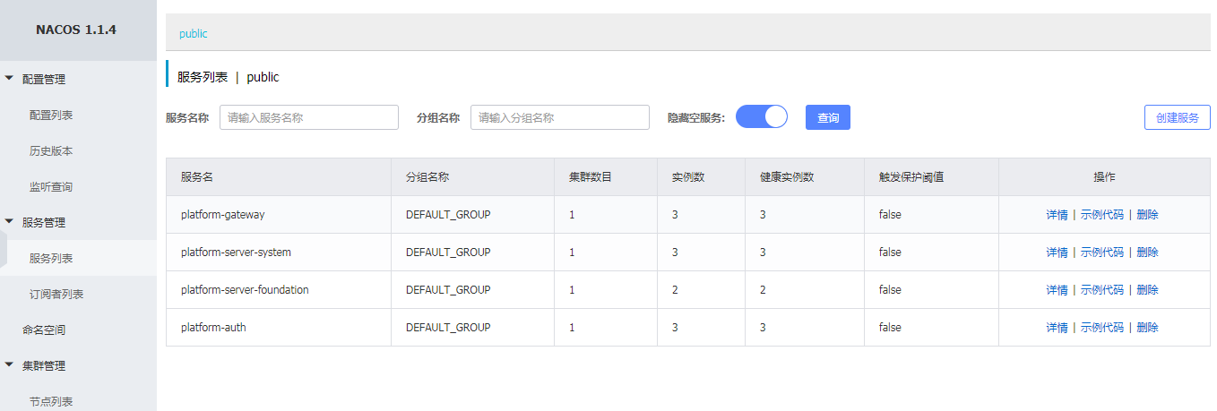

4、发送一次测试请求



没有携带令牌，返回401，说明服务已经运行。