**荧光定量PCR检测报告**

**1. Info（实验信息）**

**注：对应HTML数据文件的左边第一项Info**

|  |  |
| --- | --- |
| Experiment Filename: | 测试数据-1.lc96p |
| Run Started Date: | 17-Apr-2012 15:20:24 |
| Run End Date: | 17-Apr-2012 16:42:12 |
| Instrument Type: | LightCycler96 |
| Instrument Serial Number: | 000000000000510 |

**注：以上数据是Info里的子项目，选取其中5项**

**2. Run Profile（程序设置）**

**注：对应HTML数据文件的左边第二项Run Profile**

**Programs**

Preincubation, 1 Cycles

|  |  |  |
| --- | --- | --- |
| Description | Aquisition | Ramp Rate |
| 95°C for 600 s | None | 4.4 |

3 Step Amplification, 45 Cycles

|  |  |  |
| --- | --- | --- |
| Description | Aquisition | Ramp Rate |
| 95°C for 10 s | None | 4.4 |
| 60°C for 15 s | None | 2.2 |
| 72°C for 15 s | Single | 2.2 |

Melting, 1 Cycles

|  |  |  |
| --- | --- | --- |
| Description | Aquisition | Ramp Rate |
| 95°C for 60 s | None | 4.4 |
| 65°C for 60 s | None | 2.2 |
| 95°C for 1 s | Continuous (5 Acq/°C) | 0.2 |

Cooling, 1 Cycles

|  |  |  |
| --- | --- | --- |
| Description | Aquisition | Ramp Rate |
| 37°C for 30 s | None | 2.2 |

**注：以上数据是Run Profile里的子项目，选取Programs项所有信息**

**3. Analysis（实验分析）**

**注：对应HTML数据文件的左边第五项Analysis**

**Abs Quant**

**注：对应Analysis中的Abs Quant分析项目**

Ampification Curves

**注： Abs Quant分析项目中的Ampification Curves**

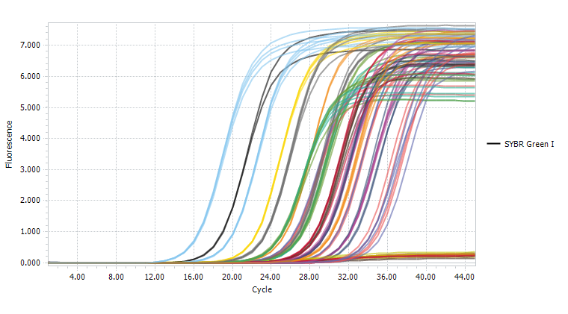

Result Table

**注： 对应Abs Quant分析项目中的 Result Table，选择All Data中的其中几列的所有数据。**

|  |  |  |  |  |  |  |
| --- | --- | --- | --- | --- | --- | --- |
| **Position** | **Sample Name** | **Gene Name** | **Cq** | **Concentration** | **Call** | **Dye** |
| A4 | Positive | Target | 26.50 | 100000 | Positive | Fam |
|  |  |  |  |  |  |  |

…