Local Queue

Condor Master

DAGMan

Pegasus

NFS

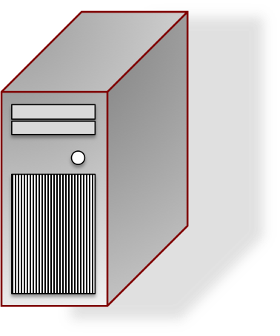

Worker Nodes

Data Server

Head Node

NFS



Worker Nodes

Data Server

Head Node