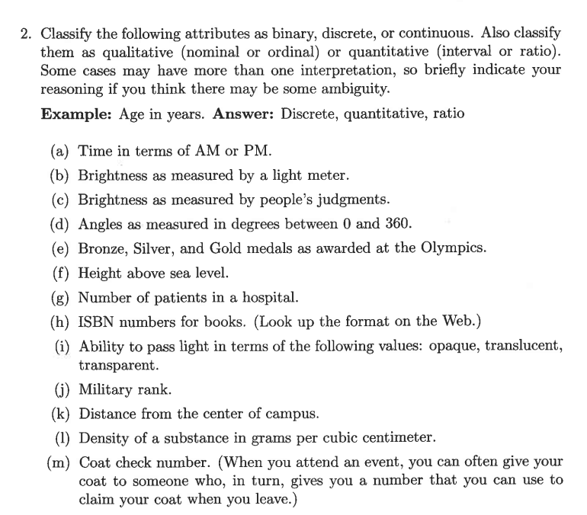

Discrete A discrete attribute has a finite or countably infinite set of values.  
Such attributes can be categorical, such as zip codes or ID numbers, or numeric, such as counts. Discrete attributes are often represented using integer variables.

Binary attributes are a special case of discrete attributes and assume only two values, e.g., true/false, yes/no, male/female, or 0f 1. Binary attributes are often represented as Boolean  
variables, or as integer variables that only take the values 0 or 1.

Continuous A continuous attribute is one whose values are real numbers. Examples include attributes such as temperature, height, or weight. Continuous attributes are typically represented as floating-point variables. Practically, real values can only be measured and represented with limited precision

Quantitative attributes, such as price, are typically aggregated by taking a sum or an average.

A qualitative attribute, such as item, can either be omitted or summarized as the set of all the items that were sold at that location.

