MySQL主从同步

1. 下载mysql数据库

wget [https://dev.mysql.com/get/Downloads/MySQL-5.7/mysql-5.7.21-linux-glibc2.12-x86\_64.tar.gz](https://dev.mysql.com/get/Downloads/MySQL-5.7/mysql-5.7.21-linux-glibc2.12-x86_64.tar.gz" \t "_blank)

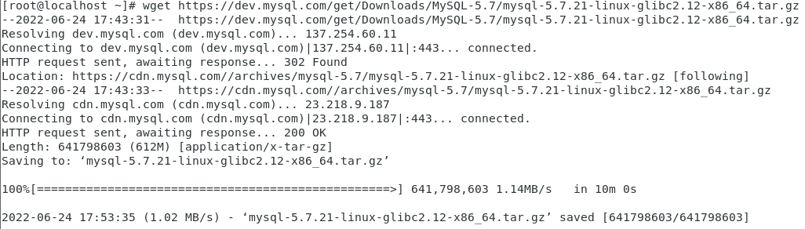



2.创建mysql用户组和mysql用户 useradd mysql



3.解压安装包，并将解压好的文件夹重命名为mysql

tar -zxvf mysql-5.7.21-linux-glibc2.12-x86\_64.tar.gz

mv mysql-5.7.21-linux-glibc2.12-x86\_64 mysql

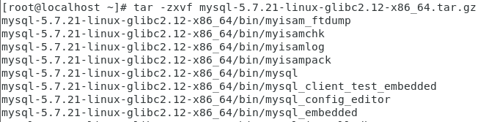



4.移动到/usr/local目录下 mv mysql /usr/local





5.创建/etc/my.cnf配置文件 vim /etc/my.cnf

主库配置文件：

[client]

port=3306

socket=/tmp/mysql.sock

[mysqld]

user=mysql

basedir=/usr/local/mysql

datadir = /usr/local/mysql/data

performance\_schema = off

innodb\_buffer\_pool\_size = 32M

bind\_address = 0.0.0.0

log-bin=mysql-bin-master

server-id=1

binlog-do-db=HA

binlog-ignore-db=mysql

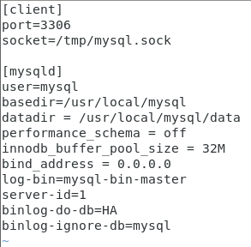

从库配置文件：

[client]

port=3306

socket=/tmp/mysql.sock

[mysqld]

user=mysql

basedir=/usr/local/mysql

datadir = /usr/local/mysql/data

server-id=2

performance\_schema = off

innodb\_buffer\_pool\_size = 32M

bind\_address = 0.0.0.0

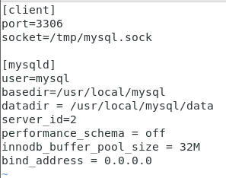

6.初始化mysql，记住数据库初始密码，初始密码在root@localhost:后



1. 运行数据库

cp /usr/local/mysql/support-files/mysql.server /etc/init.d/mysql

8.将mysql启动文件写入到环境变量中,在最底下加上2行配置 vim /etc/profile

**PATH=$PATH:/usr/local/mysql/bin**

**export PATH**





9.刷新环境变量，使最新的环境变量运行 source /etc/profile



10.查看数据库状态 /etc/init.d/mysql start



11.启动数据库 mysql -uroot -p

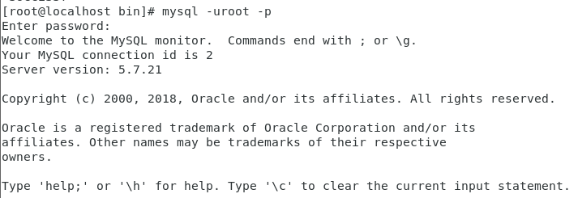

12.修改数据库密码 set password for root@'localhost'=password('123456');



13.刷新 flush privileges;



1. 主库授权，并刷新 grant replication slave on \*.\* to 'test'@'192.168.178.0' identified by '123456'; flush privileges;

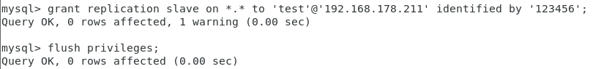

15.查看状态 show master status;

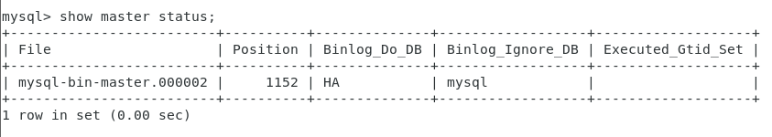

1. 从库授权，并刷新

change master to master\_host='127.0.0.1',master\_user='test',master\_password='123456';

start slave;

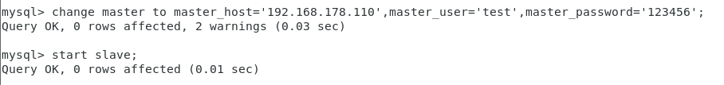

16.查看状态Slave\_IO\_Running: 和Slave\_SQL\_Running:两个状态都是yes时，代表主从库配置成功了 show slave status \G;

