Couette Flow Project

Sybil Chen

3/25/2020

**Introduction**

In general, Couette flow is a flow of a fluid in the space between two spaces, the lower one is stationary, and the upper space is moving in a constant velocity U, as shown in the Figure 1. For this project, firstly create and solve Couette flow models for Newtonian fluids such as water, Mercury and Glycerin. Then by building the model for a thixotropic fluid with a specific shear stress, to conclude few flow characteristics. In the end, analyze a laminar flow of a moving down an incline with specific shear stress in the different situation.

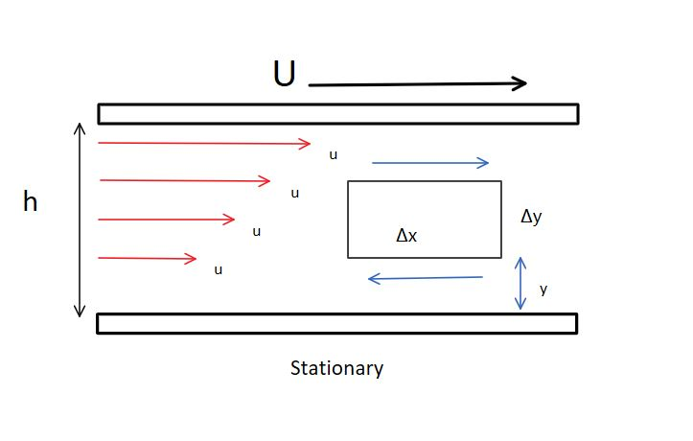

Figure 1

**Couette flow models for Newtonian fluids**

* Water (at temperature of 20℃)

Using CouetteNewtonianFluid function written in MATLAB with h =0.05m, U =0.3m/s, and μ =0.001kg/m·s. Getting the graph as shown in Figure 2.

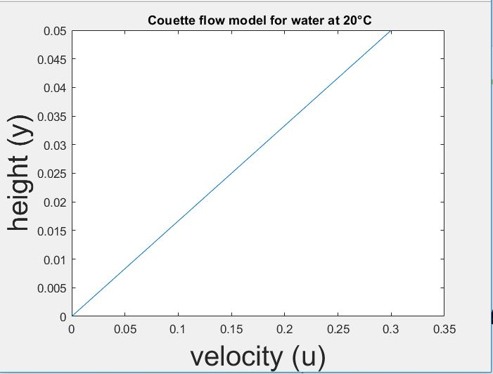

Figure 2

* Glycerin (at temperature of 20℃)

Using CouetteNewtonianFluid function written in MATLAB with h =0.05m, U =0.3m/s, and μ =1.49kg/m·s. Getting the graph as shown in Figure 3.

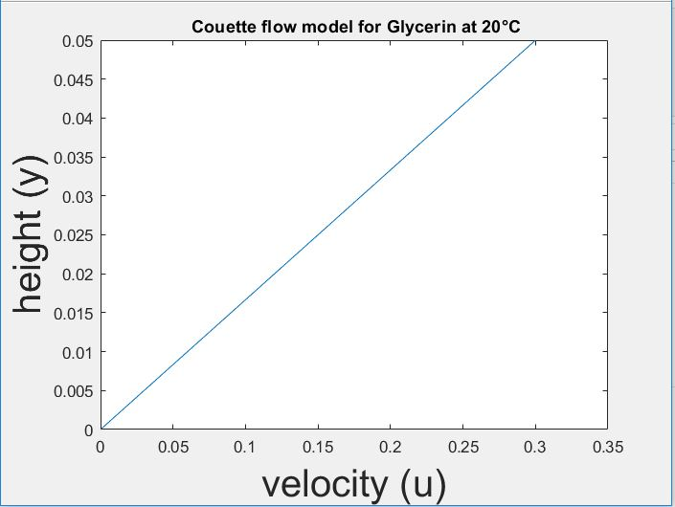

Figure 3

* Mercury

Using CouetteNewtonianFluid function written in MATLAB with h =0.05m, U =0.3m/s, and μ =1.49kg/m·s. Getting the graph as shown in Figure 4.

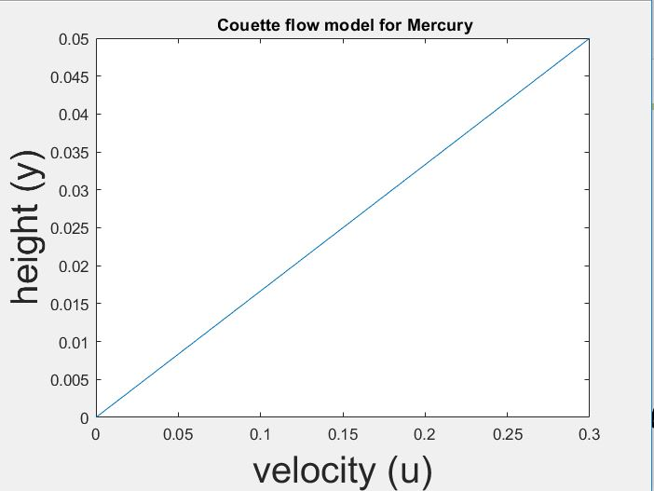

Figure 4

**Conclusion:**

Those three models shown above demonstrate that in the Couette Flow condition, for Newtonian fluids, the relationship between their velocity u and height y is linear.

**Model for a Couette ﬂow of a thixotropic ﬂuid**

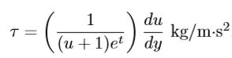Shear stress:

By using Maple function graphU1 with:

U = [ 0 0.5000 1.0000 1.5000 2.0000]

h = 0.1m

timeStp = [10^(-2)*[0:20:180], 2]

get the graph of $u_{t}$ (y) as t varies as shown in Figure 5:

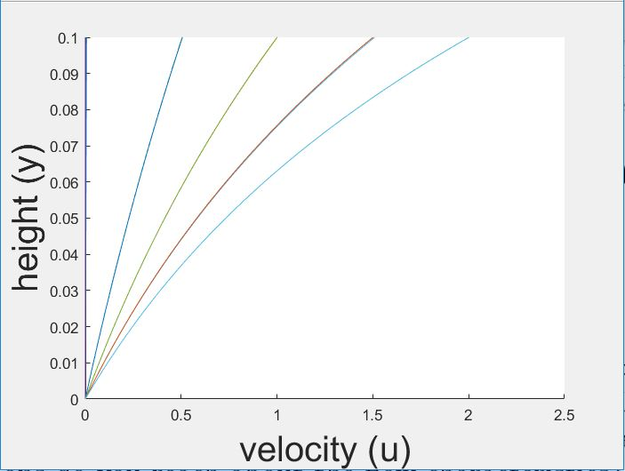

Figure 5

get the graph of τ/(du/dy) as t varies as shown in Figure 6

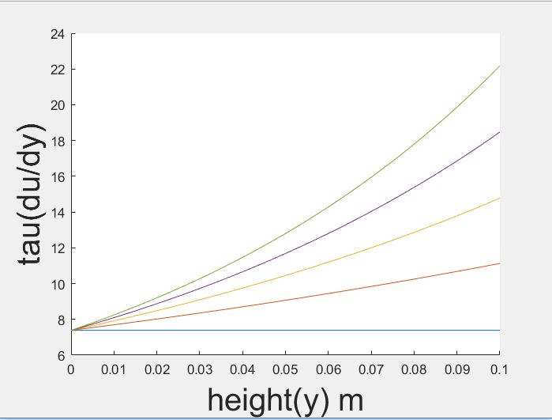

Figure 6

**Conclusion**:

According to the calculation and models above, it shows that the ratio of velocity and height is close to linear as the time increasing. The second graph illustrate that as t increases, the variation in τ/(du/dy) decreases. It shows the Newtonian fluid characteristics as time goes by even though it’s a non-Newtonian fluid.

**A laminar ﬂow of a ﬂuid moving down an incline**

Shear stress: $τ=γ\left(h-y\right)*\sin\left(θ\right) \frac{kg}{m*s^{2}}$

By combining $τ=μ\frac{ⅆu}{ⅆy} finally get u(y)=\frac{γ\left(h-y\right)\sin\left(θ\right)}{μ}$

Calculate u for SAE 30 weight oil:

By using Maple function graphU1 with:

γ = 8630kg/m2·s2 and that μ =0 .5kg/m·s, h =0 .05m. $θ=0 to\frac{π}{6}$

get the graph of u(y) as shown in Figure 7

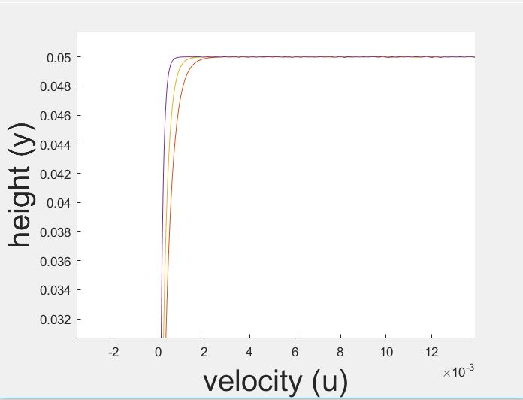

Figure 7

Calculate u for the thixotropic ﬂuid:

By using Maple function graphU2 with:

h = 0.05 m and that γ = 9220kg/m2·s2 $θ$ varies over the interval $5°$ ≤ $θ$ ≤ $10°$ and Time= (0,0.1].

Graph as shown in figure8

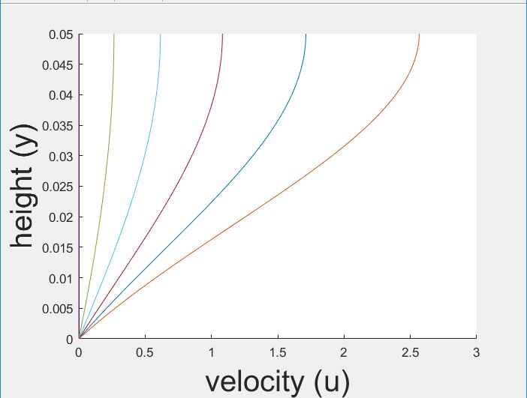

Figure 8

Figure 8 shows that as time increasing, the slope of height versus velocity is smaller. The velocity is continually increasing, as same as Newtonian ﬂuid in last part.

Calculate u for the rheopectic ﬂuid:

By using Maple function graphU2 with:

γ = 7850kg/m2·s2, h=0.05m, t=[10:0.2:11], $5°$ ≤ $θ$ ≤ $6°$

Graph as shown in figure9

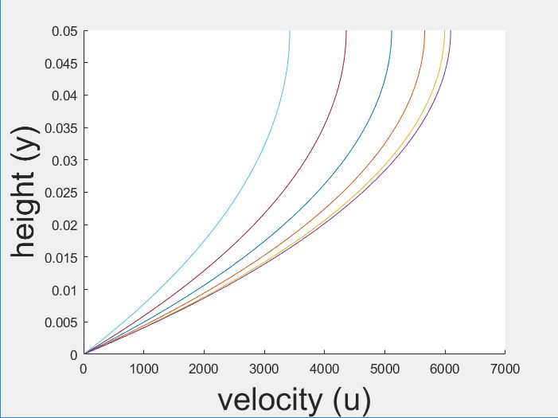

Figure 9

**Conclusion:**

For this project, firstly, the examples of water, glycerin and mercury were applied into Couette fluid model to calculate the relationship between velocity and height and analysis the characteristics for Newtonian fluids which is the ratio between velocity and height is linear. Second, by applying Couette fluid with some non-Newtonian Method, the characteristic is discovered which is the u(y) of non-Newtonian fluid can show the linear relationship as time goes by. Last but not the least, Couette fluid model can also be used to analyze a kind of fluid which is going down an incline. The characteristics still remain the same whether it’s Newtonian fluids or non-Newtonian fluids.

Work Cited

Holder, Allen, and Joseph Eichholz. *An Introduction to Computational Science*. Springer, 2019.