**Aeronautic Lift Project**

Sybil Chen

4/15/2020

**Introduction**

Airflow is the movement of air, which is caused by the existence of air. Air flowing around the surface of a wing exerts force on it. It’s important to analysis such airflows and apply into aeronautic field. In this project, we will present a computational model that can approximate a wing’s doublet strength, circulation and lift based on the 2D profile of the wing and a free stream vector. An overview of 2D profile for a wing is illustrated in Figure 1.1. From those estimate values, we further design a collection of numerical experiment to demonstrate how the wake’s length, angle and position of collection point impact the estimation of lift. We also discuss the relationship between the wing geometry and lift, specifically on how the collection points locate to make the final lift estimates as large as possible. Furthermore, we will illustrate our design for a human-powered craft.

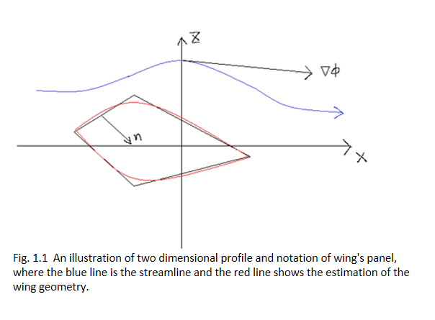

**Computational Model**

In this model, we will separate a wing into numbers of flat panels and do the calculation using MATLAB. By assembling the estimation of lift from each individual panel, we can get the calculation results for the entire wing reasonably. In this project, the free stream velocity is 76 m/s and the density of air is 1.225 kg/m^3. We will show the calculation process below.

According to the panel methods, this time we separate a wing into different individual panel. Figure 2.1 shows the wing’s profile. The mid points in the figure 2.1 defines a collection of panels. In this case, we have seven panels and one wake.

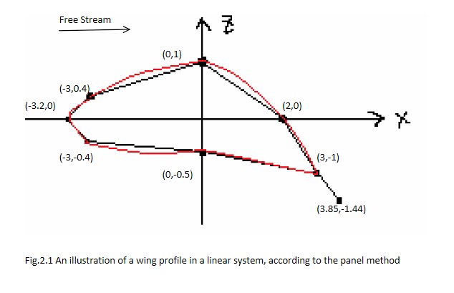

In order to estimate the value of lift, firstly we need to calculate the doublet strength μ. A doublet is a combination of source and sink, it’s strength can be scaled by $μ_{i}$ points in the outward direction of i panel. To compute the doublet strength, we need to find influence coefficient. Applying the equation 1.1 to build a coefficient matrix A:

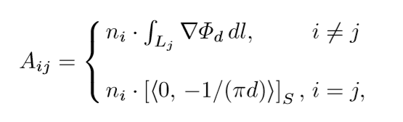

(1.1)

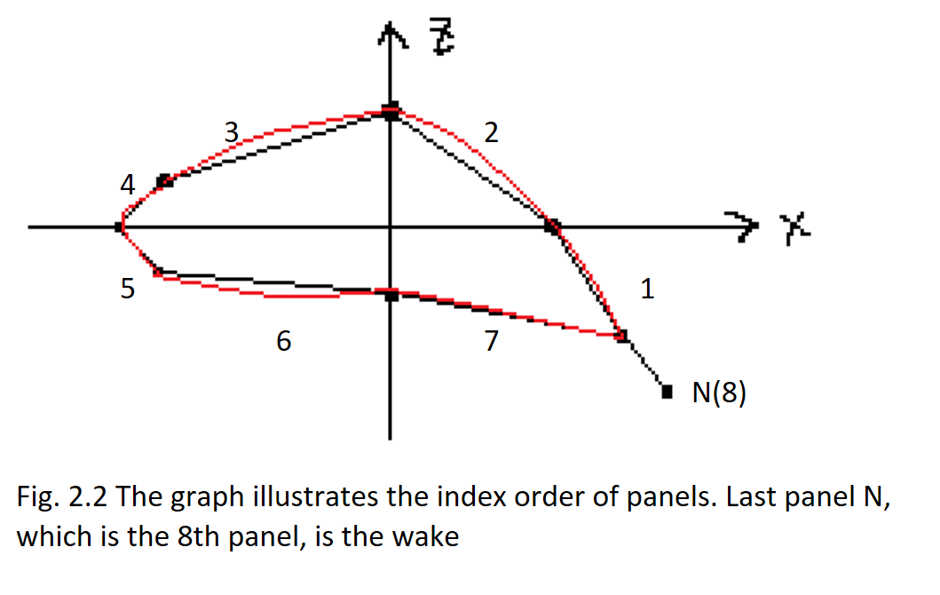Where i represents N-1 panels in sequence, j represents N points for collection, n is the normal to the ith panel. The order of panels is shown in Figure 2.2

We have seven panels and one wake, so we get A with size of 7×8 in this case. To solve the integral when i $≠$ j we need to transform the coordinate of ith panel. Angle $θ$ can be find by $\cos^{-1}\left(n_{i}⋅\left\langle 0,-1\right\rangle \right)$. For each panel, we multiply R(θ), see equation 1.2 below,

$R\left(θ\right)=\left[\begin{matrix}\cos\left(θ\right) & -\sin\left(θ\right) \\ \sin\left(θ\right) & \cos\left(θ\right)\end{matrix}\right]$ (2.2)

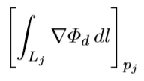We also need to find to solve the integral value, by using MATLAB to apply the

equation 2.3:

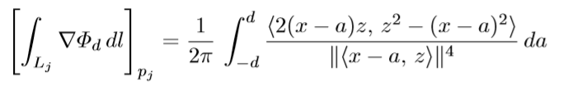 (2.3)

Where 2d is known as the panel’s length, then we can easily find d and -d, x, z are the coordinates of the points, a is the traverses from -d to d.

After those calculation, we can finally use MATLAB to calculate the integral by the equation 2.4,

(2.4) = R(θ) *

With that information, we can calculate matrix by MATLAB function.

We final get the A matrix with value:

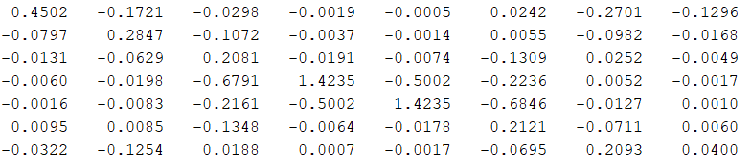

A=

Based on Kutta Condition, we update matrix A with making the first column equals the addition between it and with second column and let second last column equals its value minus the value of last column, delete the last column. Then we get a new 7×7 matrix of B which is the final coefficient matrix:

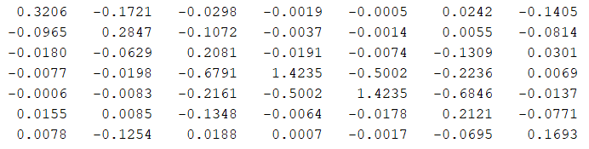

B=

At this time, we still need to find b, which is the column vector with components of the dot product of $n_{i} and ∇ϕ_{f}$. We use MATLAB function to calculate the value of b. Knowing the value B and b, we use backsolve in MATLAB to solve the linear system: $Bμ=b$

Now we get the doublet strength $μ$.

Then we will calculate the value for circulation Γ, which is the integrated sum of the velocity around the wing. Circulation can be approximated by equation 2.5:

$Γ≈μ_{last}-μ_{1}$ (2.5)

From previous calculation, we can get the value of $μ_{last} and μ_{1}$ from the double strength calculation. So we get circulation Γ equals -19.71 $m^{2}/s$ +227.1 $m^{2}/s$ which equals 207.39 $m^{2}/s$.

Lastly, we use equation 2.6 to estimate the value for lift

$L=Γ⋅v⋅d$ (2.6)

With Γ value of 207.39 $m^{2}/s$ and v value with 76 m/s and d value of 1.225 $kg/m^{3}$ we estimate the lift with 19308 N/m.

**Wake Model**

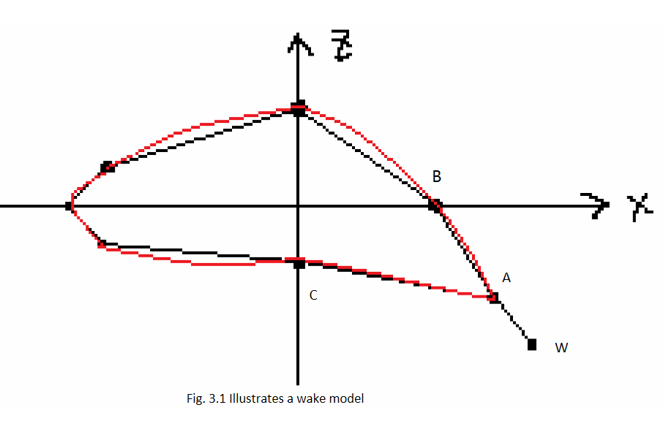See Figure 3.1, a wake can be defined from the location of first two points A, B and last point C.

Applying the position of A, B, C to the wake model (see 3.1) to find the wake W.

$\left\langle Ax,A_{y}\right\rangle -\frac{1}{2}\left(\frac{\vec{AB}}{\left\|\vec{AB}\right\|}+\frac{\vec{AC}}{\left\|\vec{AC}\right\|}\right)=\left\langle W_{x},W_{y}\right\rangle$ (3.1)

In the following report, we will analyze how the wake’s length, angle and position point effect the estimation of lift. From the previous report, we know that lift is determined by the free stream velocity, density of air and doublet strength. With constant value for velocity and density, the only variable that can alter lift value is doublet strength, which means we need to analyze the relationship between wing’s characteristics and doublet strength in order to find how the wing’s traits alter the lift value.

* Wake’s Length

We predict that with longer the wake is, the influence coefficient will become larger which will make the value of final doublet strength bigger. This will eventually lead to a larger estimation on the lift since doublet strength is in direct proportion to the lift value.

* Wake’s Angle

We predict that the wake’s angle also based on the A, B and C point. As the expand line, the angle depends on the position of points. The angle is increased, the life value will increase. Figure 3.3 shows wake with different angle.

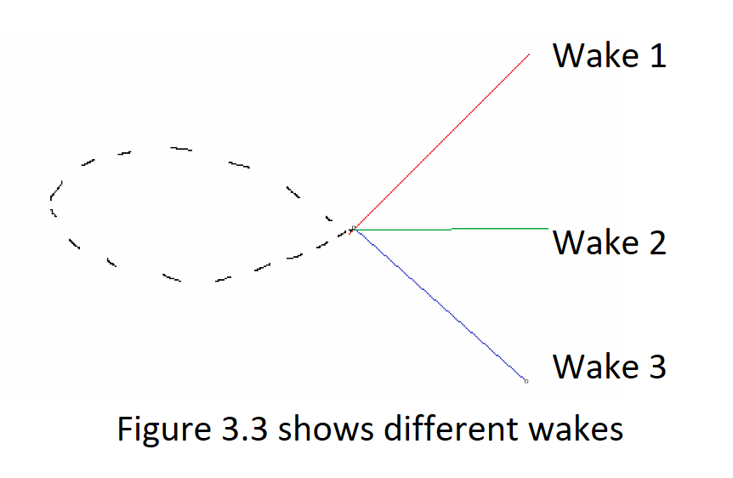

* 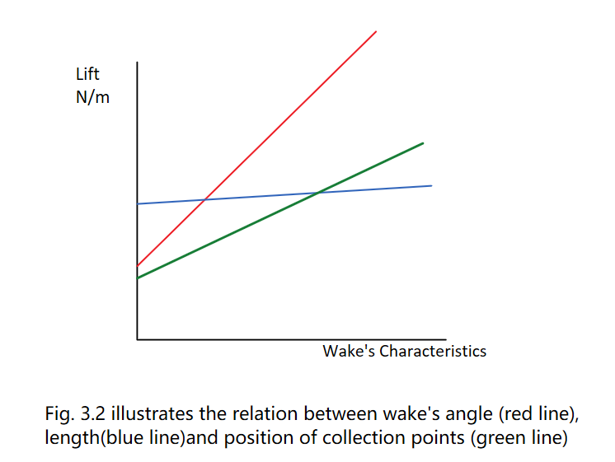Wake’s Position Point

The results are shown in the figure 3.2. To summary, based on the experiment, we found that with high positive wake’s angle, and less on the difference on z coordinate of the point, the lift estimates will result in a higher value. The length difference of the wake won’t make a huge change on the lift value.

**Wing Geometry**

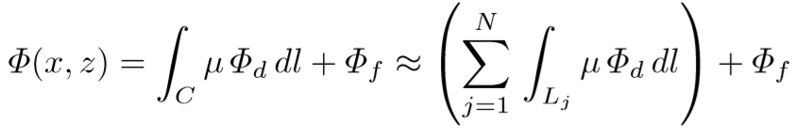We can use equation 4.1 to approximate the geometry of the wing,

(4.1)

Where C is the curve for the wing and wake, divide C into N pieces so it will get N number of rectangular panels and one segment left which is the wake. In order to make the lift estimates as large as possible, we should make the area of the wing bigger. See Figure 4.2, it shows 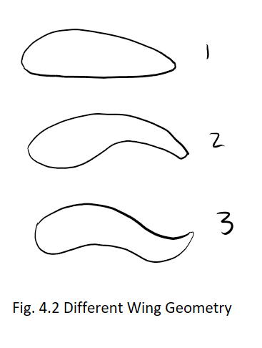different type of wing geometry

The first one has a thick wing section, it has high lift. The second one also has high lift, it has thin wing section. The last one looks very stable; however, it has low lift. We can conclude that the wing having deep camber geometry always has high lift. The geometry like the last one shown in the picture has little movement of center of pressure. It stable but don’t have high lift. Those different geometry can be applied in different use based on their characteristics.

**Design A Wing for Human-Powered Craft**

When the area of wing gets larger, the estimate lift will increase. As a human-Powered craft, we don’t have to build a huge wing. Our design, see figure 5.1 is to make the wing like the shape of a flat rectangular and with a short so that save the materials, save the cost but still keep the functions it should have. For a Human-Powered craft, we need to make it safe enough, so we think it’s suitable to choose a wing with geometry of low lift, high drag but have high stability.

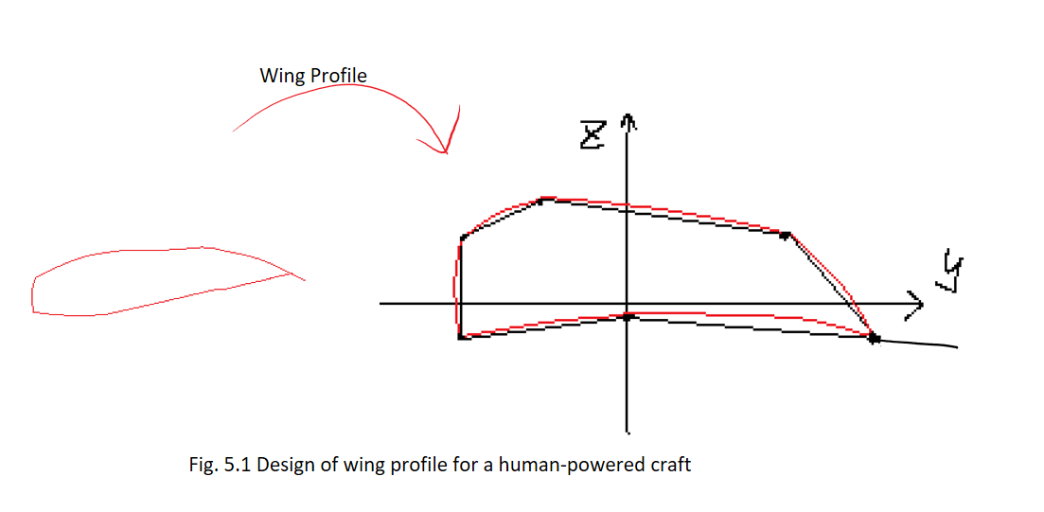

**Conclusion**

In this project, we build a computational model that help us calculate a wing’s doublet strength, circulation and lift and then we make analysis based on it. In order to do the calculation, we separate a wing into numbers of flat panels and calculate each panels doublet strength individually and sum up at the end. Applying the doublet strength into different equations we get the circulation and lift value. We use the result we have then to find out the how the wake’s characteristics alter the result of lift which is with high positive wing angle, the lift gets larger. After studying the geometry of the wing, we find out that wings with deep camber can have high lift. At the end, we design a wing for a human-powered craft.

From the project, we have better understanding of air flow and some fluid knowledges. It help us realize that it’s useful to learn that can apply into aeronautic field use.

Work Cited

Holder, Allen, and Joseph Eichholz. An Introduction to Computational Science. Springer, 2019.