**Heat and Wave Project**

Sybil Chen

5/5/2020

**Introduction**

The filed of partial differential equations is an important part in the field of applied mathematics. In this project, we apply partial equations into the study of heat and wave by doing numerical analysis and building computational models to solve few problems.

Heat equation is a partial differential equation that describes how the distribution of heat evolves over time through a uniform medium. We use model as:

$$u\left(x,y,t\right)ΔxΔy$$

to describe the heat contained within the element at time t where $u\left(x,y,t\right)$ is the average temperature over the plate at position (x, y) at time t. $Δx and Δy$ are the width and length of the element of the plate centered at (x, y). Based on it, we solve the heat equation over a described region.

Wave equation is like heat equation. It can be stated in terms of Laplacian:

$$\frac{∂^{2}u}{∂t^{2}}=α\left(∇⋅∇u\right)$$

where $∇$ is the partial differential operator for the spatial coordinates. With the equation, we add a damping term and estimate the smallest value for displacement u.

In addition, we solve the wave equation over the unit disc with boundary condition and also solve the wave equation over the unit disc for various p-norms.

**Heat Equation Model**

To find the heat equation, we apply Fourier’s law (see Equation 1.1) of heat to describe heat flow.

$F=-α∇u (1.1)$

Then we substitute the law into the previous equation we get

$$\frac{∂u}{∂t}-α∇⋅∇u=0 (1.2)$$

where $α$ is a material property which can be calculate from $α=\frac{κ}{ρc}$. $κ$ is the thermal conductivity, $ρ$ is the density of the material and c is material’s heat capacity

We also need boundary conditions to build our model. There are two boundary conditions: Dirichlet boundary condition and Neumann boundary condition. When we need to control the temperature on the plate’s boundary, we use the form of Dirichlet boundary condition:

$$u\left(x,y,t\right)=g\left(x,y,t\right)$$

where (x, y) is on the boundary of the plate. If there is no heat on plate’s boundary, we use the form of Neumann boundary condition:

$$∇u\left(x,y,t\right)⋅n\left(x,y\right)=0$$

We create a model to solve the heat equation over a described (Figure 1.1). We know that Dirichlet condition that $u\left(x,y,t\right)$ = 60 and Neumann condition:

$$\frac{∂u}{∂n}\left(x,y,t\right)=∇u\left(x,y,t\right)⋅n=-1$$

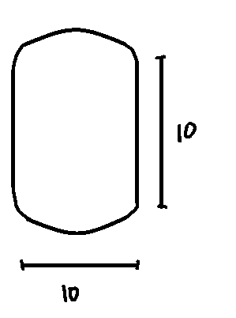

Figure 1.1: Region that heat flow

Knowing the initial temperature is 80 when t=0, we do our calculations with MATLAB and we create the model as following:

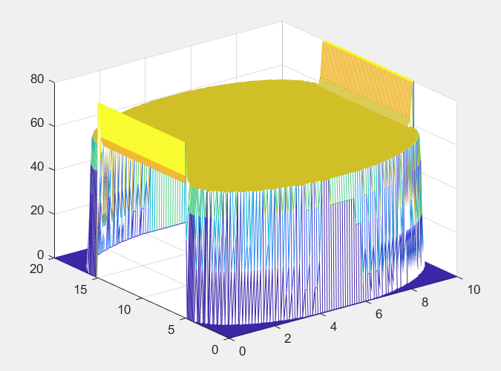

(Figure 1.2: Heat Equation Model)

We compare uniformity of three materials: copper, nickel and tin after 2 seconds.

|  |  |  |  |
| --- | --- | --- | --- |
|  | Thermal Conductivity (Btu/(hr-ft-F) | Heat capacity at 25℃ | Density(lbs/in^3) |
| Copper | 231 | 0.385 J/g℃ | 0.322 |
| Nickel | 52.4 | 0.44 J/g℃ | 0.321 |
| Tin | 38.48 | 0.39 J/g℃ | 0.263 |

Use the information above we can calculate $α$ by $α=\frac{κ}{ρc}$. Then we find out that Copper has the highest value for $α$ since its thermal conductivity is much higher than other two materials. Nickel and Tin have about the same value for $α$. In this way, we would select copper for the most uniform heat profile.

**Wave equation model**

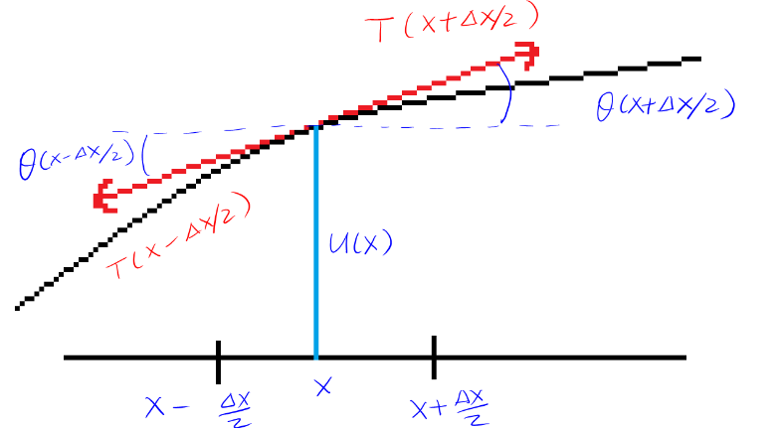Wave equation is similar to heat equation mentioned in the previous parts. In addition, wave equation can be used to interpret the movement of a vibrating wire. The description is shown in figure 2.1:

(Figure 2.1: A depiction of the wire)

where u(x) is the vertical displacement of the wire at position x with time t. Tension is the only force applied on the wire. Applying Newton’s second Law: $ma=F_{net}$ into the partial differential equation then we get the equation:

$ρΔx\frac{∂^{2}n}{∂t^{2}}\left(x,t\right)=F_{net}$ (2.1)

where $ρ$ is the density of the wire at position x and $F_{net}$ is the net vertical force.

With the relationship between tension and displacement of the wire, we can find $F_{net}$. Substitute $F_{net}$ into equation 2.1 we get:

$$\frac{∂^{2}u}{∂t^{2}}\left(x,t\right)=\frac{H}{Δxρ}\left[\frac{∂u}{∂x}\left(x+\frac{Δx}{2},t\right)-\frac{∂u}{∂x}\left(x-\frac{Δx}{2},t\right)\right]$$

Let $Δx$ →0 we get the final wave equation:

$\frac{∂^{2}u}{∂t^{2}}\left(x,t\right)=\frac{H}{ρ}\frac{∂^{2}u}{∂x^{2}}\left(x,t\right)$ (2.2)

Currently, we analysis wave equation by adding a damping term into equation 2.2 get:

$\frac{∂^{2}u}{∂t^{2}}=\frac{H}{ρ}\frac{∂^{z}u}{∂x^{2}}-κ\frac{∂u}{∂t}$ (2.3)

Just like heat equation, in order to get a specific solution, we need boundary condition. We have the initial conditions:

$$u\left(x,0\right)=0 and \frac{∂u}{∂t}\left(x,0\right)=ⅇ^{-10{\left(x-L∕2\right)}^{2}}-ⅇ^{-10{\left(L∕2\right)}^{2}}$$

In order to make it stable, our final solution should satisfy the following condition:

$$Δt<Δx⋅\sqrt{\frac{ρ}{H}}$$

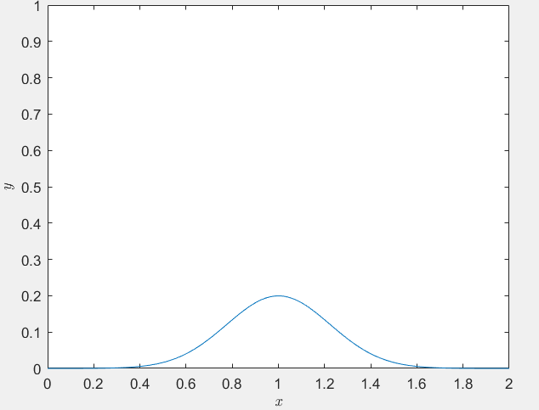We do the calculations with MATLAB get results that: when $κ$ is close to 0.25, we can approximate the smallest value for which the value of u is positive. We also make a graph to better illustrate the variation of $κ$ throughout the change in time.

(Figure 2.2)

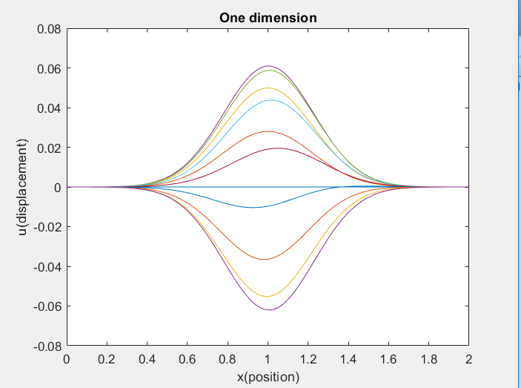We can approximate the solutions of the wave equation using MATLAB. With the value L=2, $Δx$ =0.01 and $Δt$ =0.028. We get the one-dimensional model:

(Figure 2.3)

With the similar idea, we now solve the following wave equation below over the unit disc with the boundary condition that $u\left(x,y,t\right)$ =0.1 if $x^{2}+y^{2}$ =1.

$$\frac{∂^{2}u}{∂t^{2}}=2\left(∇⋅∇u\right),u\left(x,y,0\right)=\frac{x^{2}+y^{2}}{10},\frac{∂u}{∂t}\left(x,y,0\right)=0$$

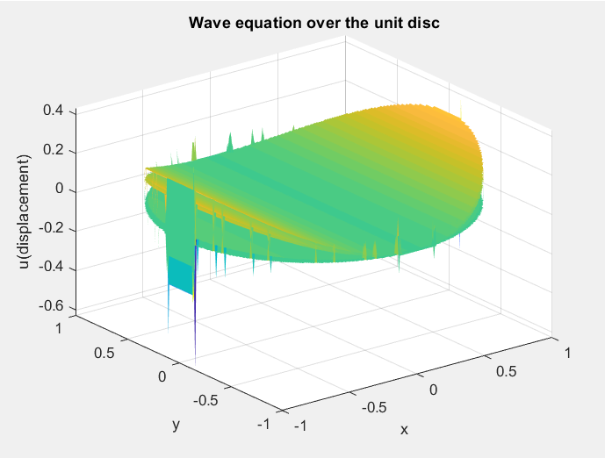(Figure 2.4)

According to the graph, when y value is lower and x value is larger, the displacement value u is larger. Based on this idea. With similar boundary conditions, we solve the wave equation over the unit disc for various p-norms:

$${∂^{2}u}/{∂t^{2}}=2\left(∇⋅∇n\right),u\left(x,y,0\right)=\frac{{\left\|\left(x,y\right)\right\|}_{p}}{10},\frac{∂u}{∂t}\left(x,y,0\right)=0$$

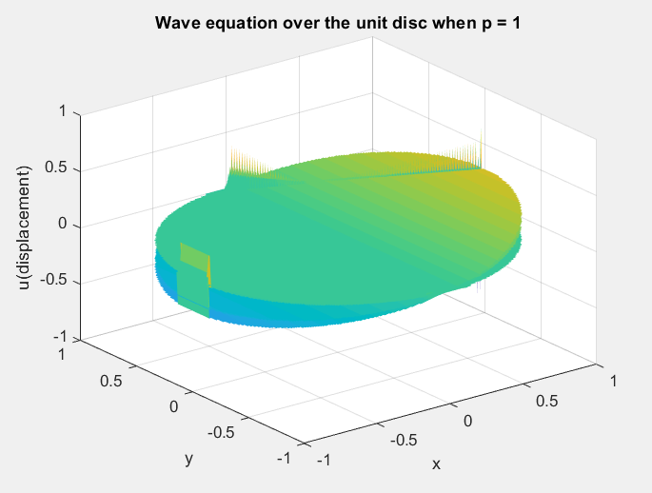When p=1, ${\left\|\left(x,y\right)\right\|}_{p}$ = x + y. The result calculated by MATLAB is showing below.

(Figure 2.5)

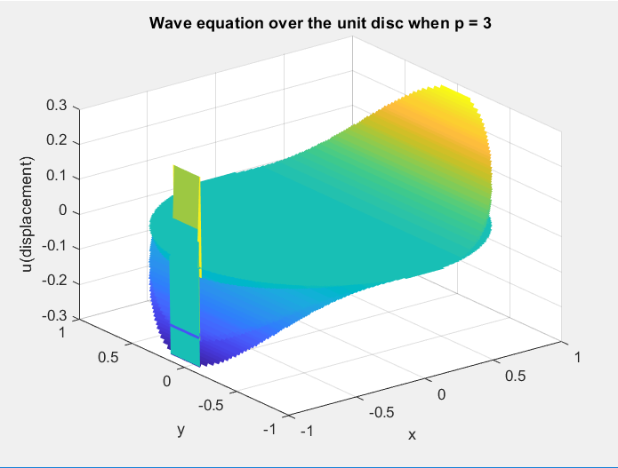When p=3, ${\left\|\left(x,y\right)\right\|}_{p}$ = $x^{3}+y^{3}$. The result calculated by MATLAB is showing below:

(Figure 2.6)

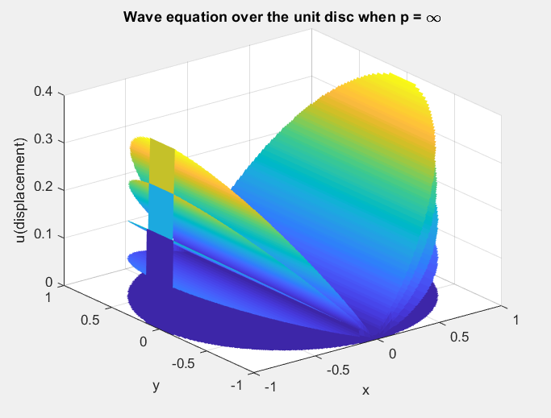 When p= $∞$, ${\left\|\left(x,y\right)\right\|}_{p}$ equals the largest magnitude of value of x, y. The result calculated by MATLAB is showing below:

(Figure 2.7)

**Conclusion**

In this project, we study and analyze heat and wave equation using multiple models. In order to solve each partial differential equation, we need to have boundary conditions which includes Dirichlet and Newman. Solving heat equation can help us to determine which materials has better uniformity with knowledge of several thermal parameters. By studying wave equation, we can now analyze the movement of a vibrating wire. Wave equation can vary by different dimensions and adding things like damping and forcing terms to make the model powerful but harder to solve.

For the difficulties throughout the project, we find it’s difficult to apply the idea into code. We try to make a movie or a gif for the graphs, so it will give a better look with how the equation changes among the change of time, but it doesn’t quite work at this time.

Work Cited

Holder, Allen, and Joseph Eichholz. An Introduction to Computational Science. Springer, 2019.