**Stock Pricing and Portfolio Optimization**

Sybil Chen

5/26/2020

**1 Introduction**

The study of optimization and simulation have always been popular in the mathematics field. They are also the powerful tools in the real-life use, especially for the stock pricing and portfolio selection. Stock pricing has always been interesting topic until nowadays. Investing in stocks is an excellent way to grow wealth. However, it’s not easy to make money. In order to get returns from the investing, there are always some risks, such as the risk of a swing in commodity prices affecting the business. In general, the higher potential return always along with the higher risks. But there is no guarantee that accepting more risks can get the higher return. To get more return with limit risks, more and more people imply computational simulation and mathematics model into the stock investment.

In this project, we build models to optimize the select of stocks for a portfolio where stock prices are stochastic and simulated. We select 34 different stocks from different companies among the world (shown in Appendix Table 1). The data of the stocks are collected from Yahoo Finance during the time period May 20, 2019 to May 18, 2020. With the simulating of the future stock prices we create a portfolio that is optimally balanced the rick and return. To get an efficient portfolio, our conclusion should fit the previous idea that higher return has higher risk.

**2 Model**

**Stock Pricing**

In the project, we use stochastic differential equation to model the price in a function of time. With a drift parameter (mu) and a volatility parameter (sigma), we define the stock price equation P(t) as

$ⅆP=μPⅆt+σPⅆz$ (2.1.1)

If there is no volatility which means no change in price, we get the solution $P\left(t\right)=P\left(0\right)ⅇ^{μt}$.In this condition, the growth of the investment is that of compounded interest with the rate of $μ$. The term of $σPⅆz$ is based on z which is a Weiner process. z(t) is a time dependent random variable. According to one condition that define z(t) as a Weiner process:

$z\left(t+Δt\right)-z\left(t\right)=\sqrt{Δt}ϕ$ (2.1.2)

where $ϕ$ is a standard normal variable. Assuming there is no deterministic drift which is $μ$ = 0. Our equation can be reduced to

$ⅆP=σPⅆz= σP\sqrt{dt}ϕ$ (2.1.3)

With all the information above we can get an approximation of stock price by sampling from a normal distribution repeatedly and updating the value of price. We now have the counterpart to 2.1.1,

$P\left(t+Δt\right)≈P\left(t\right)+μP\left(t\right)Δt+σP\left(t\right)\sqrt{Δt}ϕ$ (2.1.4)

Using this equation, we can approximate the random path (sample path) for the stock price and analysis how does the stock price change among the change in time by days.

We use Ito’s Lemma to solve the previous stochastic differential equations. Ito’s Lemma demonstrates that Let f (P, t) be twice diﬀerentiable and P be a solution to 2.1.1. Then

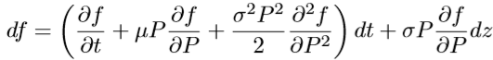 (2.1.5)

We select the application that

 (2.6)

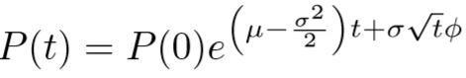to extract practical merit from a necessary condition. Combining it with the assumption that z is a Weiner process, we solve for P results in the anticipated exponential form of the solution that

(2.7)

Similar to the previous idea, when there is no volatility, we get a continuous compound interest model with rate mu. The exception can be negative if sigma is sufficiently large. But there is no guarantee to have less gains if sigma is large.

**Portfolio Selection**

Diversification is one of the strictest principles. Investing in a number of assets tends to risk over the overall economy. A diversified portfolio could simulate the overall profitability of the economy to approximate the economy’s aggregate return. A high-risk portfolio is more likely to have high return. A low-risk portfolio has lower return but more stable, the final return is more likely close to the approximate value. The main idea of portfolio is balancing the trade-off between the risk and return.

Let V be the money we use to invest in n stocks, we can calculate it among the change in time in

$V\left(t\right)=\sum_{i=1}^{n}{P_{i}\left(t\right)x_{i}\left(t\right)}$ (2.2.1)

where $P_{i}\left(t\right)$ is the price of stock i at time t, $x_{i}\left(t\right)$ is the number of shares invested in stock i at time t. Knowing $P_{i}\left(t\right)$ and a time interval of Δt, we can calculate the return by

$R_{i}\left(t\right)=\frac{\left(P_{i}\left(t+Δt\right)-P_{i}\left(t\right)\right)x_{i}\left(t\right)}{P_{i}\left(t\right)x_{i}\left(t\right)}=\frac{P_{i}\left(t+Δt\right)-P_{i}\left(t\right)}{P_{i}\left(t\right)}$ (2.2.2)

and the return of the entire portfolio is

$$R\left(t\right)=\frac{V\left(t+Δt\right)-V\left(t\right)}{V\left(t\right)}$$

$$=\frac{1}{V\left(t\right)}\sum_{i=1}^{n}{\left(P_{i}\left(t+Δt\right)-P_{i}\left(t\right)\right)x_{i}\left(t\right)}$$

= $\sum_{i=1}^{n}{\left(\frac{P_{i}\left(t\right)x_{i}\left(t\right)}{V\left(t\right)}\right)\left(\frac{P_{i}{\left(t+Δt\right)-P_{i}(t)}^{}}{P_{i}\left(t\right)}\right)}$

$=\sum_{i=1}^{n}{w_{i}\left(t\right)R_{i}\left(t\right)}$ (2.2.3)

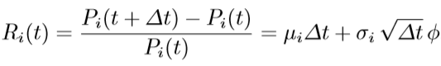Combining our previous stock price model, we can now approximate with a forward difference as

(2.2.4)

Substitute mean into 12.5 we get expected return

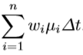

(2.2.5)

Let r be the vector with and w as a corresponding weight vector, we can calculate the expected return at time t by using $r^{T}w$.

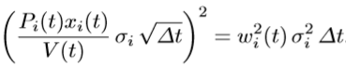 We use the variance of the stock’s return to calculate the risk of investing stocks. Assuming we invest $x_{i}\left(t\right)$ dollars at time t in stock i, we can build the risk model that

(2.2.6)

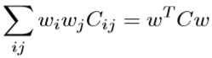From the model, we know that low-risk portfolios can only hold large amount of stocks with low volatilities. Substitute the model with a correlation factor that equals 1 we can now calculate the risk of portfolio by

(2.2.7)

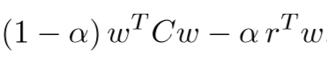This is a convenient quadratic form to represent risk. In order to select stocks that with least risk but has highest expected return, our portfolio need to minimize the weighted difference by

(2.2.8)

where $α is an investor^{'}s risk tolerance,$ it has interval $0≤α≤1$. $α$ =1 shows the maximizing return and $α$ =0 shows the condition that the risk is minimum. We use MATLAB command quadprog to solve this convex optimization problem.

**3 Result**

In this project, we collect a daily 12-month history of the 30 stocks from May 20, 2019 to May 18, 2020 to do our calculation and analysis. Each stock has a history of 250 trading days over the period.

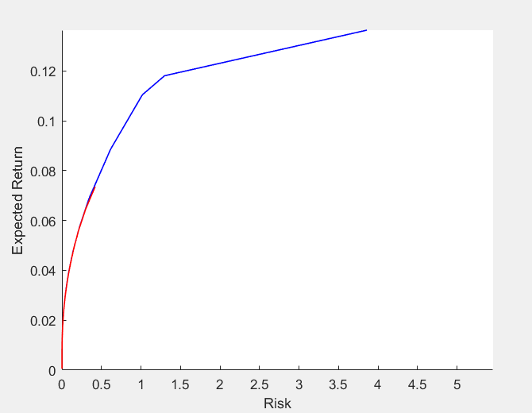 We first use quadprog function to solve the convex quadratic optimization problem with alpha = [0:0.01:1].^2. For each of the $α$ value, we calculate the value of risk and expected return and plot the graph shown in figure 3.1.

Figure 3.1

In the graph, the blue curve illustrates the efficient frontiers without any restrictions on the maximum weight and the red curve shows the efficient frontiers with 20% restriction on the maximum weight.

Knowing the price of the stocks, matrix of daily returns and a vector of sample returns for each stock, we now can calculate and plot the simulated price trajectories for the stock portfolio. The graph is shown in figure 3.2.

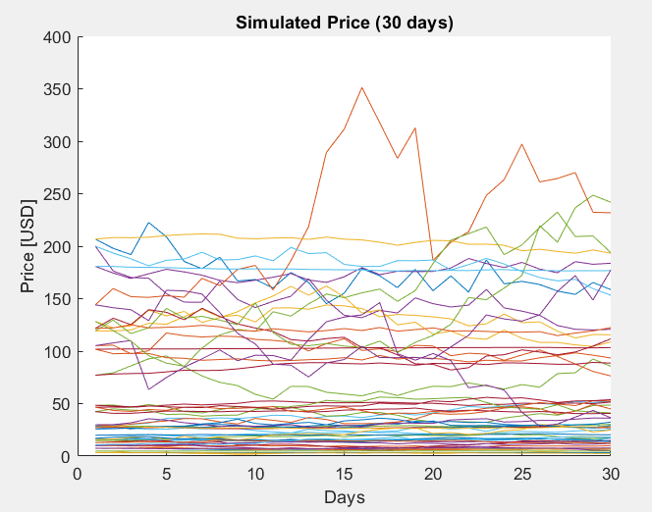

Figrue 3.2

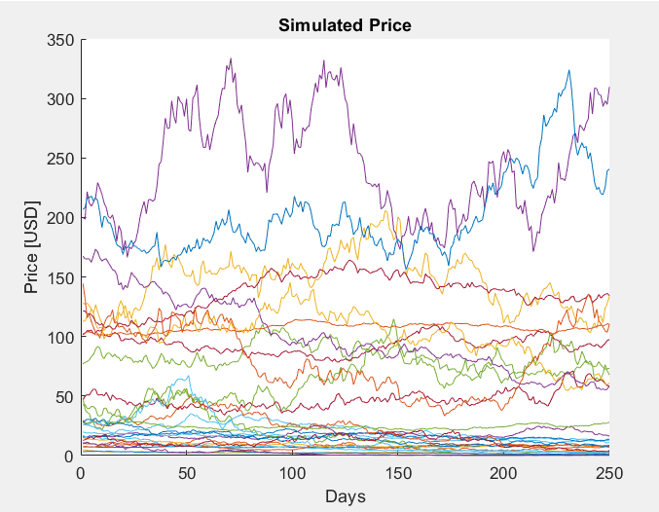Using the same calculation steps, we simulate a fixed portfolio for the next year. The graph is shown in Figure 3.3.

Figure 3.3

According to the calculation, we find that the point of diminishing returns on risk occurred at a risk factor of 0.419. This result is reasonable. We use this risk factor to simulate the future stocks. Based on the simulation results, we recalculate the new value of expected return and the quadratic optimization problem.

We calculate and simulate the stocks prices for the next one year (250 days) using the weights given by the 20% maximum weight and risk factor of 0.2 quadratic optimization problem. The portfolio is designed depends on investor’s willingness to accept risk.

**4 Conclusion**

In this project, we collect the data from 30 different stocks of one-year (250 days) period. With the information of prices of the stocks, we estimate annual drift and volatility parameters. Then we simulate portfolio using the risk tolerance of 0.2. After simulating future stocks’ prices, we simulate the stock prices for the next 30 days for each stock. Then we construct a new portfolio by re-estimate the value of drift and volatility parameters. We also simulation the prices based on the initial investment money for the next half year. Our model can be used as a reference for the selection of stocks to invest.

List of Stock

* AEO
* ANF
* BA
* BABA
* BBY
* BILI
* DIS
* FB
* GPS
* HUYA
* IQ
* JD
* JWN
* TWTR
* UBER
* WMT
* WORK
* ZM
* KO
* KSS
* LYFT
* M
* MCD
* PDD
* PINS
* SNAP
* SOGO
* TGT
* TIF
* TME

Work Cited

Holder, Allen, and Joseph Eichholz. An Introduction to Computational Science. Springer, 2019.

“Yahoo Finance - Stock Market Live, Quotes, Business & Finance News.” Yahoo! Finance,

Yahoo!, finance.yahoo.com/.