实验报告一

PB14000556 陈晓彤

实验题目：运算器ALU设计

实验要求：

设计一算数运算单元ALU

采用纯组合逻辑设计

32bit位宽

完成指定运算功能

自行设计测试例对所设计的ALU进行仿真

设计思路：

采用always和case语句可直接完成题目要求，同时设置一个一位变量检测溢出情况即可

源代码:

module ALU(

input signed [31:0] alu_a,

input signed [31:0] alu_b,

input [4:0] alu_op,

output reg sign,

output reg [31:0] alu_out

);

parameter A_NOP = 5'h00; //空运算

parameter A_ADD = 5'h01; //符号加

parameter A_SUB = 5'h02; //符号减

parameter A_AND = 5'h03; //与

parameter A_OR = 5'h04; //或

parameter A_XOR = 5'h05; //异或

parameter A_NOR = 5'h06; //或非

always@(*)

begin

case(alu_op)

A_ADD:{sign,alu_out}=alu_a+alu_b;

A_SUB:{sign,alu_out}=alu_a-alu_b;

A_AND:alu_out=alu_a&alu_b;

A_OR:alu_out=alu_a|alu_b;

A_XOR:alu_out=alu_a^alu_b;

A_NOR:alu_out=~(alu_a|alu_b);

A_NOP:alu_out=alu_out;

default:alu_out=alu_out;

endcase

end

endmodule

仿真代码：

module lab1_alu_test;

// Inputs

reg [31:0] alu_a;

reg [31:0] alu_b;

reg [4:0] alu_op;

// Outputs

wire sign;

wire [31:0] alu_out;

// Instantiate the Unit Under Test (UUT)

ALU uut (

.alu_a(alu_a),

.alu_b(alu_b),

.alu_op(alu_op),

.sign(sign),

.alu_out(alu_out)

);

initial begin

// Initialize Inputs

alu_a = 0;

alu_b = 0;

alu_op = 0;

// Wait 100 ns for global reset to finish

#100;

alu_a = 32'h00000008;

alu_b = 32'h0000000a;

alu_op = 1;

#100;

alu_op = 2;

#100;

alu_op = 3;

#100;

alu_op = 4;

#100;

alu_op = 5;

#100;

alu_op = 6;

#100;

alu_a = 32'h7fffffff;

alu_b = 32'h7fffffff;

alu_op = 1;

// Add stimulus here

end

endmodule

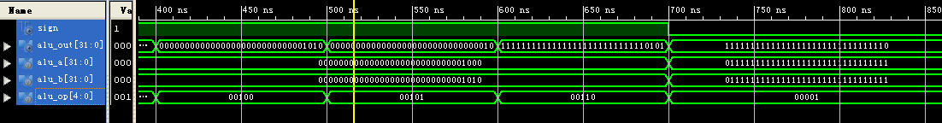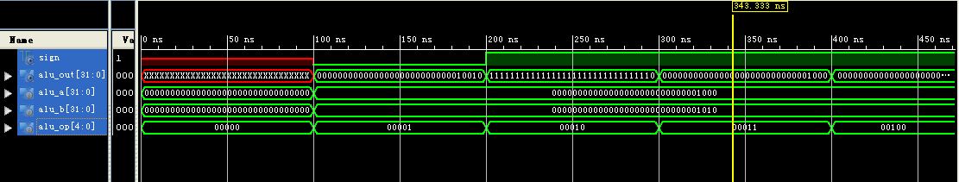仿真图：