**Data sources & cleaning & visualization**

1. **Statistics on Demographic Characteristics by district (as at 2020)**

**Colored in green (lower in % 65+ population) to red (higher in % 65+ population)**

**Sample:**

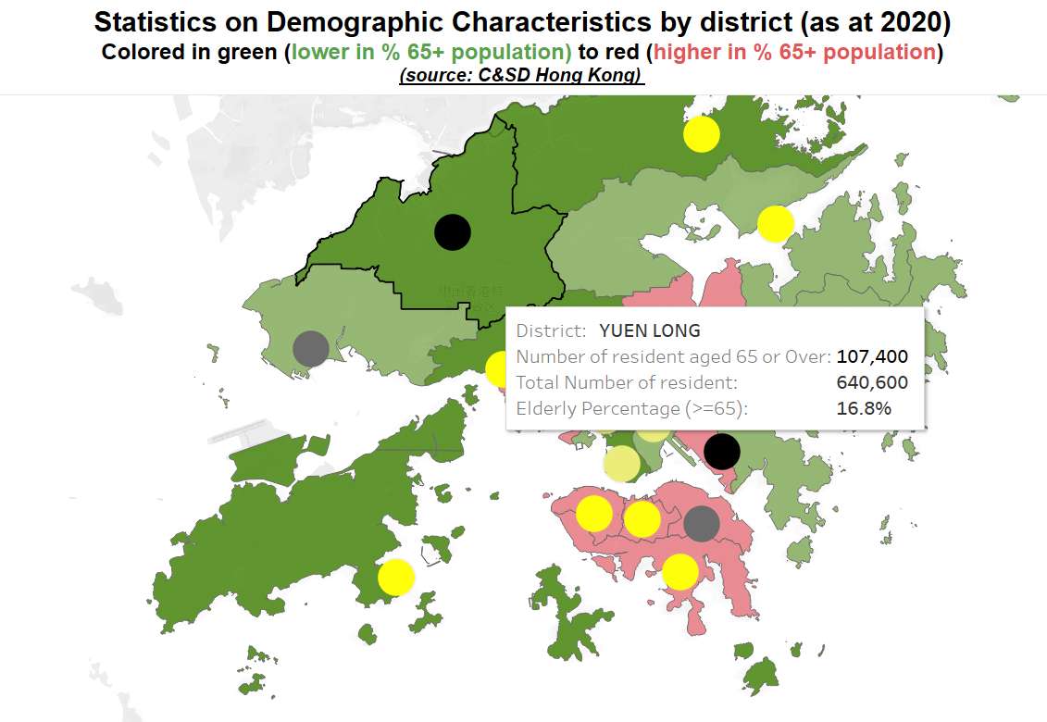

**Data source：**

Base map：

https://opendata.esrichina.hk/datasets/esrihk::hong-kong-18-districts/explore

Number of the elderly within the district and % of elderly population within the district (From Census)：

https://www.censtatd.gov.hk/en/web_table.html?id=216

**Data processing：**

Data reading to obtain information on region, gender, age group, and year.

Differentiate by year. The percentage of the population older than 65 years was calculated and plotted.

**Visualization:**

This section shows the number and proportion of the elderly population in different districts in Hong Kong. The colors of the different districts represent the proportion of elderly people (elderly people are defined as those who are older than 65 years old). The red part has a higher proportion of older people than the green part. The circle in the center of each district indicates the number of older people. Darker colors indicate that there are more older people.

1. **2016 Population By-census Statistics (by District Council District)**

**Colored in white to red (higher in % of >=65 population)**

**Sample：**

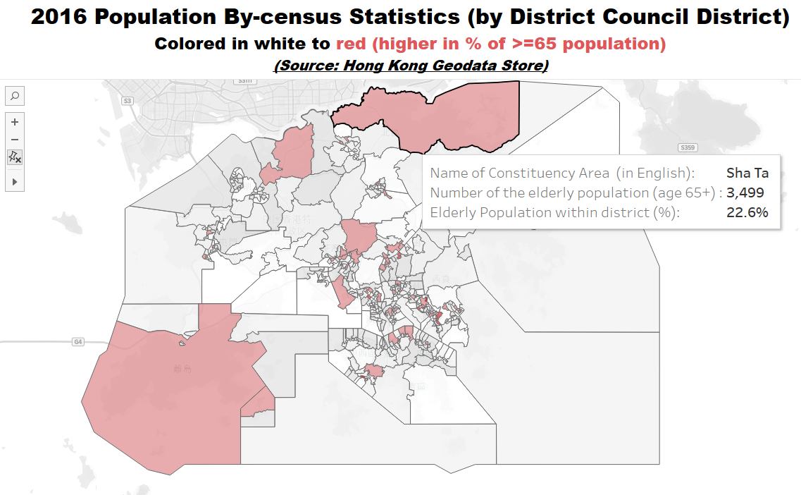

**Data source：**

Base Map:

https://geodata.gov.hk/gs/view-dataset?uuid=7469970b-9124-418f-9880-500d51ce483a&sidx=0

Number of the elderly within the district and % of elderly population within the district (From Census):

https://geodata.gov.hk/gs/view-dataset?uuid=7873fc05-64fc-45f3-8722-a4a59c44ac44&sidx=0

**Data processing：**

Same as the method in 1.

**Visualization:**

This section shows more detailed map information than tab1. By zooming into the interface, you can directly observe the street information. Similarly, the red part has a higher proportion of elderly people than the lighter part.

1. **Elderly care facilities in Hong Kong by facility type (as at 2021)**

**Sample：**

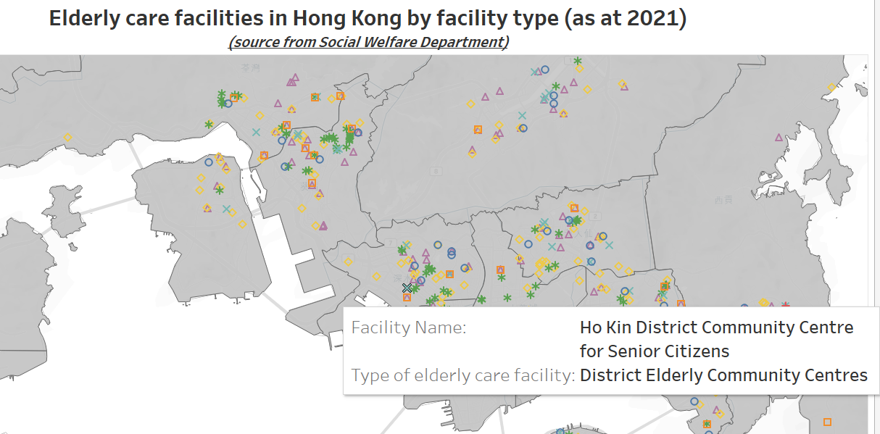

**Data source：**

Location of all the elderly facilities <https://geodata.gov.hk/gs/datasets?s=elderly>

**Data** **processing**：

Scarping the names, locations and prices of elderly facilities in each district of Hong Kong.

**Visualization:**

This section shows the distribution of elderly care facilities in Hong Kong. The different types of facilities are marked with different symbols in the map. Detailed information can be obtained by cursor position.

1. **Average Housing price for each of the estate (as at 2022)**

**Sample：**

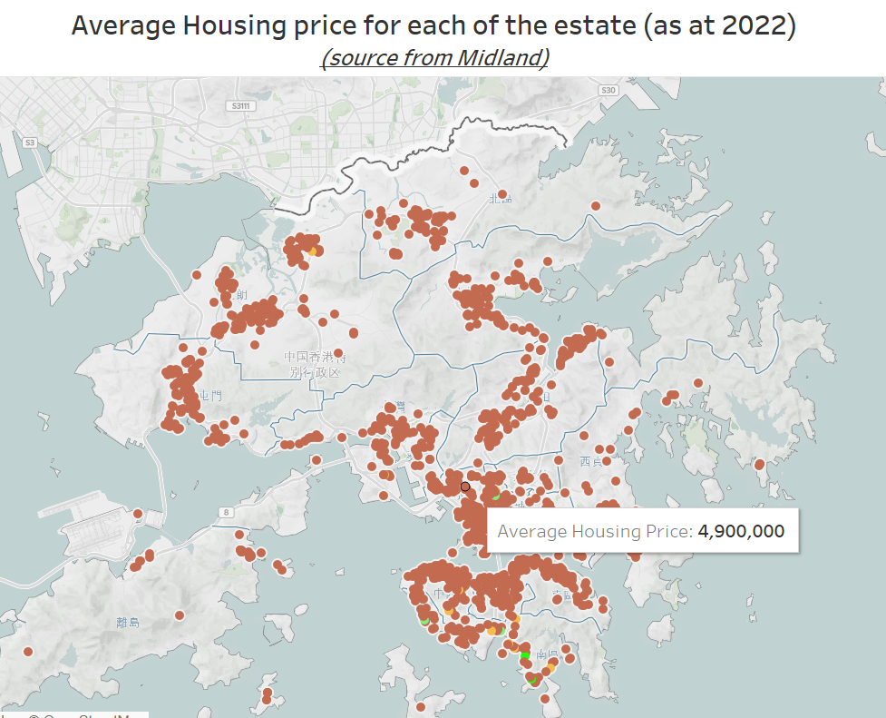

**Data source：**

Scarping data from https://www.midland.com.hk/en/list/buy

**Data processing:**

Scarping the price data of the housing estate and get the location of these housing estate through API.

**Visualization:**

This section shows the average price per unit of homes for sale in different locations in Hong Kong in 2022.

**Observation**

From the 4 tabs of tableau, it can be seen that the areas with more housing in ‘Average Housing Price’ and the areas with more facilities in ‘Elderly care facilities’ basically overlap. The proportion of seniors in these areas is also relatively high. We could identify the districts with dense elderly population and average wealth of the elderly using the property data.