[root@iz237fkzl7tz2iz mysql]# mysql -u root -p

Enter password:

//开启远程连接 给root用户 %所有IP密码Root!!2018

mysql> GRANT ALL PRIVILEGES ON \*.\* TO root@'%' IDENTIFIED BY 'Root!!2018' WITH GRANT OPTION;

mysql> flush privileges;

mysql> SELECT DISTINCT CONCAT('User: ''',user,'''@''',host,''';') AS query FROM mysql.user;

+------------------------------------+

| query |

+------------------------------------+

| User: 'root'@'%'; |

| User: 'mysql.session'@'localhost'; |

| User: 'mysql.sys'@'localhost'; |

| User: 'root'@'localhost'; |

+------------------------------------+

4 rows in set (0.00 sec)

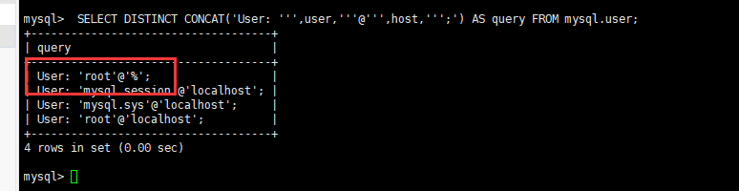

[root@iz237fkzl7tz2iz mysql]# service mysqld restar