芯片测试座子

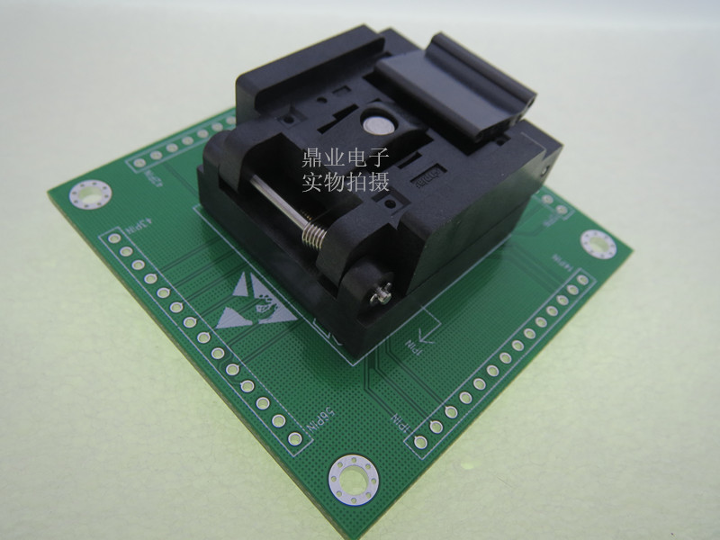

https://item.taobao.com/item.htm?spm=a230r.1.14.164.4603efe7GuZZJ5&id=537815480347&ns=1&abbucket=9#detail

主控板上对应座子

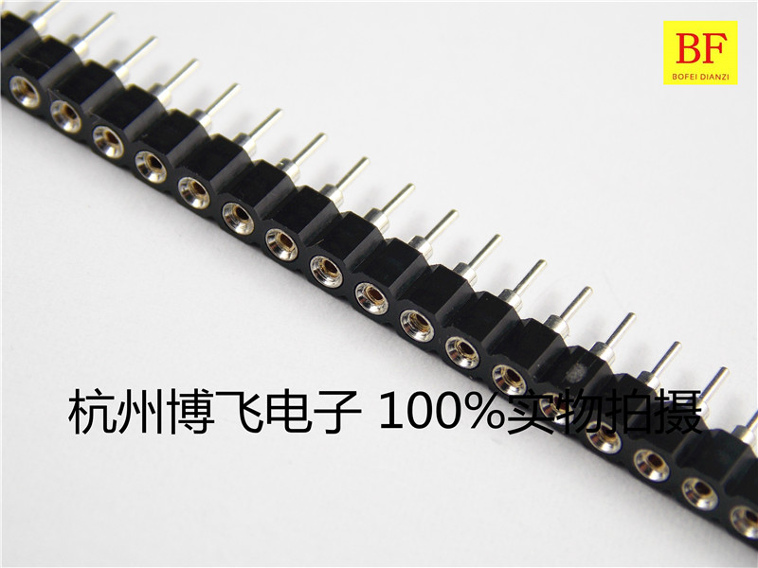

https://item.taobao.com/item.htm?spm=a230r.1.14.16.73d14e30jOQsJV&id=43174701438&ns=1&abbucket=9#detail

排线

https://item.taobao.com/item.htm?id=37319796944&ali_refid=a3_420434_1006:1120864385:N:%E6%8E%92%E7%BA%BF:d510a534279d8493e6eaf3bd489ad0c7&ali_trackid=1_d510a534279d8493e6eaf3bd489ad0c7&spm=a230r.1.1957635.7

