Witt (2020) Replication

*Introduction*

Q30 Thank you for participating!   
In this study, you will first see some materials showing the impact of social distancing to various degrees on the spread of the Coronavirus over time.   
Then, you will be presented with questions regarding social behaviors in the current situation.    
Finally, you will be presented with demographic questions.

*Stimuli-interactive*

Q20 You will go to the link below. It is a story that contains simulations of random dots to show impact of social distancing to various degrees on the spread of the Coronavirus over time. Please watch all of the simulations. You can read the story too but you do not have to read it for this study.

When you finished watching the simulations, please come back here.

<https://www.washingtonpost.com/graphics/2020/world/corona-simulator/>

1. I watched all the simulations.
2. I watched all the simulations and read the story.
3. I watched some of the simulations.

Q32 What is the name of the curve that represents the growth of the Coronavirus cases in the U.S. over time?

1. Exponential
2. Linear
3. Exportation
4. I am not sure.

Q33 What does each dot in the simulations represent?

1. A person
2. A small town
3. A sick person
4. I am not sure.

Q34 According to the story/simulations, which one of the plans below is the most effective in preventing the spread of the Coronavirus?

1. "free-for-all"
2. "attempted quarantine"
3. "moderate social distancing"
4. I am not sure.

*Stimuli-static*

Q22 This figure shows the impact of social distancing to various degrees on the spread of the Coronavirus over time.

Please review them carefully and then click on each panel before you continue.

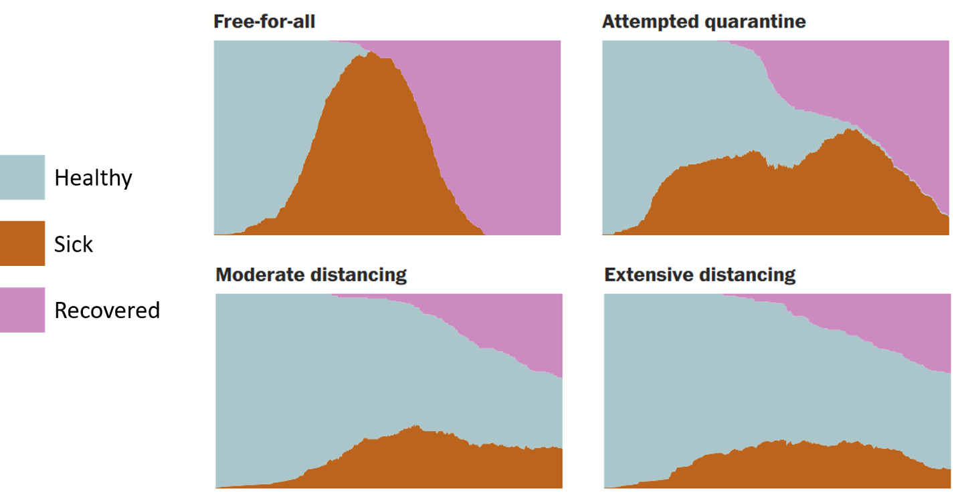

Q35 In the graphs you just saw, what does the orange-colored area indicate?

1. The number of sick people overtime.
2. The size of the town.
3. The number of recovered people overtime.
4. I am not sure.

Q36 According to the graphs, which one of the plans below is the most effective in preventing the spread of the Coronavirus?

1. "attempted quarantine"
2. "free-for-all"
3. "moderate social distancing"
4. I am not sure.

Q5 To what extent do you agree with following decisions made by a person living in your community ***right now***: (1-10 scale)

1. goes grocery shopping
2. takes his/her sick cat to the vet
3. walk his/her dog in the park alone
4. visits a close friend who lives alone
5. takes a friend who lives alone for grocery shopping
6. goes to work when he/she expects no one to be there even though he/she can work from home
7. takes his/her kid to a close friend's house for a playdate
8. goes on a walk with a close friend who lives alone
9. visits a close friend who lives with their parents
10. visits family neighborhood senior center
11. attends a board game night at his/her friend’s home
12. goes to his/her niece's birthday party
13. goes to work because he/she is a physician at the ER
14. goes to work because he/she is a paramedic
15. goes to work because he/she is a police officer

Q2 Please answer the following question below:

To what extent are you successfully engaging in social distancing as required by your state? (1-10 scale)

Q4 How strongly do you agree with the following statements (1-10 scale):

1. Social distancing will be effective in reducing COVID-19 transmission rates.
2. Social distancing will be effective in reducing number of deaths from COVID-19.
3. Social distancing should continue for as long as it takes to maintain low transmission rates.
4. Some people are taking social distancing too far and it should end now.

Q7 What is your age? (Please enter a number)

Q8 Which state do you live in?

Q9 What is your gender?

Q16 What age did you begin learning English? (Please answer in the form of a number: if you are a native speaker, please write "0")

Q17 What language do you use most at home?

Q10 What is your highest level of education completed?

Q11 Has your state directive issued a stay-at-home/shelter-in-place order?

Q12 How many people live in your household (including you)? Please enter a number

Q13 Do you personally know someone who has COVID-19?

Q15 Please answer the following questions:

1. How good are you at working with fractions? (“Not good at all, 1” to “Extremely Good, 6”)
2. How good are you at figuring out how much a shirt will cost if it is 25% off? (“Not good at all, 1” to “Extremely Good, 6”)
3. How often do you find numerical information to be useful? (“Never, 1” to “Very Often, 6”)

Q18 What is your primary source of information? (Check all that apply)

▢ Newspaper (please list newspapers) (1) ________________________________________________

▢ Social media (please give examples, such as Facebook, Twitter, etc.) (2) ________________________________________________

▢ Online news (please list news sites) (3) ________________________________________________

▢ TV (please provide main news channel) (4) ________________________________________________

▢ Other (please give examples) (5)

Q31 For the images/animations you saw, have you seen them before?

1. Yes
2. No, but I saw something like them
3. No

Q19 What is your political affiliation?

Republican

Lean republican

Lean democrat

Democrat

Independent

Other