**Response to Reviewer 1 Comments**

Thanks very much for taking your time to review this manuscript. We gratefully thank you for your excellent and constructive suggestions, which has significantly raised the quality of the manuscript and has enable us to improve the manuscript. After consultation and joint revision by all authors of the manuscript, each suggested revision and comment, brought forward by you was accurately incorporated and considered. Below the comments are response point by point and the revisions are indicated.

Point 1：

First, the context for the study needs to be set out more clearly. The reader needs to understand that the study area is effectively a 'city region' (with mixed land types). Readers unfamiliar with the territorial administration and urbanisation dynamics of southern China may find the paper confusing otherwise since a district (Lin'an) within a city (Hangzhou) could suggest an environment that is already very predominantly urban, which is not the case here. In this respect, terminology like 'city streets' (page 7 et seq.) is potentially confusing since this implies local, urban spaces; the authors are really referring here to main roads in the 'city' as territorial unit rather than as mainly urban space.

**Response 1:**

Thank you for your suggestion. First of Street in the thesis refers to a township borough rather than a particular road in a city, and to avoid ambiguity the” city street” has been changed to towns and Streets. Please see it on line 220.

Point 2：

A further point of context that needs explanation is the planning (zoning) environment. In section 5.3 the paper proposes what the district should do but this reads oddly since the reader is never told what it already does and what its powers (as a planning authority) are. Also, how effective are these powers? Are any controls (current or proposed) that it imposes strictly adhered to; or sometimes/often violated (and if so, what sanctions can it impose); or widely ignored? No planning system in the world is perfect and wholly complied with by land users. In short, the reader needs to know about the planning system as it currently is before being told how it should be.

**Response 2:**

At present, in the context of the new territorial spatial planning, the Lin’an District Government mainly relies on the Implementation Regulations for PRC Law of Land Administration and the "Three Zones and Three Lines" for integrated management. However, there will still be land use conflicts due to factors such as urbanization process. Please see it from line 342 to line 350.

Point 3：

A final point of context concerns the 'contradiction' around different land uses noted in the introduction. Again, this is not really a 'contradiction' but a tension that can, if not managed properly, create conflicts. This is, of course, a global problem and needs to be set out (briefly) as such. The current ambition to protect 30% of the world's land surface and oceans for nature by the year 2030, advocated by various international bodies, NGOs and governments, could be mentioned here.

**Response 3:**

We gratefully appreciate for your valuable comments. Following your suggestion, revised the text in the introduction. Please see it from line 43 to line 45 and 48 to 51.

Point 4：

Second, the quality of the written English is variable. The paper is mostly quite readable but the prose in the introduction (section 1) is wordy, convoluted and hard to follow. This section, particularly, needs major editing. Elsewhere, too, certain points of terminology need attention, as already noted above. Another point is the repeated use of the term 'hilly mountainous', which is somewhat tautological; elsewhere the paper uses 'hilly and mountainous', which makes more sense since it implies a range of topographies from moderate to high (which the GIS data also describes). Other points could be more clearly explained, please, again with the broader readership of Land in mind.

**Response 4:**

AJE Language Polish certificate:

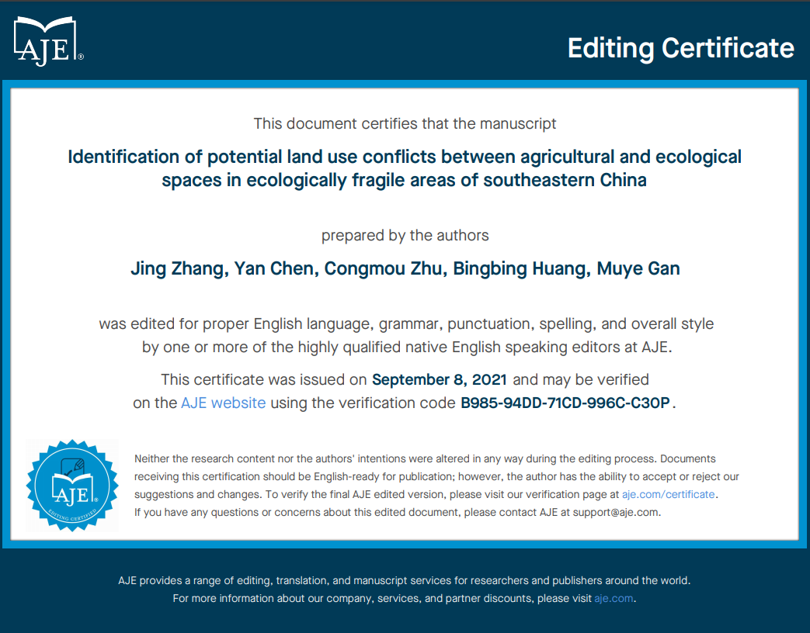

The “hilly mountains “have been changed to” hilly” according to the criteria of topographic height. Please see it on line 101 and below.

**Response to Reviewer 2 Comments**

Thanks very much for taking your time to review this manuscript. We gratefully thank you for your excellent and constructive suggestions, which has significantly raised the quality of the manuscript and has enable us to improve the manuscript. After consultation and joint revision by all authors of the manuscript, each suggested revision and comment, brought forward by you was accurately incorporated and considered. Below the comments are response point by point and the revisions are indicated.

Point 1：

(1) The abstract and conclusion need to be Improved to highlight research findings.

**Response 1:**

Thank you for your suggestion. We gratefully appreciate for your valuable comments. Following your suggestion, revised the text in the introduction. Please see it from line 26 to line 28 and 29 to 32 and 423 to 424 and 433 to 436.

Point 2：

(2) The causes of the conflicts and policy implication need to be further elaborated in the discussion.

**Response 2:**

The following points have been added to the causes of conflict: On the one hand, an increase in the output of agricultural production has led to the continuous expansion of agricultural land such as arable land and garden land, while large areas of ecological land such as water, forestland and pasture land have been occupied; on the other hand, as arable land with high slopes is unsuitable for agricultural production, arable land has been abandoned to naturally evolve into ecological land, making the phenomenon of the compound use of agricultural space and ecological space in Lin'an more common. Please see it from line 290 to line 294.

The following points have been added to the policy implication: At present, in the context of the new territorial spatial planning, the Lin’an District Government mainly relies on the Implementation Regulations for PRC Law of Land Administration and the "Three Zones and Three Lines" for integrated management, in which the "three zones" refer to the ecological, agricultural and urban functional spaces, and the "three lines" are the "three control lines”, i.e., the ecological protection red line, permanent basic agricultural land and the urban development spatial control boundary. These measures have guaranteed ecological agricultural security and have eased ecological agricultural conflicts. However, with the urbanization process, the contradiction between agricultural space and ecological space land use still exists. Please see it from line 342 to line 348.

Point 3：

(3) Line 303-304 please restructure the sentence. Sentence content is redundant.

**Response 3:**

Modified, please see it from line 304 to line 307.

Point 4：

(4) Add citation for the Land Fragility Index (Line 154-159).

**Response 4:**

References have been added, please see it from line 152 to line 158.

Point 5：

(5) All diagrams figures need to further improved according to the journal’s format, legend text is too small to read.

**Response 5:**

Modified, please see it on line 216, 258,260 and 300.

Point 6：

(6) Figure 7: not clearly visible and better to enhance quality and increase dimension for what possible.

**Response 6:**

Modified, please see it on line 300.

**Response to Reviewer 3 Comments**

Thanks very much for taking your time to review this manuscript. We gratefully thank you for your excellent and constructive suggestions, which has significantly raised the quality of the manuscript and has enable us to improve the manuscript. After consultation and joint revision by all authors of the manuscript, each suggested revision and comment, brought forward by you was accurately incorporated and considered. Below the comments are response point by point and the revisions are indicated.

Point 1：

References 34, 35 and 37, which suggest the justification for the formulas 1 and 5 are in local language, and it is not possible to be read by international readers. To overcome this problem I would suggest further justification and/or explanation of these two core formulas, so that they do not appear as arbitrary.

**Response 1:**

Equation 1 and Equation 5 are explained. please see it from line 125 to line 126, and 157 to 158.

Point 2：

No citation to support the Landscape fragility values of table 1 is provided.

**Response 2:**

References have been added. please see it on line 152.

Point 2：

Please provide explanation why grasslands were assigned as ecological space and not as agricultural space. Agricultural space is not just croplands, but grazed areas as well.

**Response 2:**

Although grassland has a livestock function, as an ecosystem it is an important part of the natural ecosystem and has ecological functions such as wind protection, sand fixation, soil conservation, climate regulation, air purification and water conservation, etc. In the context of the new territorial spatial planning, we believe that grassland is more suitable to be classified as ecological space.

Point3：

There is no citation for the Land Fragility Index (L.154 - 159)

**Response 3:**

References have been added. Please see it from line 152 to line 158.

Point 4：

L.161: typos of the letter referring to the total area of the spatial unit. It is written "a" instead of "A".

**Response 4:**

Modified, please see it on line 162.

Point 5：

L. 172: the use of * is not explained in the text. Is this a typos or is anything missing there?

**Response 5:**

Modified, please see it from line 172 to 173.

Point 6：

L. 221: please write properly the software ArcGIS

**Response 6:**

Modified, please see it on line 121 and 196.

Point 7:

L. 255: please restructure the sentence. Some section is missing

**Response 7:**

Modified, please see it on line 254.

Point 8:

L. 356: please restructure the sentence. Some section is missing

**Response 8:**

We have double-checked that the sentence is not missing. please see it on 368