Assignment 2

1. Generate a histogram of sample weights with 15 bins. Does the data look normal? Generate a histogram with 7 bins. Does the data look normal?

Solution:

Coding: (using breaks to set bins) 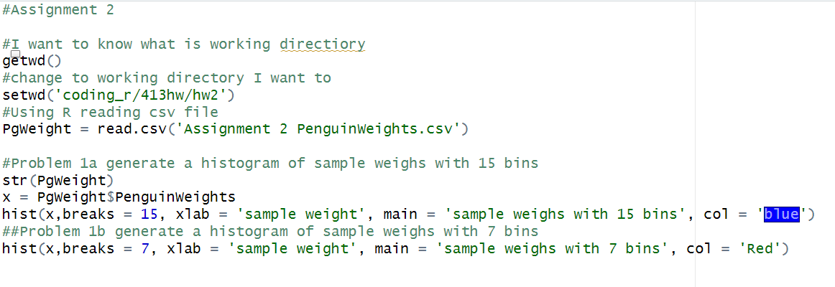

Hist gram with15 bins:

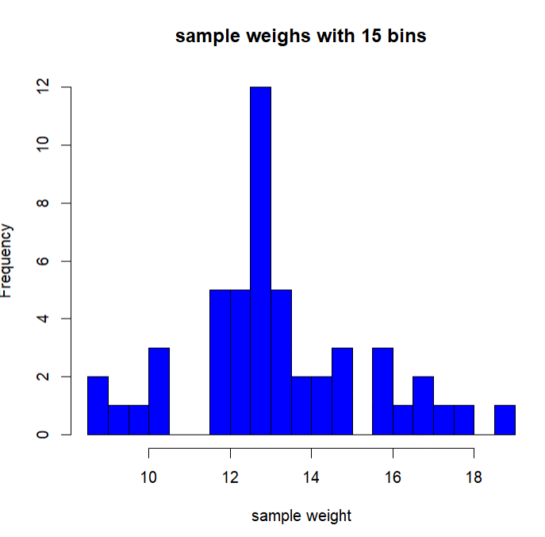

Histogram with 7 bins

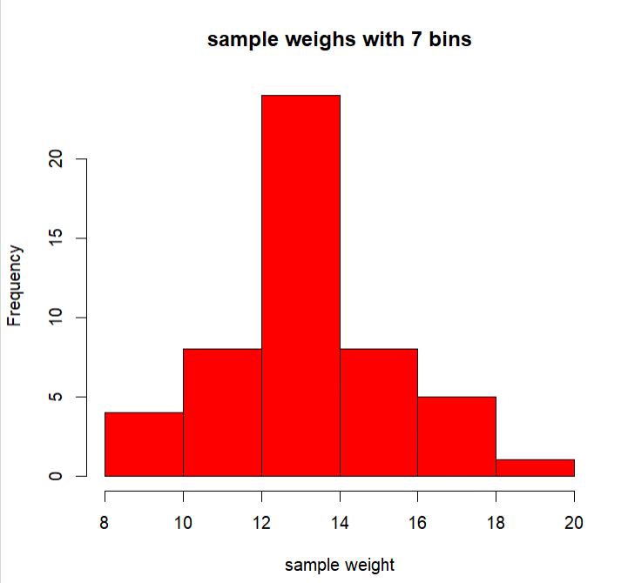

Because the graph shows that it’s very close to normal distribution for both of the two histograms. So, I think the data is follow normal distribution.

2. Determine the 95% confidence interval for mean of the penguin weights.

Solution:

Confidence Interval = $\overline{x}±Z_{α/2}*\frac{s}{\sqrt{n}}$, $Z_{0.025}=1.96$, mean = 13.134, standard deviation = 2.217, n = 50

Confidence Interval = $13.134±1.96*\frac{ 2.217}{\sqrt{50}}$ = (12.5195,13.7485).

Coding: 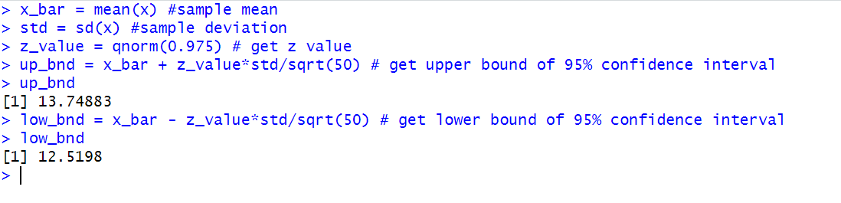

From R we can see that our calculation is extremely close to r result, so the confidence interval in R is (12.5198,13.74883).

3. Test the hypothesis that the sample is from a population of penguins with a mean weight of 13.5. Specify the p-value of the test and your interpretation on the test results.

Solution:

(1) By hand:

Null hypothesis: $μ=13.5$

Alternate hypothesis: $μ≠13.5$

Let $α$ value be 0.05 for this two-tail test. (This means p-value cannot smaller than 0.05, otherwise we have enough confidence to reject the null hypothesis,)

$Z_{\frac{0.05}{2}}= ±1.96$

By using the mean of this sample, we need to know the Z value of this sample mean.

$Z_{test}= \frac{x- μ}{σ/\sqrt{n}}=\frac{13.1343 - 13.5}{2.217/\sqrt{50}}= -1.1664$

$P_{value}=2*Φ^{-1}\left(x= -1.1664\right)=0.2434$

Because test score is -1.1664, it’s not less than -1.96 and it’s not larger than 1.96. Also p-value is larger than 0.05. So, We do not have enough evidence to reject the null hypothesis.

(2) Using R coding:

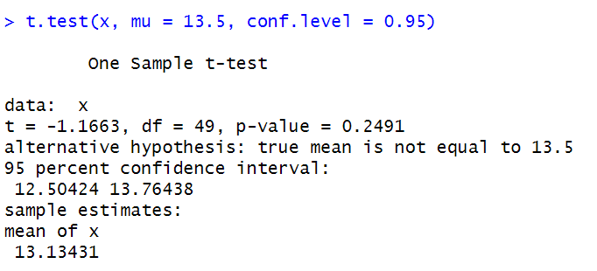

In this outcome, we can see that the p-value is 0.2491 and it is not less than 0.05. So, we do not reject null hypothesis.