Assignment #3: Test MSE and Model Complexity

Coding： 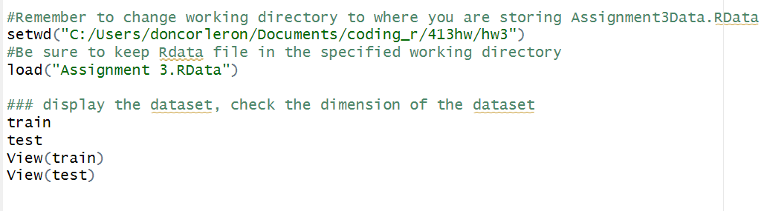

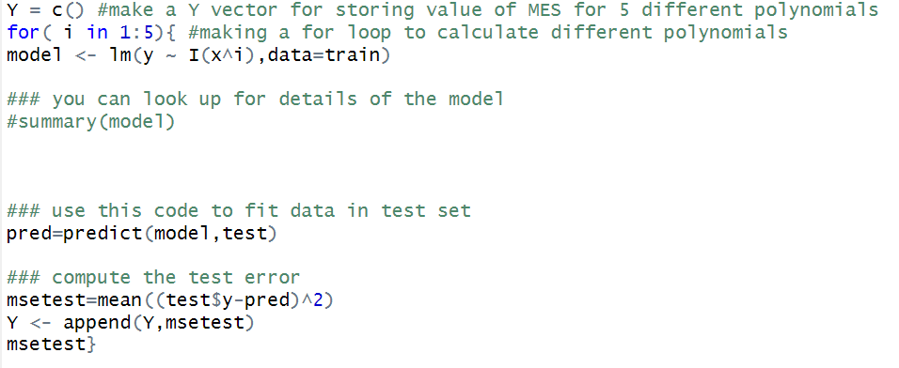

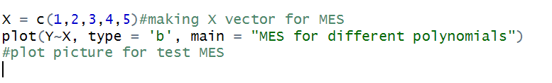

Plot:

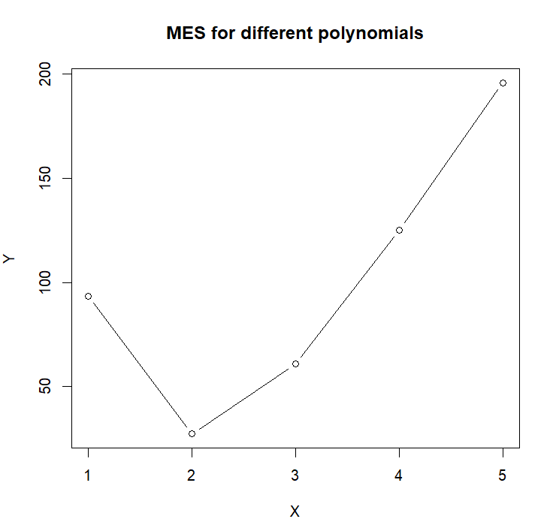

Analysis: As a data scientist, I would prefer with polynomials of degree 2. Because when the degree is 2, it has lowest test mean squared error. And for the best prediction performance, we will select the method that will lead lowest test MSE. Therefore when the degree is 2, the prediction will be the most accuracy one.