Chen Yang UFid:52109967

1. No, cuz the choose of miu value is different
2. Yes, cuz the value of M will cause the overfitting if M is too big
3. The ideal value of s is 1, s represents the standatd deviation ,
4. The choice of s affects the result of normalization if s is too large, the

Training data

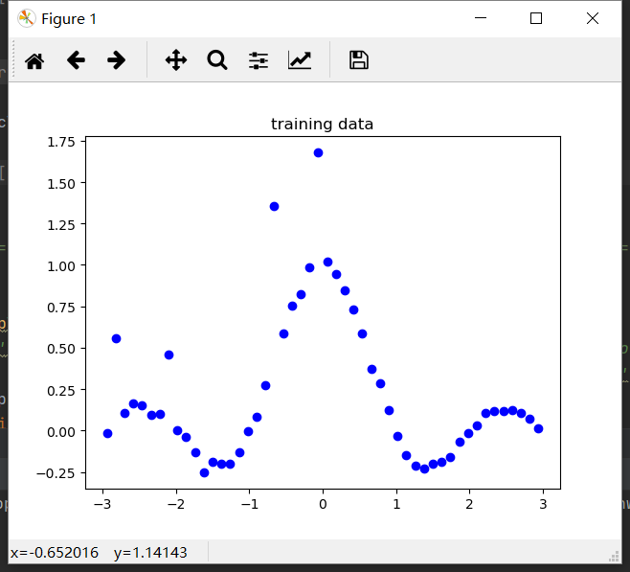

True Function

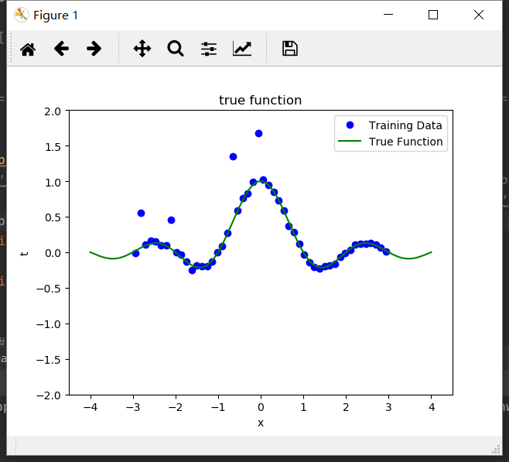

True Function vs Polynomial

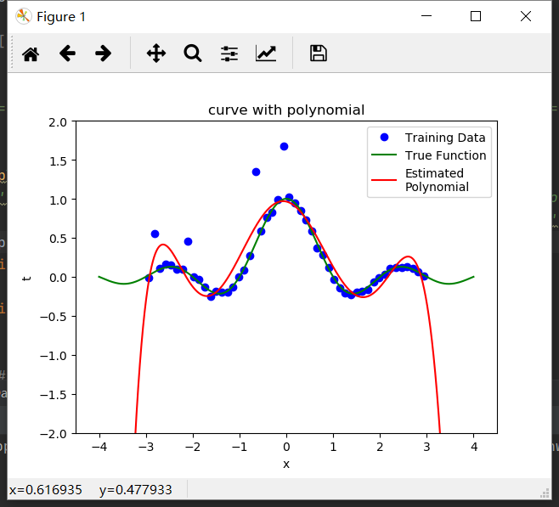

RBF evenly spaced means

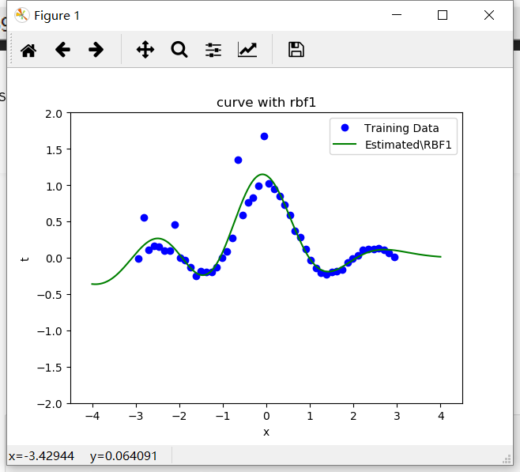

RBF training data means

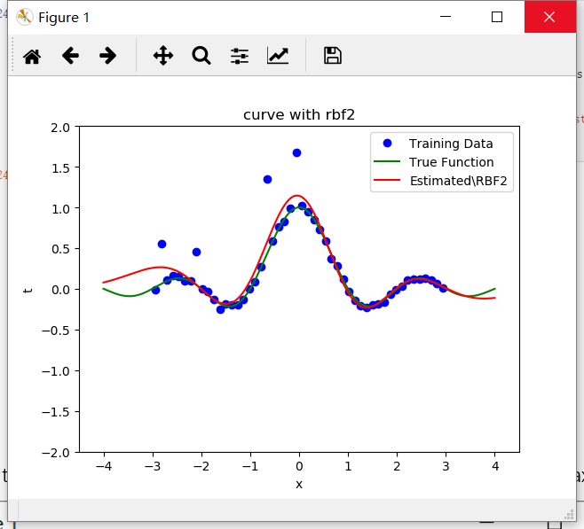

M value on the x-axis and the absolute error (|y-t|) on the Test data on the y-axis

