中国海洋大学 计算机科学与技术系
实验报告
姓名： 陈扬 学号：17150011001 专业：计算机
科目：计算机系统原理 题目：Data Lab的实验
实验时间: 2018 年 11月 6 日
实验成绩: 实验教师: 梁瑶小姐姐

一、实验目的：
1更好地熟悉和掌握计算机中整数和浮点数的二进制编码表示。
2.实验中使用有限类型和数量的运算操作实现一组给定功能的函数,在此过程中加深对数据二进制编码表示的了解
3. 熟悉linux基本操作命令，其中常用工具和程序开发环境
4.完善bits.c的各个函数，实现其功能，并通过.btest的测试
二、实验要求
1. 尽快熟悉linux基本操作命令，还有其中常用工具和程序开发环境
2. 除浮点数函数实现外，只能使用顺序程序结构，禁用if, do, while, for, switch等。
- 有限操作类型，！ ~ & ^ | + << >> 各函数不一样
- 禁用（！=、==、&&、|| 等组合操作符）
- 常量值范围 0~255
- 禁用强制类型转换
- 禁用整型外的任何其它数据类型
- 禁用定义和宏
- 不得使用函数
- 具体要求可参看bits.c各函数框架的注释
- 可以使用循环和条件控制；
- 可以使用整型和无符号整型常量及变量（取值不受[0,255]限制）；
- 不使用任何浮点数据类型、操作及常量。
- 可以使用int和unsigned两种整型数据
- 禁用浮点数据类型、struct、union或数组结构。
- 浮点数函数均使用unsigned型数据表示浮点数据。
- float_abs等函数必须能处理全范围的变量值，包括(NaN)和infinity。
三、实验内容（所修改函数代码，功能以及重要代码的解释）：
主要操作内容：位操作函数; 补码运算函数; 浮点数表示函数
/*
* CS:APP Data Lab
*
* <Please put your name and userid here>
*
* bits.c - Source file with your solutions to the Lab.
* This is the file you will hand in to your instructor.
*
* WARNING: Do not include the <stdio.h> header; it confuses the dlc
* compiler. You can still use printf for debugging without including
* <stdio.h>, although you might get a compiler warning. In general,
* it's not good practice to ignore compiler warnings, but in this
* case it's OK.
*/

#if 0
/*
* Instructions to Students:
*
* STEP 1: Read the following instructions carefully.
*/

You will provide your solution to the Data Lab by
editing the collection of functions in this source file.

INTEGER CODING RULES:

Replace the "return" statement in each function with one
or more lines of C code that implements the function. Your code
must conform to the following style:

int Funct(arg1, arg2, ...) {
/* brief description of how your implementation works */
int var1 = Expr1;
...
int varM = ExprM;

varJ = ExprJ;
...
varN = ExprN;
return ExprR;
}

Each "Expr" is an expression using ONLY the following:
1. Integer constants 0 through 255 (0xFF), inclusive. You are
not allowed to use big constants such as 0xffffffff.
2. Function arguments and local variables (no global variables).
3. Unary integer operations ! ~
4. Binary integer operations & ^ | + << >>

Some of the problems restrict the set of allowed operators even further.
Each "Expr" may consist of multiple operators. You are not restricted to
one operator per line.

You are expressly forbidden to:
1. Use any control constructs such as if, do, while, for, switch, etc.
2. Define or use any macros.
3. Define any additional functions in this file.
4. Call any functions.
5. Use any other operations, such as &&, ||, -, or ?:
6. Use any form of casting.
7. Use any data type other than int. This implies that you
cannot use arrays, structs, or unions.

You may assume that your machine:
1. Uses 2s complement, 32-bit representations of integers.
2. Performs right shifts arithmetically.
3. Has unpredictable behavior when shifting an integer by more
than the word size.

EXAMPLES OF ACCEPTABLE CODING STYLE:
/*
* pow2plus1 - returns 2^x + 1, where 0 <= x <= 31
*/
int pow2plus1(int x) {
/* exploit ability of shifts to compute powers of 2 */
return (1 << x) + 1;
}

/*
* pow2plus4 - returns 2^x + 4, where 0 <= x <= 31
*/
int pow2plus4(int x) {
/* exploit ability of shifts to compute powers of 2 */
int result = (1 << x);
result += 4;
return result;
}

FLOATING POINT CODING RULES

For the problems that require you to implent floating-point operations,
the coding rules are less strict. You are allowed to use looping and
conditional control. You are allowed to use both ints and unsigneds.
You can use arbitrary integer and unsigned constants.

You are expressly forbidden to:
1. Define or use any macros.
2. Define any additional functions in this file.
3. Call any functions.
4. Use any form of casting.
5. Use any data type other than int or unsigned. This means that you
cannot use arrays, structs, or unions.
6. Use any floating point data types, operations, or constants.

NOTES:
1. Use the dlc (data lab checker) compiler (described in the handout) to
check the legality of your solutions.
2. Each function has a maximum number of operators (! ~ & ^ | + << >>)
that you are allowed to use for your implementation of the function.
The max operator count is checked by dlc. Note that '=' is not
counted; you may use as many of these as you want without penalty.
3. Use the btest test harness to check your functions for correctness.
4. Use the BDD checker to formally verify your functions
5. The maximum number of ops for each function is given in the
header comment for each function. If there are any inconsistencies
between the maximum ops in the writeup and in this file, consider
this file the authoritative source.

/*
* STEP 2: Modify the following functions according the coding rules.
*
* IMPORTANT. TO AVOID GRADING SURPRISES:
* 1. Use the dlc compiler to check that your solutions conform
* to the coding rules.
* 2. Use the BDD checker to formally verify that your solutions produce
* the correct answers.
*/

#endif
/* Copyright (C) 1991-2016 Free Software Foundation, Inc.
This file is part of the GNU C Library.

The GNU C Library is free software; you can redistribute it and/or
modify it under the terms of the GNU Lesser General Public
License as published by the Free Software Foundation; either
version 2.1 of the License, or (at your option) any later version.

The GNU C Library is distributed in the hope that it will be useful,
but WITHOUT ANY WARRANTY; without even the implied warranty of
MERCHANTABILITY or FITNESS FOR A PARTICULAR PURPOSE. See the GNU
Lesser General Public License for more details.

You should have received a copy of the GNU Lesser General Public
License along with the GNU C Library; if not, see
<http://www.gnu.org/licenses/>. */
/* This header is separate from features.h so that the compiler can
include it implicitly at the start of every compilation. It must
not itself include <features.h> or any other header that includes
<features.h> because the implicit include comes before any feature
test macros that may be defined in a source file before it first
explicitly includes a system header. GCC knows the name of this
header in order to preinclude it. */
/* glibc's intent is to support the IEC 559 math functionality, real
and complex. If the GCC (4.9 and later) predefined macros
specifying compiler intent are available, use them to determine
whether the overall intent is to support these features; otherwise,
presume an older compiler has intent to support these features and
define these macros by default. */
/* wchar_t uses Unicode 9.0.0. Version 9.0 of the Unicode Standard is
synchronized with ISO/IEC 10646:2014, fourth edition, plus
Amd. 1 and Amd. 2 and 273 characters from forthcoming 10646, fifth edition.
(Amd. 2 was published 2016-05-01,
see https://www.iso.org/obp/ui/#iso:std:iso-iec:10646:ed-4:v1:amd:2:v1:en) */
/* We do not support C11 <threads.h>. */
/*
* lsbZero - set 0 to the least significant bit of x
* Example: lsbZero(0x87654321) = 0x87654320
* Legal ops: ! ~ & ^ | + << >>
* Max ops: 5
* Rating: 1
*/
* lsbZero - 将0设置为x的最低有效位
*示例：lsbZero（0x87654321）= 0x87654320
*法律操作：！〜＆^ | + << >>
int lsbZero(int x) {
return (x>>1)<<1;
}
/*
* byteNot - bit-inversion to byte n from word x
* Bytes numbered from 0 (LSB) to 3 (MSB)
* Examples: getByteNot(0x12345678,1) = 0x1234A978
* Legal ops: ! ~ & ^ | + << >>
* Max ops: 6
* Rating: 2
*/
设计思想：先将X向右移动一位，再向左移动一位，则最右为0并且如果先右移再左移，X的符号位不受影响。
* byteNot - 从字x到字节n的位反转
*从0（LSB）到3（MSB）编号的字节

int byteNot(int x, int n) {
int tmp=0xff;
tmp=tmp<<(n<<3);
return x^tmp;
}
/*
* byteXor - compare the nth byte of x and y, if it is same, return 0, if not, return 1

* example: byteXor(0x12345678, 0x87654321, 1) = 1

* byteXor(0x12345678, 0x87344321, 2) = 0
* Legal ops: ! ~ & ^ | + << >>
* Max ops: 20
* Rating: 2
*/
设计思想：考虑到位运算异或的特性（与1异或相当于取反，与0异或相当于不作操作）构造一个32位的数字，先用0xff的向左移动N * 8位，使得该32位数字只有在要替换的字节是1，其他位上为0。然后用这个数字与X做异或运算，得到的数字即为满足要求的结果。

int byteXor(int x, int y, int n) {
int temp;
temp = ((x^y)>>(n<<3))&0xff;
return !!temp;
return 2;
}
/*
* logicalAnd - x && y
* Legal ops: ! ~ & ^ | + << >>
* Max ops: 20
* Rating: 3
*/
设计思想：该函数的目的是实现比较X和ý的某一个字节上的数字是否相同，相同返回0，否则返回1.那么考虑到异或运算的特点（相同数字异或结果为0，不同数字异或结果为1），我们可以判断两个数字各位异或之后，指定字节是否为0。如果为0，则返回0，如果不为0，则返回1。

int logicalAnd(int x, int y) {
int temp=(!!x)&(!!y);
return temp;
}
/*
* logicalOr - x || y
* Legal ops: ! ~ & ^ | + << >>
* Max ops: 20
* Rating: 3
*/
/ *
设计思想：该函数的目的是实现逻辑与逻辑与的特点是两个操作数，如果有一个为0，则返回0。只有当两个操作数都为非零数字时，才返回1.那么我们可以将X和Y ^分别做逻辑非，判断X和Ÿ是否为0。只有当X和Ÿ都为非零数字时，X |！Y！才为0，此时做（（X！|！ Y）^ 0）得到的数字才为1。
* /

int logicalOr(int x, int y) {
int temp=(!!x)|(!!y);
return temp;
}
/*
* rotateLeft - Rotate x to the left by n
* Can assume that 0 <= n <= 31
* Examples: rotateLeft(0x87654321,4) = 0x76543218
* Legal ops: ~ & ^ | + << >> !
* Max ops: 25
* Rating: 3
*/
/ *
设计思想：该函数的目的是实现逻辑或考虑到逻辑或的特点，两个操
作数有一个为1，则结果为1，设计思路与上题相似。
* /

int rotateLeft(int x, int n) {
int L;
int R;
L=x<<n;
R=(x>>(32+(~n)+1))&~((~0)<<n);
return L|R;
}
/*
* parityCheck - returns 1 if x contains an odd number of 1's
* Examples: parityCheck(5) = 0, parityCheck(7) = 1
* Legal ops: ! ~ & ^ | + << >>
* Max ops: 20
* Rating: 4
*/
/ *
设计思想：先通过左移获得低位的数字作为答案的高位，再通过
右移32-n的位获得高位的数字作为答案的低位，然后按位与，获得答案，返回答案。
* /

int parityCheck(int x) {
x=x^(x>>16);
x=x^(x>>8);
x=x^(x>>4);
x=x^(x>>2);
x=x^(x>>1);
x=x&0x1;
return x;
return 2;
}
/*
* mul2OK - Determine if can compute 2*x without overflow
* Examples: mul2OK(0x30000000) = 1
* mul2OK(0x40000000) = 0
*
* Legal ops: ~ & ^ | + << >>
* Max ops: 20
* Rating: 2
*/
/ *
设计思想：该函数的目的是检查X二进制表示，其中1的个数是
计数还是偶数。考虑到异或的特点（相同数字异或结果为0时，不
同数字异或结果为1），我们每次折半处理，偶数个1抵消变为0，
最后考虑末尾是1还是0即可达到目的。
* /

int mul2OK(int x) {
int tmp=(x>>31)&0x1;
int tmpe=((x<<1)>>31)&0x1;
int eq=(~(tmp^tmpe))&0x1;
return eq;
return 2;
}
/*
* mult3div2 - multiplies by 3/2 rounding toward 0,
* Should exactly duplicate effect of C expression (x*3/2),
* including overflow behavior.
* Examples: mult3div2(11) = 16
* mult3div2(-9) = -13
* mult3div2(1073741824) = -536870912(overflow)
* Legal ops: ! ~ & ^ | + << >>
* Max ops: 12
* Rating: 2
*/
/ *
设计思想：获得X和2倍的符号位，比较是否相等，如果没溢出，如果不相等，则溢出。
* /

int mult3div2(int x) {
int tmp=x;
x=(x<<1)+tmp;
int low=x&0x1;
int fuhao=(x>>31)&0x1;
x=x>>1;
x+=(low&fuhao);
return x ;
}
/*
* subOK - Determine if can compute x-y without overflow
* Example: subOK(0x80000000,0x80000000) = 1,
* subOK(0x80000000,0x70000000) = 0,
* Legal ops: ! ~ & ^ | + << >>
* Max ops: 20
* Rating: 3
*/
/ *
设计思想：通过一个偏置量的操作来对数字处理，如果是正数，
则加0，否则加1，然后向右移动1位实现除以2的操作。
* /

int subOK(int x, int y) {
int tmp=x+(~y+1);
int ans=!(((tmp^x)&(x^y))>>31);
return ans;
}
/*

* absVal - absolute value of x
* Example: absVal(-1) = 1.
* You may assume -TMax <= x <= TMax
* Legal ops: ! ~ & ^ | + << >>
* Max ops: 10
* Rating: 4
*/
/ *
设计思想：将减法转化为加一个补码，如果两个加数的符号位
相同，而与它们的和的符号位不同，发生溢出，否则没有溢出
* /

int absVal(int x) {
int fuhao=(x>>31)&0x1;
int m=fuhao+~0x0;
x=(m&x)|(~m&(~x+1));
return x;
}
/*
* float_abs - Return bit-level equivalent of absolute value of f for
* floating point argument f.
* Both the argument and result are passed as unsigned int's, but
* they are to be interpreted as the bit-level representations of
* single-precision floating point values.
* When argument is NaN, return argument..
* Legal ops: Any integer/unsigned operations incl. ||, &&. also if, while
* Max ops: 10
* Rating: 2
*/
/ *
设计思想：如果是正数则不做处理，否则取反码加1转化为原码，将符号位变为0
* /

unsigned float_abs(unsigned uf) {
unsigned temp = (uf >> 23) & 0xFF;
unsigned frac = uf & 0x7FFFFF;
if ((temp == 0xFF) && (frac != 0)) {
return uf;
}
return uf&(~((1)<<31));
}
/*
* float_f2i - Return bit-level equivalent of expression (int) f
* for floating point argument f.
* Argument is passed as unsigned int, but
* it is to be interpreted as the bit-level representation of a
* single-precision floating point value.
* Anything out of range (including NaN and infinity) should return
* 0x80000000u.
* Legal ops: Any integer/unsigned operations incl. ||, &&. also if, while
* Max ops: 30
* Rating: 4
*/
int float_f2i(unsigned uf) {
Return 2;
}

四、实验结果（在虚拟机中，进行语法检查，编译，正确性检查的截图）：

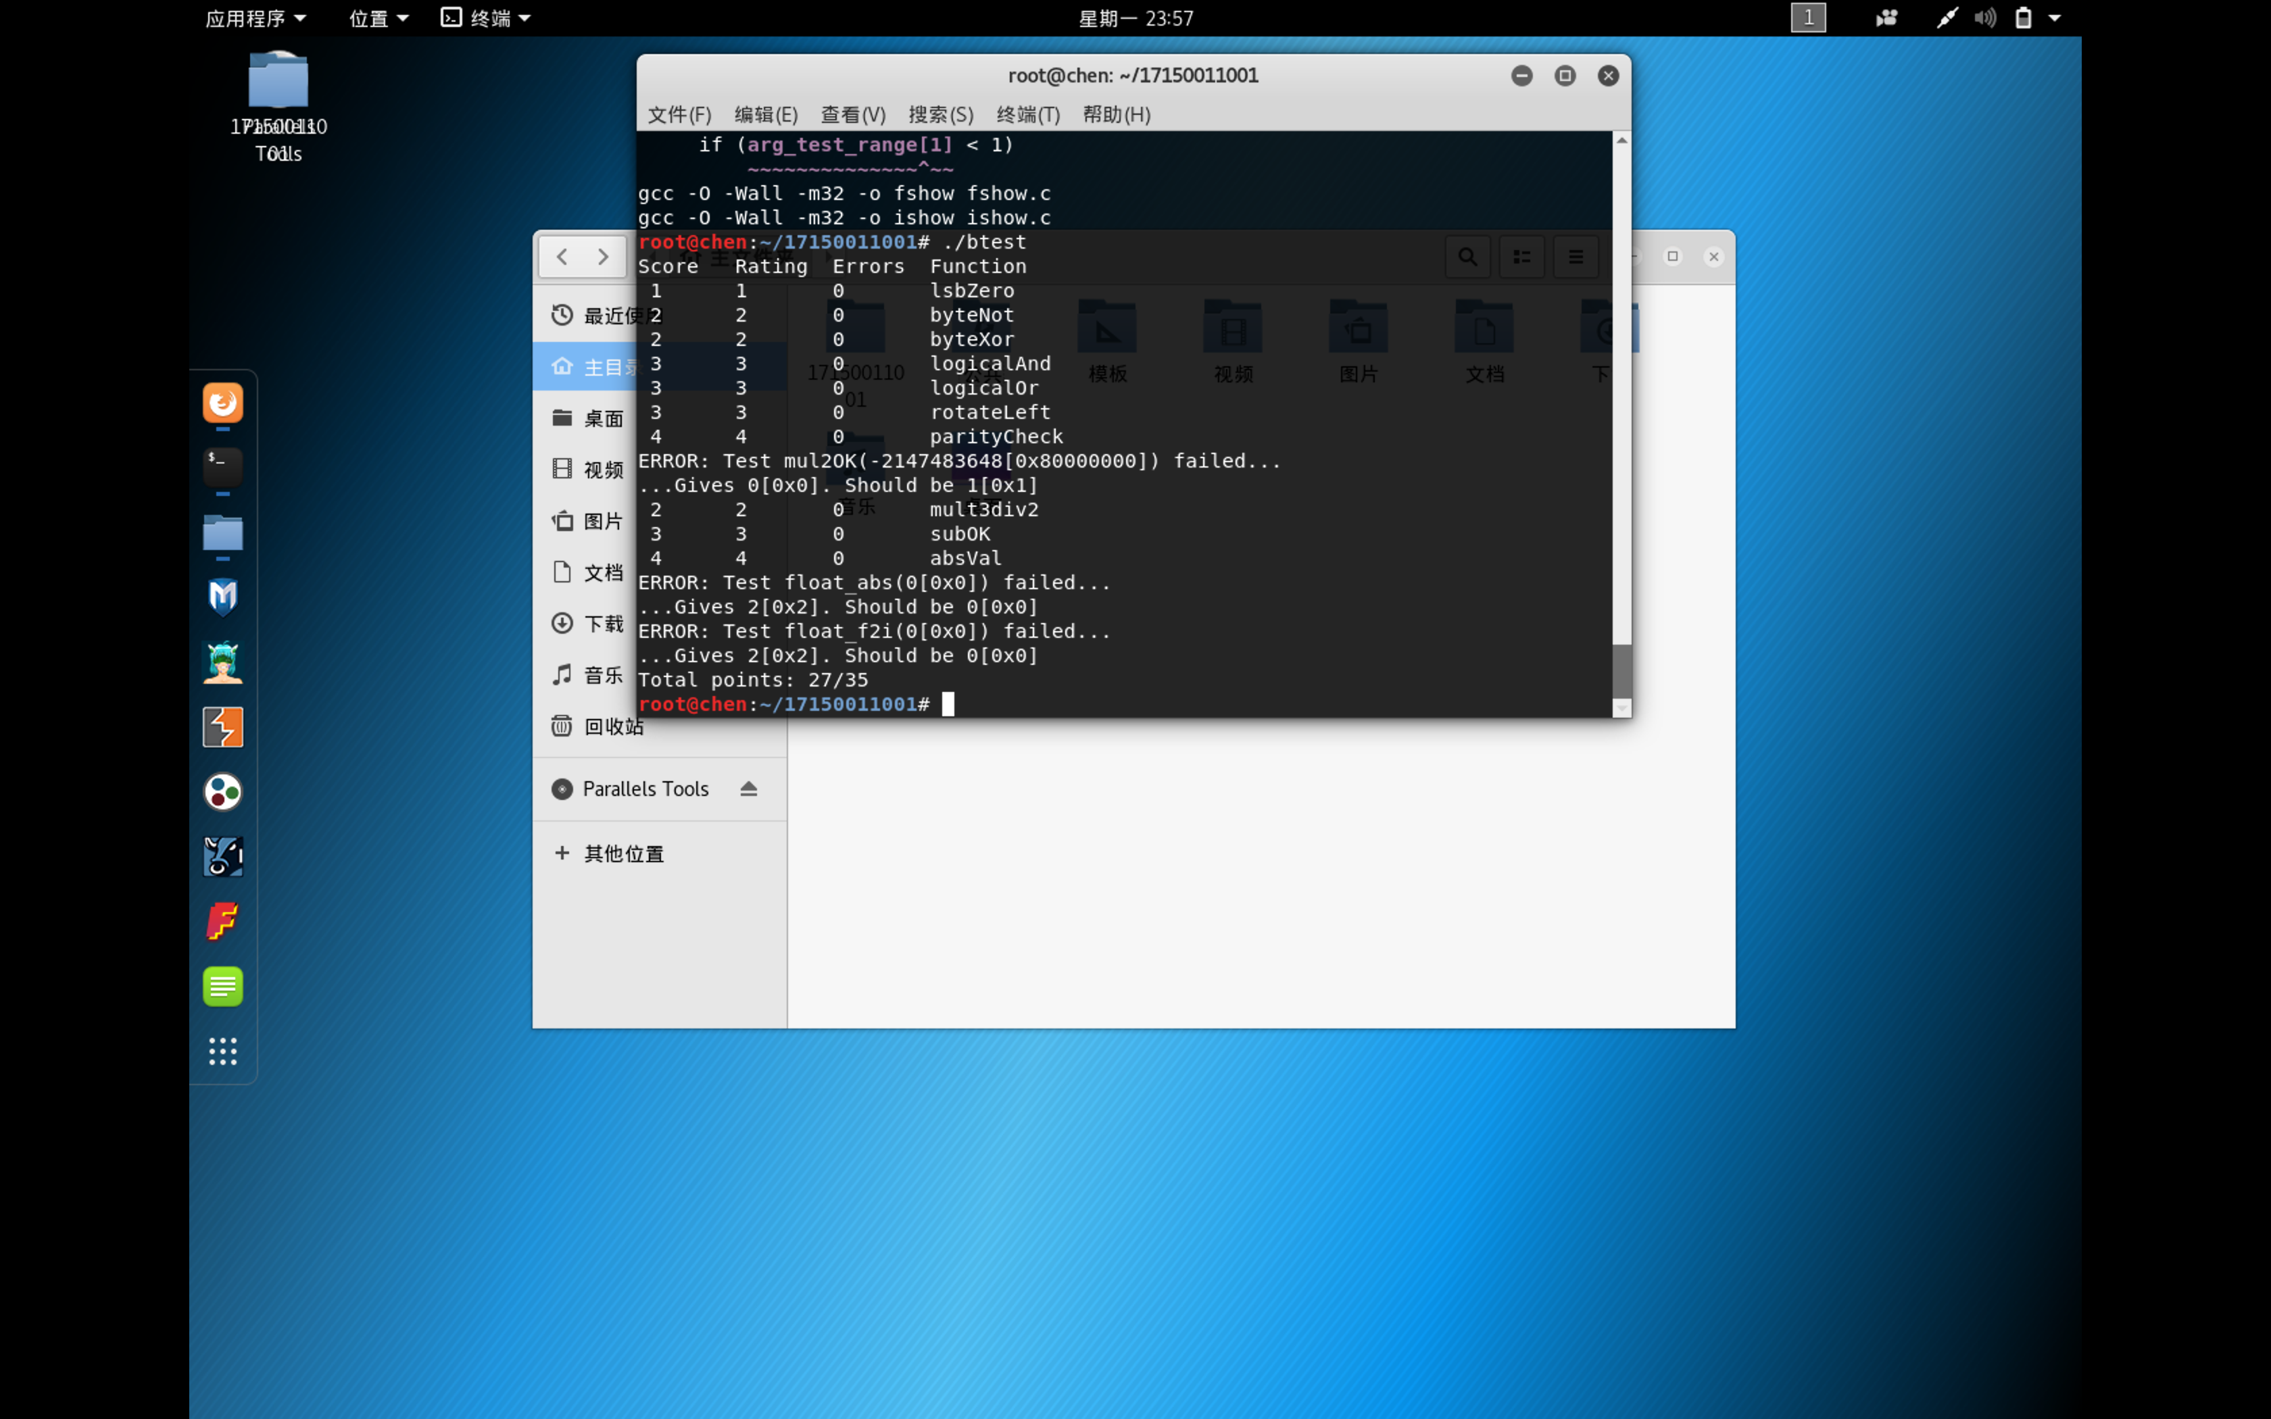

五、实验总结

在实验中，我明明在学校的电脑上可以跑的通30分，在自己的虚拟机上却有一个编译后过不了，我实在是没搞懂我的parallels 为什么装kali会这样，最后两个float的实验做不了了，老师我前面的可以过是真的，解释在代码里面了。

