Lecture_2_Assignment

Chen, Yen-Ting

2021/10/5

# Exponential Population Growth with Constant Immigration

pacman::p_load(dplyr,tidyr,  
 ggplot2,  
 deSolve)

## Q1

You are a curious student in the Introduction to Theoretical Ecology course. After the class, you decide to do a small experiment on population growth. You set up a “massive” fish tank and introduce $N_{0}$ flatworm individuals. Also, each day you add I new individuals into the tank, hoping that the population will increase faster. Assuming that the intrinsic rate of increase is r (per day) and there is no factor limiting the growth and reproduction of these flatworms, the population dynamics can be described by the following differential equation:

$$\frac{dN}{dt}=rN+I$$

The analytical solution to this differential equation is:

$$N=N_{0}e^{rt}+(e^{rt}−1)\frac{I}{r}$$

Please use what you have learned in the lecture to derive the solution for this differential equation step by step. (You can either write down the answer on a paper and embed a picture of it or directly type the equations in Word.)

### Solution

To find $N_{t}$, I first rearranged the variables and then integrated both sides of the equation.

$$\frac{1}{(rN+I)} dN=dt$$

$$∫\frac{1}{(rN+I)} dN=∫dt$$

For the left hand side, I substituted the $rN+I$ term with $u$ to get a new differentials $du$; for the right hand side, the integration is simply all the increments $dt$ being summed up, thereby $t$;

$$u=rN+I$$

$$du=r dN$$

$$∫\frac{1}{ru}du=∫dt$$

After the method of substitution and lifting the natural log, the result is clear

$$\frac{1}{r}\text{ln}(rN+I)=t+c$$

$$rN+I=e^{rt}e^{rc}$$

Rearranging the equation, we can get the equation of population size of all time $t$.

$$N=(e^{rt}e^{rc}−I)/r$$

Despite the effort for deriving the equation, there is an ambiguous $c$ term in the equation which can not help us generalize the result. To resolve the ambiguity of the result, we can plugin $t=0$ for calculating the initial condition of the population.

$$\text{Let t = 0}$$

$$N_{0}=(e^{rc}−I)/r$$

If $N_{0}$ is a known constant then the ambiguous term $e^{rc}$ is equal to $rN_{0}+I$. After defining all these terms, I can finally close this question by plug in all the terms:

$$N_{t}=(e^{rt}(rN_{0}+I)−I)/r$$

Rearranging the above equation we can get the solution:

$$N_{t}=e^{rt}N_{0}+(e^{rt}−1)\frac{I}{r}$$

This equation tells us that the population size $N$ at time $t$ is related to the initial condition $N_{0}$, the population growth rate $r$, and the constant immigration rate $I$. The behavior of this equation is explored in the subsequent questions.

P.S. Thanks Chueh-Chen for brushing up my Calculus.

## Q2

Suppose that $N_{0}$ = 10,, $r$ = 1.2, and $I$ = 3. How will the flatworm population change over a week? Solve the differential equation numerically and visualize the population trajectory. Please show the figure along with the R code you used to generate the results.

# set up an equation  
exp_g <- function(time, y, parms){  
 with(as.list(c(parms, y)), {  
 dN_dt <- r*N  
 return(list(c(dN_dt)))  
 })  
   
 }  
  
time <- seq(0, 30, 0.1)  
y <- c(N = 10)  
parms <- c(r = 1.2,  
 I = 3)  
  
pop_size <-  
 ode(func = exp_g,  
 y = y,  
 times = time,  
 parms = parms)  
head(pop_size)

## time N  
## [1,] 0.0 10.00000  
## [2,] 0.1 11.27497  
## [3,] 0.2 12.71250  
## [4,] 0.3 14.33330  
## [5,] 0.4 16.16075  
## [6,] 0.5 18.22120

### Visualization

ggplot(as.data.frame(pop_size), aes(x = time, y = N)) +  
 geom_line(linetype = 2, alpha = 0.3) +  
 geom_point()

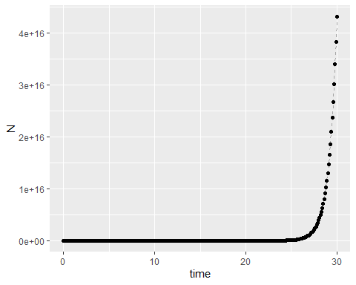

## Q3

Compare the population growth with and without constant immigration and explain the model dynamics in your own words. How does the constant immigration term $I$ affect the population dynamics? Do you think your daily addition of new flatworm individuals make a big difference?

# set up an equation  
exp_g <- function(time, y, parms){  
 with(as.list(c(parms, y)), {  
 with_I <- r*N1 + I  
 no_I <- r*N2  
 return(list(c(with_I, no_I)))  
 })  
   
 }  
  
time <- seq(0, 100, 0.1)  
y <- c(N1 = 10, N2 = 10)  
parms <- c(r = 1.2,  
 I = 3)  
  
pop_size <-  
 ode(func = exp_g,  
 y = y,  
 times = time,  
 parms = parms)  
head(pop_size)

## time N1 N2  
## [1,] 0.0 10.00000 10.00000  
## [2,] 0.1 11.59371 11.27497  
## [3,] 0.2 13.39062 12.71250  
## [4,] 0.3 15.41662 14.33330  
## [5,] 0.4 17.70094 16.16075  
## [6,] 0.5 20.27649 18.22120

### Visualization

as.data.frame(pop_size) %>%   
 pivot_longer(cols = c("N1", "N2"), names_to = "variables", values_to = "values") %>%   
 ggplot(aes(x = time, y = values, color = variables)) +  
 geom_line(linetype = 2, alpha = 0.3) +  
 ylab("Linear scale") +  
 geom_point() +  
 ggtitle("Whole time frame")

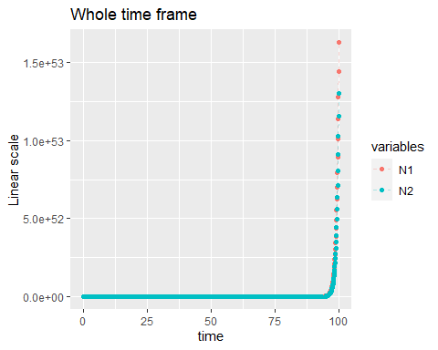

Figure 1.

as.data.frame(pop_size) %>%   
 filter(time <= 5) %>%   
 pivot_longer(cols = c("N1", "N2"), names_to = "variables", values_to = "values") %>%   
 ggplot(aes(x = time, y = values, color = variables)) +  
 geom_line(linetype = 2, alpha = 0.3) +  
 ylab("Linear scale") +  
 geom_point() +  
 ggtitle("Time frame t = 0~5")#+

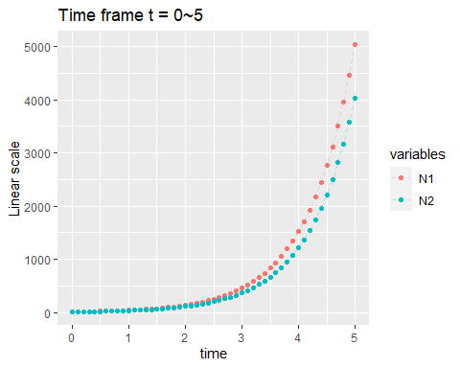

# scale_y_log10()

figure

as.data.frame(pop_size) %>%   
 filter(time >= 95) %>%   
 pivot_longer(cols = c("N1", "N2"), names_to = "variables", values_to = "values") %>%   
 ggplot(aes(x = time, y = values, color = variables)) +  
 geom_line(linetype = 2, alpha = 0.3) +  
 ylab("Linear scale") +  
 geom_point() +  
 ggtitle("Time frame t = 95~100")#+

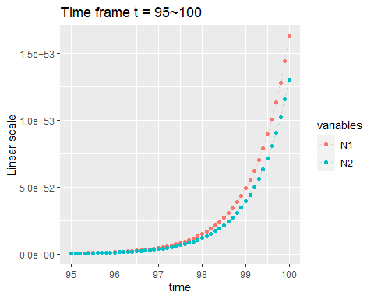

# scale_y_log10()

### Personal comments

Let’s review the equations first. The two populations $N_{1}$ and $N_{2}$ have the same growth rate and unlimited resources. The first population size $N_{1}$ receives a constant inflow of immigrants $I$ while the second population $N_{2}$ do not.

$$N_{t1}=e^{rt}N_{0}+(e^{rt}−1)\frac{I}{r}$$

$$N_{t2}=N_{0}e^{rt}$$

The difference of the two equations suggests that $N_{1}$ will always exceeds $N_{2}$ $(e^{rt}−1)\frac{I}{r}$ individuals whenever $t>0$. Judging the figures, this observation from the equation is true. The general pattern of the two models both demonstrate a exponential growth pattern (fig. 1), with the exact value of $N_{1}$ being “slightly larger” than $N_{2}$. By judging the visuals of the numerical result, the constant influx contributed by immigration have similar proportions of impacts through different points of time (fig. 2, 3).