Breif notes on polychaete composition:

* Taxa > 1% of total polychaete abundance were removed, reducing the total taxa from 101 to 21 (I think).
* The best exp for Box-Cox chord transformation is 0.4.
* PERMANOVA
  + Single-variable and two-way interactions are all significant (p < 0.05)
  + All input factors explains relatively much variance (r2 = 6%-8%, 40% in total).
* Barplot
  + March S7 has the highest contributions of rare taxe (as shown in high contributions of “others”).
  + Genus Sternaspis showed the strongest variations among samples. High loadings of Sternaspis in PCA and RDA also agreed with this pattern.
* PCA
  + First two PCs explained only 30% of the assemblage variation, which I think is not enough to describe the polychaete assemblage.
  + S4 and S5 clumped close together, indicating some degree of sheltering in deeper waters.
  + Huge composition shifts between S3, S6, and S7, showing huge variations in shallower waters.
  + S1 is the outlier of polychaete composition.
* RDA
  + A fairly good model in compare to the low taxonomic resolution RDAs. ~20% of the total variance explained, vif < 10, .
  + Relationships between organic carbon factors (TOC, CN, and Chla) and genuses indicates food quality/quantity control.
  + Porosity is removed from the environmental variable set, indicating sedimentation has limited impact on polychaete turnover.
  + Fluorescence is selected in the model (negative side of RDA1).
* Final remarks
  + I also made figures of DRM for PCA and RDA, but I don’t wanna stuff too much info here.
  + Composition wise, PCA in polychaetes mirrored that in low resolution taxa assemblage. However, the variability in polychaete assemblage is a bit complicated. I might need to examine more PCs.
  + RDA, with high polychaete resolution, showed strong relationships between specific environmental factors and polychaete genus.



Table x. The PERMANOVA table of polychaete assemblage.

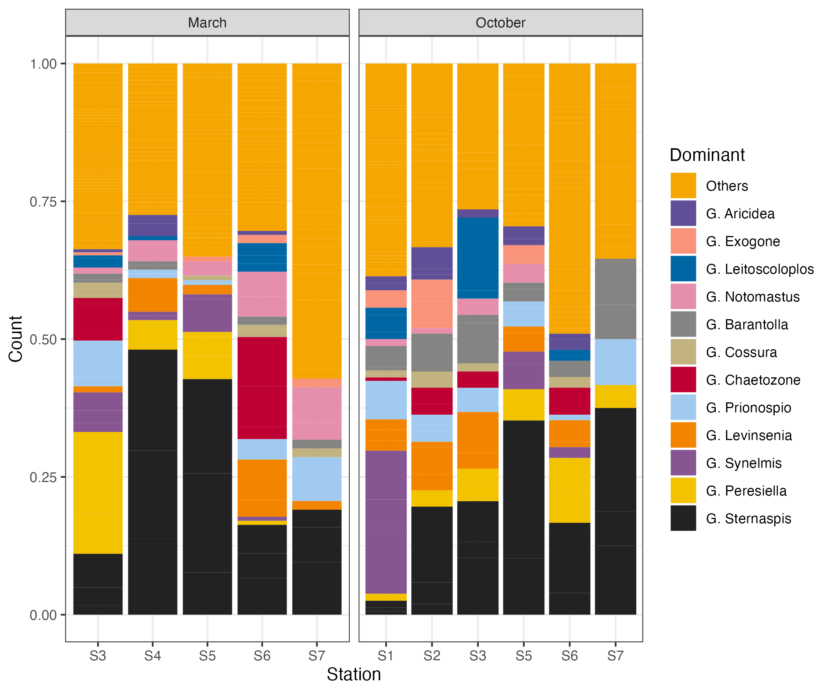

Figure x. The density composition of polychaete genuses. Genuses with density lesser than 1% of the total polychaete abundance is clumped in the “others” category.

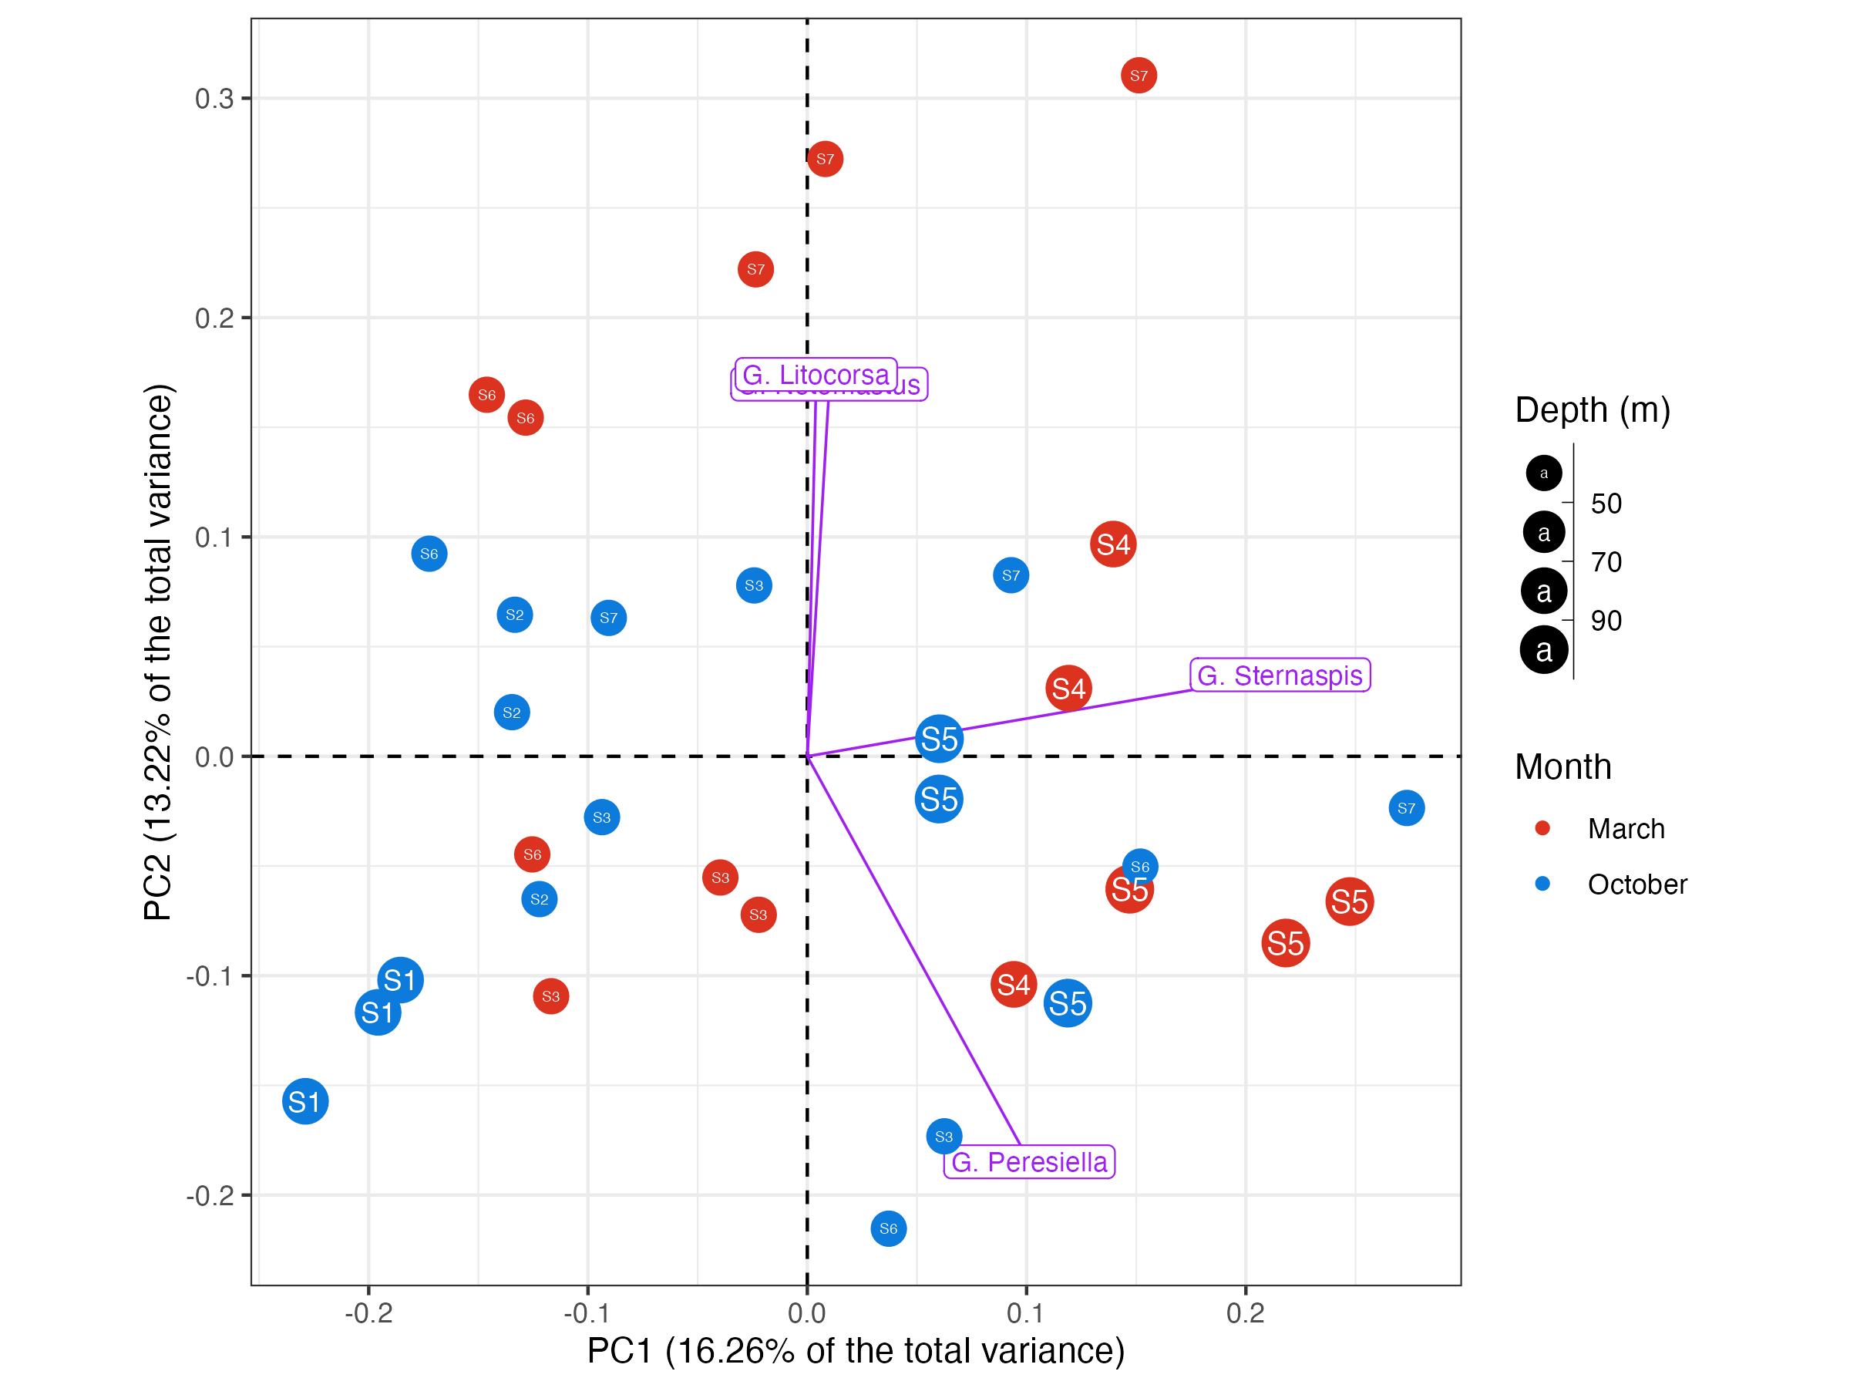

Figure x. The PCA figure of polychaete assemblage. Only genuses with more than 40% variance explained were included.

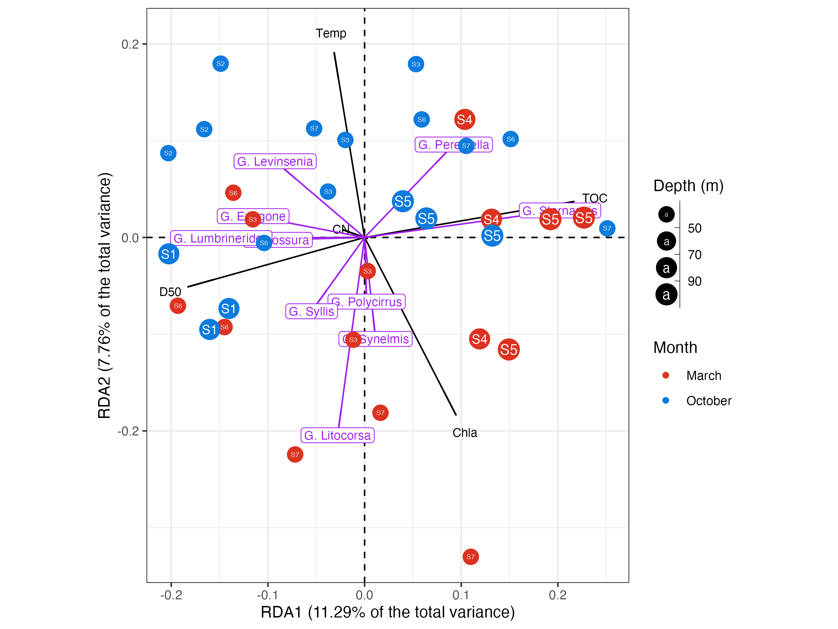

Figure x. The RDA figure of polychaete composition. Fluo, Chla, CN, TOC, Temp, and D50 were selected in the final model.