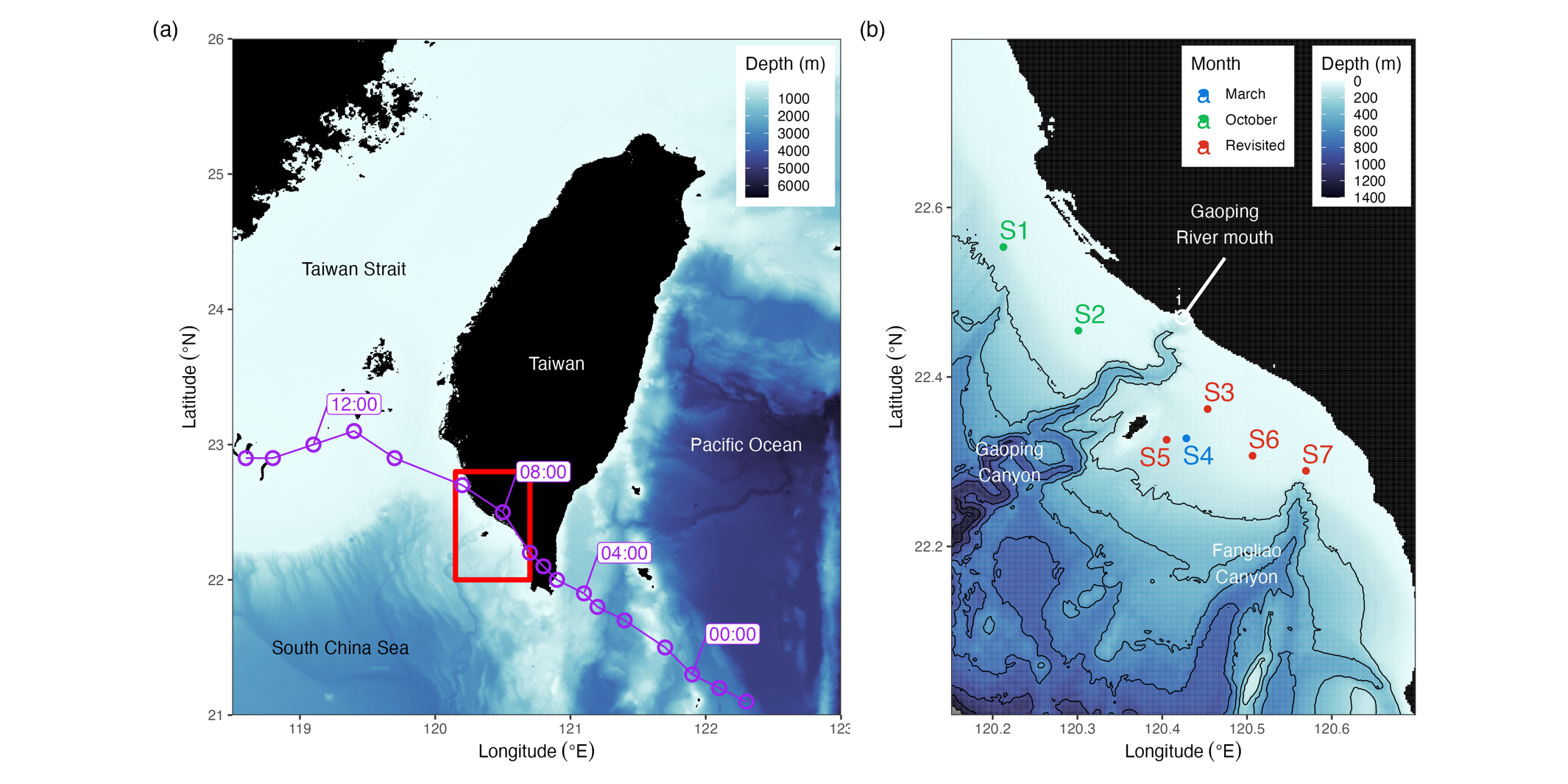

Figure 1. The (a) geographical location of the study area and (b) the sampling sites on the Gaoping Continental Shelf. The track of Typhoon Bailu at UTC August 24th was labeled in purple. The stations visited in March, October, and both of the months were colored in blue, green, and red, respectively.

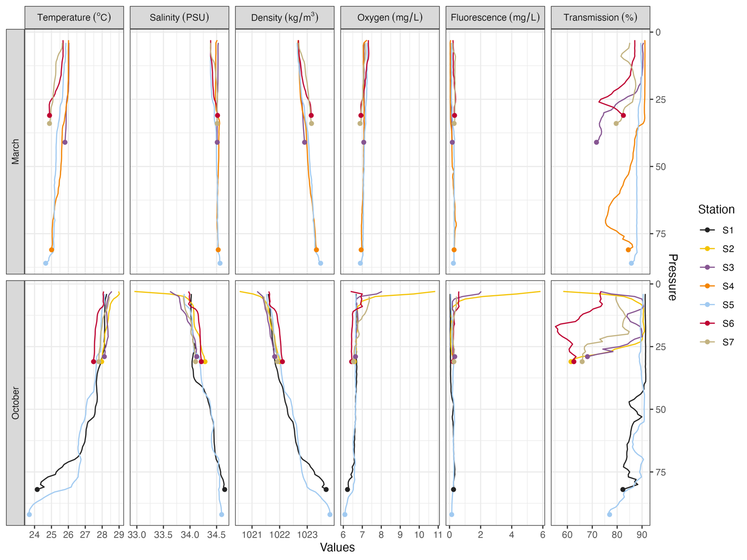

Figure 2. The conductivity-temperature-salinity profiles of all stations.

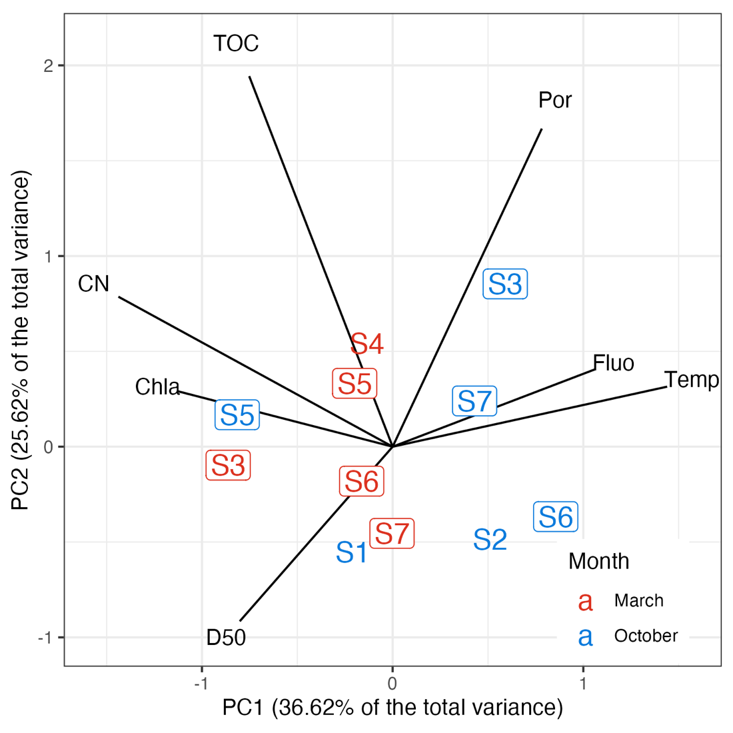

Figure 3. The distance scaling principal component analysis of the selected environmental variables. The revisited statations were padded.

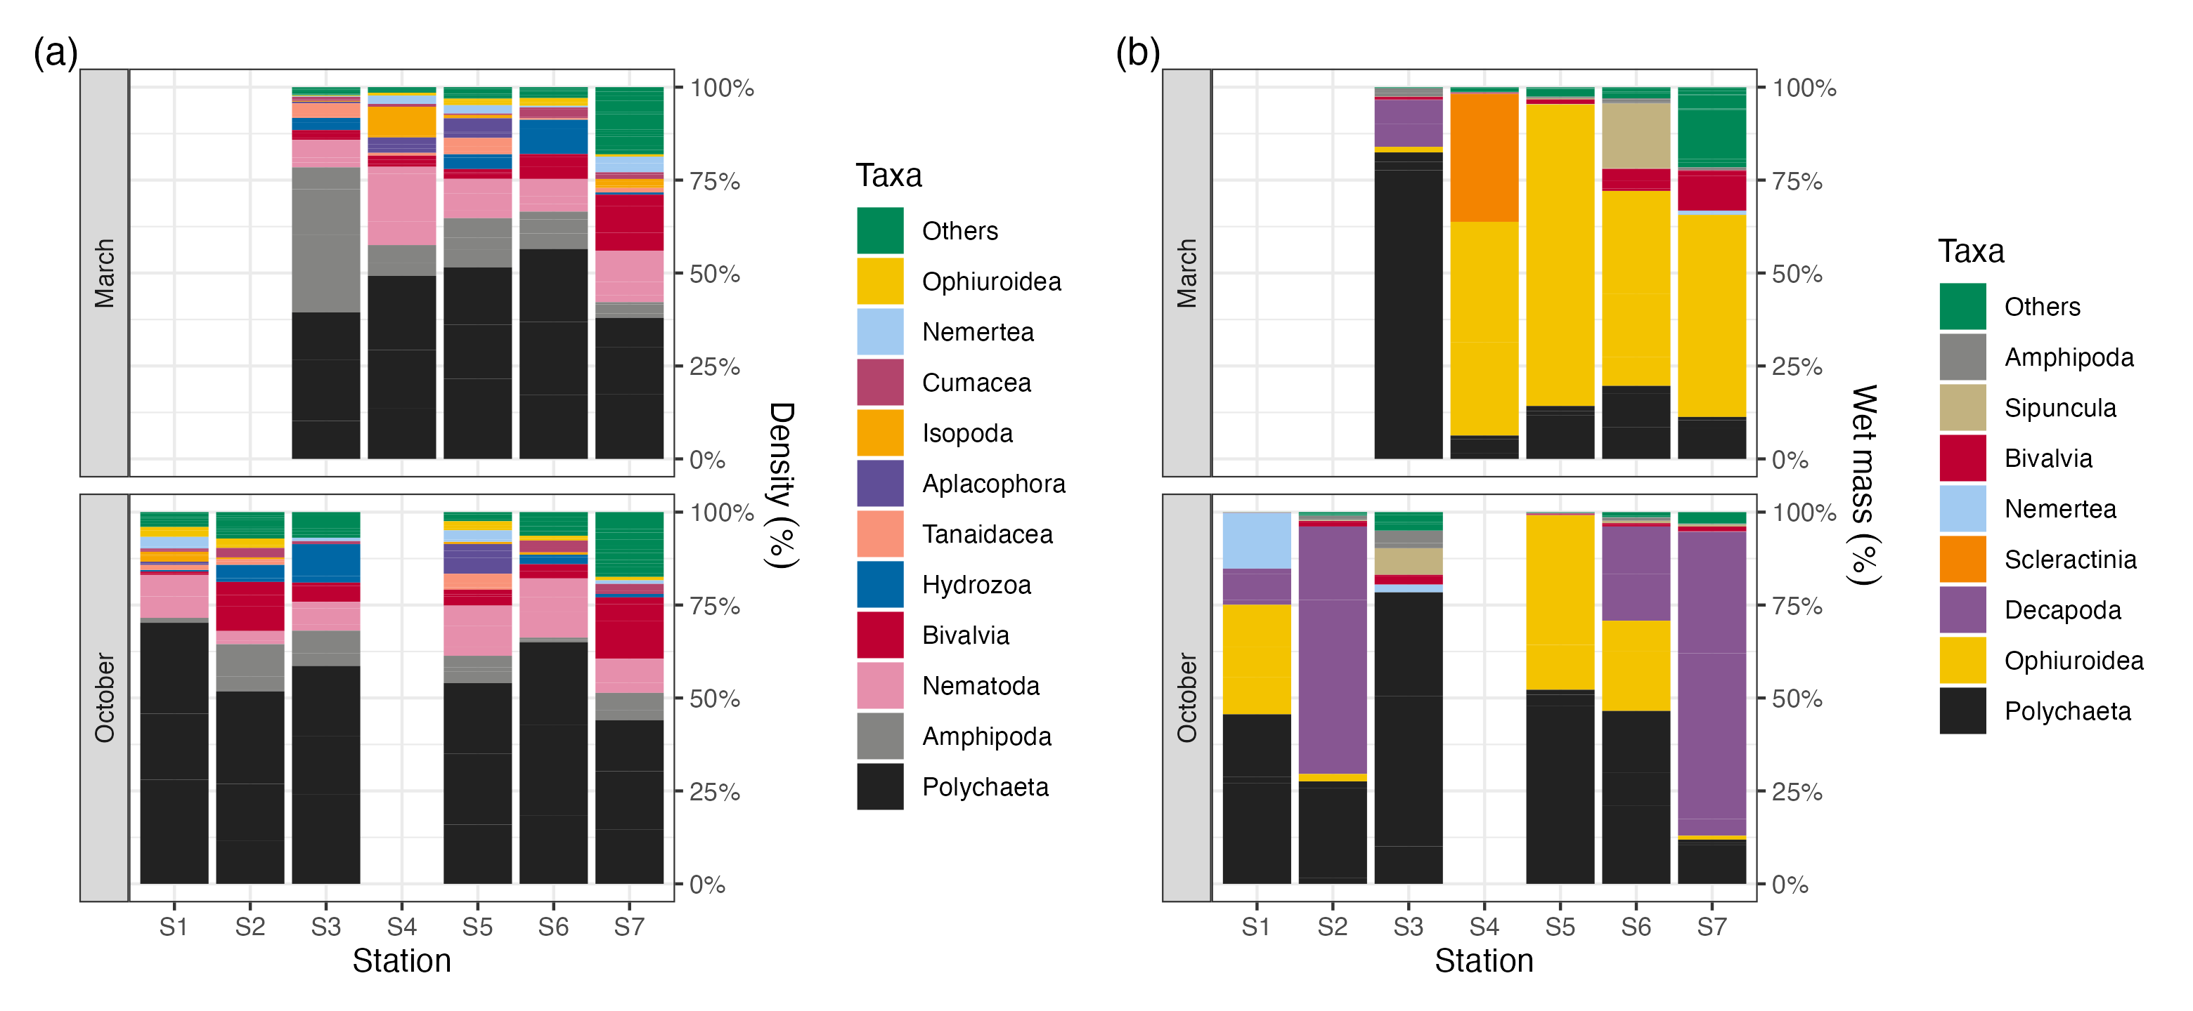

Figure 4. The macrofauna composition in terms of (a) abundance and (b) biomass. Taxa with total abundance and biomass contribution smaller than 1% and 0.5% were combined in the others category, respectively.

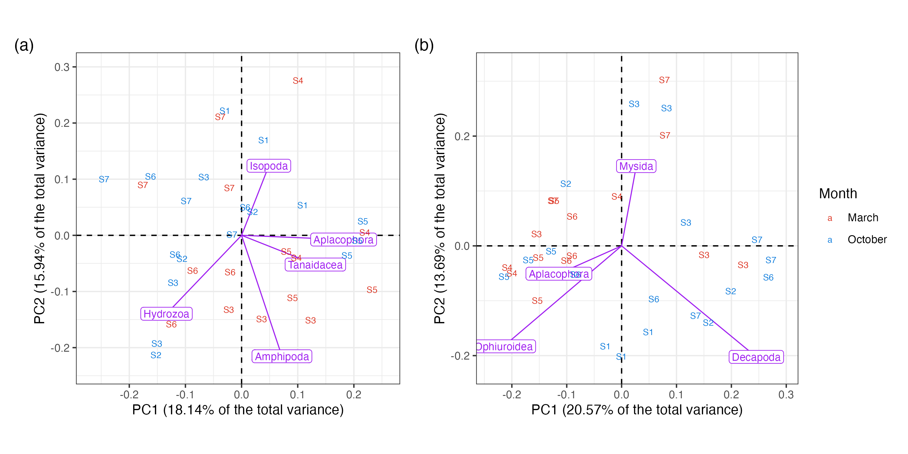

Figure 5. The distance scaling principal component analysis of macrofauna assemblage in terms of (a) abundance and (b) biomass. The purple species vectors were scaled to one-fifth of its original length for better visualizations.

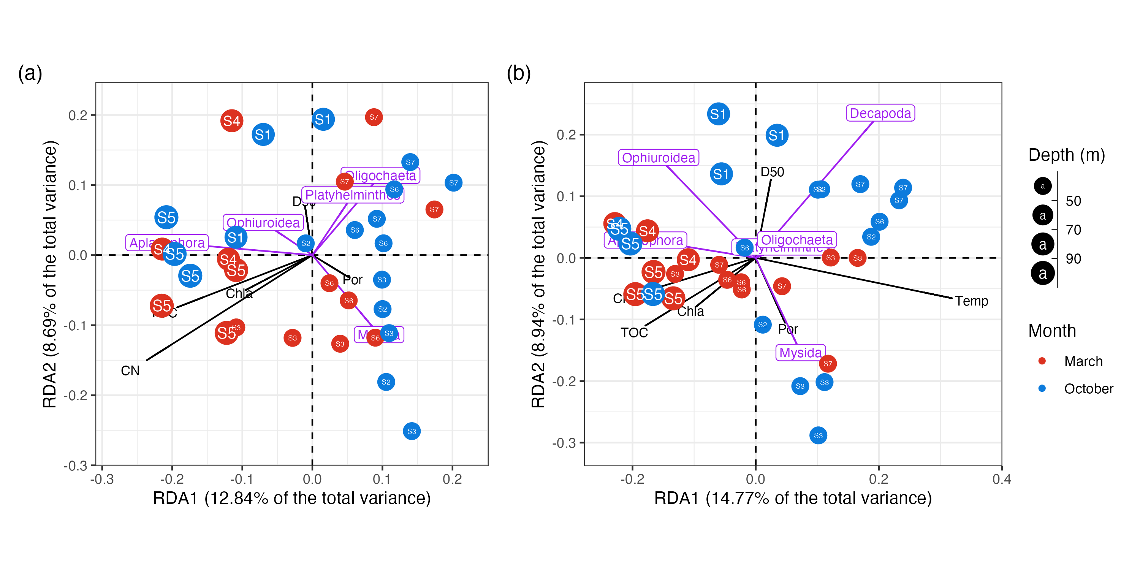

Figure 6. The distance scaling principal component analysis of macrofauna assemblage in terms of (a) abundance and (b) biomass. The water depth of each site corresponds with it size. The purple species vectors were scaled to one-fifth of its original length for better visualizations.

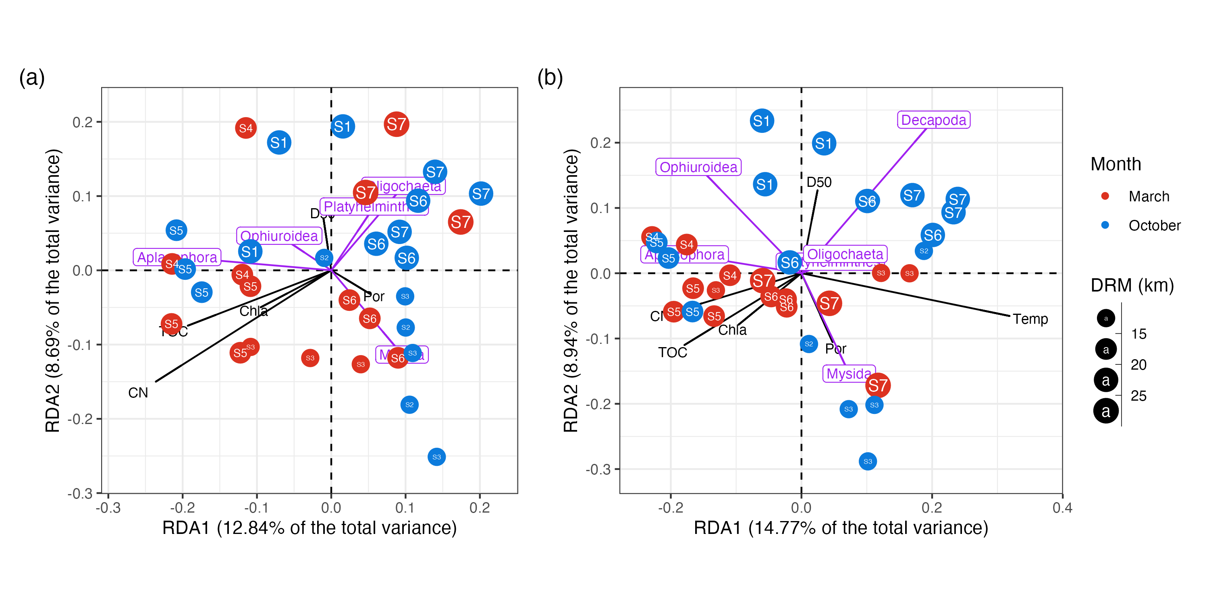

Figure 7. The distance scaling principal component analysis of macrofauna assemblage in terms of (a) abundance and (b) biomass. The distance from the river mouth (DRM) to each site corresponds with it size. The purple species vectors were scaled to one-fifth of its original length for better visualizations.

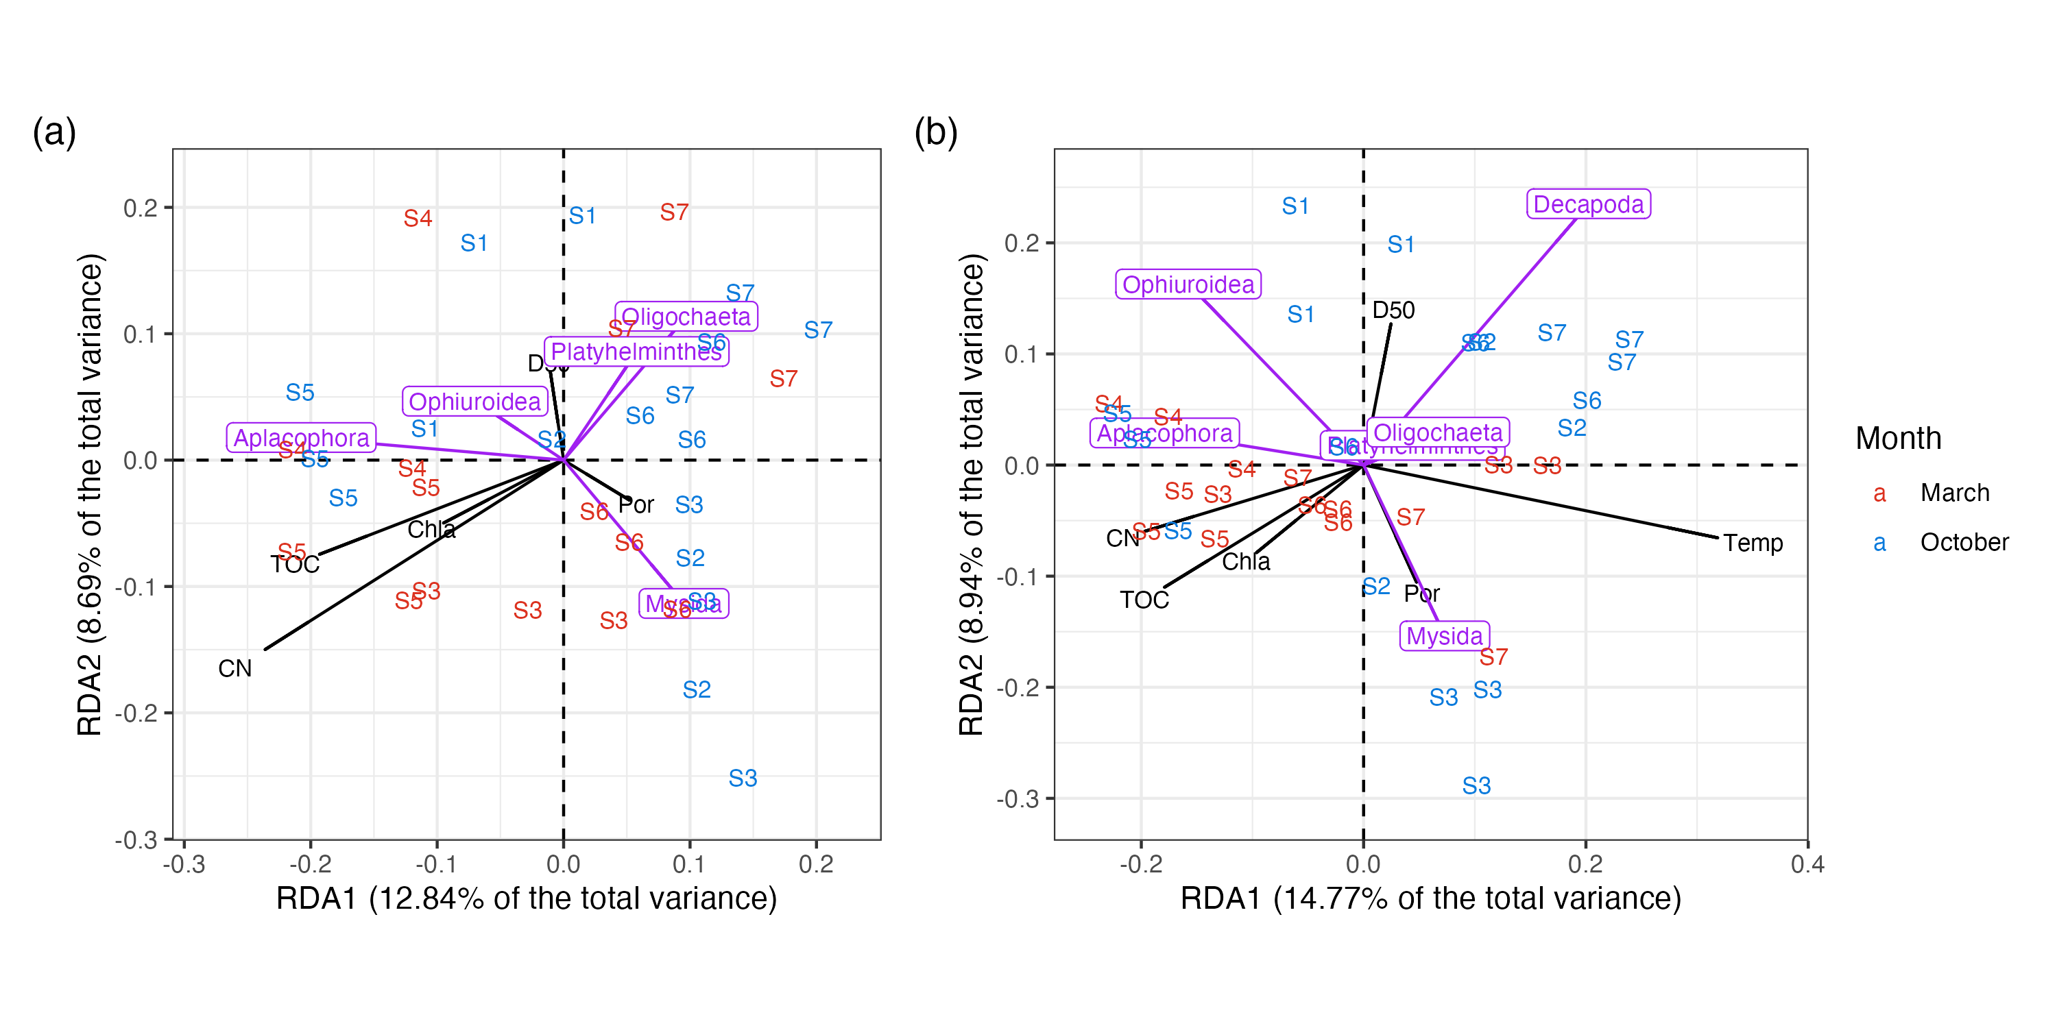

Figure 8. The distance scaling redundancy analysis of macrofauna assemblage in terms of (a) abundance and (b) biomass. The purple species vectors were scaled to one-fifth of its original length for better visualizations.



Figure 9. The distance scaling redundancy analysis of macrofauna assemblage in terms of (a) abundance and (b) biomass. The water depth of each site corresponds with it size. The purple species vectors were scaled to one-fifth of its original length for better visualizations.



Figure 10. The distance scaling redundancy analysis of macrofauna assemblage in terms of (a) abundance and (b) biomass. The distance from the river mouth (DRM) to each site corresponds with it size. The purple species vectors were scaled to one-fifth of its original length for better visualizations.

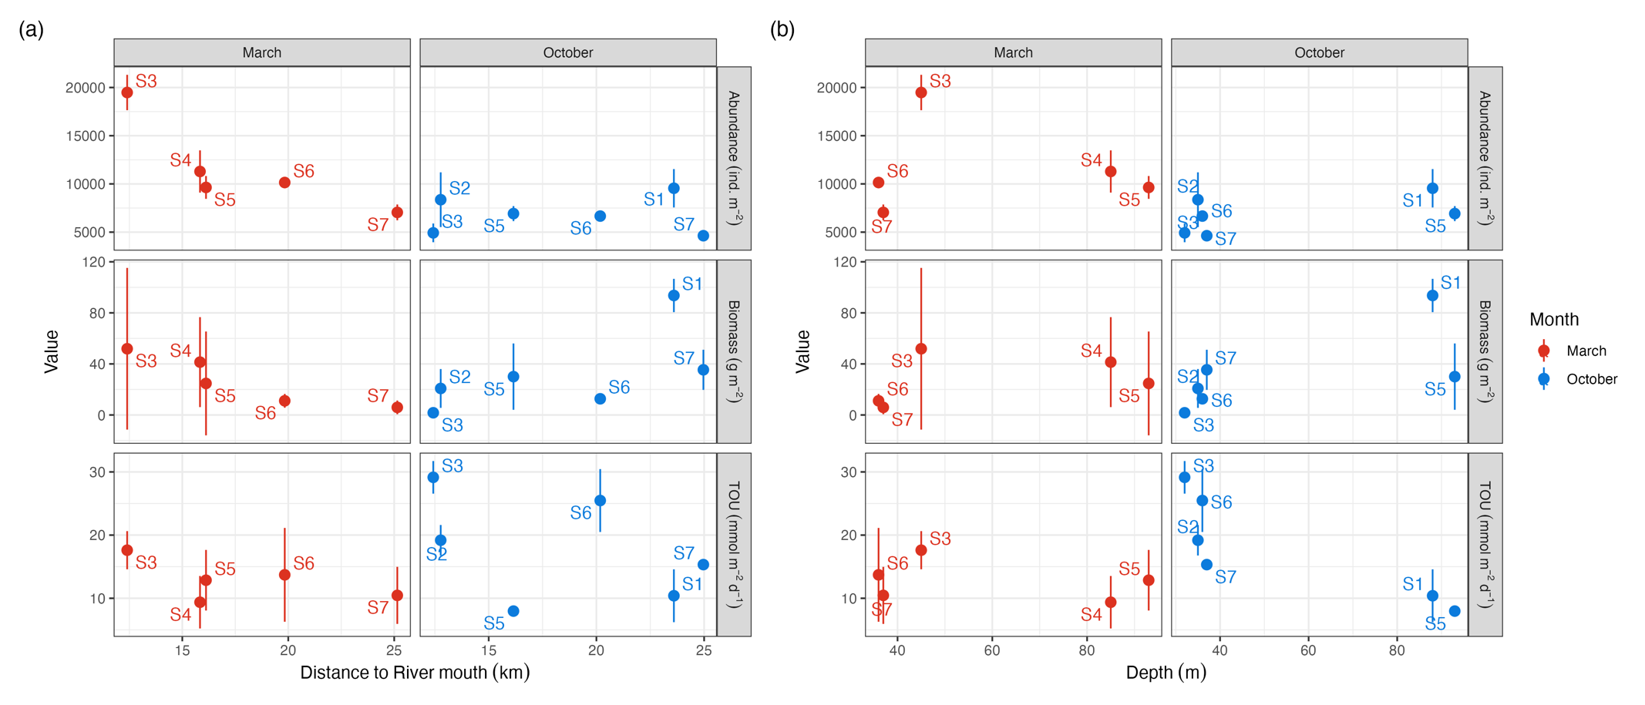

Figure 7. The relationship of macrofauna abundance, macrofauna biomass, and sediment community oxygen consumption (TOU) with respect to (a) the distance to river mouth and (b) water depth.