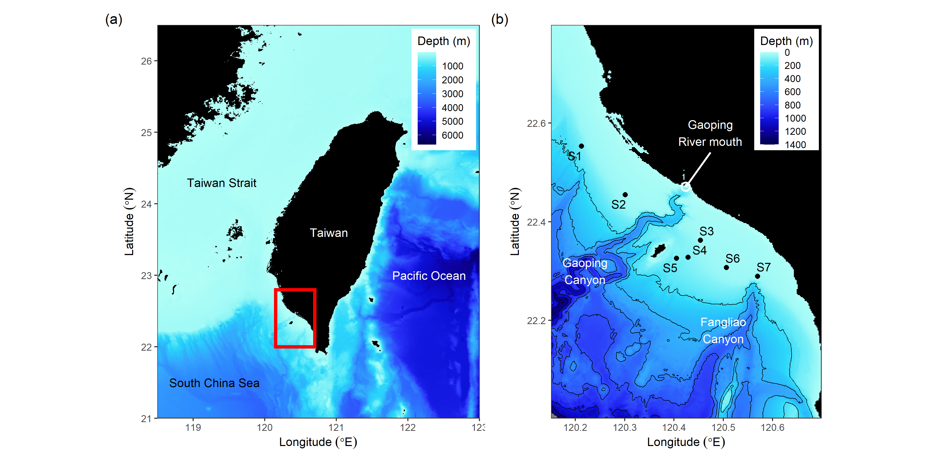

Figure 1. The (a) geographical location of the study area and (b) the sampling sites on the Gaoping Continental Shelf. The bathymetric data was downloaded from GEBCO (2023).

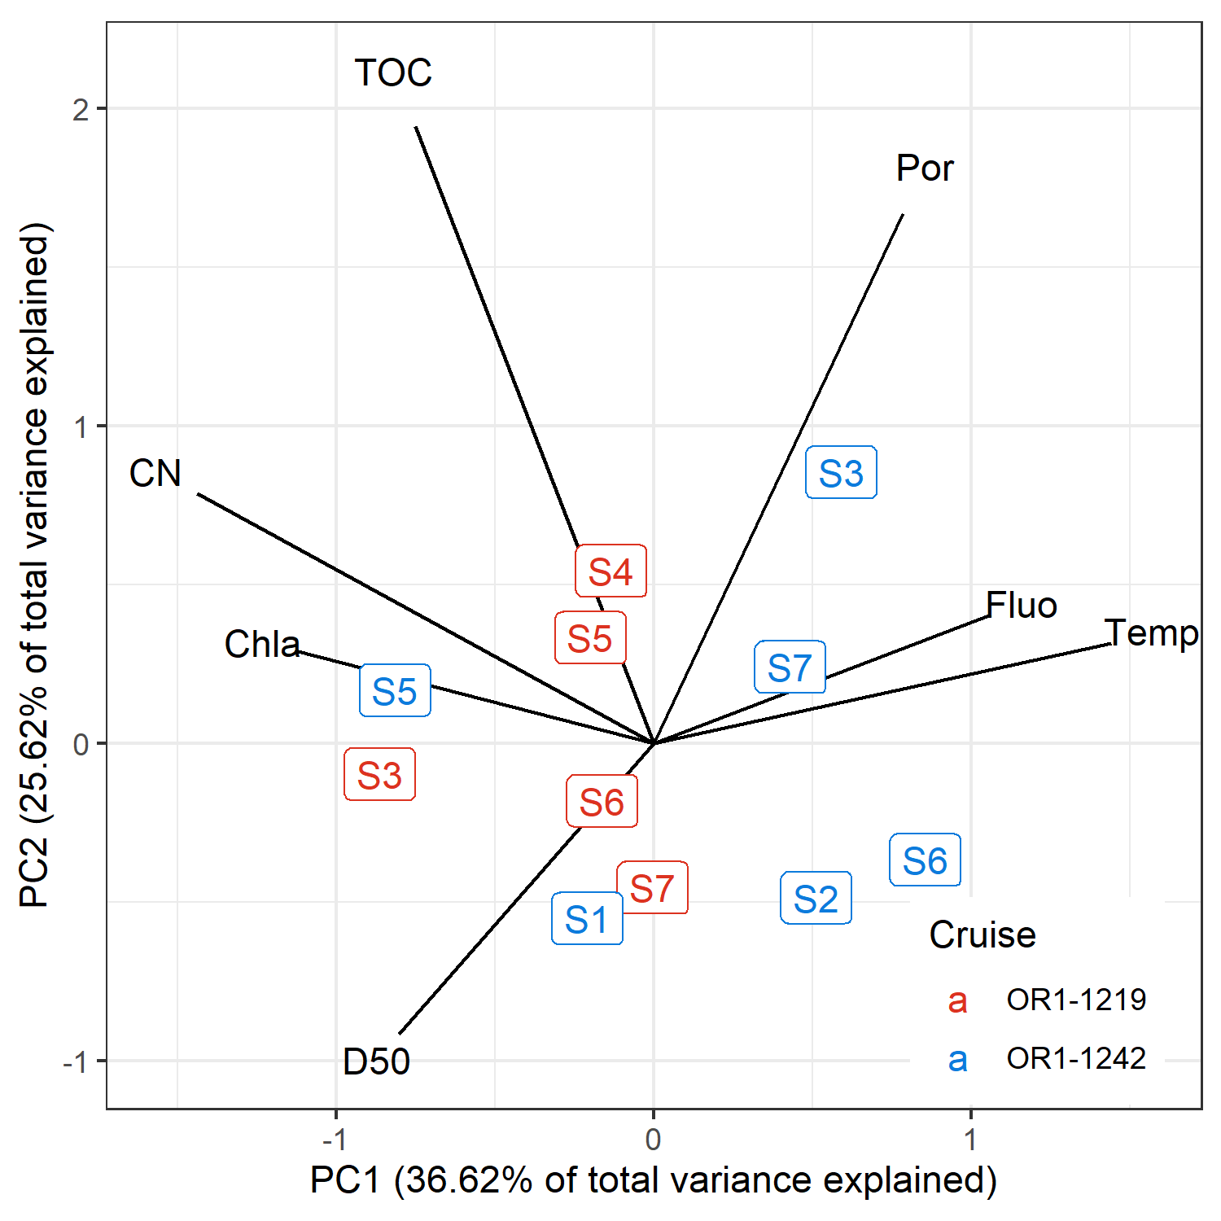

Figure 2. The distance scaling principal component analysis of the selected environmental variables.

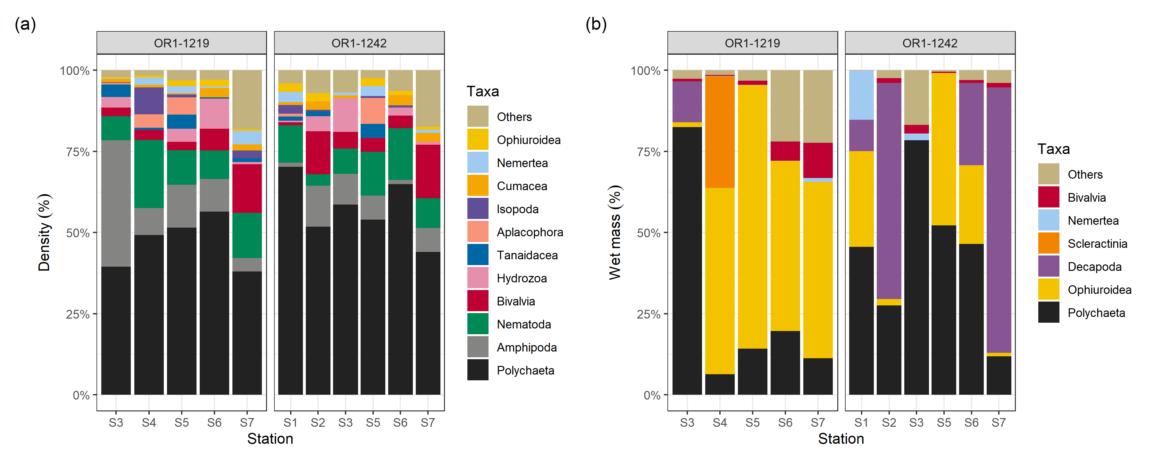

Figure 3. The macrofauna composition in terms of (a) abundance and (b) biomass. Taxa with total abundance and biomass contribution smaller than 1% were combined in the others category.

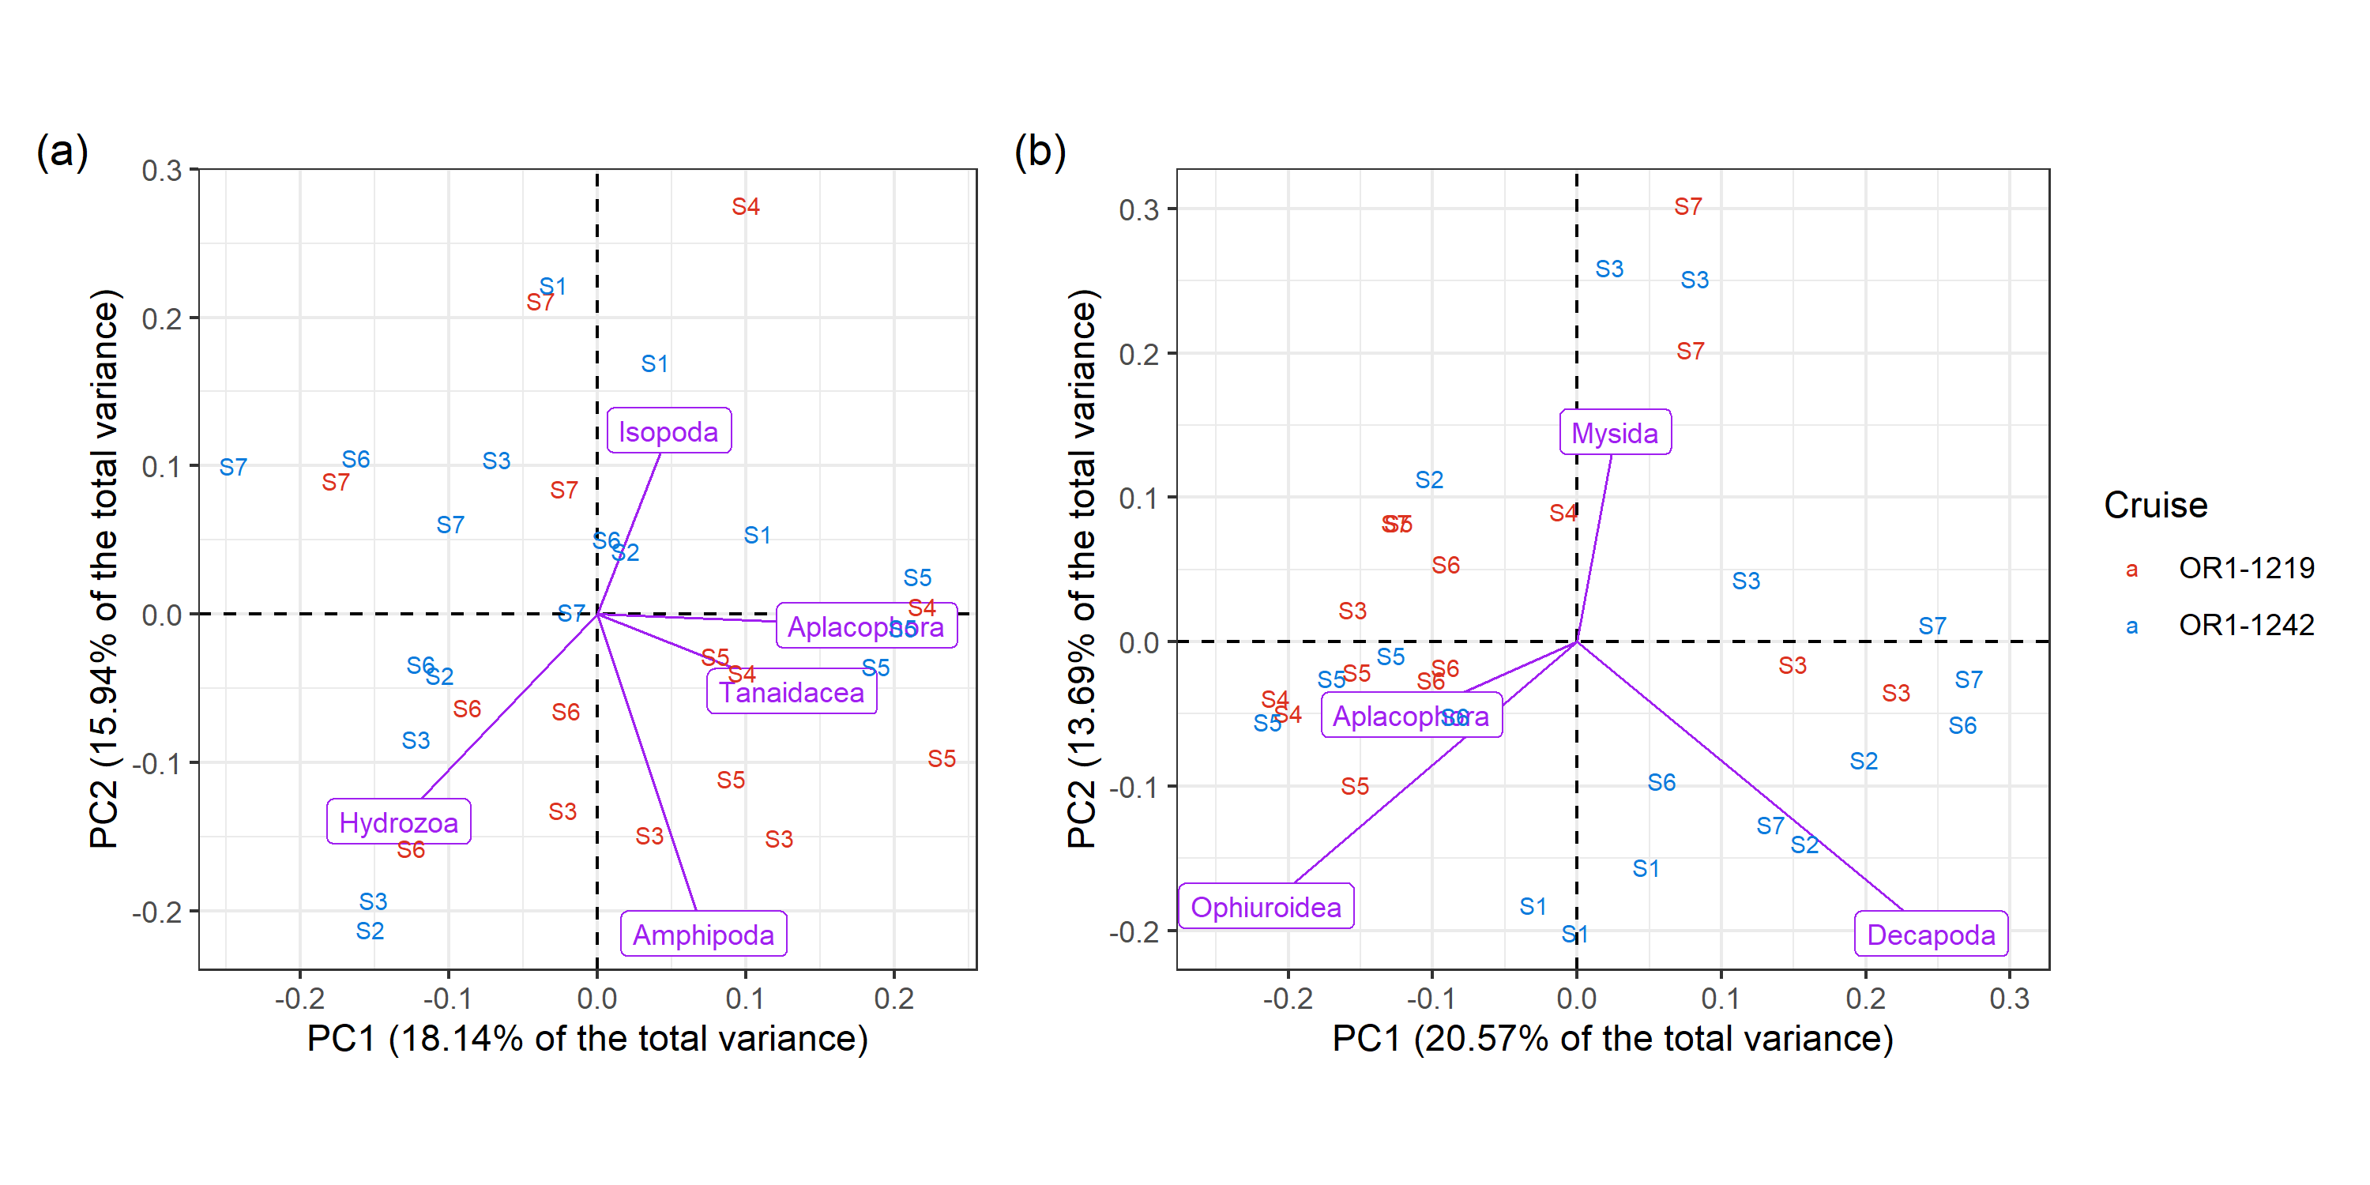

Figure 4. The distance scaling principal component analysis of macrofauna assemblage in terms of (a) abundance and (b) biomass. The purple species vectors were scaled to one-fifth of its original length for better visualizations.

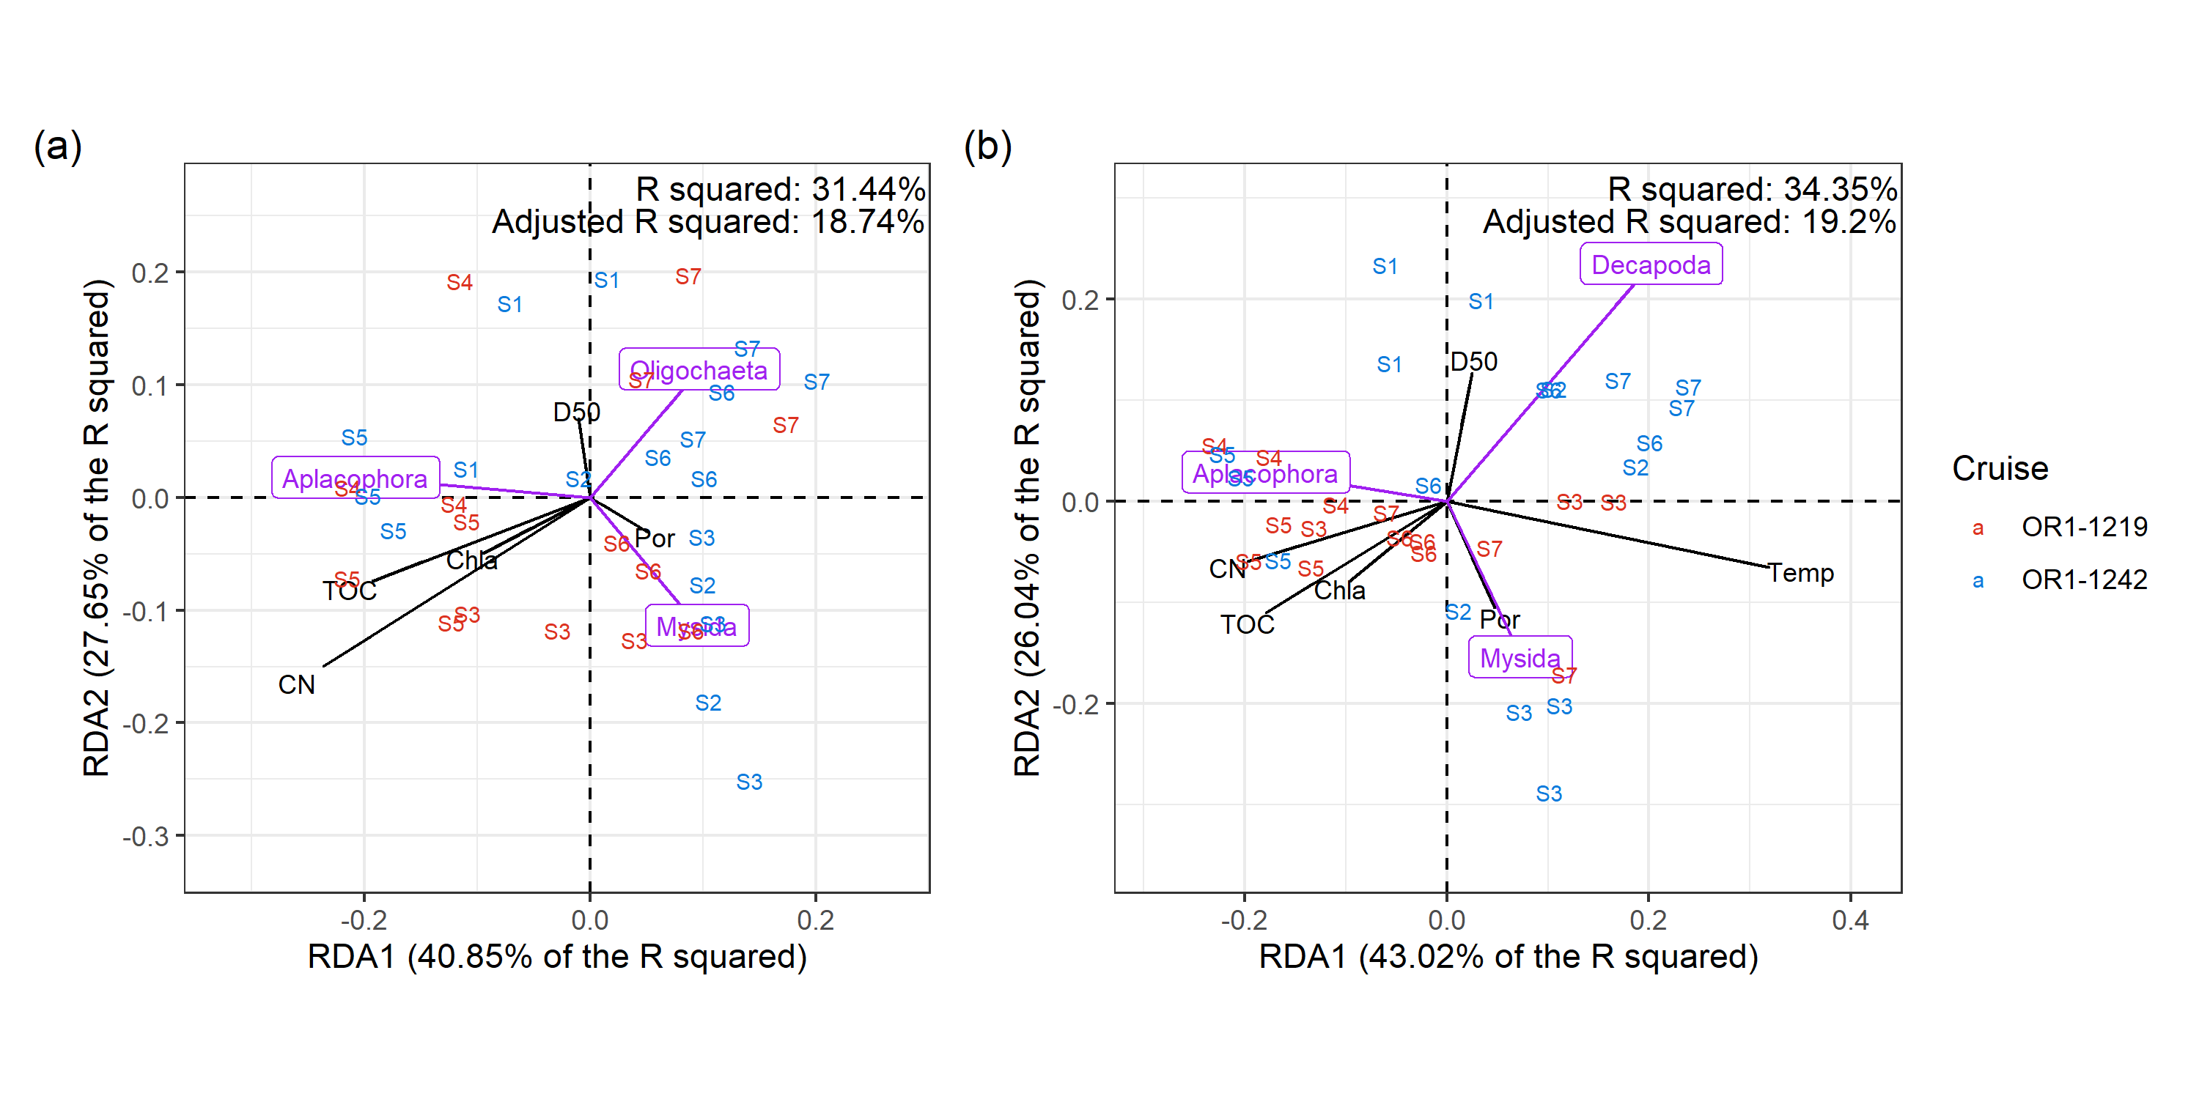

Figure 5. The distance scaling redundancy analysis of macrofauna assemblage in terms of (a) abundance and (b) biomass. The purple species vectors were scaled to one-fifth of its original length for better visualizations.

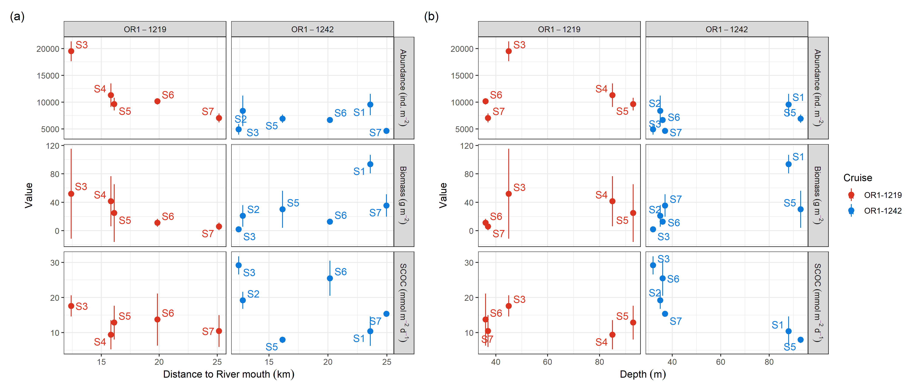

Figure 6. The relationship of macrofauna abundance, macrofauna biomass, and sediment community oxygen consumption (SCOC) with respect to (a) the distance to river mouth and (b) water depth.