電通二甲微處理器實驗 實驗結報

實驗名稱 | 走馬燈
組別 | 22 | 組員 | 戴寧 陳佑庭

- 實驗目的
Arduino UNO D1 – D8 分別接到 LED，實作跑馬燈展 示
- 實驗步驟
1. LED 向左及向右執行花色展示 2. 執行自定花色展示: 所有LED亮滅兩次 -> 左移八次 -> 所有LED亮滅兩次 -> 右移八次
- 程式碼
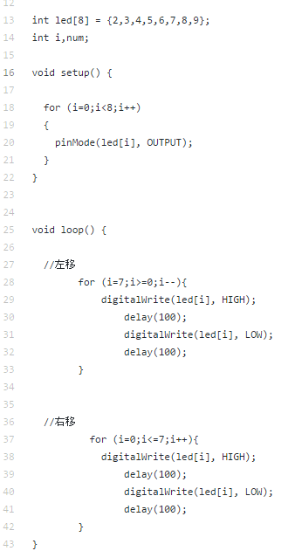

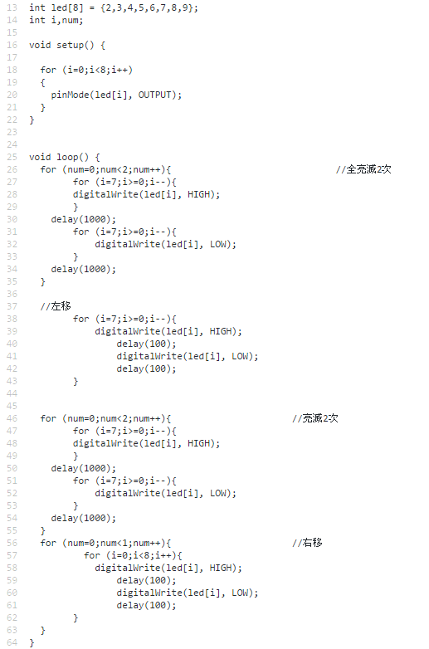

int led[8] = {2,3,4,5,6,7,8,9};
int i,num;
// the setup routine runs once when you press reset:
void setup() {
// initialize the digital pin as an output.
for (i=0;i<8;i++)
{
pinMode(led[i], OUTPUT);
}
pinMode(13,INPUT);
Serial.begin(9600);
for (i=0;i<8;i++)
{
digitalWrite(led[i], LOW);
}
}
// the loop routine runs over and over again forever:
void loop() {
if(digitalRead(13)==0)
{
/*for (num=0;num<2;num++){ //全亮滅2次
for (i=7;i>=0;i--){
digitalWrite(led[i], HIGH); // turn the LED on (HIGH is the voltage level
}
delay(1000);
for (i=7;i>=0;i--){
digitalWrite(led[i], LOW); // turn the LED on (HIGH is the voltage level
}
delay(1000);
}*/
for (i=0;i<=7;i++){
if(digitalRead(13)==1)
{
break;
}
else
{
digitalWrite(led[i], HIGH); // turn the LED on (HIGH is the voltage level)
delay(100); // wait for a second
digitalWrite(led[i], LOW); // turn the LED off by making the voltage LOW
delay(100);
// wait for a second
}
}
/* for (num=0;num<2;num++){ //亮滅2次
for (i=7;i>=0;i--){
digitalWrite(led[i], HIGH); // turn the LED on (HIGH is the voltage level
}
delay(1000);
for (i=7;i>=0;i--){
digitalWrite(led[i], LOW); // turn the LED on (HIGH is the voltage level
}
delay(1000);
}*/
for (i=7;i>=0;i--){
if(digitalRead(13)==1)
{
break;
}
else
{
digitalWrite(led[i], HIGH); // turn the LED on (HIGH is the voltage level)
delay(100); // wait for a second
digitalWrite(led[i], LOW); // turn the LED off by making the voltage LOW
delay(100); // wait for a second
}
}
}
else
{
for (num=0;num<2;num++)
{
//全亮滅2次
for (num=0;num<2;num++){ //全亮滅2次
for (i=7;i>=0;i--){
digitalWrite(led[i], HIGH);
}
delay(1000);
for (i=7;i>=0;i--){
digitalWrite(led[i], LOW);
}
delay(1000);
}
//左移
for (i=7;i>=0;i--){
digitalWrite(led[i], HIGH);
delay(100);
digitalWrite(led[i], LOW);
delay(100);
}
for (num=0;num<2;num++){ //亮滅2次
for (i=7;i>=0;i--){
digitalWrite(led[i], HIGH);
}
delay(1000);
for (i=7;i>=0;i--){
digitalWrite(led[i], LOW);
}
delay(1000);
}
for (num=0;num<1;num++){ //右移
for (i=0;i<8;i++){
digitalWrite(led[i], HIGH);
delay(100);
digitalWrite(led[i], LOW);
delay(100);
}
}
{
digitalWrite(led[i], HIGH); // turn the LED on (HIGH is the voltage level
}
delay(1000);
for (i=7;i>=0;i--)
{
digitalWrite(led[i], LOW); // turn the LED on (HIGH is the voltage level
}
delay(1000);
}
}
}

- 實驗結果及分析
發亮的燈泡\
- 心得討論

又要電路圖又要打成是真得很麻煩
但是看到LED量真得很興奮
- 修正電路圖
- 修正程式碼

