# Jira安装文档

## 一、需要MySQL 和Java环境

apt-get install mysql-server mysql-client

## 二、安装Java环境

下载jdk1.8 解压至/usr/local/java

export JAVA_HOME=/usr/local/java

export PATH=/usr/local/java/bin:$PATH

## 三、执行安装jire

bash atlassian-jira-software-7.6.0-x64.bin

1、创建数据库

create database jira default character set utf8 collate utf8_bin;

2、破解

/opt/atlassian/jira/bin/catalina.sh stop

cp atlassian-extras-3.2.jar mysql-connector-java-5.1.44-bin.jar /opt/atlassian/jira/atlassian-jira/WEB-INF/lib/

/opt/atlassian/jira/bin/catalina.sh start

## 四、访问：<http://192.168.240.179:8080>

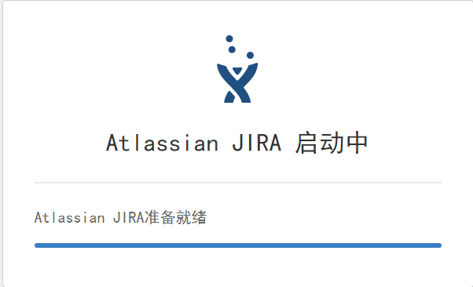

#### 1、选择语言和设置

#### 2、设置数据库为MySQL

可能要等一段时间配置数据库

#### 3、设置名称和访问URL

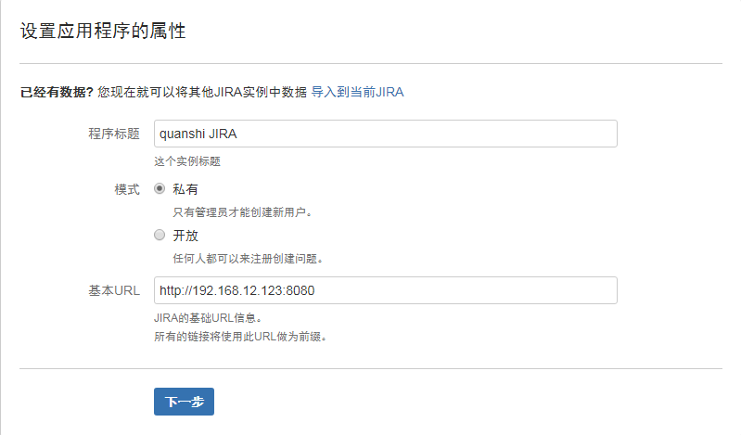

#### 4、获取许可

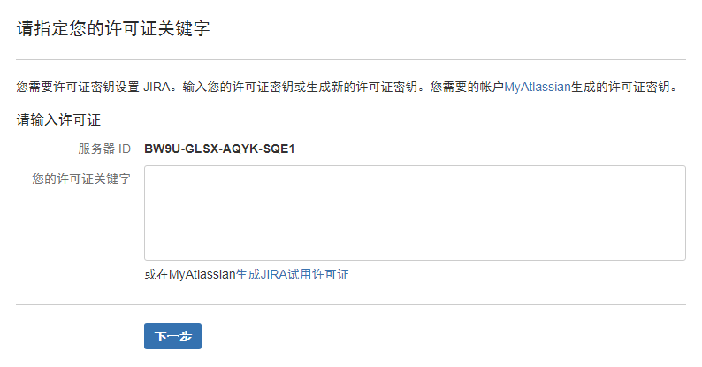

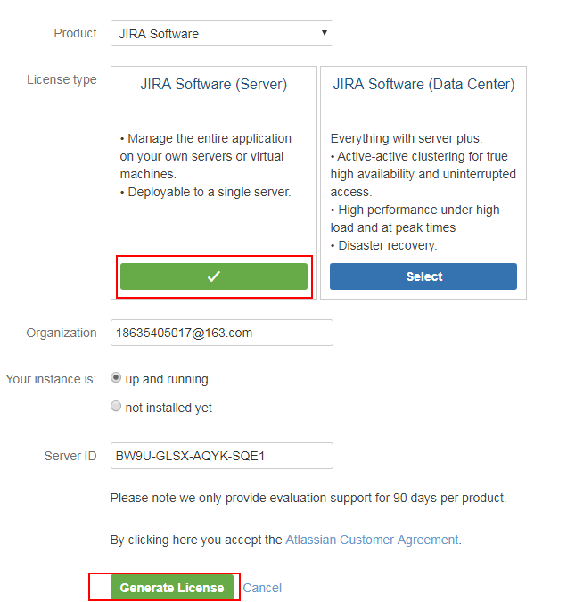

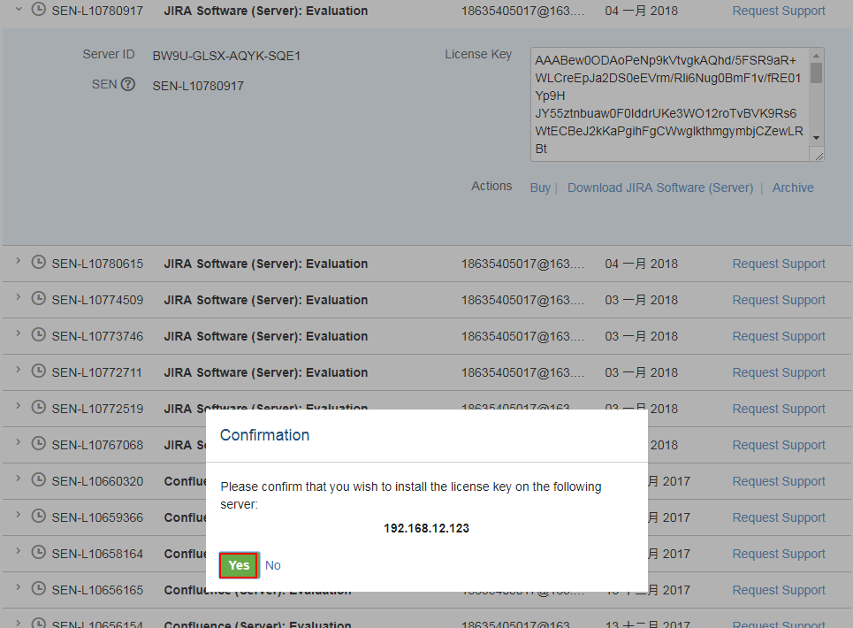

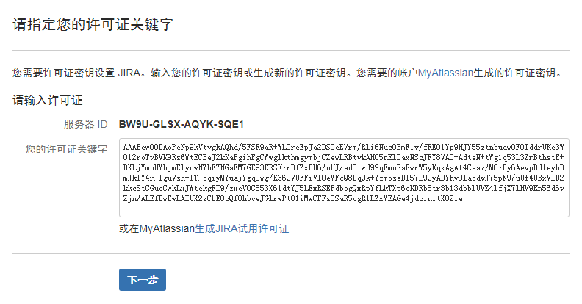

#### 5、设置管理员账号

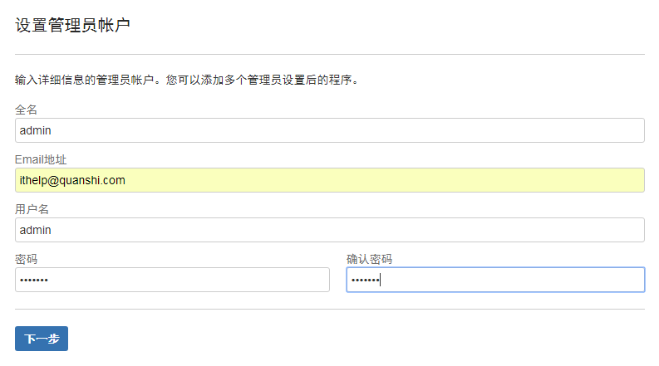

#### 6、设置邮件服务器

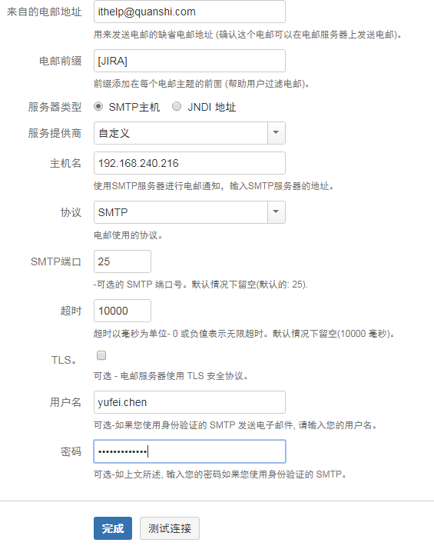

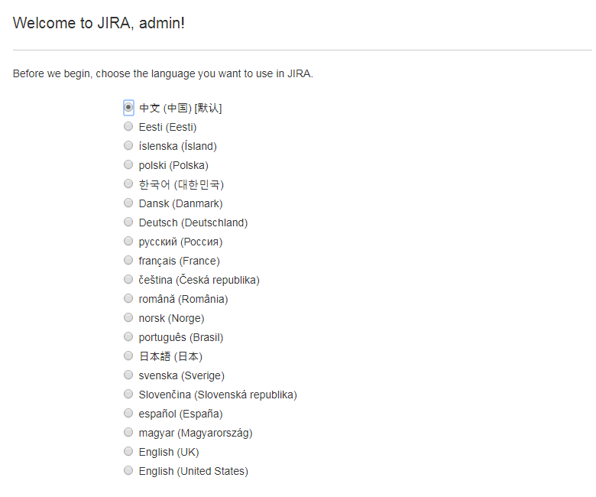



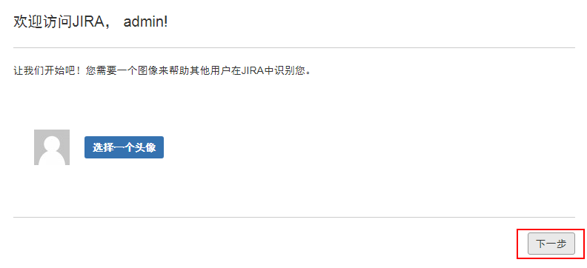

#### 7、配置ldap验证

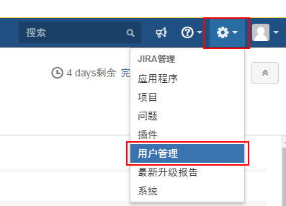

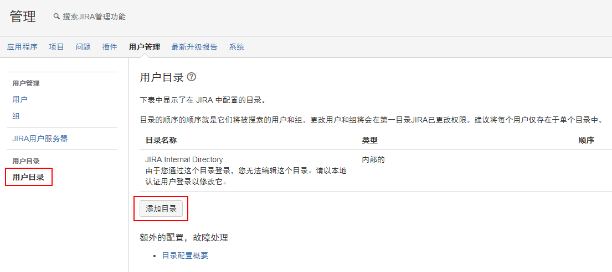

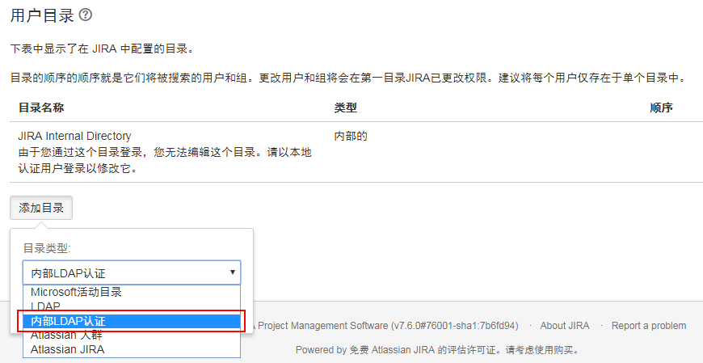

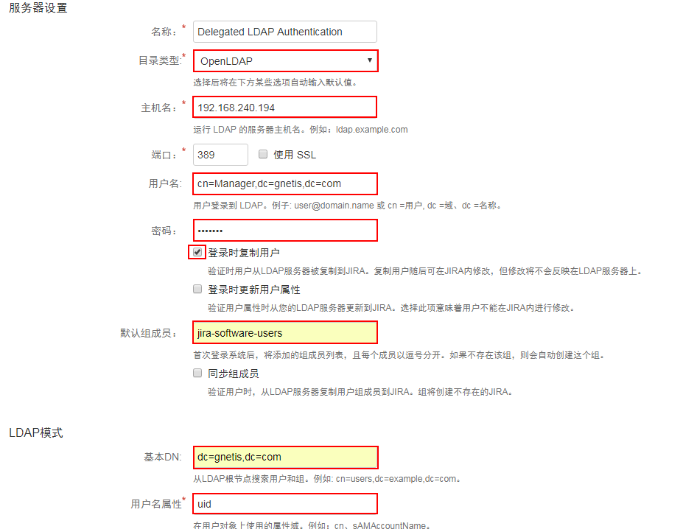

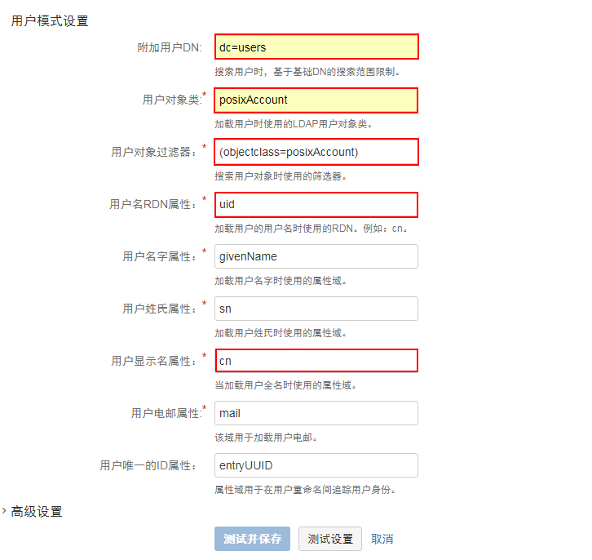

配置完后使用ldap账号登录即可

优化使用内存：

vim /opt/atlassian/jira/bin/setenv.sh

JVM_MINIMUM_MEMORY="8192m"

JVM_MAXIMUM_MEMORY="16384m"

nginx安装

apt-get install nginx

vim /etc/nginx/site-enable

server {

listen 80;

server_name jira.gnetis.com;

access_log /var/log/nginx/access.log;

error_log /var/log/nginx/error.log;

#root html;

index index.html index.htm index.php index.jspa index.jsp Dashboard.jspa;

port_in_redirect off;

location ~* ^.+/.(jpg|jpeg|gif|png|swf|rar|zip|css|js)$ { ##static file

rewrite ^(.*) http://jira.gnetis.com:8080/$1;

break;

}

location / {

proxy_pass http://127.0.0.1:8080;

proxy_redirect off;

proxy_set_header Host $host:$server_port; ##重点在$server_port

proxy_set_header X-Real-IP $remote_addr;

proxy_set_header X-Forwarded-For $proxy_add_x_forwarded_for;

proxy_max_temp_file_size 500M;

# proxy_connect_timeout 90;

# proxy_send_timeout 90;

# proxy_read_timeout 90;

# proxy_buffer_size 4k;

# proxy_buffers 4 32k;

# proxy_busy_buffers_size 64k;

proxy_hide_header Vary;

proxy_set_header Accept-Encoding '';

proxy_set_header Referer $http_referer;

proxy_set_header Cookie $http_cookie;

client_max_body_size 500M;

client_body_buffer_size 256k;

client_body_temp_path /etc/nginx/proxy_temp;

}

}

修改jira的配置

vim /opt/atlassian/jira/conf/server.xml

找到下面8080的位置添加项目proxyName和proxyPort

<Connector port="8080"

maxThreads="150"

minSpareThreads="25"

connectionTimeout="20000"

enableLookups="false"

maxHttpHeaderSize="8192"

protocol="HTTP/1.1"

useBodyEncodingForURI="true"

redirectPort="8443"

acceptCount="100"

disableUploadTimeout="true"

bindOnInit="false"

proxyName="jira.gnetis.com"

proxyPort="80"

/>