# JAVA编程进阶上机报告



**学 院 智能与计算**

**专 业 软件工程**

**班 级 一班**

**学 号 3018216063**

**姓 名 陈宇涛**

**一、实验要求**

1、针对每个组件的每个品牌，设计一个类，并画成整体的类图

2、设计计算机类（Computer.java），由上述四类组件组装而成，包括计算机的名称、计算机的描述（包括各个组件名）以及总价格等

3、设计计算机销售主类（ComputerStore.java），包括3个由不同组件组装在一起的计算机实例，可实现计算机商品一览表，可展示每台计算机的描述、价格、工作等。

4、设计时基于抽象类和接口，要尽可能的实现高内聚、低耦合。

类图

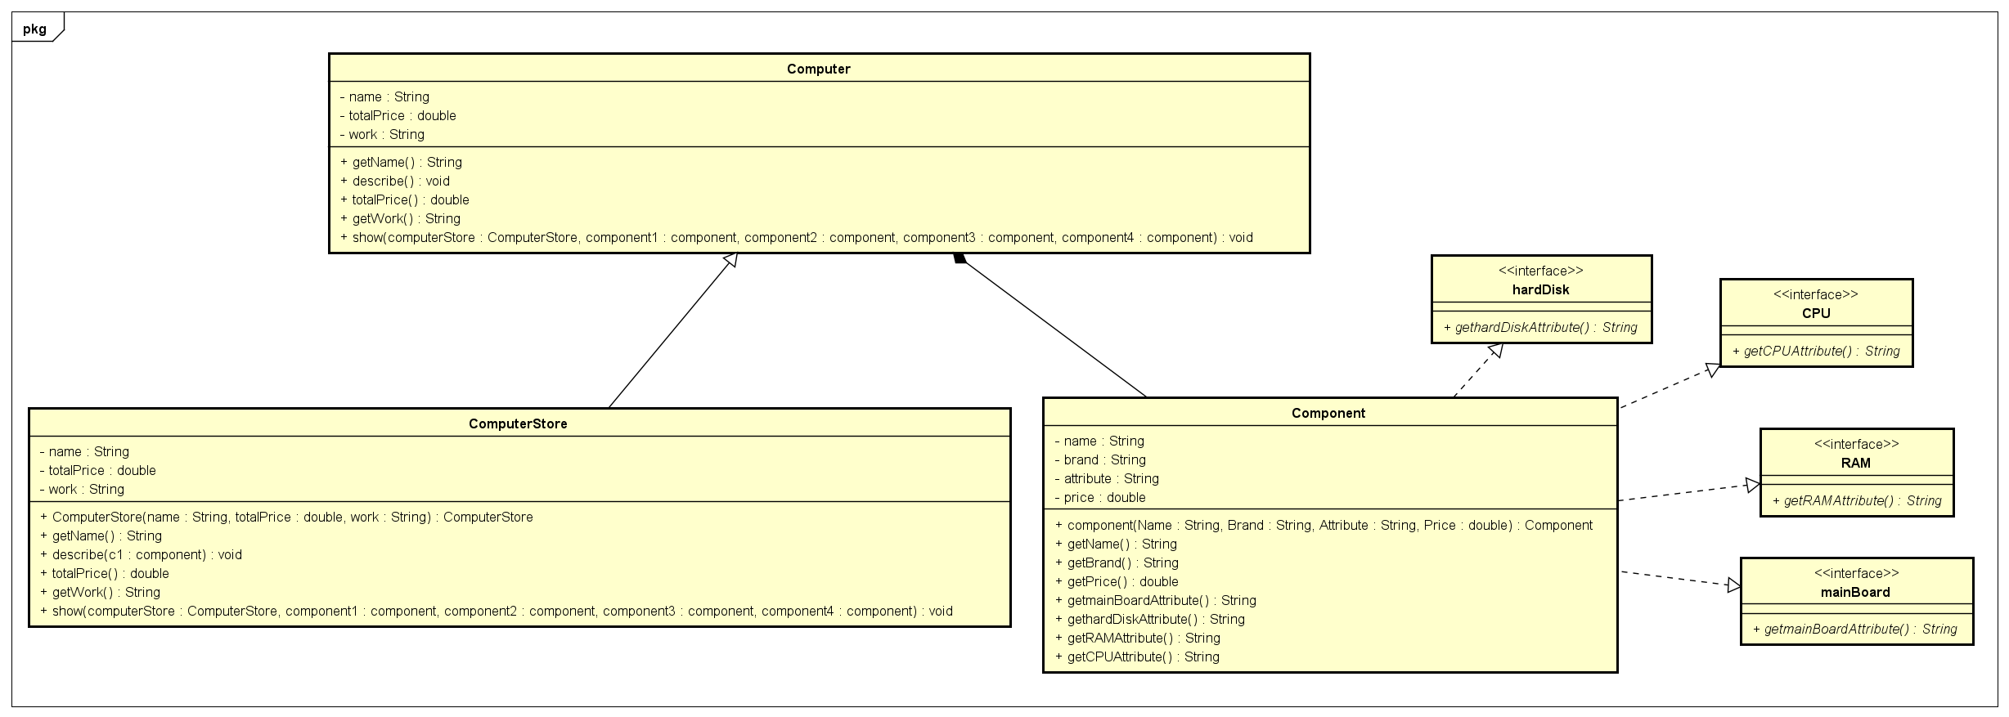

**二、源代码**

**Component类：**

**package** homework;

**public** **class** component **implements** CPU,RAM,hardDisk,mainBoard{

**private** String name;

**private** String brand;

**private** String attribute;

**private** **double** price;

**public** component(String Name,String Brand,String Attribute,**double** Price) {

name = Name;

brand = Brand;

attribute = Attribute;

price = Price;

}

**public** String getName() {

**return** name;

}

**public** String getBrand() {

**return** brand;

}

**public** **double** getPrice() {

**return** price;

}

@Override

**public** String getmainBoardAttribute() {

// **TODO** Auto-generated method stub

**return** "speed: "+attribute;

}

@Override

**public** String gethardDiskAttribute() {

// **TODO** Auto-generated method stub

**return** "volume: "+attribute;

}

@Override

**public** String getRAMAttribute() {

// **TODO** Auto-generated method stub

**return** "volume: "+attribute;

}

@Override

**public** String getCPUAttribute() {

// **TODO** Auto-generated method stub

**return** "coreNum: "+attribute;

}

}

**Computer类：**

**package** homework;

**abstract** **public** **class** Computer {

**private** String name;

**private** **double** totalPrice;

**private** String work;

**abstract** **public** String getName();

**abstract** **public** **void** describe(component c1);

**abstract** **public** **double** totalPrice();

**abstract** **public** String getWork();

**abstract** **void** show(ComputerStore computerStore,component component1,component component2,component component3,component component4);

}

**ComputerStore类：**

**package** homework;

**public** **class** ComputerStore **extends** Computer {

**private** String name = **null**;

**private** **double** totalPrice = 0;

**private** String work = **null**;

**public** ComputerStore(String name,**double** totalPrice,String work) {

**this**.name = name;

**this**.totalPrice = totalPrice;

**this**.work = work;

}

**public** String getName() {

**return** name;

}

**public** **void** describe(component c1) {

// **TODO** Auto-generated method stub

**if**(c1.getBrand().equals("Intel")||c1.getBrand().equals("AMD")) {

System.***out***.println("CPU: "+c1.getName()+", brand： "+c1.getBrand()+", "+c1.getCPUAttribute()+", price： "+c1.getPrice());

}**else** **if**(c1.getBrand().equals("Samsung")||c1.getBrand().equals("Kingston")) {

System.***out***.println("内存: "+c1.getName()+", brand： "+c1.getBrand()+", "+c1.getRAMAttribute()+", price： "+c1.getPrice());

}**else** **if**(c1.getBrand().equals("Seagate")||c1.getBrand().equals("WestDigitals")){

System.***out***.println("硬盘: "+c1.getName()+", brand： "+c1.getBrand()+", "+c1.gethardDiskAttribute()+", price： "+c1.getPrice());

}**else** {

System.***out***.println("主板: "+c1.getName()+", brand： "+c1.getBrand()+", "+c1.getmainBoardAttribute()+", price： "+c1.getPrice());

}

}

**public** **double** totalPrice() {

// **TODO** Auto-generated method stub

**return** totalPrice;

}

**public** String getWork() {

// **TODO** Auto-generated method stub

**return** work;

}

**public** **void** show(ComputerStore computerStore,component component1,component component2,component component3,component component4) {

System.***out***.println("计算机名称： "+computerStore.getName());

System.***out***.println("描述: ");

computerStore.describe(component1);

computerStore.describe(component2);

computerStore.describe(component3);

computerStore.describe(component4);

System.***out***.println("工作: "+computerStore.getWork());

System.***out***.println("计算机价格： "+computerStore.totalPrice());

}

}

**CPU接口：**

**package** homework;

**public** **interface** CPU {

**public** String getCPUAttribute();

}

**hardDisk接口：**

**package** homework;

**public** **interface** hardDisk {

**public** String gethardDiskAttribute();

}

**mainBoard接口：**

**package** homework;

**public** **interface** mainBoard {

**public** String getmainBoardAttribute();

}

**RAM类：**

**package** homework;

**public** **interface** RAM {

**public** String getRAMAttribute();

}

**Test类：**

**package** homework;

**public** **class** test {

**public** **static** **void** main(String[] args) {

System.***out***.println("计算机商品一览表");

component com1 = **new** component("CPU1","Intel","4",1500);

component com2 = **new** component("CPU2","AMD","4",1300);

component com3 = **new** component("内存1","Samsung","8G",400);

component com4 = **new** component("内存2","Kingston","6G",300);

component com5 = **new** component("硬盘1","Seagate","500G",1000);

component com6 = **new** component("硬盘2","WestDigitals","1T",2100);

component com7 = **new** component("主板1","Asus","4.8G",200);

component com8 = **new** component("主板2","Gigabyte","5.1G",300);

ComputerStore c1 = **new** ComputerStore("c1",com1.getPrice()+com4.getPrice()+com5.getPrice()+com8.getPrice(),

com1.getName()+com4.getName()+com5.getName()+com8.getName()+" work");

ComputerStore c2 = **new** ComputerStore("c2",com2.getPrice()+com3.getPrice()+com6.getPrice()+com7.getPrice(),

com2.getName()+com3.getName()+com6.getName()+com7.getName()+" work");

ComputerStore c3 = **new** ComputerStore("c3",com1.getPrice()+com3.getPrice()+com6.getPrice()+com8.getPrice(),

com1.getName()+com3.getName()+com6.getName()+com8.getName()+" work");

c1.show(c1,com1,com4,com5,com8);

c2.show(c2,com2,com3,com6,com7);

c3.show(c3, com1, com3, com6, com8);

}

}

**三、实验结果**

