# JAVA编程进阶上机报告



**学 院 智能与计算**

**专 业 软件工程**

**班 级 一班**

**学 号 3018216063**

**姓 名 陈宇涛**

1. **实验要求**

编写程序，统计了不起的盖茨比中各个单词出现的频次（结果按照单词的频次倒序排列），并为输入文件，创建一个 output.txt

1. **源代码**

**package** lab2;

**import** java.io.BufferedReader;

**import** java.io.File;

**import** java.io.FileInputStream;

**import** java.io.FileNotFoundException;

**import** java.io.FileWriter;

**import** java.io.IOException;

**import** java.io.InputStream;

**import** java.io.InputStreamReader;

**import** java.io.Writer;

**import** java.util.ArrayList;

**import** java.util.Collections;

**import** java.util.Comparator;

**import** java.util.HashMap;

**import** java.util.Iterator;

**import** java.util.List;

**import** java.util.Map;

**import** java.util.Map.Entry;

**import** java.util.TreeMap;

**public** **class** readfile {

**public** **static** **boolean** code(File file) **throws** IOException {

**try** {

InputStream ios=**new** FileInputStream(file);

**byte**[] b=**new** **byte**[3];

ios.read(b);

ios.close();

**if**(b[0]==-17&&b[1]==-69&&b[2]==-65) {

**return** **true**;

}

}**catch** (Exception e) {

System.***out***.println("读取文件错误");

e.printStackTrace();

}

**return** **false**;

}

**public** **static** Map<String,Integer> readFile(String filePath){

Map<String,Integer> map = **new** TreeMap<String,Integer>();

**try** {

File file=**new** File(filePath);

**if**(!file.canRead()) {

System.***out***.println("文件无读权限");

}**else** **if**(*code*(file)){

System.***out***.println("文件编码错误");

}**else** **if**(file.exists()){

BufferedReader Bufferedreader = **new** BufferedReader(**new** InputStreamReader(**new** FileInputStream(filePath)));

String words = "";

**while**((words = Bufferedreader.readLine())!=**null**){

String[] wordline = words.split("\\s+");

**for**(String word:wordline){

**if**(map.containsKey(word)){

**int** n =1 + map.get(word);

map.remove(word);

map.put(word, (Integer)n);

}**else**{

map.put(word, 1);

}

}

}

Bufferedreader.close(); }**else**{

System.***out***.println("没有指定的文件");

}

} **catch** (Exception e) {

System.***out***.println("无法读取文件");

e.printStackTrace();

}

**return** map;

}

**public** **static** List<Map.Entry<String,Integer>> sort(Map<String,Integer> map) {

List<Map.Entry<String,Integer>> list = **new** ArrayList<Map.Entry<String,Integer>>(map.entrySet());

Collections.*sort*(list,**new** Comparator<Map.Entry<String,Integer>>() {

**public** **int** compare(Entry<String, Integer> o1,

Entry<String, Integer> o2) {

**return** o2.getValue().compareTo(o1.getValue());

}

});

**return** list;

}

**public** **static** **void** write(List<Map.Entry<String,Integer>> list) **throws** IOException {

**try** {

File file = **new** File("D:" + File.***separator*** + "output.txt");

Writer writer = **new** FileWriter(file);

Iterator<Entry<String, Integer>> iterator = list.iterator();

**while**(iterator.hasNext()){

Entry<String, Integer> entry = iterator.next();

String str = entry.getKey()+" "+entry.getValue()+"\n";

**char**[] c = str.toCharArray();

writer.write(c);

}

writer.flush();

writer.close(); }**catch** (Exception e) {

System.***out***.println("输出文件出错");

e.printStackTrace();

}

}

**public** **static** **void** main(String argv[]) **throws** IOException{

Map<String,Integer> map = **new** TreeMap<String,Integer>();

map = *readFile*("D:/Download/了不起的盖茨比英文.txt");

List<Map.Entry<String,Integer>> list = *sort*(map);

*write*(list);

}

}

1. **实验结果**

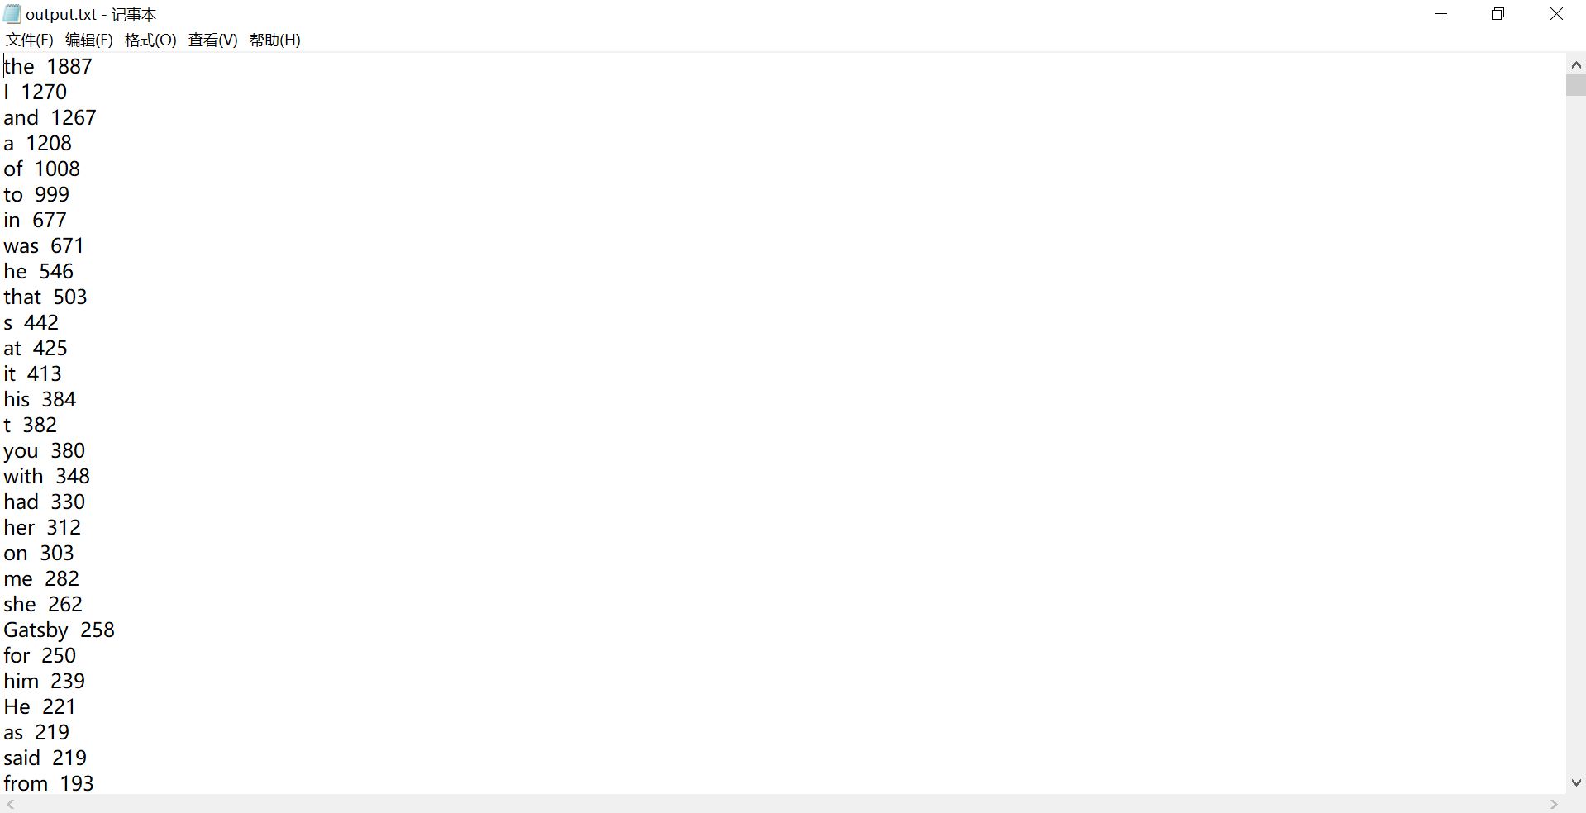

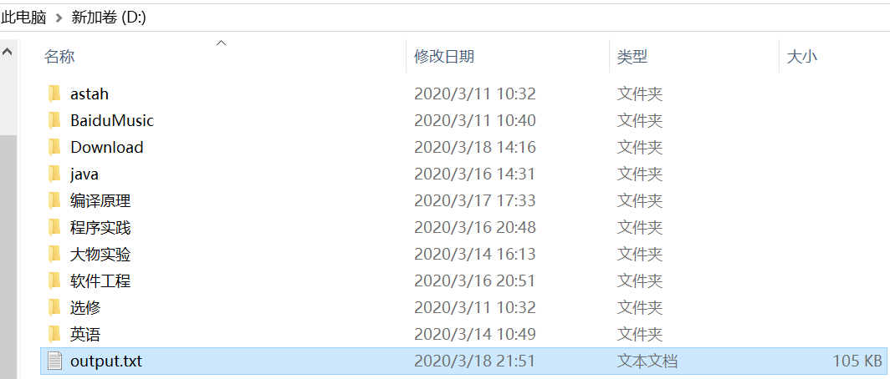

**四、设计**

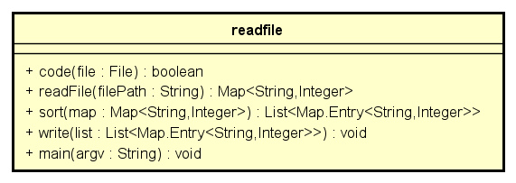

readfile：读入文件，若文件不存在、无读权限、文件编码错误则抛出异常，若正常则一个个读入单词并通过map<String,Integer>记录次数

code: 通过InputStream读取文件并通过前3个字节判断编码类型

sort：转成list通过Collections.sort函数按Value值倒着排序

write: 遍历list并转成String通过writer.write写入对应文件中