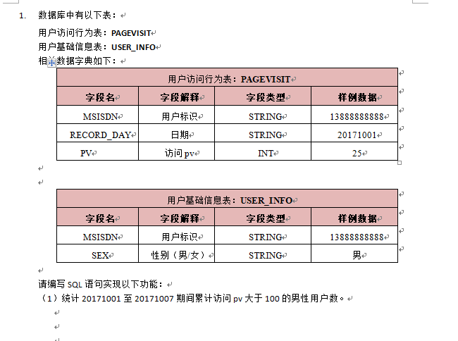

Oracle：

select count(distinct a.msisdn) from pagevisit a, user_info b

where a.msisdn = b.msisdn

and b.sex='男'

and a.pv > 100

and to_number(a.record_day) between 20171001 and 20171007;

Mysql：

select count(distinct a.msisdn) from pagevisit a, user_info b

where a.msisdn = b.msisdn

and b.sex='男'

and a.pv > 100

and (a.record_day + 0) between 20171001 and 20171007;



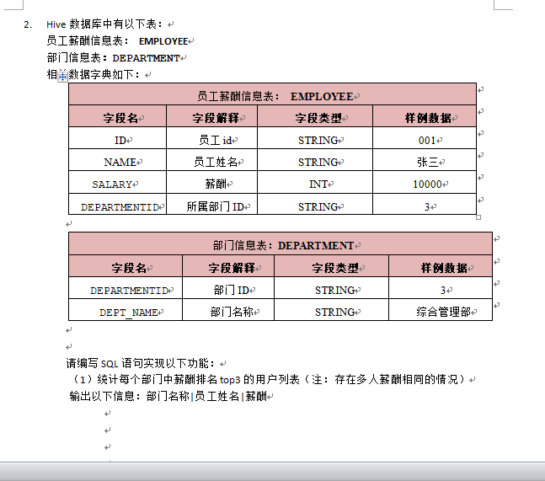

排名第三的sql：

Mysql 数据库:

select a.*, b.dept_name from employee a, department b

where a.departmentid = b.departmentid

and a.salary <=(select distinct salary from employee order by salary desc limit 2, 1);

Oracle数据库

SELECT A .*, b.dept_name FROM employee A, department b WHERE

A .departmentid = b.departmentid AND A .salary <= ( SELECT salary FROM(SELECT salary,rownum rn FROM(SELECT DISTINCT salary

FROM employee ORDER BY salary DESC))WHERE rn = 3);

备注：薪水排名前三的sql

select d.Name Department ,e1.Name Employee,e1.Salary Salary

from Employee e1

inner join Department d on e1.DepartmentId= d.Id

where 3 >= (

select count(distinct(e2.Salary)) from Employee e2 where e2.Salary >=e1.Salary and e2.DepartmentId=d.Id

) order by d.Name,e1.Salary Desc;

SQL可能还会加一道题：

Trips 表中存所有出租车的行程信息。每段行程有唯一健 Id，Client_Id 和 Driver_Id 是 Users 表中 Users_Id 的外键。Status 是枚举类型，枚举成员为 (‘completed’, ‘cancelled_by_driver’, ‘cancelled_by_client’)。

+----+-----------+-----------+---------+--------------------+----------+

| Id | Client_Id | Driver_Id | City_Id | Status |Request_at|

+----+-----------+-----------+---------+--------------------+----------+

| 1 | 1 | 10 | 1 | completed |2013-10-01|

| 2 | 2 | 11 | 1 | cancelled_by_driver|2013-10-01|

| 3 | 3 | 12 | 6 | completed |2013-10-01|

| 4 | 4 | 13 | 6 | cancelled_by_client|2013-10-01|

| 5 | 1 | 10 | 1 | completed |2013-10-02|

| 6 | 2 | 11 | 6 | completed |2013-10-02|

| 7 | 3 | 12 | 6 | completed |2013-10-02|

| 8 | 2 | 12 | 12 | completed |2013-10-03|

| 9 | 3 | 10 | 12 | completed |2013-10-03|

| 10 | 4 | 13 | 12 | cancelled_by_driver|2013-10-03|

+----+-----------+-----------+---------+--------------------+----------+

Users 表存所有用户。每个用户有唯一键 Users_Id。Banned 表示这个用户是否被禁止，Role 则是一个表示（‘client’, ‘driver’, ‘partner’）的枚举类型。

+----------+--------+--------+

| Users_Id | Banned | Role |

+----------+--------+--------+

| 1 | No | client |

| 2 | Yes | client |

| 3 | No | client |

| 4 | No | client |

| 10 | No | driver |

| 11 | No | driver |

| 12 | No | driver |

| 13 | No | driver |

+----------+--------+--------+

写一段 SQL 语句查出 2013年10月1日 至 2013年10月3日 期间非禁止用户的取消率。基于上表，你的 SQL 语句应返回如下结果，取消率（Cancellation Rate）保留两位小数。

select t.Request_at Day,ROUND(sum((casewhen t.Status like 'cancelled%' then 1 else 0 end))/count(*),2) as'Cancellation Rate' from Trips t inner join Users u on u.Users_Id =t.Client_Id and u.Banned = 'No' where t.Request_at between '2013-10-01'and'2013-10-03' group by t.Request_at;

+------------+-------------------+

| Day | Cancellation Rate |

+------------+-------------------+

| 2013-10-01 | 0.33 |

| 2013-10-02 | 0.00 |

| 2013-10-03 | 0.50 |

+------------+-------------------+