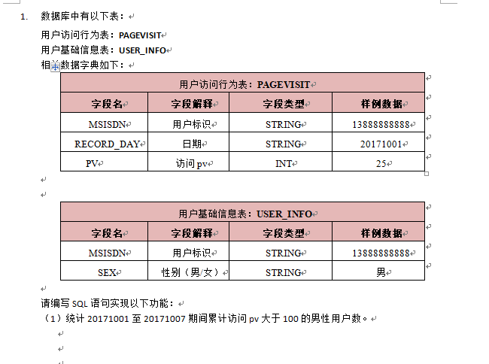

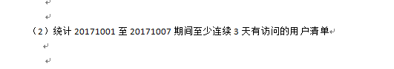

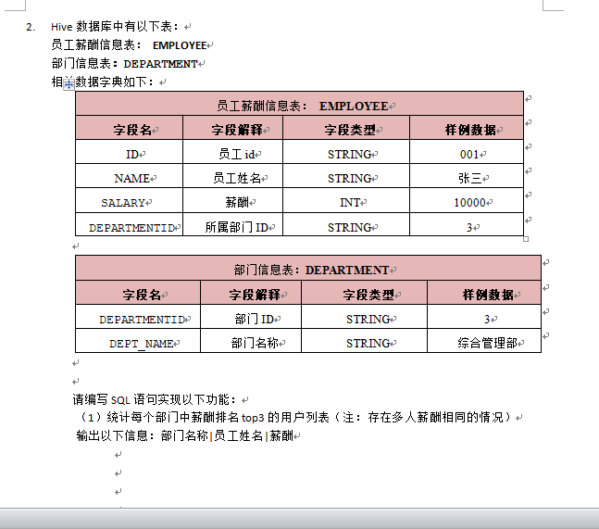

SQL可能还会加一道题：

Trips 表中存所有出租车的行程信息。每段行程有唯一健 Id，Client_Id 和 Driver_Id 是 Users 表中 Users_Id 的外键。Status 是枚举类型，枚举成员为 (‘completed’, ‘cancelled_by_driver’, ‘cancelled_by_client’)。

+----+-----------+-----------+---------+--------------------+----------+

| Id | Client_Id | Driver_Id | City_Id | Status |Request_at|

+----+-----------+-----------+---------+--------------------+----------+

| 1 | 1 | 10 | 1 | completed |2013-10-01|

| 2 | 2 | 11 | 1 | cancelled_by_driver|2013-10-01|

| 3 | 3 | 12 | 6 | completed |2013-10-01|

| 4 | 4 | 13 | 6 | cancelled_by_client|2013-10-01|

| 5 | 1 | 10 | 1 | completed |2013-10-02|

| 6 | 2 | 11 | 6 | completed |2013-10-02|

| 7 | 3 | 12 | 6 | completed |2013-10-02|

| 8 | 2 | 12 | 12 | completed |2013-10-03|

| 9 | 3 | 10 | 12 | completed |2013-10-03|

| 10 | 4 | 13 | 12 | cancelled_by_driver|2013-10-03|

+----+-----------+-----------+---------+--------------------+----------+

Users 表存所有用户。每个用户有唯一键 Users_Id。Banned 表示这个用户是否被禁止，Role 则是一个表示（‘client’, ‘driver’, ‘partner’）的枚举类型。

+----------+--------+--------+

| Users_Id | Banned | Role |

+----------+--------+--------+

| 1 | No | client |

| 2 | Yes | client |

| 3 | No | client |

| 4 | No | client |

| 10 | No | driver |

| 11 | No | driver |

| 12 | No | driver |

| 13 | No | driver |

+----------+--------+--------+

写一段 SQL 语句查出 2013年10月1日 至 2013年10月3日 期间非禁止用户的取消率。基于上表，你的 SQL 语句应返回如下结果，取消率（Cancellation Rate）保留两位小数。

+------------+-------------------+

| Day | Cancellation Rate |

+------------+-------------------+

| 2013-10-01 | 0.33 |

| 2013-10-02 | 0.00 |

| 2013-10-03 | 0.50 |

+------------+-------------------+